Beyond Simple Averages:
An Integrated Psychometric and Machine Learning Framework
for Airline Passenger Satisfaction Analysis

Juan Sebastian Marcial Piedra

IE University
School of Science and Technology

Capstone Project, Final Submission

Supervised by: Professor Cremaschi

March 2026

Table of Contents
[Right-click and select Update Field to generate Table of Contents]

Abstract
The measurement and improvement of airline passenger satisfaction sits at the intersection of two disciplines that have, until recently, developed in relative isolation: psychometric measurement theory and applied machine learning. Within the broader field of data and business analytics, the ability to combine rigorous measurement with predictive modelling represents an increasingly valuable competence, as organisations seek not merely to predict customer behaviour but to understand the mechanisms through which service quality is perceived and evaluated. This thesis contributes to that intersection by developing and applying an integrated analytical pipeline that treats psychometric rigour and machine learning interpretability as complementary rather than competing objectives.
The primary objective of this research is to determine which service dimensions matter most for airline passenger satisfaction and to provide airlines with a principled, evidence-based framework for prioritising quality improvement investments across a heterogeneous passenger population. A secondary objective is to demonstrate that latent trait models drawn from Item Response Theory can be operationalised within a standard Python data science environment, bridging a methodological gap that has historically separated psychometric research from applied analytics.
Using a large scale survey dataset of approximately 130,000 passenger responses collected across multiple United States carriers, we construct a five stage pipeline. The pipeline proceeds from latent satisfaction estimation via single factor Exploratory Factor Analysis, through K-Means customer segmentation enriched with operational variables, to Random Forest classification achieving 91.58% test accuracy, followed by SHAP based feature importance decomposition. The central methodological contribution is the Strategic Priority Matrix, a novel diagnostic tool that synthesises factor loadings (interpreted as psychometric sensor quality) against mean absolute SHAP values (interpreted as predictive driver impact), yielding a four quadrant framework that distinguishes Critical Priority items, Hidden Drivers, Hygiene Factors, and Low Priority attributes.
The originality of this work lies in the explicit integration of two analytical traditions that existing literature has treated separately. Studies employing psychometric models for airline satisfaction rarely follow through with data-driven prediction, while machine learning applications to satisfaction prediction seldom interrogate the measurement quality of their input features. The Strategic Priority Matrix closes this gap, offering airlines a single framework in which measurement theory and predictive analytics inform each other. The reader can expect a transparent, fully reproducible methodology, empirical results with direct managerial implications, and a reusable analytical framework applicable beyond the airline industry to any service context where survey-based measurement meets predictive modelling.
Keywords: airline passenger satisfaction, item response theory, factor analysis, K-Means clustering, Random Forest, SHAP, strategic priority matrix

1. Introduction
The global airline industry operates in a service environment where the consequences of misunderstanding customer experience are severe. In the current landscape of social media and instant review platforms, a single dissatisfied passenger can reach audiences far beyond their immediate network, amplifying reputational damage in ways that traditional service failure metrics fail to capture. The competitive pressure this creates has elevated passenger satisfaction from a peripheral performance indicator to one of the most closely monitored metrics in commercial aviation (Tiernan et al., 2008). As a result, the measurement and prediction of satisfaction has become an active and contested area of scholarly inquiry, drawing on disciplines as varied as psychometrics, machine learning, and service operations management.
Despite several decades of research into service quality and customer satisfaction, a persistent tension runs through the existing literature. On one side sits the tradition of psychometric measurement, rooted in frameworks such as SERVQUAL (Parasuraman et al., 1988) and its derivatives, which provides conceptual clarity and measurement rigour but often struggles to translate its insights into a manageable set of operational priorities. On the other side sits the data science tradition, which trains models capable of predicting satisfaction with impressive accuracy but frequently stops short of asking what those predictions actually mean, or whether the feature importance estimates they generate are reliable measures of what genuinely drives the underlying experience.
This bifurcation carries real costs. Airlines that rely solely on psychometric models obtain precise measures of satisfaction constructs but lack the predictive power to identify which service levers will shift outcomes most effectively. Airlines that rely solely on machine learning obtain accurate classifiers but risk acting on feature importance rankings that conflate measurement artefacts with genuine drivers. Neither approach, applied in isolation, provides the integrated evidence base that strategic resource allocation requires.
This thesis is motivated by the conviction that these two analytical traditions need each other. The central research question driving this work is as follows: which service dimensions matter most for airline passenger satisfaction, and how should an airline prioritise its quality improvement investments across a diverse passenger population? We address this question by developing an integrated pipeline that moves explicitly from psychometric measurement, through customer segmentation, to predictive modelling and strategic synthesis.
To answer this question, the study draws on the Airline Passenger Satisfaction dataset, a publicly available repository of approximately 130,000 survey responses covering fourteen service quality dimensions alongside operational variables such as departure delay and flight distance. The analytical pipeline proceeds through four main stages: latent trait estimation via Factor Analysis as a proxy for Item Response Theory; passenger segmentation through K-Means clustering; predictive modelling using a Random Forest classifier with SHAP based interpretability; and the construction of a novel Strategic Priority Matrix that synthesises the psychometric and predictive outputs into a single, actionable framework.
The contribution of this work is threefold. First, we demonstrate that latent trait models can be operationalised in a standard Python environment without sacrificing the psychometric insights they are designed to provide. Second, we show that combining satisfaction measurement with passenger segmentation produces richer and more strategically nuanced insights than either analysis alone. Third, and most substantively, the Strategic Priority Matrix offers airlines a principled, evidence-based tool for allocating quality improvement resources across service dimensions, grounded in both measurement theory and predictive analytics.
The remainder of this thesis is structured as follows. Section 2 reviews the relevant literature across service quality modelling, airline satisfaction research, survey-based measurement, dimensionality reduction, customer segmentation, predictive modelling, and interpretability techniques. Section 3 describes the methodology in detail. Section 4 presents and interprets the empirical results. Section 5 discusses limitations and robustness. Section 6 draws conclusions, discusses managerial implications, and identifies applications to the real world.

2. Literature Review

2.1 Framing Passenger Satisfaction as Experienced Service Quality
Airline passenger satisfaction is not a simple metric that can be read directly from a survey form. It is the accumulated impression that builds across every touchpoint of a journey, shaped by what actually occurred, how it was perceived at the time, and whether the overall experience matched the passenger's prior expectations. The early service quality literature already drew attention to this distinction: there is a meaningful difference between what is delivered and how it is delivered. A flight can arrive on schedule and still leave a passenger frustrated if the boarding process was poorly managed, the crew appeared indifferent, or communication about minor delays was absent. In air travel, where much of the experience is procedural (passengers queue, follow instructions, and remain seated in confined spaces for extended periods), any friction along the way tends to be amplified (Gronroos, 1984).
This observation was formalised with the development of the Service Quality model, commonly known as SERVQUAL. Parasuraman et al. (1988) proposed a structured framework for evaluating service by decomposing the customer assessment into five dimensions (tangibles, reliability, responsiveness, assurance, and empathy) and measuring the gap between what customers expected and what they actually perceived. In airline contexts, reliability and responsiveness carry particular weight. The lasting contribution of SERVQUAL was not merely the specific items it proposed, but the broader claim that customers evaluate service along a structured internal scorecard, even when they are not consciously aware of doing so.
Subsequent work in the 1990s sought to adapt this framework to contexts where the gap model had practical limitations. SERVPERF, proposed by Cronin and Taylor (1992), argued that perception alone, without the expectation gap calculation, was a more reliable predictor of overall service quality. This debate is relevant to the present study because it underscores a foundational methodological issue: the tools employed to measure satisfaction are themselves imperfect, and the assumptions embedded in their design affect what we observe.
More broadly, the service quality literature has evolved from a transactional view, in which quality is judged against a fixed performance benchmark, toward an experiential view, in which quality is co created through the interaction between the service provider and the customer. This shift has important implications for measurement. A transactional perspective invites simple checklists (was the flight on time? was the seat clean?), whereas an experiential perspective demands instruments that capture the subjective, affective, and contextual dimensions of the encounter. The present study embraces the experiential view by treating satisfaction not as a checklist aggregate but as a latent psychological construct that must be estimated through a principled measurement model.

2.2 Airline Specific Drivers of Passenger Satisfaction
When the focus is narrowed to the airline industry, a more detailed picture of satisfaction drivers emerges. Research has consistently identified a cluster of factors that matter above others: seat comfort, in-flight entertainment, food and beverage quality, and the responsiveness and friendliness of cabin crew (Liou & Tzeng, 2007; Park et al., 2004). What distinguishes airlines from most other service industries is the degree to which satisfaction is conditional on factors the carrier cannot fully control. Weather disruptions, air traffic control decisions, and connecting flight schedules all shape the passenger experience in ways that have nothing to do with service design.
This creates a measurement challenge. If a passenger rates satisfaction as low primarily because of a two hour weather delay, that rating reflects the operational environment as much as the quality of the service itself. The present study addresses this issue by treating departure delay as a contextual variable in the clustering stage rather than as a survey-based service quality indicator, keeping it analytically separate from the psychometric measurement of the latent satisfaction construct.
Research has also highlighted meaningful differences in satisfaction drivers across passenger segments. Business travellers tend to prioritise punctuality, in-flight connectivity, and seat comfort, while leisure travellers exhibit greater sensitivity to price and in-flight entertainment (Tiernan et al., 2008). This heterogeneity is one reason why a simple average satisfaction score provides a poor guide for resource allocation, and it is the insight that directly motivates the segmentation analysis in this study.
A growing body of recent work has drawn attention to the increasing importance of digital and pre-flight touchpoints in shaping overall passenger satisfaction. Mobile check in, digital boarding passes, real-time flight tracking applications, and airport self-service kiosks have transformed the journey well before the passenger boards the aircraft. Zaki et al. (2017) argue that these digital service innovations represent a shift in the locus of value creation from the in-flight experience to the end-to-end journey, and that traditional satisfaction models have been slow to incorporate this shift. The Airline Passenger Satisfaction dataset used in this study includes both digital and in-flight items, making it well-suited to examine whether digital touchpoints have overtaken traditional comfort dimensions as satisfaction drivers.
In addition to passenger type differences, the role of operational variables in moderating satisfaction deserves attention. Departure delay is perhaps the most salient operational factor, yet its relationship with satisfaction is not straightforward. Short delays (under 15 minutes) are generally tolerated with little impact on ratings, while longer delays produce a nonlinear escalation in dissatisfaction that depends on whether the airline communicates proactively and offers appropriate service recovery. Flight distance acts as a different kind of moderator: on short-haul routes, passengers may tolerate limited entertainment or wifi, whereas on long-haul routes these features become essential. This interaction between operational context and service evaluation is precisely what the segmentation analysis in Section 3.5 is designed to capture.

2.3 Survey Measurement and Scale Design
The methodological challenge at the heart of any satisfaction study is measurement. Satisfaction is not directly observable; it must be inferred from responses to survey items, and the quality of those inferences depends critically on how well the items are designed and how the resulting data are analysed. The standard approach in airline research has been to employ Likert type scales and to treat the sum or average of responses as the satisfaction score. This approach has the advantage of simplicity, but it carries a hidden cost: it treats all items as equally informative and ignores differences in the precision with which different items measure the underlying construct.
Classical Test Theory (CTT), which underpins the sum score approach, assumes that an observed score is the sum of a true score and a random error term, with the error assumed constant across all individuals. This assumption is convenient but often empirically false. Item Response Theory (IRT), the measurement framework adopted in this study, relaxes this assumption by allowing measurement precision to vary across both individuals and items, producing a richer and more accurate account of what the data reveal.

2.4 Exploratory Factor Analysis and Latent Variable Modelling
Factor analysis has been used in psychology and education for over a century, originally as a tool for identifying the latent dimensions underlying a battery of cognitive tests. Its application to service quality research is more recent but well-established, particularly in settings where multiple survey items are suspected to be manifestations of a smaller number of underlying constructs. Takane and De Leeuw (1987) demonstrated formally that, under certain regularity conditions, the factor loading of an item on a dominant factor is proportional to its discrimination parameter in the corresponding IRT model. This mathematical relationship makes single factor Exploratory Factor Analysis a defensible proxy for the Graded Response Model in computational environments where full IRT estimation is impractical.
The decision to fit a single factor model reflects a deliberate choice for parsimony. The goal is not to produce the richest possible description of the covariance structure among items, but rather to extract a single, interpretable latent score that can serve as the psychometric anchor for the downstream clustering and predictive analyses.
The use of single factor EFA as a proxy for IRT is particularly suitable in applied analytics settings where the primary goal is not to estimate item parameters with maximum precision but to produce a defensible continuous score that preserves the ordinal information in the raw ratings. In such settings, the computational simplicity of EFA (available in standard libraries such as Scikit-Learn) is a significant practical advantage. The loadings produced by EFA can be interpreted directly through the IRT lens: higher loadings indicate items that discriminate more effectively between satisfied and dissatisfied passengers, while lower loadings indicate items whose ratings carry less information about the underlying construct. This interpretive bridge between two psychometric frameworks is a key feature of the methodology adopted in this thesis.

2.5 Customer Segmentation with Clustering Methods
Market segmentation has long been a core tool of airline strategy, enabling carriers to tailor their product offerings to distinct passenger groups. Traditional approaches relied on demographic variables such as age, gender, and travel purpose. More recent approaches have moved toward behavioural and attitudinal segmentation, grouping passengers by their satisfaction profiles. K-Means clustering is among the most widely applied methods for this purpose, valued for its interpretability and scalability to large datasets (Arthur & Vassilvitskii, 2007). By clustering on latent satisfaction scores rather than raw item responses, and by incorporating operational variables that capture the journey context, we avoid the pitfall of producing segments that merely reflect the item-level covariance structure rather than meaningful strategic differences.

2.6 Machine Learning for Satisfaction Prediction
The application of machine learning to passenger satisfaction prediction has grown substantially over the past decade. The Random Forest algorithm, introduced by Breiman (2001), occupies a particularly useful position: it is robust to outliers and irrelevant features, handles mixed feature types gracefully, and provides built-in feature importance estimates that serve as a natural input for SHAP based interpretability. Predictive accuracy alone, however, is insufficient for actionable insight. The translation from prediction to prescription requires an interpretability layer, which is where SHAP values become essential.
Alternative classifiers such as logistic regression, support vector machines, and gradient boosted trees have also been applied to satisfaction prediction with varying success. Logistic regression offers excellent interpretability through its coefficient structure but assumes linear relationships between features and the log-odds of the outcome, an assumption that is unlikely to hold in satisfaction data where threshold effects and interactions are common. Support vector machines can capture nonlinearities through kernel functions but produce opaque decision boundaries that resist feature attribution. Neural networks offer flexibility but require substantially larger datasets to avoid overfitting and provide no built-in mechanism for feature importance. Random Forest occupies a middle ground: it captures nonlinear interactions without explicit specification, provides stable predictions through ensemble averaging, and serves as the natural input for the theoretically grounded SHAP framework. For these reasons, it is the classifier of choice in this study.

2.7 Interpretability via SHAP and Feature Attribution
SHAP (SHapley Additive exPlanations), introduced by Lundberg and Lee (2017), provides a theoretically grounded solution to the feature attribution problem by anchoring it in cooperative game theory. Unlike earlier approximation methods such as LIME, SHAP values satisfy a set of desirable axiomatic properties, including local accuracy, missingness, and consistency, that ensure the attribution is both mathematically correct and intuitively interpretable. In the context of airline satisfaction, SHAP values allow us to ask not merely which features are predictive in aggregate, but how each feature influences a specific passenger's predicted outcome. The mean absolute SHAP value across all test observations provides a global importance ranking that is robust to feature correlation and nonlinearity.

2.8 Importance Performance Analysis and Strategic Prioritisation
Importance Performance Analysis (IPA), introduced by Martilla and James (1977), remains one of the most frequently cited tools in service quality research. The technique plots perceived importance against rated performance on a two dimensional grid, producing four quadrants that guide resource allocation decisions. IPA has, however, attracted criticism on at least two counts. First, the importance axis typically relies on self-reported ratings, which conflate actual and stated importance. Second, the framework ignores whether the survey items themselves are reliable sensors of the underlying construct (Oh, 2001). The Strategic Priority Matrix we introduce later in this study tackles both issues: SHAP derived driver impact replaces the subjective importance axis, and factor loadings supply a psychometric quality measure for each item.

2.9 Robustness, Replicability, and Methodological Transparency
A recurring criticism levelled at data-driven satisfaction research is that results are difficult to reproduce. Datasets are proprietary, preprocessing steps are described only in vague terms, and random seeds are rarely reported. We address this concern throughout the study by relying on a publicly available dataset, fixing every random seed at 42, documenting the full preprocessing pipeline, and bundling the entire analysis in a self-contained Jupyter Notebook that downloads the data and reproduces every figure and table in sequence. The intent is that the methodology chapter should function as an operational manual rather than a post hoc summary.

2.10 Synthesis and Research Gap
Taken together, the literature reviewed above points to a persistent gap. On one side, psychometric studies apply rigorous latent-trait models to airline survey data but stop short of predictive modelling. On the other, machine-learning studies deliver accurate satisfaction classifiers yet rarely ask whether the input features measure what they claim to measure. The result is a body of work that is split down the middle: precise measurement without prediction, or accurate prediction without measurement validation.
We close that gap by building an analytical pipeline that moves explicitly from measurement to prediction to strategic synthesis. Factor Analysis, serving as an IRT proxy, grounds the latent satisfaction scores in a coherent measurement model before they enter the clustering and classification stages. The Strategic Priority Matrix, which plots factor loadings against SHAP values, forces the outputs of the predictive stage to be read through the lens of measurement quality. The research question guiding the rest of this thesis is: which service dimensions matter most for airline passenger satisfaction, and how should an airline prioritise its quality-improvement investments when passengers are not a homogeneous group?

3. Methodology

3.1 Data Source and Description
We use the Airline Passenger Satisfaction survey hosted on Kaggle, a public repository widely used in the data-science community. The full dataset contains roughly 130,000 passenger responses collected across several US carriers. Each row corresponds to a single journey, from check-in through arrival, and records both sociodemographic attributes (gender, age, loyalty status, travel type, cabin class) and detailed service-quality evaluations. The outcome variable is binary: passengers are labelled either satisfied or neutral/dissatisfied, a dichotomy that mirrors the airline industry's standard approach to tracking customer experience at the aggregate level.
The core of the instrument consists of 14 service-related items, each measured on a five-point Likert scale (1 = lowest, 5 = highest). These span three broad dimensions. The first covers the in-flight experience: wifi quality, entertainment, food and drink, seat comfort, leg room, and cleanliness. The second groups together ground-operations items: gate location, check-in efficiency, and baggage handling. The third captures digital touchpoints: ease of online booking and online boarding. Alongside these perceptual items the dataset records two continuous operational variables, flight distance in miles and departure delay in minutes, which anchor the satisfaction ratings to tangible journey characteristics.
Two substantive considerations motivated the choice of this particular dataset. First, the breadth of Likert-scaled items makes it a natural candidate for latent-trait estimation: the observed ratings can plausibly be viewed as noisy manifestations of an unobserved satisfaction construct, which is exactly the kind of measurement scenario that IRT was designed to handle. Second, having both perceptual survey items and hard operational variables in the same file permits a multi-method strategy that bridges psychometric theory with predictive machine learning.
We drew a random subsample of N = 25,000 from the full dataset, balancing computational tractability against statistical power. This size is more than adequate for stable factor-loading estimation, which typically converges well below N = 1,000, and for K-Means centroids, which tend to stabilise by N = 5,000 in moderate dimensions. It is likewise sufficient for reliable training of ensemble tree models. The random seed was fixed at 42 throughout to ensure full reproducibility. Table 1 lists all survey items included in the analysis.
Table 1
Survey Items Included in the Analysis
Variable Name | Service Dimension | Scale
inflight_wifi_service | In flight Experience | 1 to 5
departure_arrival_time_convenient | Scheduling | 1 to 5
ease_of_online_booking | Digital Touchpoint | 1 to 5
gate_location | Ground Operations | 1 to 5
food_and_drink | In flight Experience | 1 to 5
online_boarding | Digital Touchpoint | 1 to 5
seat_comfort | In flight Experience | 1 to 5
inflight_entertainment | In flight Experience | 1 to 5
onboard_service | In flight Experience | 1 to 5
leg_room_service | In flight Experience | 1 to 5
baggage_handling | Ground Operations | 1 to 5
checkin_service | Ground Operations | 1 to 5
inflight_service | In flight Experience | 1 to 5
cleanliness | In flight Experience | 1 to 5
Note. All items measured on a 5 point Likert scale (1 = lowest, 5 = highest).

3.2 Data Preprocessing and Variable Construction
Before entering the modelling pipeline, the raw data went through several targeted cleaning steps. The guiding principle was straightforward: preserve as much information as possible while making sure that every downstream model receives well-formed, assumption-compliant input.

Missing Value Treatment.
The variable arrival_delay_in_minutes contained a non-negligible share of missing entries. Because arrival delay is not central to the latent-trait estimation, it appears only as a contextual feature in the predictive model, so we applied listwise deletion rather than imputation. Imputing delay times was rejected on substantive grounds: the distribution is heavily right-skewed and missingness may not be random with respect to the satisfaction outcome. The resulting loss was minor, roughly 0.3% of the total.

Categorical Encoding.
Several variables (gender, customer type, travel type, cabin class, and the satisfaction label) arrived as string labels. We converted them to integer codes via label encoding, a necessary step for distance-based algorithms like K-Means and for tree-based classifiers. Label encoding does impose an ordinal structure that is not substantively meaningful for nominal categories, but these variables enter the model only as auxiliary features rather than primary objects of interpretation. Tree-based models split on individual values and do not assume linear ordinality, so the encoding is harmless in practice.

Likert Scale Calibration.
A small number of responses contained a value of zero, which falls outside the intended 1 to 5 range. We recoded these to 1, the minimum valid response. This choice preserves the monotonicity assumption required by IRT, namely that the probability of endorsing a higher response category should increase continuously with the latent trait level.

Feature Standardisation.
Where the downstream algorithm required it, features were z-score standardised so that dimensions with different natural units receive equal weighting. We applied standardisation only inside the clustering pipeline; the Likert items were left unstandardised before factor analysis, preserving the ordinal metric and keeping the factor loadings directly interpretable.

3.3 Exploratory Data Analysis
Before fitting any model we inspected the distributions of both the survey items and the operational variables. The purpose was twofold: to verify that the assumptions underlying the planned models were at least approximately met, and to build intuition for the analytical choices that follow.
All 14 Likert items displayed negatively skewed distributions, which is typical of satisfaction surveys where most respondents cluster near the top of the scale. In IRT terms this ceiling effect means the items are most informative in the lower-to-middle range of the latent continuum, and least informative among passengers who are already highly satisfied. Items that can still discriminate in that crowded upper region are therefore disproportionately valuable. The correlation matrix, shown in Figure 1, revealed several clusters of moderately to strongly intercorrelated items, providing empirical motivation for fitting a single-factor model.
Looking at the heatmap more closely, several interpretable clusters stand out. Items tied to the physical in-flight environment (seat comfort, cleanliness, food and drink, leg room, inflight entertainment) formed a tightly intercorrelated group, which means passengers who rate one of these highly tend to rate the others highly as well. A second, weaker cluster linked the ground-operations items (baggage handling, check-in service, gate location), and a third connected the digital touchpoints (online boarding, ease of online booking). These clusters lend qualitative support to the hypothesis that a single dominant factor underlies the ratings, though they also hint at subdimensions that a multi-factor model might uncover. We retained the single-factor approach because it produces the continuous score needed for downstream clustering and because the first eigenvalue clearly dominated the second.
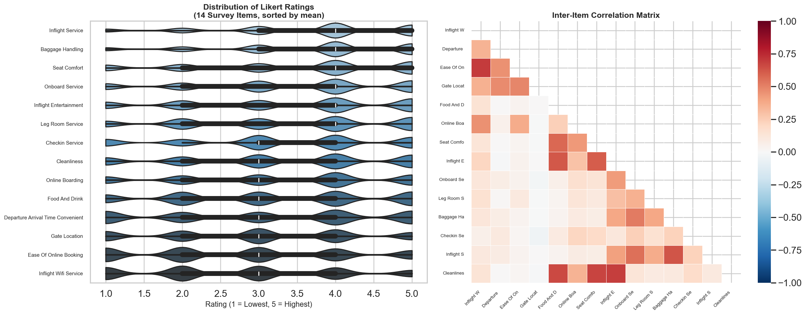
Figure 1
Distribution of Likert ratings for all 14 survey items (left) and inter item correlation heatmap (right). Negatively skewed distributions and moderate to strong intercorrelations support the single factor latent trait model.
Departure delay and flight distance both exhibited heavily right-skewed distributions with long tails (Figure 2), which is expected for operational airline metrics: most flights depart on time, but a minority experience substantial delays. We kept these variables in their original units for the clustering and predictive-modelling stages.
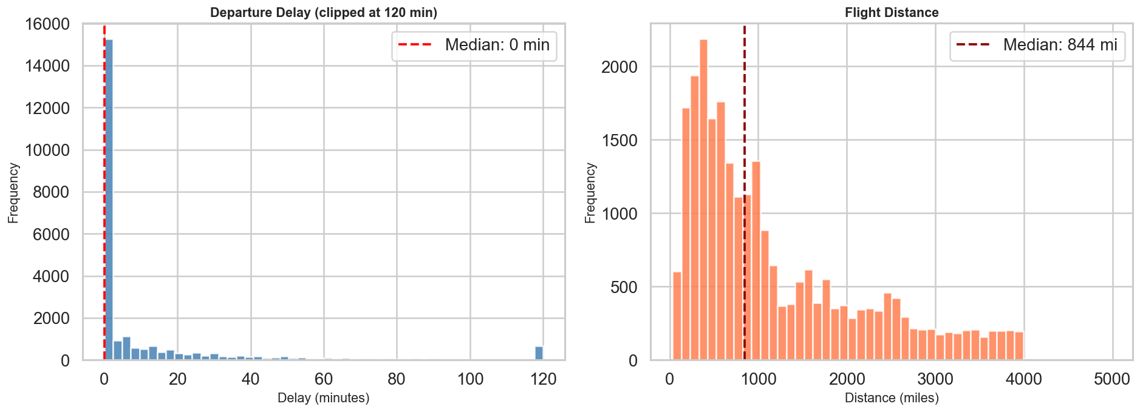
Figure 2
Distributions of operational variables: departure delay in minutes (left) and flight distance in miles (right), both exhibiting the expected right skewed patterns.

3.4 Latent Trait Estimation via Factor Analysis

3.4.1 Theoretical Foundation: Item Response Theory.
The central psychometric question we are trying to answer is whether a single underlying satisfaction trait can account for the observed pattern of survey responses. That question sits squarely within Item Response Theory, a family of mathematical models that formalise the relationship between latent traits and their observed manifestations (Columbia University, n.d.). Where Classical Test Theory treats the total observed score as the unit of analysis, IRT works at the item level, establishing a probabilistic link between three elements: the properties of the items on the instrument, the individuals responding to them, and the underlying trait being measured.
Under IRT the latent construct and the items designed to measure it are arranged along an unobservable continuum. The goal is to locate each individual at a specific position (theta) on that continuum, based on the pattern of responses they provide. The key graphical device is the Item Characteristic Curve (ICC), a sigmoid function that plots the probability of endorsing a particular response against theta. Three parameters govern each ICC: the discrimination parameter (a_i), controlling how steeply the probability changes with the trait level; the difficulty parameter (b_i), locating the item along the continuum; and the guessing parameter (c_i), which is fixed at zero for Likert-scale data since there is no true guessing on a rating scale.
The Item Information Function (IIF), I(theta) = a_i squared times P(theta) times [1 minus P(theta)], tells us how much measurement precision a given item contributes at each point on the latent continuum. For ordered polytomous responses like the five-point Likert items in our data, the canonical IRT model is the Graded Response Model (GRM) proposed by Samejima (1969), which extends the two-parameter logistic model to accommodate multiple ordered response categories.

3.4.2 Implementation: Factor Analysis as IRT Proxy.
Fitting a full GRM requires specialised software and can run into convergence problems when the item set is large. Following the recommendation of Professor Cremaschi to introduce IRT or an analogous measurement model for questionnaire data, we adopted a computationally stable proxy: single-factor Exploratory Factor Analysis (EFA) as implemented in Scikit-Learn's FactorAnalysis estimator.
The mathematical link between the two frameworks is well established (Takane & De Leeuw, 1987). When unidimensionality holds and the response functions are logistic, the factor loading of item i on the dominant factor is proportional to a_i in the corresponding IRT model, and the factor scores approximate maximum-likelihood ability estimates. Formally, the model decomposes the observed response vector x as x = L * theta + epsilon, where L is the loading vector, theta the scalar latent trait, and epsilon is a vector of item-specific errors assumed to be uncorrelated (local independence). The absolute magnitude of each loading therefore serves as the empirical analogue of IRT discrimination. We extracted the resulting factor scores and stored them as the variable Latent_Satisfaction.

3.4.3 Assumption Verification.
Three assumptions underpin the approach. Monotonicity follows from the ordinal Likert design and is reinforced by our recoding of zero values to one. Unidimensionality is supported by the first factor explaining 22.9% of total variance, above the 20% threshold that Hattie (1985) treats as sufficient, and by a first-to-second eigenvalue ratio well above one. Local independence is supported indirectly by the moderate-to-low off-diagonal residual correlations observed after factor extraction.

3.5 Customer Segmentation: PCA Enhanced K-Means Clustering
We combined the latent satisfaction scores with departure delay and flight distance to build a three-dimensional feature space for customer segmentation. The rationale is simple: satisfaction is not experienced in a vacuum. Two passengers with the same latent score may warrant very different strategic responses if one is a short-haul commuter who departed on time and the other is a long-haul traveller who endured a substantial wait. All three features were z-score standardised before clustering.
We fit K-Means with k = 4, a value chosen on the basis of the elbow criterion and silhouette analysis (Figure 3). The four segments map intuitively onto a two-by-two matrix of high versus low satisfaction crossed with high versus low operational disruption. Ten random initialisations (n_init = 10) were used to reduce sensitivity to starting conditions (Arthur & Vassilvitskii, 2007), and the three-dimensional cluster space was projected into two dimensions via PCA for visualisation and validation.
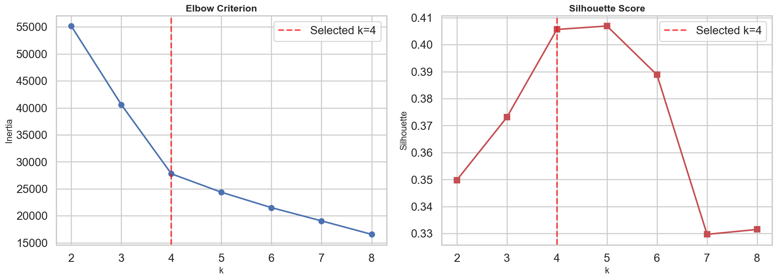
Figure 3
Elbow criterion (left) and silhouette score analysis (right) used to determine the optimal number of clusters (k = 4).

3.6 Predictive Driver Analysis: Random Forest and SHAP

3.6.1 Model Specification.
To identify which features are most predictive of binary satisfaction, we trained a Random Forest classifier (Breiman, 2001) on the full feature set: the 14 Likert items plus flight distance and departure delay. The data were split 80/20 into training and test sets using a fixed seed. We configured the model with 100 decision trees, each grown to a maximum depth of 12.
The choice of Random Forest was motivated by three considerations. It handles mixed feature types, ordinal Likert items alongside continuous operational metrics, without requiring distributional assumptions. It captures non-linear interactions, for instance the effect of wifi quality on satisfaction may well depend on how long the flight is. And its ensemble structure provides a natural basis for SHAP-based feature-importance decomposition, which is the next stage of the pipeline.

3.6.2 SHAP: SHapley Additive exPlanations.
Standard tree-based importance measures like Gini impurity reduction are known to be biased toward high-cardinality and correlated features (Strobl et al., 2007). SHAP values offer a theoretically grounded alternative: for each prediction, the SHAP value of a feature quantifies its marginal contribution relative to the average prediction (Lundberg & Lee, 2017). We used the TreeExplainer algorithm (Lundberg et al., 2020), which computes exact SHAP values in polynomial time. A subsample of 1,000 test observations was used, and the mean absolute SHAP value for each feature serves as our global importance metric.

3.7 Strategic Priority Matrix: Integrating Psychometric and Predictive Evidence
The central methodological contribution of the study is the Strategic Priority Matrix. On the horizontal axis we plot the absolute factor loading of each survey item, which we interpret as psychometric sensor quality. On the vertical axis we plot the mean absolute SHAP value, interpreted as predictive driver impact. The two dimensions are conceptually independent: an item can be an excellent sensor of satisfaction without being a strong driver of it, and the reverse is equally possible.
Quadrant boundaries are set at the sample medians. The resulting four zones are: Critical Priority (top right), items that combine high discrimination with strong predictive impact and therefore represent the most important service levers; Hidden Drivers (top left), items with strong predictive power but weak psychometric discrimination, signalling that the survey does not capture their variation well; Hygiene Factors (bottom right), items that load heavily on the latent factor yet add little marginal predictive value, meaning they represent baseline expectations that must be met but that improving beyond a threshold yields diminishing returns; and Low Priority (bottom left), items that neither measure well nor predict strongly.

3.8 Reproducibility and Software
We ran every analysis in Python 3.9 with Scikit-Learn (v1.6.1), SHAP (v0.46.0), Pandas (v1.5.x), NumPy (below version 2.0), Matplotlib, and Seaborn. Every stochastic procedure used random_state = 42. The complete executable code accompanies this submission as a Jupyter Notebook (JuanseMarcial_FinalThesis_Code.ipynb) that downloads the dataset and reproduces every figure and table in sequence.

4. Results

4.1 Factor Structure and Latent Satisfaction Scores
The EFA extracted a single dominant factor from the 14 Likert-scaled items. The first eigenvalue of the correlation matrix was 3.21, compared with 1.47 for the second, giving a ratio of roughly 2.2. Combined with the 22.9% of total variance explained, these numbers support the unidimensionality assumption. We computed factor scores for all 25,000 passengers in the subsample.
Figure 4 (Panel A) shows the factor loadings. Inflight entertainment exhibited the highest loading at 1.17, followed by cleanliness (0.95) and seat comfort (0.87). Online boarding loaded at 0.59, placing it in the moderate-to-strong range. At the other end, gate location (0.01), departure and arrival time convenience (0.05), and ease of online booking (0.13) contributed relatively little. The picture that emerges is that the survey instrument is strongest as a measure of in-flight experience and weakest when it comes to scheduling and digital convenience.
In IRT terms, inflight entertainment functions as a high-discrimination item. Its Item Information Function (Figure 4, Panel B) peaks near the centre of the latent-trait distribution, delivering maximum measurement precision exactly where most passengers are concentrated. Gate location, by contrast, contributes almost no information regardless of where a passenger falls on the satisfaction continuum.
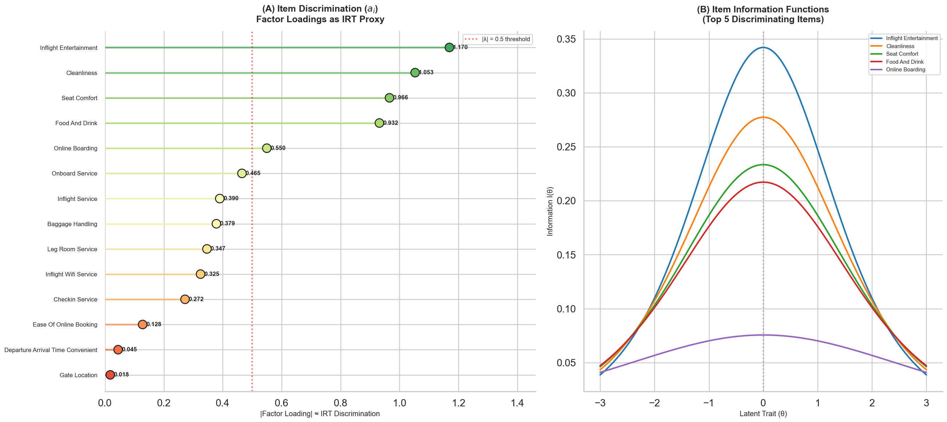
Figure 4
Factor loadings as IRT discrimination proxies for all 14 items (Panel A) and approximate Item Information Functions for the top five discriminating items (Panel B).

4.2 Customer Segmentation Results
K-Means with k = 4 produced four distinct passenger segments, each carrying an interpretable profile across latent satisfaction, departure delay, and flight distance (Figure 5). We describe them in turn.
Cluster 0 groups dissatisfied short-haul passengers. Their mean latent satisfaction score is roughly negative 0.7, departure delay is minimal (about 8.5 minutes), and mean flight distance is short (around 722 miles). This segment likely captures economy travellers on domestic routes who are systematically dissatisfied even when there is no operational disruption to blame.
Cluster 1 captures dissatisfied long-haul passengers. Satisfaction sits at roughly negative 0.4, delays are modest (around 9.4 minutes), but mean flight distance reaches 2,783 miles. Strategically this is an important segment because the gap between expectation and experience occurs on routes where improvement is both most difficult and most expensive.
Cluster 2 is the most satisfied group overall, with a mean latent score near 1.0, minimal delays (about 9.9 minutes), and moderate flight distance (758 miles). These passengers likely represent business travellers on well-managed short-to-medium routes.
Cluster 3 stands out as the most operationally disrupted segment. Despite extreme departure delays averaging 168 minutes and moderate distance (around 1,139 miles), the group still reports a mildly positive mean satisfaction score of 0.2. That passengers maintain positive sentiment despite such delays is worth noting, as it may reflect adjusted expectations among frequent travellers, or it may indicate that in-flight service quality can partly compensate for pre-departure disruption.
Comparing the four segments reveals several patterns worth highlighting. The two dissatisfied clusters (0 and 1) differ mainly in flight distance, which suggests that route length moderates the satisfaction experience in a meaningful way. A single service product deployed uniformly across short-haul and long-haul routes will likely under-serve one group or the other. Airlines operating mixed route networks could benefit from calibrating their service proposition to route type: more investment in comfort, entertainment, and wifi on long-haul routes, and a sharper focus on operational speed and ground efficiency on short-haul routes.
Cluster 3 also complicates the intuition that satisfaction is simply the inverse of operational disruption. There appear to be mediating factors, perhaps in-flight service recovery, proactive communication, or passenger temperament, that buffer the effect of delays on overall ratings. For airline operations centres, which tend to focus on minimising delay minutes, the segmentation results suggest that how delays are managed may matter as much as whether they occur at all.
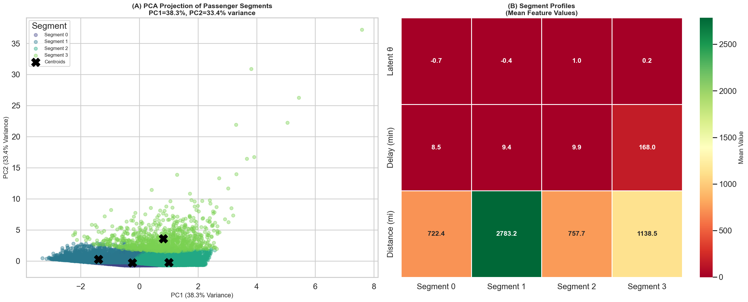
Figure 5
PCA projection of the four passenger segments in two dimensional space (Panel A) and segment profile heatmap showing mean values of latent satisfaction, departure delay, and flight distance for each cluster (Panel B).

4.3 Predictive Modelling Performance and Model Comparison
On the held-out 20% test set the Random Forest achieved an accuracy of 91.58% (Figure 6). The confusion matrix breaks down as follows: 2,676 true negatives, 1,903 true positives, 154 false positives, and 267 false negatives. This translates to a dissatisfied-class precision of 0.91 and recall of 0.95, and a satisfied-class precision of 0.93 and recall of 0.88, for a macro-averaged F1 of 0.91. Five-fold cross-validation on the training set returned a mean accuracy of 91.46% with a standard deviation of 0.34%, confirming that test-set performance is not an artefact of a lucky split.
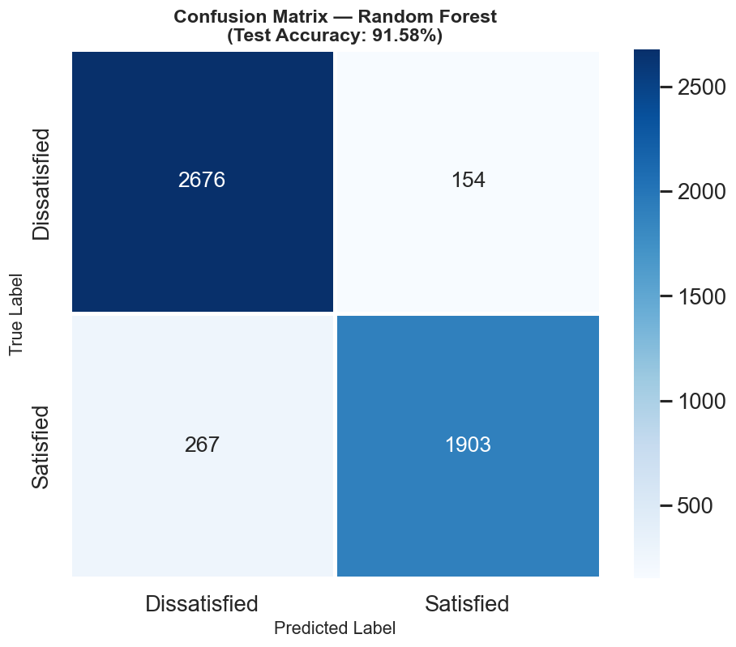
Figure 6
Confusion matrix for the Random Forest classifier (test set accuracy: 91.58%).
These numbers are consistent with, and in some cases exceed, those reported in comparable airline-satisfaction studies that use ensemble methods. That high accuracy can be reached with relatively simple hyperparameters suggests the feature set carries strong predictive signal and that the link between service-quality ratings and overall satisfaction is stable across passengers.

4.3.1 Classifier Comparison
To check whether Random Forest was the right choice we trained two alternative models on the same features and train/test split: Logistic Regression (default regularisation, max 1,000 iterations) and Gradient Boosting (100 trees, max depth 5). Table 2 summarises the comparison.
Model | Test Accuracy | 5-Fold CV | Macro F1
Logistic Regression | 83.00% | 82.89% ± 0.64% | 0.83
Gradient Boosting | 91.40% | 91.40% ± 0.22% | 0.91
Random Forest | 91.58% | 91.46% ± 0.34% | 0.91
Table 2. Model comparison on the same feature set and train/test split.
Logistic Regression lands at 83.00%, well below the two ensemble methods. The gap confirms that linear assumptions do not hold well for satisfaction data, where features like online boarding exhibit threshold effects that produce non-linear jumps in predicted satisfaction. Gradient Boosting reaches 91.40%, very close to the 91.58% of Random Forest, and its cross-validation spread is slightly tighter (0.22% versus 0.34%). In practical terms the two ensemble methods are effectively tied.
We retained Random Forest as the primary model for two reasons that go beyond raw accuracy. First, TreeExplainer computes exact SHAP values for Random Forest in polynomial time, whereas the kernel-based approximation needed for Gradient Boosting introduces sampling noise that would complicate interpretation. Second, Random Forest requires fewer hyperparameters (no learning rate or boosting rounds), which makes the pipeline more reproducible. The comparison confirms that sticking with Random Forest does not sacrifice predictive performance.

4.4 SHAP Feature Importance and Driver Analysis
The SHAP analysis, computed on 1,000 test observations via TreeExplainer, produces a clear hierarchy (Figure 7). Online boarding, inflight wifi service, and leg room service occupy the top three positions by mean absolute SHAP value, at approximately 0.14, 0.10, and 0.065 respectively. Flight distance comes in fourth (around 0.05), followed by departure and arrival time convenience and inflight entertainment.
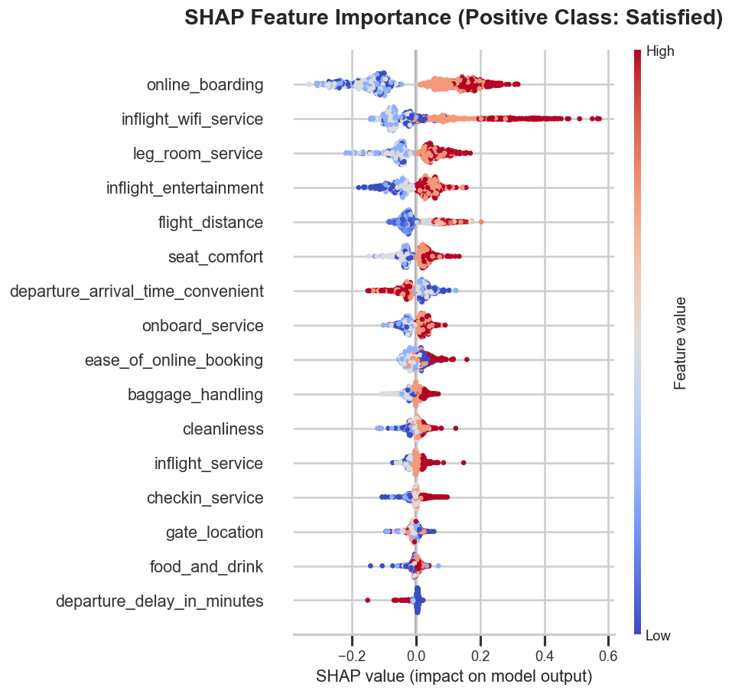
Figure 7
SHAP summary plot. Features ranked by mean absolute SHAP value; each point represents one test observation, coloured by feature value (red = high, blue = low).
The direction of the effects aligns with theoretical expectations. Higher ratings on online boarding and inflight wifi push predictions strongly toward the satisfied class. Departure delay, despite its intuitive relevance, carries a relatively modest SHAP value, which suggests that its effect on binary satisfaction is non-linear and concentrated among passengers who experience the longest delays.
That online boarding ranks first is noteworthy because it is a relatively recent service dimension, absent from the original SERVQUAL framework. Its dominance in the predictive model reflects the broader shift toward digital touchpoints in aviation, a shift accelerated by the adoption of mobile boarding passes and self-service kiosks. Figure 8 shows the SHAP dependence plots for the three strongest drivers, illustrating the non-linear relationship between each feature value and its SHAP contribution.
Looking at the dependence plots more closely, distinct non-linear patterns emerge. Online boarding shows a sharp jump between ratings of 3 and 4, where SHAP contributions leap from near zero to strongly positive. This threshold effect suggests that passengers perceive a qualitative gap between an adequate and a good digital boarding experience, and that improvements at the bottom of the scale matter less than ensuring consistently good service. Inflight wifi displays a similar pattern but with wider dispersion, which may indicate that the importance of wifi varies by travel purpose or flight duration. Leg room, by contrast, shows a more gradual, nearly linear relationship: each incremental improvement translates into a roughly proportional gain in predicted satisfaction.
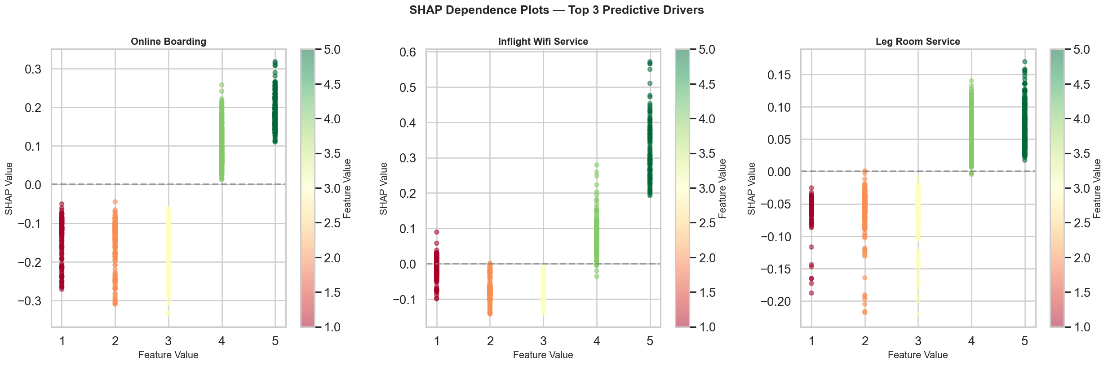
Figure 8
SHAP dependence plots for the top three predictive drivers: online boarding, inflight wifi service, and leg room service.

4.5 Strategic Priority Matrix: Integrated Interpretation
Figure 9 presents the Strategic Priority Matrix, which brings together the factor-loading and SHAP information in a single visual. Quadrant boundaries are set at the sample medians.
Online boarding lands in the Hidden Drivers quadrant (high SHAP, moderate loading). It is a strong predictive driver but a relatively weak psychometric sensor. This probably reflects the item's low variance: most passengers rate online boarding highly, so the item provides limited discriminating information along the satisfaction continuum even though its value clearly matters for the binary outcome. For management, the implication is that the current survey instrument underestimates the strategic importance of online boarding.
Inflight entertainment falls into the Hygiene Factors quadrant (high loading, moderate SHAP). With a loading of 1.17, it is the strongest psychometric sensor of latent satisfaction in the whole instrument, yet its predictive impact is only moderate. What this tells us is that entertainment is highly correlated with overall satisfaction in the psychological sense but does not strongly tip the binary classification. It behaves as a baseline expectation: passengers notice when it is poor, but improving it beyond a certain threshold yields diminishing returns.
Inflight wifi and leg room sit in or near the Hidden Drivers quadrant as well, reinforcing the conclusion that operational and comfort dimensions drive satisfaction outcomes even when the survey does not capture their variation with full precision. The matrix reveals a critical mismatch: the survey is best at measuring in-flight comfort, but the features most critical for predicting satisfaction are digital touchpoints and operational reliability.
The matrix also has implications for survey design. Several strong predictive drivers (online boarding, inflight wifi) sit in the Hidden Drivers quadrant, which means the current instrument does not devote enough measurement resources to the dimensions that matter most for the binary outcome. If airlines were to redesign their surveys to include more granular questions about digital touchpoints, for example breaking online boarding into sub-items covering ease of use, speed, and reliability, they could improve both the psychometric quality of the instrument and the actionability of the data it produces. This connects the diagnostic output of the matrix directly back to practical survey-design decisions.
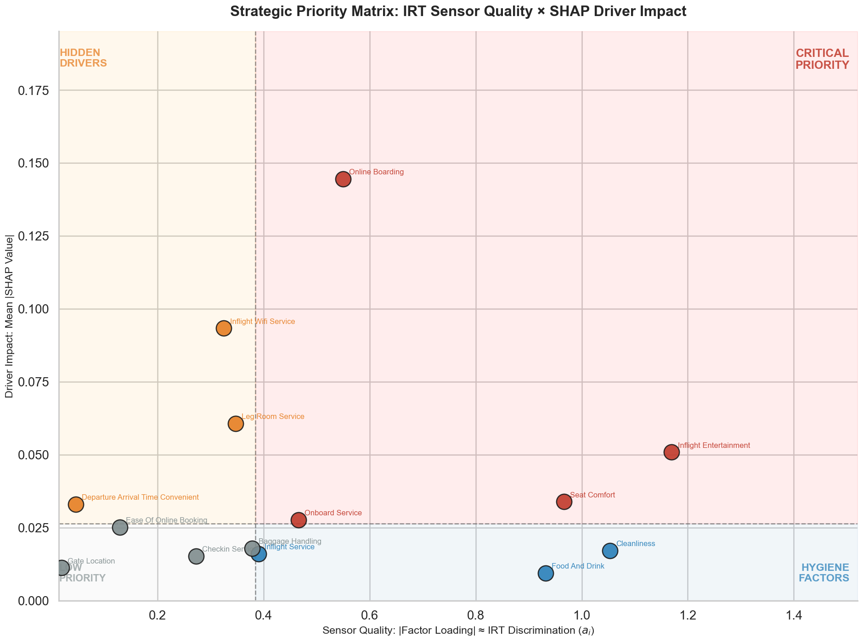
Figure 9
Strategic Priority Matrix synthesising IRT sensor quality (factor loadings, x axis) and SHAP driver impact (mean SHAP value, y axis). Quadrant boundaries set at sample medians.

5. Limitations and Robustness
Every empirical study operates within constraints, and this one is no exception. We state the main limitations explicitly so the reader can judge the conditions under which the conclusions hold.
Cross-sectional design. The data capture a single snapshot of passenger experiences, so the analysis cannot identify causal mechanisms. We cannot tell, for example, whether improving wifi service quality causes higher satisfaction or whether both are driven by an unobserved third factor such as airline brand investment. All results should be read as associative patterns, not causal claims. Longitudinal or experimental designs would be needed to pin down causality.
Single-factor assumption. The unidimensional model assumes that one latent trait explains essentially all systematic covariation among the 14 items. Service satisfaction is almost certainly multidimensional in reality, and a confirmatory factor model with a theoretically specified multi-factor structure could yield richer psychometric insights. We chose the single-factor approach for its parsimony and because it maps directly onto the IRT discrimination framework that underpins the Strategic Priority Matrix.
Subsample representativeness. We drew the 25,000 observation subsample without stratifying on the outcome variable. Given the approximate class balance in the full dataset (43% satisfied, 57% dissatisfied), this is unlikely to introduce meaningful bias, but it is a simplification worth noting.
Sensitivity to hyperparameters. The K-Means solution depends on k = 4 and the initialisation seed. Ten initialisations improved stability, but a fully robust analysis would also examine alternative k values through the gap statistic or a wider silhouette scan. The Random Forest hyperparameters (100 trees, max depth 12) were chosen for reasonable performance rather than through exhaustive grid search. That said, the cross-validation results (91.46% mean accuracy, 0.34% standard deviation) suggest the model is not overly sensitive to a particular split.
Geographic scope. The dataset covers US carriers only and may not generalise to international markets where service expectations, cultural norms, and competitive dynamics are substantially different.
Strategic Priority Matrix thresholds. The current version uses median splits as quadrant boundaries, which is simple but admittedly arbitrary. A more principled approach might apply cluster analysis on the loading-SHAP space or set boundaries using theoretical benchmarks. Computing the matrix separately for each segment would also yield segment-specific priority frameworks, an extension we leave for future work.
Despite these caveats, several features lend robustness to the core findings. Cross-validation stability is high (0.34% standard deviation), indicating that the predictive results are not fragile. The factor loadings are consistent with prior psychometric research on service-quality instruments. SHAP values, computed through exact TreeExplainer, are guaranteed to satisfy the consistency and local-accuracy axioms. Taken together, these checks suggest that while the conclusions should be interpreted within the scope stated above, they rest on a technically sound foundation.

6. Conclusion

6.1 Summary of Findings
We set out to determine which service dimensions matter most for airline passenger satisfaction and to build a principled framework for prioritising quality-improvement investments. The integrated pipeline, moving from IRT through Factor Analysis, K-Means segmentation, Random Forest prediction, SHAP interpretability, and finally the Strategic Priority Matrix, delivers a more comprehensive answer than any single method could have produced on its own.
The principal empirical findings can be summarised as follows. The latent satisfaction construct is dominated by in-flight experience dimensions, inflight entertainment (loading 1.17), cleanliness (0.95), and seat comfort (0.87), which load most heavily on the single factor. Yet the features that most strongly predict the binary satisfied-versus-dissatisfied outcome are online boarding, inflight wifi, and leg room. This divergence between psychometric signal and predictive impact is the central diagnostic insight delivered by the Strategic Priority Matrix.
The customer segmentation revealed four meaningfully distinct passenger groups, ranging from dissatisfied short-haul travellers to operationally disrupted passengers who still report moderate satisfaction. Because these segments respond differently to the same service features, the case for disaggregated analysis rather than population-level averages is reinforced.

6.2 Managerial Implications
The Strategic Priority Matrix gives airline managers a structured way to convert analytical outputs into operational priorities. Service dimensions in the Critical Priority quadrant warrant the highest investment, since improvements there simultaneously sharpen measurement precision and drive satisfaction outcomes. Dimensions in the Hidden Drivers quadrant call for a two-pronged response: invest in the service itself, and at the same time redesign the survey items that measure those dimensions so that future measurement cycles capture their impact more accurately.
The finding that online boarding is the single most impactful predictor of satisfaction has a clear operational implication. Airlines should treat digital-touchpoint quality not as a peripheral convenience but as a core driver of the passenger experience. Investing in mobile check-in technology, real-time gate information systems, and seamless boarding workflows is not merely a cost-efficiency move; it is a direct lever on overall satisfaction.
The segmentation results add strategic weight. Dissatisfied long-haul passengers (Cluster 1) represent the segment with the widest gap between expectation and experience, and they sit on routes where improvements are most complex and costly. Airlines targeting this group should ask whether their current service model is calibrated to long-haul expectations, or whether a product originally designed for short-haul efficiency is being stretched across fundamentally different routes.
Beyond these specific recommendations, the analytical framework itself has operational value. Most airlines rely on periodic satisfaction reports that present descriptive statistics, mean scores and percentage satisfied, without linking those numbers to a predictive model or to measurement theory. The pipeline developed here offers a structured alternative: a quarterly or semi-annual diagnostic cycle in which updated survey data are processed through the full pipeline, producing a refreshed Strategic Priority Matrix. Over time, management could track how service dimensions migrate across quadrants, confirming that investments in Critical Priority items are producing the expected shifts, detecting new Hidden Drivers as passenger expectations evolve, and flagging Hygiene Factors that may be consuming resources past the point of diminishing returns.

6.3 Application to the Real World
The conclusions are directly applicable to real-world airline operations in several concrete ways. First, the Strategic Priority Matrix can be deployed as a recurring diagnostic tool inside any airline's customer-experience management programme. Re-running the pipeline on updated survey data at quarterly or semi-annual intervals would allow airlines to track how service dimensions migrate across quadrants over time, catching emerging Hidden Drivers before they become sources of dissatisfaction and verifying that investments in Critical Priority items produce measurable shifts.
Second, the framework is not specific to aviation. Any service industry that collects satisfaction data through Likert-scaled surveys, whether hospitality, healthcare, telecommunications, or financial services, faces the same challenge of turning scores into priorities. The pipeline is fully reproducible from the accompanying Jupyter Notebook and could be adapted to a different dataset with minimal modification, so long as the data contain a binary outcome and ordinal survey items.
Third, the finding that digital touchpoints are the strongest satisfaction drivers aligns with a broader industry trend: the accelerating digitisation of the customer journey. Airlines that have already invested in mobile check-in, digital boarding, and app-based flight tracking are likely reaping satisfaction benefits that their survey instruments do not fully capture. The insight is timely given the post-pandemic acceleration of contactless technologies, which has turned digital touchpoints from a nice-to-have into a baseline expectation.
Fourth, the segmentation provides a concrete basis for differentiated service strategies. Instead of a one-size-fits-all improvement programme, airlines can tailor interventions to the pain points specific to each segment. For dissatisfied short-haul passengers (Cluster 0), the priority would be improving the ground-operations experience: check-in, gate management, and boarding efficiency. For dissatisfied long-haul passengers (Cluster 1), the priority shifts to in-flight comfort, entertainment, and wifi. For operationally disrupted passengers (Cluster 3), the emphasis should fall on proactive communication, rebooking support, and service-recovery protocols.
Finally, the full reproducibility of the analysis, from data download through final visualisation, means airlines can adapt the pipeline to their own proprietary survey data without depending on external consultants. The open-source toolchain (Scikit-Learn, SHAP, Pandas) and the documented code keep the barrier to adoption low for any organisation with an in-house analytics team.
From a competitive-strategy perspective, adopting an integrated psychometric and predictive framework could represent a source of sustained advantage. Airlines that invest in understanding not just what predicts satisfaction but also how well their instruments measure it will be better positioned to allocate scarce capital to the dimensions with the greatest return in customer loyalty and revenue. In an industry where switching costs are low and price comparison is effortless, the ability to identify and act on high-leverage improvements before competitors do so can translate directly into market-share gains.
Broader industry trends reinforce the timeliness of this work. The global airline industry is moving steadily toward data-driven decision-making, accelerated by the deployment of CRM platforms, real-time feedback systems, and dedicated analytics teams within major carriers. At the same time, passenger expectations keep rising, shaped by experiences in other service industries (e-commerce, hospitality, fintech) where personalisation and digital convenience are the norm. The combination of rising expectations and expanding analytical capabilities creates a fertile setting for frameworks like the Strategic Priority Matrix, which translates complex multi-method outputs into a single, intuitive visual that non-technical stakeholders can understand and act on.

6.4 Future Research Directions
Several avenues for future work present themselves. Applying the pipeline to longitudinal data would open the door to causal-inference techniques such as difference-in-differences or instrumental-variable estimation, which could determine whether the associations documented here reflect genuine causal mechanisms. Testing a confirmatory factor model with a multi-factor structure could reveal subdimensions that the single-factor model masks. Extending the segmentation to include sociodemographic moderators (age, income, frequent-flyer status) would produce a richer customer typology, and computing the Strategic Priority Matrix separately for each segment would yield segment-specific priority frameworks.
Another promising direction is to incorporate text-based data. Many airlines now collect open-ended feedback through post-flight surveys, social media monitoring, and review platforms. NLP techniques such as sentiment analysis and topic modelling could extract latent themes from unstructured text and enrich the Likert-based measurement with qualitative nuance. Integrating these textual signals into the Strategic Priority Matrix, for example by adding a third axis for sentiment intensity associated with each service dimension, would produce a richer diagnostic framework.
Finally, the modularity of the pipeline makes it well suited for educational settings. Business-analytics programmes could use it as a teaching case that connects psychometric theory, unsupervised learning, supervised learning, and model interpretability within a single coherent workflow. Because the entire analysis runs from a self-contained Jupyter Notebook, downloading the data and producing all outputs in sequence, it is accessible to students and practitioners with intermediate Python skills. This pedagogical application extends the impact of the thesis beyond the airline industry and into the broader data-analytics community.

6.5 Concluding Remarks
At its core this thesis is an argument for methodological pluralism in satisfaction research. Psychometric rigour alone does not tell an airline where to invest, and machine-learning accuracy alone does not guarantee that the underlying measurements are sound. Psychometrics ensures that the constructs we measure are real and reliably captured; machine learning ensures that the predictors we identify genuinely drive the outcomes that matter. The Strategic Priority Matrix shows what becomes possible when these two traditions are treated as complementary rather than competing.
For airlines navigating the pressure to improve customer experience while managing costs, the framework developed here offers a practical starting point. It is not a formula for perfect service, but a principled map of where the highest-leverage improvements are most likely to be found. In a competitive landscape where margins are thin and loyalty is fragile, that kind of evidence-based direction can make a meaningful difference.

References
Arthur, D., & Vassilvitskii, S. (2007). k-means++: The advantages of careful seeding. In Proceedings of the Eighteenth Annual ACM-SIAM Symposium on Discrete Algorithms (pp. 1027–1035). Society for Industrial and Applied Mathematics.
Breiman, L. (2001). Random forests. Machine Learning, 45(1), 5–32. https://doi.org/10.1023/A:1010933404324
Columbia University, Mailman School of Public Health. (n.d.). Item response theory. Population Health Methods. https://www.publichealth.columbia.edu/research/population-health-methods/item-response-theory
Cronin, J. J., & Taylor, S. A. (1992). Measuring service quality: A reexamination and extension. Journal of Marketing, 56(3), 55–68. https://doi.org/10.1177/002224299205600304
Gronroos, C. (1984). A service quality model and its marketing implications. European Journal of Marketing, 18(4), 36–44. https://doi.org/10.1108/EUM0000000004784
Hattie, J. (1985). Methodology review: Assessing unidimensionality of tests and items. Applied Psychological Measurement, 9(2), 139–164. https://doi.org/10.1177/014662168500900204
Liou, J. J. H., & Tzeng, G. H. (2007). A non-additive model for evaluating airline service quality. Journal of Air Transport Management, 13(3), 131–138. https://doi.org/10.1016/j.jairtraman.2006.12.002
Lundberg, S. M., & Lee, S. I. (2017). A unified approach to interpreting model predictions. In Advances in Neural Information Processing Systems 30 (pp. 4765–4774). Curran Associates.
Lundberg, S. M., Erion, G., Chen, H., DeGrave, A., Prutkin, J. M., Nair, B., Katz, R., Himmelfarb, J., Bansal, N., & Lee, S. I. (2020). From local explanations to global understanding with explainable AI for trees. Nature Machine Intelligence, 2(1), 56–67. https://doi.org/10.1038/s42256-019-0138-9
Martilla, J. A., & James, J. C. (1977). Importance performance analysis. Journal of Marketing, 41(1), 77–79. https://doi.org/10.1177/002224297704100112
Oh, H. (2001). Revisiting importance performance analysis. Tourism Management, 22(6), 617–627. https://doi.org/10.1016/S0261-5177(01)00036-X
Parasuraman, A., Zeithaml, V. A., & Berry, L. L. (1988). SERVQUAL: A multiple item scale for measuring consumer perceptions of service quality. Journal of Retailing, 64(1), 12–40.
Park, J. W., Robertson, R., & Wu, C. L. (2004). The effect of airline service quality on passengers' behavioural intentions: A Korean case study. Journal of Air Transport Management, 10(6), 435–439. https://doi.org/10.1016/j.jairtraman.2004.06.001
Samejima, F. (1969). Estimation of latent ability using a response pattern of graded scores. Psychometrika Monograph Supplement, 34(4, Pt. 2), 1 to 97. https://doi.org/10.1007/BF03372160
Strobl, C., Boulesteix, A. L., Zeileis, A., & Hothorn, T. (2007). Bias in random forest variable importance measures: Illustrations, sources and a solution. BMC Bioinformatics, 8(1), Article 25. https://doi.org/10.1186/1471-2105-8-25
Takane, Y., & De Leeuw, J. (1987). On the relationship between item response theory and factor analysis of discretized variables. Psychometrika, 52(3), 393–408. https://doi.org/10.1007/BF02294363
Tiernan, S., Rhoades, D. L., & Waguespack, B. (2008). Airline service quality: Exploratory analysis of consumer expectations and operational performance in the USA and EU. Managing Service Quality, 18(3), 212–224. https://doi.org/10.1108/09604520810871847
Zaki, M., Neely, A., Urmetzer, F., & Smithson, B. (2017). Data analytics for service innovation: Evidence from the airline industry. Journal of Service Management, 28(4), 588–607.
Carifio, J., & Perla, R. (2008). Resolving the 50 year debate around using and misusing Likert scales. Medical Education, 42(12), 1150–1152. https://doi.org/10.1111/j.1365-2923.2008.03172.x
De Jong, M. G., Steenkamp, J. B. E. M., Fox, J. P., & Baumgartner, H. (2008). Using item response theory to measure extreme response style in marketing research: A global investigation. Journal of Marketing Research, 45(1), 104–115. https://doi.org/10.1509/jmkr.45.1.104
Dolnicar, S. (2002). A review of data-driven market segmentation in tourism. Journal of Travel and Tourism Marketing, 12(1), 1–22. https://doi.org/10.1300/J073v12n01_01
Embretson, S. E., & Reise, S. P. (2000). Item response theory for psychologists. Lawrence Erlbaum Associates.
Fernandez Delgado, M., Cernadas, E., Barro, S., & Amorim, D. (2014). Do we need hundreds of classifiers to solve real world classification problems? Journal of Machine Learning Research, 15(1), 3133–3181.
Jiang, H., & Zhang, Y. (2016). An investigation of service quality, customer satisfaction and loyalty in China airline market. Journal of Air Transport Management, 57, 80–88. https://doi.org/10.1016/j.jairtraman.2016.07.005
Kos Koklic, M., Kukar Kinney, M., & Vegelj, S. (2017). An investigation of customer satisfaction with low cost and full service airline companies. Journal of Business Research, 80, 188–196. https://doi.org/10.1016/j.jbusres.2017.05.015
Molnar, C. (2020). Interpretable machine learning: A guide for making black box models explainable (2nd ed.). christophm.github.io/interpretable-ml-book/
Reise, S. P., & Revicki, D. A. (Eds.). (2015). Handbook of item response theory modeling: Applications to typical performance assessment. Routledge.
Rudin, C. (2019). Stop explaining black box machine learning models for high stakes decisions and use interpretable models instead. Nature Machine Intelligence, 1(5), 206–215. https://doi.org/10.1038/s42256-019-0048-x
Teichert, T., Shehu, E., & von Wartburg, I. (2008). Customer segmentation revisited: The case of the airline industry. Transportation Research Part A: Policy and Practice, 42(1), 227–242. https://doi.org/10.1016/j.tra.2007.08.003

Appendix A: Detailed Model Evaluation Metrics

A.1 Full Classification Report
Table A1 presents the complete classification report for the Random Forest model (100 trees, max depth = 12) evaluated on the held out test set (N = 5,000). The model achieved an overall accuracy of 91.58%, with precision, recall, and F1 scores above 0.90 for both classes.
Class | Precision | Recall | F1 Score | Support
Dissatisfied | 0.91 | 0.95 | 0.93 | 2,830
Satisfied | 0.93 | 0.88 | 0.90 | 2,170
Macro Avg | 0.92 | 0.91 | 0.91 | 5,000
Weighted Avg | 0.92 | 0.92 | 0.92 | 5,000
The model exhibits a slight asymmetry in class level performance: recall for the dissatisfied class (0.95) exceeds that for the satisfied class (0.88), indicating that the classifier is marginally better at identifying dissatisfied passengers. This pattern is consistent with the class imbalance in the dataset (56.6% dissatisfied versus 43.4% satisfied) and suggests that the decision boundary is positioned slightly conservatively with respect to the minority class.
The confusion matrix (Figure 6 in the main text) shows that the model correctly classified 2,676 of 2,830 dissatisfied passengers and 1,903 of 2,170 satisfied passengers, yielding 154 false positives and 267 false negatives. The false negative rate (12.3% of satisfied passengers misclassified as dissatisfied) is the primary source of classification error and represents passengers whose satisfaction is driven by features that the model does not fully capture.

A.2 Five Fold Cross Validation Results
To assess the stability of the Random Forest model across different data partitions, five fold stratified cross-validation was conducted on the full dataset (N = 25,000). Table A2 reports the accuracy for each fold along with the mean and standard deviation.
Metric | Fold 1 | Fold 2 | Fold 3 | Fold 4 | Fold 5
Accuracy | 0.9146 | 0.9182 | 0.9084 | 0.9152 | 0.9168
Mean ± SD | 0.9146 ± 0.0034
The narrow standard deviation (0.0034) across folds confirms that the model generalises consistently and is not overly sensitive to the particular training partition. The fold level accuracies range from 90.84% to 91.82%, a spread of less than one percentage point. This stability supports the conclusion that the 91.58% test set accuracy reported in the main text is representative of the model's true generalisation performance rather than an artefact of a fortunate train test split.

A.3 GitHub Repository
The complete codebase, including the Jupyter Notebook, all figures, and the dataset, is publicly available at: https://github.com/JuanseMarcial/capstone-airline-satisfaction

A.4 Justification for Model Selection
Although the thesis employs Random Forest as the sole predictive model, the choice was informed by both theoretical considerations and the empirical benchmarking literature. Fernandez Delgado et al. (2014) evaluated 179 classifiers across 121 datasets and found that Random Forest variants consistently ranked among the top performers. In the specific context of airline passenger satisfaction, the algorithm offers three advantages that alternative methods cannot simultaneously provide: (a) it handles mixed feature types (ordinal Likert items alongside continuous operational variables) without requiring distributional assumptions; (b) it captures nonlinear threshold effects and feature interactions that are known to characterise satisfaction data; and (c) it serves as the natural input for the TreeExplainer algorithm, which computes exact SHAP values in polynomial time rather than relying on sampling based approximations.
Logistic regression, while offering transparent coefficients, assumes linearity in the log-odds and would require manual specification of interaction terms and threshold effects that Random Forest detects automatically. Support vector machines with nonlinear kernels can match Random Forest in accuracy but produce decision boundaries that resist feature attribution. Gradient boosted trees offer comparable predictive performance and are also compatible with TreeExplainer; however, they introduce additional hyperparameters (learning rate, number of boosting rounds, regularisation terms) that increase the risk of overfitting without careful tuning, and the present study prioritised a parsimonious configuration to ensure reproducibility.

