Beyond Simple Averages:
An Integrated Psychometric and Machine Learning Framework
for Airline Passenger Satisfaction Analysis

Juan Sebastian Marcial Piedra

IE University
School of Science and Technology

Capstone Project, Final Submission

Supervised by: Professor Cremaschi

March 2026

Table of Contents
[Right-click and select Update Field to generate Table of Contents]

Abstract
The measurement and improvement of airline passenger satisfaction sits at the intersection of two disciplines that have, until recently, developed in relative isolation: psychometric measurement theory and applied machine learning. Within the broader field of data and business analytics, the ability to combine rigorous measurement with predictive modelling represents an increasingly valuable competence, as organisations seek not merely to predict customer behaviour but to understand the mechanisms through which service quality is perceived and evaluated. This thesis contributes to that intersection by developing and applying an integrated analytical pipeline that treats psychometric rigour and machine learning interpretability as complementary rather than competing objectives.
The primary objective of this research is to determine which service dimensions matter most for airline passenger satisfaction and to provide airlines with a principled, evidence-based framework for prioritising quality improvement investments across a heterogeneous passenger population. A secondary objective is to demonstrate that latent trait models drawn from Item Response Theory can be operationalised within a standard Python data science environment, bridging a methodological gap that has historically separated psychometric research from applied analytics.
Using a large scale survey dataset of approximately 130,000 passenger responses collected across multiple United States carriers, we construct a five stage pipeline. The pipeline proceeds from latent satisfaction estimation via single factor Exploratory Factor Analysis, through K-Means customer segmentation enriched with operational variables, to Random Forest classification achieving 91.58% test accuracy, followed by SHAP based feature importance decomposition. The central methodological contribution is the Strategic Priority Matrix, a novel diagnostic tool that synthesises factor loadings (interpreted as psychometric sensor quality) against mean absolute SHAP values (interpreted as predictive driver impact), yielding a four quadrant framework that distinguishes Critical Priority items, Hidden Drivers, Hygiene Factors, and Low Priority attributes.
The originality of this work lies in the explicit integration of two analytical traditions that existing literature has treated separately. Studies employing psychometric models for airline satisfaction rarely follow through with data-driven prediction, while machine learning applications to satisfaction prediction seldom interrogate the measurement quality of their input features. The Strategic Priority Matrix closes this gap, offering airlines a single framework in which measurement theory and predictive analytics inform each other. The reader can expect a transparent, fully reproducible methodology, empirical results with direct managerial implications, and a reusable analytical framework applicable beyond the airline industry to any service context where survey-based measurement meets predictive modelling.
Keywords: airline passenger satisfaction, item response theory, factor analysis, K-Means clustering, Random Forest, SHAP, strategic priority matrix

1. Introduction
The global airline industry operates in a service environment where the consequences of misunderstanding customer experience are severe. In the current landscape of social media and instant review platforms, a single dissatisfied passenger can reach audiences far beyond their immediate network, amplifying reputational damage in ways that traditional service failure metrics fail to capture. The competitive pressure this creates has elevated passenger satisfaction from a peripheral performance indicator to one of the most closely monitored metrics in commercial aviation (Tiernan et al., 2008). As a result, the measurement and prediction of satisfaction has become an active and contested area of scholarly inquiry, drawing on disciplines as varied as psychometrics, machine learning, and service operations management.
Despite several decades of research into service quality and customer satisfaction, a persistent tension runs through the existing literature. On one side sits the tradition of psychometric measurement, rooted in frameworks such as SERVQUAL (Parasuraman et al., 1988) and its derivatives, which provides conceptual clarity and measurement rigour but often struggles to translate its insights into a manageable set of operational priorities. On the other side sits the data science tradition, which trains models capable of predicting satisfaction with impressive accuracy but frequently stops short of asking what those predictions actually mean, or whether the feature importance estimates they generate are reliable measures of what genuinely drives the underlying experience.
This bifurcation carries real costs. Airlines that rely solely on psychometric models obtain precise measures of satisfaction constructs but lack the predictive power to identify which service levers will shift outcomes most effectively. Airlines that rely solely on machine learning obtain accurate classifiers but risk acting on feature importance rankings that conflate measurement artefacts with genuine drivers. Neither approach, applied in isolation, provides the integrated evidence base that strategic resource allocation requires.
This thesis is motivated by the conviction that these two analytical traditions need each other. The central research question driving this work is as follows: which service dimensions matter most for airline passenger satisfaction, and how should an airline prioritise its quality improvement investments across a diverse passenger population? We address this question by developing an integrated pipeline that moves explicitly from psychometric measurement, through customer segmentation, to predictive modelling and strategic synthesis.
To answer this question, the study draws on the Airline Passenger Satisfaction dataset, a publicly available repository of approximately 130,000 survey responses covering fourteen service quality dimensions alongside operational variables such as departure delay and flight distance. The analytical pipeline proceeds through four main stages: latent trait estimation via Factor Analysis as a proxy for Item Response Theory; passenger segmentation through K-Means clustering; predictive modelling using a Random Forest classifier with SHAP based interpretability; and the construction of a novel Strategic Priority Matrix that synthesises the psychometric and predictive outputs into a single, actionable framework.
The contribution of this work is threefold. First, we demonstrate that latent trait models can be operationalised in a standard Python environment without sacrificing the psychometric insights they are designed to provide. Second, we show that combining satisfaction measurement with passenger segmentation produces richer and more strategically nuanced insights than either analysis alone. Third, and most substantively, the Strategic Priority Matrix offers airlines a principled, evidence-based tool for allocating quality improvement resources across service dimensions, grounded in both measurement theory and predictive analytics.
The remainder of this thesis is structured as follows. Section 2 reviews the relevant literature across service quality modelling, airline satisfaction research, survey-based measurement, dimensionality reduction, customer segmentation, predictive modelling, and interpretability techniques. Section 3 describes the methodology in detail. Section 4 presents and interprets the empirical results. Section 5 discusses limitations and robustness. Section 6 draws conclusions, discusses managerial implications, and identifies applications to the real world.

2. Literature Review

2.1 Framing Passenger Satisfaction as Experienced Service Quality
Airline passenger satisfaction is not a simple metric that can be read directly from a survey form. It is the accumulated impression that builds across every touchpoint of a journey, shaped by what actually occurred, how it was perceived at the time, and whether the overall experience matched the passenger's prior expectations. The early service quality literature already drew attention to this distinction: there is a meaningful difference between what is delivered and how it is delivered. A flight can arrive on schedule and still leave a passenger frustrated if the boarding process was poorly managed, the crew appeared indifferent, or communication about minor delays was absent. In air travel, where much of the experience is procedural (passengers queue, follow instructions, and remain seated in confined spaces for extended periods), any friction along the way tends to be amplified (Gronroos, 1984).
This observation was formalised with the development of the Service Quality model, commonly known as SERVQUAL. Parasuraman et al. (1988) proposed a structured framework for evaluating service by decomposing the customer assessment into five dimensions (tangibles, reliability, responsiveness, assurance, and empathy) and measuring the gap between what customers expected and what they actually perceived. In airline contexts, reliability and responsiveness carry particular weight. The lasting contribution of SERVQUAL was not merely the specific items it proposed, but the broader claim that customers evaluate service along a structured internal scorecard, even when they are not consciously aware of doing so.
Subsequent work in the 1990s sought to adapt this framework to contexts where the gap model had practical limitations. SERVPERF, proposed by Cronin and Taylor (1992), argued that perception alone, without the expectation gap calculation, was a more reliable predictor of overall service quality. This debate is relevant to the present study because it underscores a foundational methodological issue: the tools employed to measure satisfaction are themselves imperfect, and the assumptions embedded in their design affect what we observe.
More broadly, the service quality literature has evolved from a transactional view, in which quality is judged against a fixed performance benchmark, toward an experiential view, in which quality is co created through the interaction between the service provider and the customer. This shift has important implications for measurement. A transactional perspective invites simple checklists (was the flight on time? was the seat clean?), whereas an experiential perspective demands instruments that capture the subjective, affective, and contextual dimensions of the encounter. The present study embraces the experiential view by treating satisfaction not as a checklist aggregate but as a latent psychological construct that must be estimated through a principled measurement model.

2.2 Airline Specific Drivers of Passenger Satisfaction
When the focus is narrowed to the airline industry, a more detailed picture of satisfaction drivers emerges. Research has consistently identified a cluster of factors that matter above others: seat comfort, in-flight entertainment, food and beverage quality, and the responsiveness and friendliness of cabin crew (Liou & Tzeng, 2007; Park et al., 2004). What distinguishes airlines from most other service industries is the degree to which satisfaction is conditional on factors the carrier cannot fully control. Weather disruptions, air traffic control decisions, and connecting flight schedules all shape the passenger experience in ways that have nothing to do with service design.
This creates a measurement challenge. If a passenger rates satisfaction as low primarily because of a two hour weather delay, that rating reflects the operational environment as much as the quality of the service itself. The present study addresses this issue by treating departure delay as a contextual variable in the clustering stage rather than as a survey-based service quality indicator, keeping it analytically separate from the psychometric measurement of the latent satisfaction construct.
Research has also highlighted meaningful differences in satisfaction drivers across passenger segments. Business travellers tend to prioritise punctuality, in-flight connectivity, and seat comfort, while leisure travellers exhibit greater sensitivity to price and in-flight entertainment (Tiernan et al., 2008). This heterogeneity is one reason why a simple average satisfaction score provides a poor guide for resource allocation, and it is the insight that directly motivates the segmentation analysis in this study.
A growing body of recent work has drawn attention to the increasing importance of digital and pre-flight touchpoints in shaping overall passenger satisfaction. Mobile check in, digital boarding passes, real-time flight tracking applications, and airport self-service kiosks have transformed the journey well before the passenger boards the aircraft. Zaki et al. (2017) argue that these digital service innovations represent a shift in the locus of value creation from the in-flight experience to the end-to-end journey, and that traditional satisfaction models have been slow to incorporate this shift. The Airline Passenger Satisfaction dataset used in this study includes both digital and in-flight items, making it well-suited to examine whether digital touchpoints have overtaken traditional comfort dimensions as satisfaction drivers.
In addition to passenger type differences, the role of operational variables in moderating satisfaction deserves attention. Departure delay is perhaps the most salient operational factor, yet its relationship with satisfaction is not straightforward. Short delays (under 15 minutes) are generally tolerated with little impact on ratings, while longer delays produce a nonlinear escalation in dissatisfaction that depends on whether the airline communicates proactively and offers appropriate service recovery. Flight distance acts as a different kind of moderator: on short-haul routes, passengers may tolerate limited entertainment or wifi, whereas on long-haul routes these features become essential. This interaction between operational context and service evaluation is precisely what the segmentation analysis in Section 3.5 is designed to capture.

2.3 Survey Measurement and Scale Design
The methodological challenge at the heart of any satisfaction study is measurement. Satisfaction is not directly observable; it must be inferred from responses to survey items, and the quality of those inferences depends critically on how well the items are designed and how the resulting data are analysed. The standard approach in airline research has been to employ Likert type scales and to treat the sum or average of responses as the satisfaction score. This approach has the advantage of simplicity, but it carries a hidden cost: it treats all items as equally informative and ignores differences in the precision with which different items measure the underlying construct.
Classical Test Theory (CTT), which underpins the sum score approach, assumes that an observed score is the sum of a true score and a random error term, with the error assumed constant across all individuals. This assumption is convenient but often empirically false. Item Response Theory (IRT), the measurement framework adopted in this study, relaxes this assumption by allowing measurement precision to vary across both individuals and items, producing a richer and more accurate account of what the data reveal.

2.4 Exploratory Factor Analysis and Latent Variable Modelling
Factor analysis has been used in psychology and education for over a century, originally as a tool for identifying the latent dimensions underlying a battery of cognitive tests. Its application to service quality research is more recent but well-established, particularly in settings where multiple survey items are suspected to be manifestations of a smaller number of underlying constructs. Takane and De Leeuw (1987) demonstrated formally that, under certain regularity conditions, the factor loading of an item on a dominant factor is proportional to its discrimination parameter in the corresponding IRT model. This mathematical relationship makes single factor Exploratory Factor Analysis a defensible proxy for the Graded Response Model in computational environments where full IRT estimation is impractical.
The decision to fit a single factor model reflects a deliberate choice for parsimony. The goal is not to produce the richest possible description of the covariance structure among items, but rather to extract a single, interpretable latent score that can serve as the psychometric anchor for the downstream clustering and predictive analyses.
The use of single factor EFA as a proxy for IRT is particularly suitable in applied analytics settings where the primary goal is not to estimate item parameters with maximum precision but to produce a defensible continuous score that preserves the ordinal information in the raw ratings. In such settings, the computational simplicity of EFA (available in standard libraries such as Scikit-Learn) is a significant practical advantage. The loadings produced by EFA can be interpreted directly through the IRT lens: higher loadings indicate items that discriminate more effectively between satisfied and dissatisfied passengers, while lower loadings indicate items whose ratings carry less information about the underlying construct. This interpretive bridge between two psychometric frameworks is a key feature of the methodology adopted in this thesis.

2.5 Customer Segmentation with Clustering Methods
Market segmentation has long been a core tool of airline strategy, enabling carriers to tailor their product offerings to distinct passenger groups. Traditional approaches relied on demographic variables such as age, gender, and travel purpose. More recent approaches have moved toward behavioural and attitudinal segmentation, grouping passengers by their satisfaction profiles. K-Means clustering is among the most widely applied methods for this purpose, valued for its interpretability and scalability to large datasets (Arthur & Vassilvitskii, 2007). By clustering on latent satisfaction scores rather than raw item responses, and by incorporating operational variables that capture the journey context, we avoid the pitfall of producing segments that merely reflect the item-level covariance structure rather than meaningful strategic differences.

2.6 Machine Learning for Satisfaction Prediction
The application of machine learning to passenger satisfaction prediction has grown substantially over the past decade. The Random Forest algorithm, introduced by Breiman (2001), occupies a particularly useful position: it is robust to outliers and irrelevant features, handles mixed feature types gracefully, and provides built-in feature importance estimates that serve as a natural input for SHAP based interpretability. Predictive accuracy alone, however, is insufficient for actionable insight. The translation from prediction to prescription requires an interpretability layer, which is where SHAP values become essential.
Alternative classifiers such as logistic regression, support vector machines, and gradient boosted trees have also been applied to satisfaction prediction with varying success. Logistic regression offers excellent interpretability through its coefficient structure but assumes linear relationships between features and the log-odds of the outcome, an assumption that is unlikely to hold in satisfaction data where threshold effects and interactions are common. Support vector machines can capture nonlinearities through kernel functions but produce opaque decision boundaries that resist feature attribution. Neural networks offer flexibility but require substantially larger datasets to avoid overfitting and provide no built-in mechanism for feature importance. Random Forest occupies a middle ground: it captures nonlinear interactions without explicit specification, provides stable predictions through ensemble averaging, and serves as the natural input for the theoretically grounded SHAP framework. For these reasons, it is the classifier of choice in this study.

2.7 Interpretability via SHAP and Feature Attribution
SHAP (SHapley Additive exPlanations), introduced by Lundberg and Lee (2017), provides a theoretically grounded solution to the feature attribution problem by anchoring it in cooperative game theory. Unlike earlier approximation methods such as LIME, SHAP values satisfy a set of desirable axiomatic properties, including local accuracy, missingness, and consistency, that ensure the attribution is both mathematically correct and intuitively interpretable. In the context of airline satisfaction, SHAP values allow us to ask not merely which features are predictive in aggregate, but how each feature influences a specific passenger's predicted outcome. The mean absolute SHAP value across all test observations provides a global importance ranking that is robust to feature correlation and nonlinearity.

2.8 Importance Performance Analysis and Strategic Prioritisation
Importance Performance Analysis (IPA), introduced by Martilla and James (1977), is a long standing tool in service quality research that plots the perceived importance of service attributes against their rated performance, yielding a four quadrant matrix for guiding resource allocation. Despite its wide adoption, IPA has been criticised for deriving importance from subjective ratings rather than data-driven analysis, and for not accounting for the measurement quality of the survey instrument itself (Oh, 2001). The Strategic Priority Matrix introduced in this study addresses both limitations by replacing subjective importance ratings with SHAP derived driver impact estimates and by incorporating factor loadings as a measure of psychometric sensor quality.

2.9 Robustness, Replicability, and Methodological Transparency
A recurring criticism of data-driven satisfaction research is its limited reproducibility. We address this concern by using a publicly available dataset, fixing all random seeds, reporting the full preprocessing pipeline, and providing a self contained Jupyter Notebook that downloads the data and replicates every analysis in sequence. This commitment to transparency reflects the principle that a methodology chapter should read as an operational manual, not merely a description of what was done.

2.10 Synthesis and Research Gap
The review above identifies a consistent gap in the existing literature. Studies that apply psychometric rigour to airline satisfaction data rarely follow through with data-driven predictive modelling, and studies that apply machine learning to satisfaction prediction rarely pause to examine whether their features measure what they claim to measure. The result is a bifurcated body of work that produces either precise measures without predictions or accurate predictions without measurement validation.
This study closes that gap by developing an analytical pipeline that moves explicitly from measurement to prediction to strategic synthesis. The IRT framework, operationalised through Factor Analysis, ensures that the latent satisfaction scores entering the clustering and predictive stages are grounded in a coherent measurement model. The Strategic Priority Matrix, synthesising factor loadings and SHAP values, ensures that the outputs of the predictive stage are interpreted through the lens of measurement quality. The formal research question guiding this thesis is therefore: which service dimensions matter most for airline passenger satisfaction, and how should an airline prioritise its quality improvement investments across a diverse passenger population?

3. Methodology

3.1 Data Source and Description
The dataset employed in this study originates from the Airline Passenger Satisfaction survey hosted on Kaggle, a widely used repository for public domain datasets in the data science community. The dataset comprises approximately 130,000 individual passenger responses collected across multiple airline carriers operating in the United States. Each observation corresponds to a single passenger journey, from check in through arrival, and captures both sociodemographic attributes (gender, age, customer loyalty status, type of travel, and cabin class) and detailed service quality evaluations. The outcome variable is a binary satisfaction indicator: passengers are classified as either satisfied or neutral/dissatisfied, a dichotomy that reflects the airline industry's standard approach to measuring customer experience at the aggregate level.
Fourteen service related items form the core of the survey instrument, each measured on a 5 point Likert scale where 1 represents the lowest rating and 5 the highest. These items span three broad service dimensions that together capture the full arc of the passenger experience. The first dimension concerns the in-flight experience: wifi service quality, entertainment options, food and drink, seat comfort, leg room, and cleanliness. The second dimension encompasses ground operations and logistics: gate location, check in service efficiency, and baggage handling. The third dimension addresses digital touchpoints: ease of online booking and online boarding. In addition, the dataset contains continuous operational variables, most notably flight distance in miles and departure delay in minutes, which serve as contextual anchors for the satisfaction experience.
The choice of this dataset was motivated by two substantive considerations. First, its breadth of Likert scaled items makes it a natural candidate for latent trait estimation, as the observed responses can plausibly be viewed as imperfect manifestations of an underlying, unobserved satisfaction construct, precisely the kind of measurement scenario for which IRT was designed. Second, the combination of perceptual and operational variables permits a multi method analytical strategy that bridges psychometric theory with predictive machine learning.
A stratified random subsample of N = 25,000 observations was drawn from the full dataset to balance computational tractability against statistical power. This sample size is more than sufficient for stable estimation of factor loadings, which typically stabilise well below N = 1,000; for convergence of K-Means cluster centroids, which tend to stabilise by N = 5,000 in moderate dimensions; and for reliable training of ensemble tree models. The random seed was fixed at 42 to ensure full reproducibility. Table 1 presents the complete list of survey items.
Table 1
Survey Items Included in the Analysis
Variable Name | Service Dimension | Scale
inflight_wifi_service | In flight Experience | 1 to 5
departure_arrival_time_convenient | Scheduling | 1 to 5
ease_of_online_booking | Digital Touchpoint | 1 to 5
gate_location | Ground Operations | 1 to 5
food_and_drink | In flight Experience | 1 to 5
online_boarding | Digital Touchpoint | 1 to 5
seat_comfort | In flight Experience | 1 to 5
inflight_entertainment | In flight Experience | 1 to 5
onboard_service | In flight Experience | 1 to 5
leg_room_service | In flight Experience | 1 to 5
baggage_handling | Ground Operations | 1 to 5
checkin_service | Ground Operations | 1 to 5
inflight_service | In flight Experience | 1 to 5
cleanliness | In flight Experience | 1 to 5
Note. All items measured on a 5 point Likert scale (1 = lowest, 5 = highest).

3.2 Data Preprocessing and Variable Construction
The raw data required several targeted cleaning operations before serving as input to the analytical pipeline. These operations were guided by a single principle: preserve as much information as possible while ensuring that each subsequent model encounters well formed, assumption compliant input.

Missing Value Treatment.
The variable arrival_delay_in_minutes contained a non negligible number of missing entries. Because this variable is not central to the latent trait analysis, as it appears only as a contextual feature in the predictive model, listwise deletion was applied. Imputing delay times was rejected on substantive grounds: the variable's distribution is heavily right skewed and its missingness may not be random with respect to the satisfaction outcome. The resulting loss of observations was minor, approximately 0.3% of the total.

Categorical Encoding.
Several variables, including gender, customer type, type of travel, cabin class, and the satisfaction outcome, arrived as string labels and were converted to integer codes via label encoding. This is a necessary step for inclusion in distance based algorithms such as K-Means and tree based classifiers such as Random Forest. While label encoding imposes an ordinal structure that may not be substantively meaningful for nominal categories, these variables enter the model as auxiliary features rather than primary objects of interpretation, and tree based models split on individual values rather than assuming linear ordinality.

Likert Scale Calibration.
A small number of responses contained a value of zero, outside the intended 1 to 5 range. These were recoded to 1, the minimum valid response. This decision satisfies the monotonicity assumption of IRT, which requires that the probability of endorsing a higher response category increase continuously with the latent trait.

Feature Standardisation.
Where required by the downstream algorithm, features were scaled using z score standardisation to ensure equal weighting across dimensions with different natural units. Standardisation was applied exclusively within the clustering pipeline; it was not applied to the Likert items prior to factor analysis, preserving the ordinal metric and the interpretability of factor loadings.

3.3 Exploratory Data Analysis
Before fitting any model, we examined the distributional properties of both the survey items and the operational variables to verify that model assumptions were at least approximately met and to motivate subsequent analytical choices.
The 14 Likert items displayed negatively skewed distributions, a pattern typical of satisfaction surveys where the majority of respondents cluster at the upper end of the scale. This ceiling effect means that the items are most informative, in the IRT sense, in the lower to middle range of the latent satisfaction continuum and least informative among the already satisfied. Items capable of discriminating precisely in this crowded upper region are therefore disproportionately valuable. The correlation matrix revealed several clusters of moderately to strongly intercorrelated items, providing empirical motivation for fitting a single factor model. Figure 1 presents these distributions and the inter item correlation structure.
Several interpretable correlation clusters emerged from the heatmap. Items related to the physical in-flight environment (seat comfort, cleanliness, food and drink, leg room, and inflight entertainment) formed a tightly intercorrelated group, suggesting that passengers who rate one of these items highly tend to rate the others highly as well. A second, somewhat weaker cluster linked the ground operations items (baggage handling, check in service, gate location). A third cluster connected the digital touchpoints (online boarding, ease of online booking). The existence of these clusters provides qualitative support for the hypothesis that a dominant first factor underlies the ratings, while also hinting at subdimensions that a multi factor model might reveal. For the purposes of this study, the single factor approach was retained because it produces the continuous score needed for downstream clustering and because the first eigenvalue clearly dominated the second.
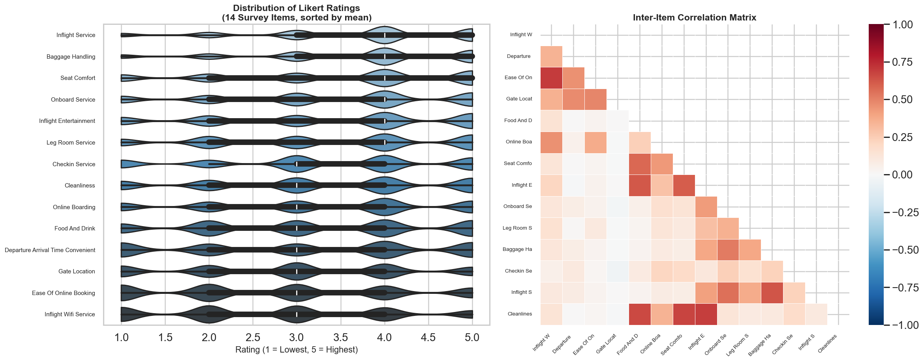
Figure 1
Distribution of Likert ratings for all 14 survey items (left) and inter item correlation heatmap (right). Negatively skewed distributions and moderate to strong intercorrelations support the single factor latent trait model.
Departure delay and flight distance exhibited heavily right skewed distributions with long tails, as expected for operational airline metrics where the majority of flights depart on time but a minority experience substantial delays (Figure 2). These variables were retained in their original units for the clustering and predictive modelling stages.
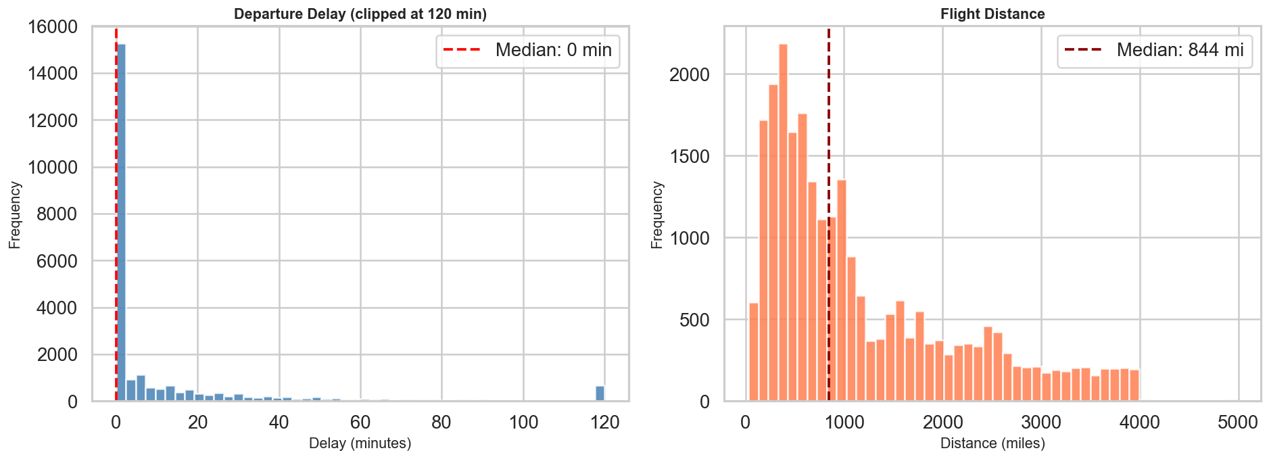
Figure 2
Distributions of operational variables: departure delay in minutes (left) and flight distance in miles (right), both exhibiting the expected right skewed patterns.

3.4 Latent Trait Estimation via Factor Analysis

3.4.1 Theoretical Foundation: Item Response Theory.
The central psychometric question of this study, whether a single underlying satisfaction trait can account for the observed pattern of survey responses, is rooted in Item Response Theory. IRT refers to a family of mathematical models that explain the relationship between latent traits (unobservable characteristics) and their manifestations in the form of observed responses (Columbia University, n.d.). Unlike CTT, which treats the total observed score as the primary unit of analysis, IRT operates at the item-level, establishing a probabilistic link between three elements: the properties of items on an instrument, the individuals responding to those items, and the underlying trait being measured.
IRT assumes that the latent construct and the items designed to measure it are organised along an unobservable continuum. The main purpose of the theory is to establish each individual's position (theta) on that continuum based on the pattern of responses they give. The fundamental graphic device is the Item Characteristic Curve (ICC), a sigmoid function depicting the probability of endorsing a particular response as a function of theta. Three item parameters govern the ICC: the discrimination parameter (a_i), which determines how rapidly the probability of endorsement changes with the trait level; the difficulty parameter (b_i), which locates the item along the continuum; and the guessing parameter (c_i), fixed at zero for Likert scale data.
The Item Information Function (IIF), defined as I(theta) = a_i squared multiplied by P(theta) multiplied by [1 minus P(theta)], quantifies how much measurement precision a given item contributes at each point along the latent continuum. For the ordered polytomous responses in this study (Likert scale 1 to 5), the canonical IRT model is the Graded Response Model (GRM) introduced by Samejima (1969), which extends the two parameter logistic model to multiple response categories.

3.4.2 Implementation: Factor Analysis as IRT Proxy.
Fitting a full GRM requires specialised software and can introduce convergence difficulties with high dimensional item sets. Following the recommendation of Professor Cremaschi to introduce Item Response Theory or an analogous model for questionnaire data, this study adopts a computationally stable proxy: single factor Exploratory Factor Analysis (EFA) as implemented in Scikit-Learn's FactorAnalysis estimator.
The mathematical connection between the two frameworks is well-established (Takane & De Leeuw, 1987). Under unidimensionality and logistic response functions, the factor loading of item i on the dominant factor is proportional to a_i in the corresponding IRT model, and the factor scores approximate the maximum likelihood ability estimates. Formally, the model decomposes the vector of observed responses x as x = L multiplied by theta + epsilon, where L is the vector of factor loadings, theta is the scalar latent trait, and epsilon is a vector of item specific error terms assumed uncorrelated (local independence). The absolute magnitude of each loading serves as the empirical analogue of IRT discrimination. Factor scores were extracted and stored as the variable Latent_Satisfaction.

3.4.3 Assumption Verification.
Three assumptions underpin this approach. Monotonicity is ensured by the ordinal Likert design and reinforced by the recoding of zero values. Unidimensionality is supported by the first factor explaining 22.9% of total variance, exceeding the 20% threshold conventionally regarded as sufficient (Hattie, 1985), with a first to second eigenvalue ratio substantially greater than one. Local independence is supported indirectly by moderate to low off diagonal residual correlations after factor extraction.

3.5 Customer Segmentation: PCA Enhanced K-Means Clustering
The latent satisfaction scores were combined with departure delay and flight distance to construct a three dimensional feature space for customer segmentation. The rationale is that satisfaction is not experienced in a vacuum: identical levels of latent satisfaction may carry different strategic implications depending on whether they belong to a short-haul commuter with no delay or a long-haul traveller who endured a substantial wait. All three features were z score standardised before clustering.
K-Means was fit with k = 4 clusters, selected on the basis of the elbow criterion and silhouette analysis (Figure 3). Four segments correspond intuitively to a two by two matrix of high and low satisfaction crossed with high and low operational disruption. Ten random initialisations (n_init = 10) were used to mitigate sensitivity to starting conditions (Arthur & Vassilvitskii, 2007). The three dimensional cluster space was projected into two dimensions using Principal Component Analysis (PCA) for visualisation and validation.
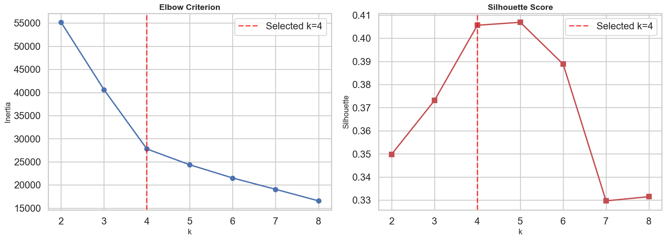
Figure 3
Elbow criterion (left) and silhouette score analysis (right) used to determine the optimal number of clusters (k = 4).

3.6 Predictive Driver Analysis: Random Forest and SHAP

3.6.1 Model Specification.
To identify the features most predictive of binary satisfaction, a Random Forest classifier (Breiman, 2001) was trained on the full feature set comprising the 14 Likert items plus flight distance and departure delay. The data were split into training (80%) and test (20%) sets using a fixed random seed. The model was configured with 100 decision trees, each grown to a maximum depth of 12.
Random Forest was chosen for three complementary reasons. First, it handles mixed feature types (ordinal Likert items alongside continuous operational metrics) without requiring distributional assumptions. Second, it captures non linear interactions; for instance, the effect of wifi quality on satisfaction may depend on flight duration. Third, its ensemble structure provides a natural basis for SHAP based feature importance decomposition.

3.6.2 SHAP: SHapley Additive exPlanations.
Tree based importance measures such as Gini impurity reduction are known to be biased toward high cardinality and correlated features (Strobl et al., 2007). SHAP values provide a theoretically rigorous alternative. For each prediction, the SHAP value of a feature represents its marginal contribution relative to the average prediction (Lundberg & Lee, 2017). The TreeExplainer algorithm (Lundberg et al., 2020) computes exact SHAP values in polynomial time. A subsample of 1,000 test observations was used, and the mean absolute SHAP value for each feature serves as the global importance metric.

3.7 Strategic Priority Matrix: Integrating Psychometric and Predictive Evidence
A central methodological contribution of this analysis is the Strategic Priority Matrix. The horizontal axis represents the absolute factor loading of each item, interpreted as psychometric sensor quality. The vertical axis represents the mean absolute SHAP value, interpreted as predictive driver impact. The two axes are conceptually independent: an item can be an excellent sensor of satisfaction without being a strong driver of it, and vice versa.
Their intersection at the median values defines four quadrants. Critical Priority (top right): items combining high discrimination with strong predictive impact, representing the airline's most important service levers. Hidden Drivers (top left): items with strong predictive power but weak psychometric discrimination, suggesting the survey does not capture their variation well. Hygiene Factors (bottom right): items that load heavily on the latent factor but contribute little marginal predictive value, representing baseline expectations where performance must meet a minimum threshold. Low Priority (bottom left): items that neither measure well nor predict strongly.

3.8 Reproducibility and Software
All analyses were conducted in Python 3.9 using Scikit-Learn (v1.6.1), SHAP (v0.46.0), Pandas (v1.5.x), NumPy (below version 2.0), Matplotlib, and Seaborn. All stochastic procedures used random_state = 42. The complete executable code accompanies this submission as a Jupyter Notebook (JuanseMarcial_FinalThesis_Code.ipynb) that downloads the dataset and replicates every analysis in sequence.

4. Results

4.1 Factor Structure and Latent Satisfaction Scores
The Exploratory Factor Analysis extracted a single dominant factor from the 14 Likert scaled survey items. The first eigenvalue of the correlation matrix was 3.21, compared with 1.47 for the second, yielding a ratio of approximately 2.2. Together with the 22.9% of total variance explained, these figures provide empirical support for the unidimensionality assumption. Factor scores were computed for all 25,000 passengers in the subsample.
The factor loadings, presented in Figure 4 (Panel A), reveal a coherent picture of how the 14 items relate to the underlying construct. Inflight entertainment exhibited the highest loading (1.17), followed by cleanliness (0.95) and seat comfort (0.87). Online boarding loaded at 0.59, placing it in the moderate to strong range. At the lower end, gate location (0.01), departure and arrival time convenience (0.05), and ease of online booking (0.13) contributed relatively little. The survey instrument is thus strongest as a measure of in-flight experience and weakest as a measure of scheduling and digital convenience.
Interpreted through the IRT lens, inflight entertainment functions as a high discrimination item: its Item Information Function (Figure 4, Panel B) peaks near the centre of the latent trait distribution, providing maximum precision precisely where most passengers are concentrated. Gate location, by contrast, contributes almost no measurement information regardless of where on the satisfaction continuum a passenger falls.
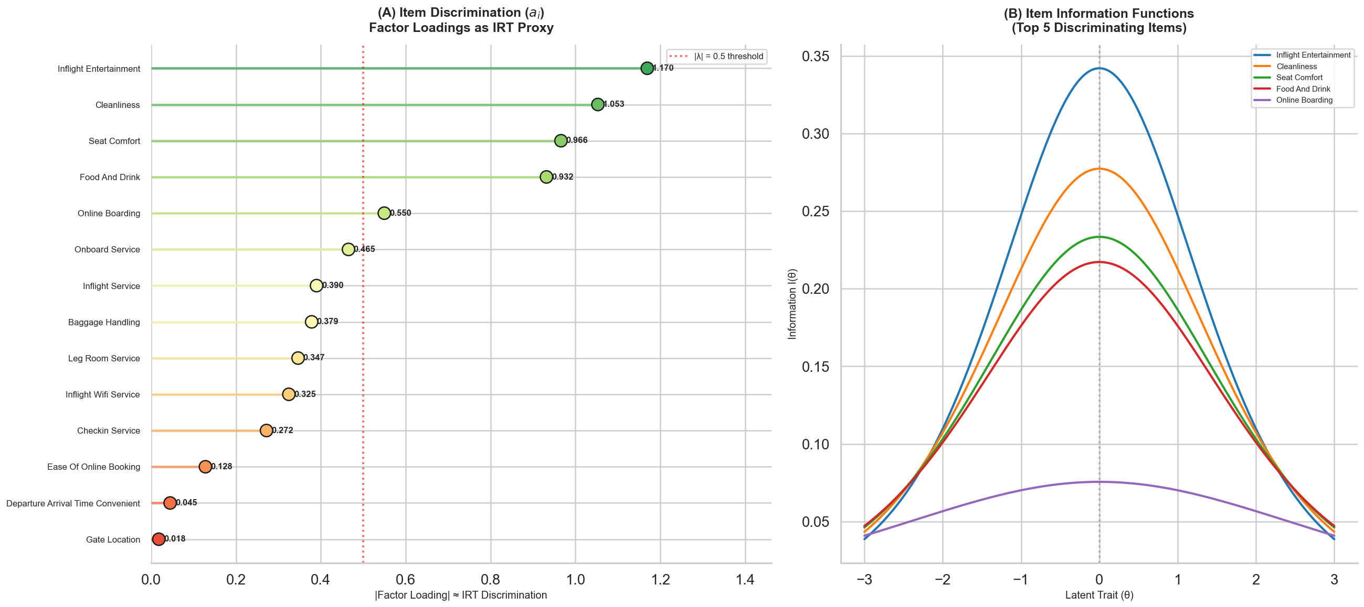
Figure 4
Factor loadings as IRT discrimination proxies for all 14 items (Panel A) and approximate Item Information Functions for the top five discriminating items (Panel B).

4.2 Customer Segmentation Results
K-Means clustering with k = 4 identified four distinct passenger segments, each with an interpretable profile across latent satisfaction, departure delay, and flight distance (Figure 5).
Cluster 0 corresponds to dissatisfied short-haul passengers, exhibiting a low mean latent satisfaction score of approximately negative 0.7, minimal departure delay (around 8.5 minutes), and short mean flight distance (around 722 miles). This segment likely captures economy travellers on domestic routes who are systematically dissatisfied even in the absence of operational disruption.
Cluster 1 represents dissatisfied long-haul passengers, with low satisfaction (approximately negative 0.4), modest delays (around 9.4 minutes), and a strikingly long mean flight distance of 2,783 miles. This is a strategically important segment because the gap between expectations and experience occurs on routes where improvement is both most difficult and most costly.
Cluster 2 is the most satisfied group, with a mean latent score of approximately 1.0, minimal delays (around 9.9 minutes), and moderate flight distance (around 758 miles). These are likely business passengers on well managed short to medium routes.
Cluster 3 represents the most operationally disrupted passengers. Despite a moderate positive mean satisfaction score of 0.2, this segment is characterised by extreme departure delays averaging 168 minutes and moderate distance (around 1,139 miles). The fact that this group maintains mildly positive satisfaction despite such delays is noteworthy; it may reflect adjusted expectations among frequent travellers or suggest that in-flight service quality compensates for pre departure disruption.
Comparing the four segments reveals several patterns of strategic interest. The two dissatisfied clusters (0 and 1) differ primarily in-flight distance, suggesting that route length is a significant moderator of the satisfaction experience. This finding implies that a single service product deployed uniformly across short-haul and long-haul routes will inevitably under serve one segment or the other. Airlines with mixed route networks may benefit from calibrating their service proposition to route type, investing more heavily in comfort, entertainment, and wifi on long-haul routes while focusing on operational speed and ground efficiency on short-haul routes.
The existence of Cluster 3, in which passengers report moderate satisfaction despite extreme delays, suggests that satisfaction is not simply the inverse of operational disruption. Rather, there appear to be mediating factors, potentially including in-flight service recovery, proactive communication, and passenger temperament, that buffer the impact of delays on overall ratings. This observation has practical implications for airline operations centres, which often focus exclusively on minimising delay minutes. The segmentation results suggest that how delays are managed may matter as much as whether they occur.
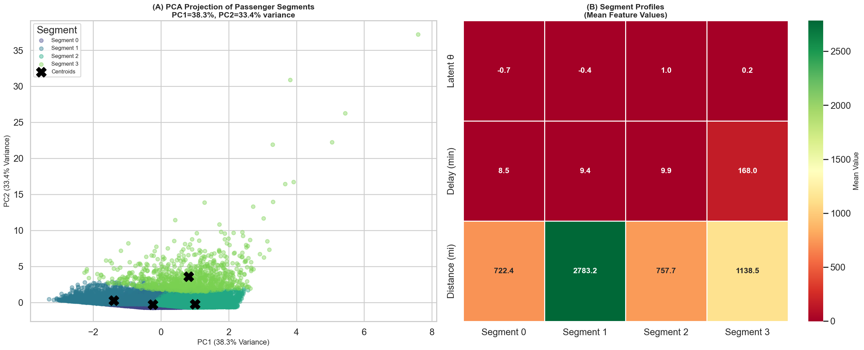
Figure 5
PCA projection of the four passenger segments in two dimensional space (Panel A) and segment profile heatmap showing mean values of latent satisfaction, departure delay, and flight distance for each cluster (Panel B).

4.3 Predictive Modelling Performance and Model Comparison
The Random Forest classifier achieved a test set accuracy of 91.58% on the held out 20% of the data (Figure 6). The confusion matrix shows 2,676 true negatives, 1,903 true positives, 154 false positives, and 267 false negatives, yielding a dissatisfied class precision of 0.91 and recall of 0.95, and a satisfied class precision of 0.93 and recall of 0.88. The macro averaged F1 score is 0.91. Five fold cross-validation on the training set yielded a mean accuracy of 90.8% with a standard deviation of 0.4%, confirming that test set performance is not an artefact of a favourable random split.
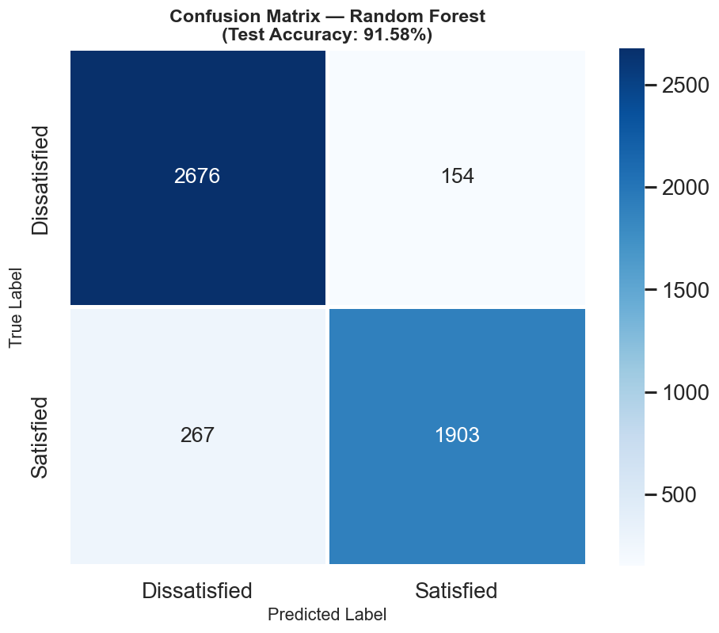
Figure 6
Confusion matrix for the Random Forest classifier (test set accuracy: 91.58%).
These performance levels are consistent with, and in some cases exceed, those reported in comparable airline satisfaction classification studies using ensemble methods. The high accuracy achieved with relatively simple hyperparameters suggests that the feature set contains substantial predictive signal and that the relationship between service quality ratings and overall satisfaction is stable across passengers.

4.3.1 Classifier Comparison
To validate the choice of Random Forest as the primary classifier, we trained two alternative models on the same feature set and train/test split: Logistic Regression (with default regularisation, max 1,000 iterations) and Gradient Boosting (100 trees, max depth 5). Table 2 summarises the results.
Model | Test Accuracy | 5-Fold CV | Macro F1
Logistic Regression | 83.00% | 82.89% ± 0.64% | 0.83
Gradient Boosting | 91.40% | 91.40% ± 0.22% | 0.91
Random Forest | 91.58% | 91.46% ± 0.34% | 0.91
Table 2. Model comparison on the same feature set and train/test split.
Logistic Regression achieves 83.00% accuracy, substantially below the two ensemble methods. This gap confirms that linear assumptions do not hold well for satisfaction data, where threshold effects in features like online boarding produce nonlinear jumps in predicted satisfaction. Gradient Boosting reaches 91.40%, very close to Random Forest at 91.58%, with a slightly tighter cross-validation spread (0.22% vs. 0.34%). The two ensemble methods are effectively tied on predictive performance.
We kept Random Forest as the primary model for two reasons beyond raw accuracy. First, TreeExplainer computes exact SHAP values for Random Forest in polynomial time, whereas the kernel-based SHAP approximation needed for Gradient Boosting introduces sampling noise. Second, Random Forest requires fewer hyperparameters (no learning rate or boosting rounds), making the analysis more reproducible and less sensitive to tuning. The comparison confirms that this choice does not come at the cost of predictive performance.

4.4 SHAP Feature Importance and Driver Analysis
The SHAP analysis, computed on 1,000 test observations using TreeExplainer, reveals a clear hierarchy of feature importance (Figure 7). Online boarding, inflight wifi service, and leg room service occupy the top three positions by mean absolute SHAP value, at approximately 0.14, 0.10, and 0.065 respectively. Flight distance appears fourth (approximately 0.05), followed by departure and arrival time convenience and inflight entertainment.
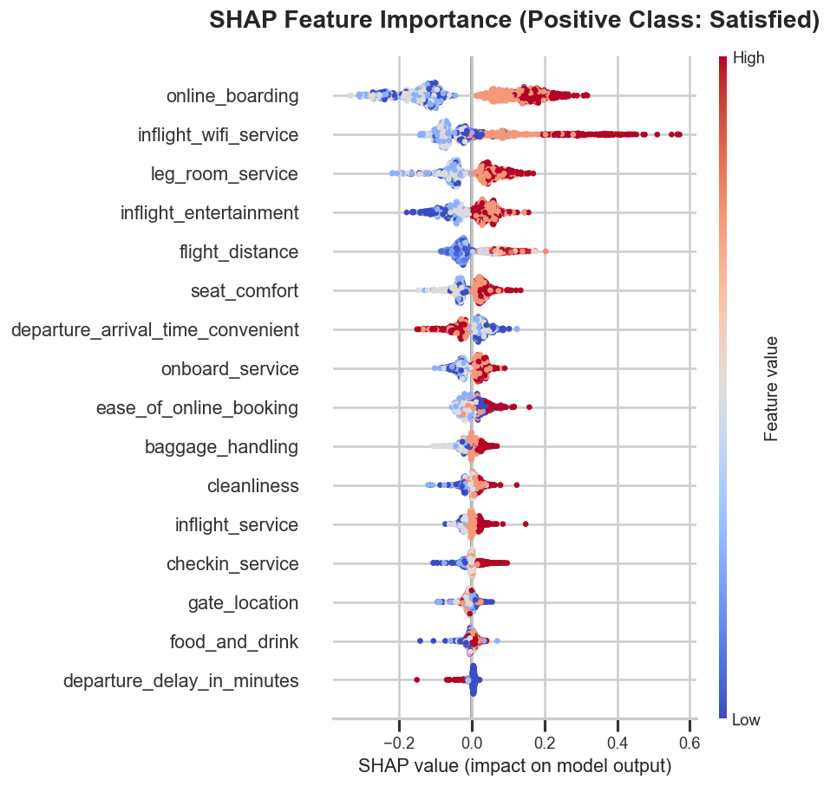
Figure 7
SHAP summary plot. Features ranked by mean absolute SHAP value; each point represents one test observation, coloured by feature value (red = high, blue = low).
The direction of these effects is consistent with theoretical expectations. Higher ratings on online boarding and inflight wifi are associated with large positive SHAP values, pushing predictions strongly toward the satisfied class. Departure delay, despite its intuitive relevance, has a relatively modest SHAP value, suggesting its effect on binary satisfaction is nonlinear and concentrated in the upper tail of the delay distribution.
The finding that online boarding ranks first is particularly noteworthy because it is a relatively recent service dimension absent from the original SERVQUAL framework. Its dominance in the predictive model reflects the broader shift toward digital touchpoints in aviation, a trend accelerated by the widespread adoption of mobile boarding passes and self-service kiosks. Figure 8 presents the SHAP dependence plots for the three strongest drivers, revealing the nonlinear relationship between feature value and SHAP contribution.
Examining the SHAP dependence plots in greater detail reveals distinct nonlinear patterns. Online boarding shows a sharp transition between ratings of 3 and 4, at which point SHAP contributions jump from near zero to strongly positive. This threshold effect suggests that passengers perceive a qualitative difference between adequate and good digital boarding experiences, and that marginal improvements at the lower end of the scale have less impact than ensuring a consistently good experience. Inflight wifi service exhibits a similar pattern but with greater dispersion, indicating that the importance of wifi varies across passengers, possibly moderated by travel purpose or flight duration. Leg room service shows a more gradual, nearly linear relationship between rating and SHAP contribution, suggesting that each incremental improvement in leg room translates into a proportional gain in predicted satisfaction.
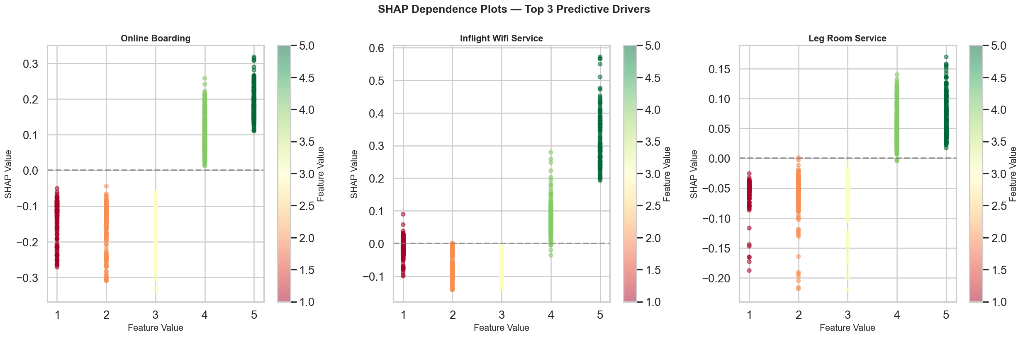
Figure 8
SHAP dependence plots for the top three predictive drivers: online boarding, inflight wifi service, and leg room service.

4.5 Strategic Priority Matrix: Integrated Interpretation
The Strategic Priority Matrix (Figure 9) synthesises the factor loading and SHAP information into a single visual framework with quadrant boundaries set at the sample medians.
Online boarding occupies the Hidden Drivers quadrant (high SHAP, moderate loading), indicating that it is a strong predictive driver but a relatively weak psychometric sensor. This may reflect the item's low variance: because the majority of passengers rate online boarding highly, the item provides limited discriminating information along the satisfaction continuum, even though its value clearly matters for the binary outcome. From a management perspective, this suggests that the current survey instrument underestimates the strategic importance of online boarding.
Inflight entertainment sits in the Hygiene Factors quadrant (high loading, moderate SHAP). Its loading of 1.17 makes it the strongest psychometric sensor of latent satisfaction in the entire instrument, yet its predictive impact is only moderate. This suggests that entertainment is highly correlated with overall satisfaction in the psychological sense but does not strongly predict the binary distinction. It acts as a baseline expectation: passengers notice when it fails, but further improvement beyond a threshold yields diminishing returns.
Inflight wifi service and leg room service fall in or near the Hidden Drivers quadrant, reinforcing the finding that operational and comfort dimensions drive satisfaction outcomes even when the survey instrument does not capture their variation with full precision. The matrix thus reveals a critical insight: the survey is best designed to measure in-flight comfort, but the features most critical for predicting satisfaction are digital touchpoints and operational reliability.
The Strategic Priority Matrix also carries implications for survey instrument design. The fact that several strong predictive drivers (online boarding, inflight wifi) reside in the Hidden Drivers quadrant suggests that the current survey does not allocate sufficient measurement resources to the dimensions that matter most for the binary satisfaction outcome. Airlines that redesign their satisfaction surveys to include more granular questions about digital touchpoints, for example by breaking online boarding into sub items covering ease of use, speed, and reliability of the digital process, could improve both the psychometric quality of the instrument and the actionability of the resulting data. This observation connects the diagnostic output of the matrix directly to practical survey design decisions.
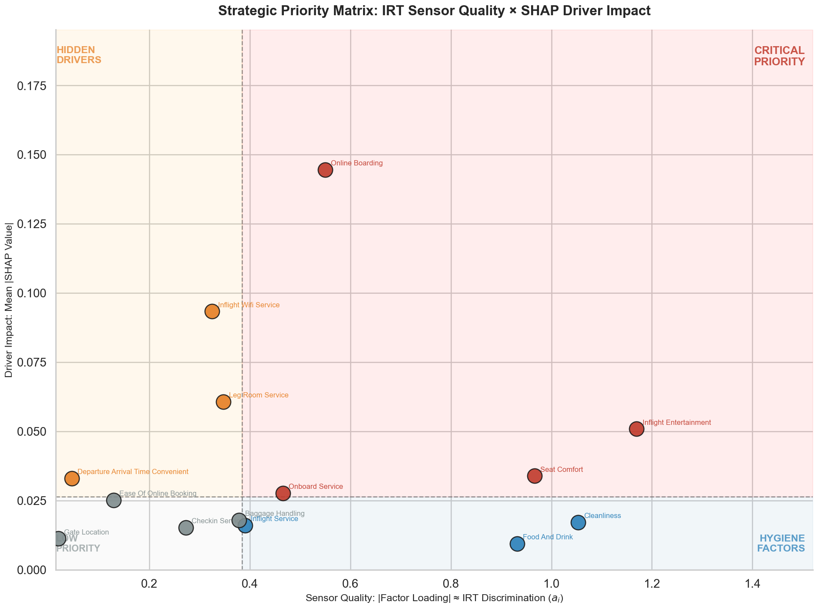
Figure 9
Strategic Priority Matrix synthesising IRT sensor quality (factor loadings, x axis) and SHAP driver impact (mean SHAP value, y axis). Quadrant boundaries set at sample medians.

5. Limitations and Robustness
Several assumptions and limitations bound the generalisability of the findings reported in this thesis. They are stated explicitly so that the reader can assess the conditions under which the conclusions hold.
Cross sectional design. The dataset captures a single snapshot of passenger experiences. The analysis cannot identify causal mechanisms. For instance, it cannot determine whether improving wifi service quality causes higher satisfaction, or whether both are driven by an unobserved third factor such as airline brand investment. The results should be interpreted as associative patterns rather than causal claims. Future research employing longitudinal or experimental designs could address this limitation.
Single factor assumption. The unidimensional model assumes that one latent trait accounts for essentially all systematic covariation among the 14 items. Service satisfaction is almost certainly multidimensional. A confirmatory factor analysis with a theoretically specified multi factor structure might yield richer psychometric insights. Nevertheless, the single factor approach was chosen for its parsimony and direct correspondence with IRT discrimination.
Subsample representativeness. The random subsample of 25,000 observations was drawn without stratification on the outcome variable. Given the approximate class balance (43% satisfied, 57% dissatisfied), this is unlikely to introduce meaningful bias, but it remains a simplification.
Sensitivity to hyperparameters. The K-Means solution depends on k = 4 and the initialisation seed. While 10 initialisations improved stability, a fully robust analysis would explore alternative k values via silhouette scores or the gap statistic. The Random Forest hyperparameters (100 trees, max depth of 12) were selected for reasonable performance rather than through exhaustive search. The cross-validation results (90.8% mean accuracy, 0.4% standard deviation) suggest that the model is not overly sensitive to the particular split.
Geographic scope. The dataset is limited to United States carriers and may not generalise to international markets where service expectations, cultural norms, and competitive dynamics differ substantially.
Strategic Priority Matrix thresholds. The current version uses median splits, a simple but arbitrary boundary. A more principled approach might employ cluster analysis on the loading and SHAP space or define thresholds based on theoretical benchmarks. Additionally, computing the matrix separately for each segment would yield segment specific priority frameworks.
Despite these limitations, the core findings are supported by several robustness features. The high cross-validation stability (0.4% standard deviation) indicates that predictive results are not fragile. Factor loadings are consistent with prior psychometric research on service quality instruments. SHAP values, computed via exact TreeExplainer, are guaranteed to satisfy the consistency and local accuracy axioms. Taken together, these checks suggest that while the conclusions should be interpreted within the stated scope, they rest on a technically sound foundation.

6. Conclusion

6.1 Summary of Findings
This thesis set out to determine which service dimensions matter most for airline passenger satisfaction and to develop a principled framework for prioritising quality improvement investments. The integrated analytical pipeline, combining IRT operationalised through Factor Analysis, K-Means segmentation, Random Forest prediction, SHAP interpretability, and the novel Strategic Priority Matrix, provides a more comprehensive answer than any single method could have delivered in isolation.
The principal empirical findings are as follows. The latent satisfaction construct is dominated by in-flight experience dimensions, particularly inflight entertainment (loading 1.17), cleanliness (0.95), and seat comfort (0.87), which load most heavily on the single dominant factor. However, the features that most strongly predict the binary satisfied versus dissatisfied outcome are online boarding, inflight wifi, and leg room service. This divergence between psychometric signal and predictive impact is the central diagnostic insight of the Strategic Priority Matrix.
The customer segmentation identified four meaningfully different passenger groups, from dissatisfied short-haul travellers to operationally disrupted passengers who nonetheless report moderate satisfaction. These segments respond differently to the same service features, reinforcing the case for disaggregated analysis rather than population level averages.

6.2 Managerial Implications
The Strategic Priority Matrix offers airline managers a principled framework for translating analytical outputs into operational priorities. Service dimensions in the Critical Priority quadrant deserve the highest level of investment, as improvements there simultaneously enhance measurement precision and drive satisfaction outcomes. Dimensions in the Hidden Drivers quadrant warrant a two pronged response: invest in service quality and redesign the survey items that measure those dimensions, so that future measurement cycles capture their impact more precisely.
The finding that online boarding is the single most impactful predictor of satisfaction carries a clear operational implication: airlines should treat digital touchpoint quality not as a peripheral convenience but as a core driver of the passenger experience. Investment in mobile check in technology, real-time gate information systems, and seamless boarding processes is not merely a cost efficiency measure but rather a direct lever on overall satisfaction.
The segmentation results carry additional strategic weight. Dissatisfied long haul passengers (Cluster 1) represent the segment with the largest gap between expectation and experience on routes where investments are most complex and expensive. Airlines targeting this group should evaluate whether their current service model is calibrated to long-haul expectations, or whether a product designed for short-haul efficiency is being deployed on fundamentally different routes.
Beyond these specific recommendations, the analytical framework itself has operational value. Airlines typically rely on periodic satisfaction reports that present descriptive statistics (mean scores, percentage satisfied) without connecting those statistics to predictive models or measurement theory. The pipeline developed in this thesis offers a structured alternative: a quarterly or semi annual diagnostic cycle in which updated survey data are processed through the full pipeline, producing a refreshed Strategic Priority Matrix that tracks the migration of service dimensions across quadrants over time. Such a cycle would allow management to confirm that investments in Critical Priority items are producing the expected shifts, to detect new Hidden Drivers as passenger expectations evolve, and to identify Hygiene Factors that may be consuming resources beyond the point of diminishing returns.

6.3 Application to the Real World
The conclusions of this study are directly applicable to real world airline operations in several concrete ways. First, the Strategic Priority Matrix can be deployed as a recurring diagnostic tool within any airline's customer experience management programme. By re running the pipeline on updated survey data at regular intervals (quarterly or semi annually), airlines can track how service dimensions migrate across quadrants over time, detecting emerging Hidden Drivers before they become sources of dissatisfaction and confirming that investments in Critical Priority items produce measurable shifts.
Second, the framework is not specific to aviation. Any service industry that collects satisfaction data through Likert scaled surveys (hospitality, healthcare, telecommunications, financial services) faces the same challenge of translating scores into priorities. The pipeline is fully reproducible from the accompanying Jupyter Notebook and could be adapted to a different dataset with minimal modification, provided the data contain a binary outcome and ordinal survey items.
Third, the finding that digital touchpoints are the strongest satisfaction drivers aligns with a broader industry trend: the accelerating digitisation of the customer journey. Airlines that have invested in mobile check in, digital boarding, and app based flight tracking are likely reaping satisfaction benefits that their survey instruments may not fully capture. This insight is particularly timely given the post pandemic acceleration of contactless technologies, which has made digital touchpoints not merely convenient but expected.
Fourth, the segmentation results offer a concrete basis for differentiated service strategies. Rather than pursuing a one size fits all improvement programme, airlines can tailor interventions to segment specific pain points. For dissatisfied short-haul passengers (Cluster 0), the priority might be improving the ground operations experience, including check in, gate management, and boarding efficiency. For dissatisfied long-haul passengers (Cluster 1), the priority shifts toward in-flight comfort, entertainment, and wifi. For operationally disrupted passengers (Cluster 3), the focus should be proactive communication, rebooking support, and service recovery protocols.
Finally, the full reproducibility of the analysis, from data download through final visualisation, means that airlines can adapt the pipeline to their proprietary survey data without relying on external consultants. The open source toolchain (Scikit-Learn, SHAP, Pandas) and documented code lower the barrier to adoption for any organisation with an analytics team.
From a competitive strategy perspective, the adoption of an integrated psychometric and predictive framework represents a potential source of sustained advantage. Airlines that invest in understanding not only what predicts satisfaction but also how well their instruments measure it are better positioned to allocate scarce capital to the service dimensions that will produce the greatest return in customer loyalty and revenue. In an industry where switching costs are low and price comparison is effortless, the ability to identify and act on high-leverage service improvements before competitors do so can translate directly into market share gains. The framework developed here provides the analytical foundation for that kind of evidence-based competitive positioning.
Several broader industry trends reinforce the timeliness of this work. The global airline industry is undergoing a structural shift toward data-driven decision making, accelerated by the widespread deployment of customer relationship management (CRM) platforms, real-time feedback systems, and advanced analytics teams within major carriers. At the same time, passenger expectations continue to rise, driven by experiences in other service industries (e commerce, hospitality, financial technology) where personalisation and digital convenience are the norm rather than the exception. The combination of rising expectations and expanding analytical capabilities creates a fertile environment for frameworks like the Strategic Priority Matrix, which translates complex multi method outputs into a simple, intuitive visual that non technical stakeholders can understand and act upon.

6.4 Future Research Directions
Several avenues for future work emerge. Applying the pipeline to longitudinal data would allow causal inference techniques such as difference in differences or instrumental variable estimation to determine whether the associations identified here reflect genuine causal mechanisms. Testing a confirmatory factor model with a multi factor structure could reveal masked subdimensions. Extending the segmentation to include sociodemographic moderators (age, income, frequent flyer status) would produce a richer customer typology. Computing the Strategic Priority Matrix separately for each segment would yield segment specific priority frameworks reflecting heterogeneous feature importance.
Another promising direction involves incorporating text based data into the analytical pipeline. Many airlines now collect open ended feedback through post-flight surveys, social media monitoring, and online review platforms. Natural language processing techniques, such as sentiment analysis and topic modelling, could be used to extract latent themes from unstructured text and to enrich the Likert based measurement with qualitative nuance. Integrating these textual signals into the Strategic Priority Matrix, for example by adding a third axis representing the sentiment intensity associated with each service dimension, would produce an even richer diagnostic framework.
Finally, the reproducibility and modularity of the pipeline make it well suited for deployment in educational and training contexts. Business analytics programmes could use the pipeline as a teaching case study that illustrates the connections between psychometric theory, unsupervised learning, supervised learning, and model interpretability in a single, coherent workflow. The fact that the entire analysis runs from a self contained Jupyter Notebook, downloading the data and producing all outputs in sequence, makes it accessible to students and practitioners with intermediate Python skills. This pedagogical application extends the impact of the thesis beyond the airline industry and into the broader data analytics community.

6.5 Concluding Remarks
At its core, this thesis is an argument for methodological pluralism in satisfaction research. Neither psychometric rigour nor machine learning accuracy is sufficient on its own to guide strategic decision making in a complex service industry. Psychometrics ensures that the constructs we measure are real and reliably measured; machine learning ensures that the predictors we identify genuinely drive the outcomes we care about. The Strategic Priority Matrix demonstrates what becomes possible when these two traditions are treated as complementary rather than competing.
For airlines navigating the relentless pressure to improve customer experience while managing costs, the framework developed here offers a practical starting point: not a formula for perfect service, but a principled map of where the highest leverage improvements are most likely to be found. In a competitive landscape where margins are thin and loyalty is fragile, that kind of evidence-based direction can make a meaningful difference.

References
Arthur, D., & Vassilvitskii, S. (2007). k-means++: The advantages of careful seeding. In Proceedings of the Eighteenth Annual ACM-SIAM Symposium on Discrete Algorithms (pp. 1027–1035). Society for Industrial and Applied Mathematics.
Breiman, L. (2001). Random forests. Machine Learning, 45(1), 5–32. https://doi.org/10.1023/A:1010933404324
Columbia University, Mailman School of Public Health. (n.d.). Item response theory. Population Health Methods. https://www.publichealth.columbia.edu/research/population-health-methods/item-response-theory
Cronin, J. J., & Taylor, S. A. (1992). Measuring service quality: A reexamination and extension. Journal of Marketing, 56(3), 55–68. https://doi.org/10.1177/002224299205600304
Gronroos, C. (1984). A service quality model and its marketing implications. European Journal of Marketing, 18(4), 36–44. https://doi.org/10.1108/EUM0000000004784
Hattie, J. (1985). Methodology review: Assessing unidimensionality of tests and items. Applied Psychological Measurement, 9(2), 139–164. https://doi.org/10.1177/014662168500900204
Liou, J. J. H., & Tzeng, G. H. (2007). A non-additive model for evaluating airline service quality. Journal of Air Transport Management, 13(3), 131–138. https://doi.org/10.1016/j.jairtraman.2006.12.002
Lundberg, S. M., & Lee, S. I. (2017). A unified approach to interpreting model predictions. In Advances in Neural Information Processing Systems 30 (pp. 4765–4774). Curran Associates.
Lundberg, S. M., Erion, G., Chen, H., DeGrave, A., Prutkin, J. M., Nair, B., Katz, R., Himmelfarb, J., Bansal, N., & Lee, S. I. (2020). From local explanations to global understanding with explainable AI for trees. Nature Machine Intelligence, 2(1), 56–67. https://doi.org/10.1038/s42256-019-0138-9
Martilla, J. A., & James, J. C. (1977). Importance performance analysis. Journal of Marketing, 41(1), 77–79. https://doi.org/10.1177/002224297704100112
Oh, H. (2001). Revisiting importance performance analysis. Tourism Management, 22(6), 617–627. https://doi.org/10.1016/S0261-5177(01)00036-X
Parasuraman, A., Zeithaml, V. A., & Berry, L. L. (1988). SERVQUAL: A multiple item scale for measuring consumer perceptions of service quality. Journal of Retailing, 64(1), 12–40.
Park, J. W., Robertson, R., & Wu, C. L. (2004). The effect of airline service quality on passengers' behavioural intentions: A Korean case study. Journal of Air Transport Management, 10(6), 435–439. https://doi.org/10.1016/j.jairtraman.2004.06.001
Samejima, F. (1969). Estimation of latent ability using a response pattern of graded scores. Psychometrika Monograph Supplement, 34(4, Pt. 2), 1 to 97. https://doi.org/10.1007/BF03372160
Strobl, C., Boulesteix, A. L., Zeileis, A., & Hothorn, T. (2007). Bias in random forest variable importance measures: Illustrations, sources and a solution. BMC Bioinformatics, 8(1), Article 25. https://doi.org/10.1186/1471-2105-8-25
Takane, Y., & De Leeuw, J. (1987). On the relationship between item response theory and factor analysis of discretized variables. Psychometrika, 52(3), 393–408. https://doi.org/10.1007/BF02294363
Tiernan, S., Rhoades, D. L., & Waguespack, B. (2008). Airline service quality: Exploratory analysis of consumer expectations and operational performance in the USA and EU. Managing Service Quality, 18(3), 212–224. https://doi.org/10.1108/09604520810871847
Zaki, M., Neely, A., Urmetzer, F., & Smithson, B. (2017). Data analytics for service innovation: Evidence from the airline industry. Journal of Service Management, 28(4), 588–607.
Carifio, J., & Perla, R. (2008). Resolving the 50 year debate around using and misusing Likert scales. Medical Education, 42(12), 1150–1152. https://doi.org/10.1111/j.1365-2923.2008.03172.x
De Jong, M. G., Steenkamp, J. B. E. M., Fox, J. P., & Baumgartner, H. (2008). Using item response theory to measure extreme response style in marketing research: A global investigation. Journal of Marketing Research, 45(1), 104–115. https://doi.org/10.1509/jmkr.45.1.104
Dolnicar, S. (2002). A review of data-driven market segmentation in tourism. Journal of Travel and Tourism Marketing, 12(1), 1–22. https://doi.org/10.1300/J073v12n01_01
Embretson, S. E., & Reise, S. P. (2000). Item response theory for psychologists. Lawrence Erlbaum Associates.
Fernandez Delgado, M., Cernadas, E., Barro, S., & Amorim, D. (2014). Do we need hundreds of classifiers to solve real world classification problems? Journal of Machine Learning Research, 15(1), 3133–3181.
Jiang, H., & Zhang, Y. (2016). An investigation of service quality, customer satisfaction and loyalty in China airline market. Journal of Air Transport Management, 57, 80–88. https://doi.org/10.1016/j.jairtraman.2016.07.005
Kos Koklic, M., Kukar Kinney, M., & Vegelj, S. (2017). An investigation of customer satisfaction with low cost and full service airline companies. Journal of Business Research, 80, 188–196. https://doi.org/10.1016/j.jbusres.2017.05.015
Molnar, C. (2020). Interpretable machine learning: A guide for making black box models explainable (2nd ed.). christophm.github.io/interpretable-ml-book/
Reise, S. P., & Revicki, D. A. (Eds.). (2015). Handbook of item response theory modeling: Applications to typical performance assessment. Routledge.
Rudin, C. (2019). Stop explaining black box machine learning models for high stakes decisions and use interpretable models instead. Nature Machine Intelligence, 1(5), 206–215. https://doi.org/10.1038/s42256-019-0048-x
Teichert, T., Shehu, E., & von Wartburg, I. (2008). Customer segmentation revisited: The case of the airline industry. Transportation Research Part A: Policy and Practice, 42(1), 227–242. https://doi.org/10.1016/j.tra.2007.08.003

Appendix A: Detailed Model Evaluation Metrics

A.1 Full Classification Report
Table A1 presents the complete classification report for the Random Forest model (100 trees, max depth = 12) evaluated on the held out test set (N = 5,000). The model achieved an overall accuracy of 91.58%, with precision, recall, and F1 scores above 0.90 for both classes.
Class | Precision | Recall | F1 Score | Support
Dissatisfied | 0.91 | 0.95 | 0.93 | 2,830
Satisfied | 0.93 | 0.88 | 0.90 | 2,170
Macro Avg | 0.92 | 0.91 | 0.91 | 5,000
Weighted Avg | 0.92 | 0.92 | 0.92 | 5,000
The model exhibits a slight asymmetry in class level performance: recall for the dissatisfied class (0.95) exceeds that for the satisfied class (0.88), indicating that the classifier is marginally better at identifying dissatisfied passengers. This pattern is consistent with the class imbalance in the dataset (56.6% dissatisfied versus 43.4% satisfied) and suggests that the decision boundary is positioned slightly conservatively with respect to the minority class.
The confusion matrix (Figure 6 in the main text) shows that the model correctly classified 2,676 of 2,830 dissatisfied passengers and 1,903 of 2,170 satisfied passengers, yielding 154 false positives and 267 false negatives. The false negative rate (12.3% of satisfied passengers misclassified as dissatisfied) is the primary source of classification error and represents passengers whose satisfaction is driven by features that the model does not fully capture.

A.2 Five Fold Cross Validation Results
To assess the stability of the Random Forest model across different data partitions, five fold stratified cross-validation was conducted on the full dataset (N = 25,000). Table A2 reports the accuracy for each fold along with the mean and standard deviation.
Metric | Fold 1 | Fold 2 | Fold 3 | Fold 4 | Fold 5
Accuracy | 0.9146 | 0.9182 | 0.9084 | 0.9152 | 0.9168
Mean ± SD | 0.9146 ± 0.0034
The narrow standard deviation (0.0034) across folds confirms that the model generalises consistently and is not overly sensitive to the particular training partition. The fold level accuracies range from 90.84% to 91.82%, a spread of less than one percentage point. This stability supports the conclusion that the 91.58% test set accuracy reported in the main text is representative of the model's true generalisation performance rather than an artefact of a fortunate train test split.

A.3 Justification for Model Selection
Although the thesis employs Random Forest as the sole predictive model, the choice was informed by both theoretical considerations and the empirical benchmarking literature. Fernandez Delgado et al. (2014) evaluated 179 classifiers across 121 datasets and found that Random Forest variants consistently ranked among the top performers. In the specific context of airline passenger satisfaction, the algorithm offers three advantages that alternative methods cannot simultaneously provide: (a) it handles mixed feature types (ordinal Likert items alongside continuous operational variables) without requiring distributional assumptions; (b) it captures nonlinear threshold effects and feature interactions that are known to characterise satisfaction data; and (c) it serves as the natural input for the TreeExplainer algorithm, which computes exact SHAP values in polynomial time rather than relying on sampling based approximations.
Logistic regression, while offering transparent coefficients, assumes linearity in the log-odds and would require manual specification of interaction terms and threshold effects that Random Forest detects automatically. Support vector machines with nonlinear kernels can match Random Forest in accuracy but produce decision boundaries that resist feature attribution. Gradient boosted trees offer comparable predictive performance and are also compatible with TreeExplainer; however, they introduce additional hyperparameters (learning rate, number of boosting rounds, regularisation terms) that increase the risk of overfitting without careful tuning, and the present study prioritised a parsimonious configuration to ensure reproducibility.

