Tugas Dibimbing.id

**1. Normalize this table from 1NF to 3NF**

Student_Grade_Report (StudentNo, StudentName, Major, CourseNo, CourseName, InstructorNo, InstructorName, InstructorLocation, Grade)

(HINT: in 3NF, there will be 4 tables)

(Make it using word or notepad is fine)

**2. Create ERD based on the table you normalized**

(Make it using draw.io and share the answer or screenshot the result)

**3. Create data model using *star schema and snowflake* method consist of these 5 table below:**

*Note: don’t forget about the fact and dim table concept and it’s fine to add a new column if you think it’s necessary*

Table :

• Customer (customer_id, Name, Age, Gender, Dob)

• Order (id, order_date, product_id, quantity, price, store_id, customer_id, staff_cashier_id)

• Store (store_id, store_branch_name, store_city, store_country)

• Staff (staff_cashier_id , name, age, gender)

• Product (product_id, product_name, product_expiry_date, store_id)

(Make it using draw.io and capture the result)

1. Normalisasi Tabel dari 1NF ke 3NF

Tabel awal:

scss

Student_Grade_Report (Nomor Siswa, NamaSiswa, Jurusan, NoKursus, NamaKursus, Nomor Instruktur, NamaInstruktur, Lokasi Instruktur, Nilai)

Normalisasi ke 3NF:

scss

Siswa (Nomor Siswa, NamaSiswa, Jurusan)

Kursus (NoKursus, NamaKursus)

Instruktur (Nomor Instruktur, NamaInstruktur, Lokasi Instruktur)

Nilai (Nomor Siswa, NoKursus, Nilai)

2. ERD

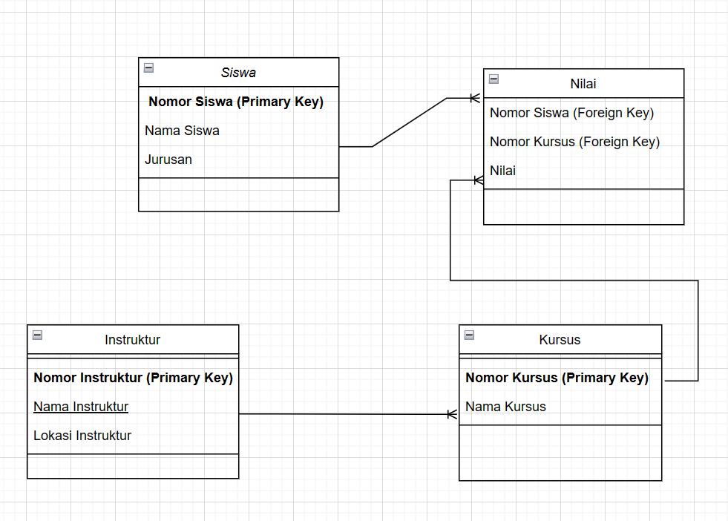

3. Star Schema dan Snowflake Schema

