Communications Software, Protocols and Architectures

Project work

Specifications Document

Group ID 01
Members: Juan Antonio Aldea Armenteros 0404450
Topic A: Reversi

Table of Contents
1 Game overview 3
2 System overview 4
3 Component description 5
3.1 Reversi Server 5
3.1.1 UI 5
3.1.2 Game Logic 5
3.1.3 Network System 5
3.2 Reversi Client 5
3.3 UI 5
3.4 Logic 5
3.5 Network System 5
3.6 Game Protocol 5
4 Layer model 6
4.1 Layer diagram 6
4.2 Layers description 6
4.2.1 Game Layer 6
4.2.2 Network Layer 6
4.3 Layer interfaces 7
5 Protocol data units 7
5.1 Abstract Message Definitions 7
5.2 Concrete Message Definitions 7
5.3 Message IDs enum 9
5.4 Player IDs enum 9
5.5 Type catalog 9
6 State machine diagrams 9
7 Use Case model 11
7.1 Requirements 11
7.2 Use Case diagram 11
7.3 Use case sequence diagrams 11
References: 12
Appenix 1: Use case sequence diagrams 13

Game overview
Reversi is a two players turn-based board game, played on an 8x8 squares board. There are 64 pieces and all are identical, each has a black side and a white side. Every turn one player places one piece on the board with his color facing up.
Each piece must be place so that an opponent's piece, or a row of opponent's pieces, is flanked by your pieces. All of the opponent's pieces between the player’s pieces are then turned over to become the player’s color.
Start of the game: The game is started in the position shown below on a Reversi board consisting of 64 squares in an 8×8 grid.
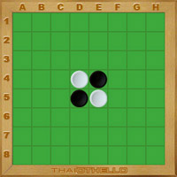Illustration 1: Starting Board
Aim of the game: The objective of the game is to own more pieces than your opponent when the game end. The game is over when neither player has a move. This occurs when the grid has filled up or when neither player can legally place a piece in any of the remaining squares. Players take alternate turns. If a player cannot make a valid move, turn is given to the other player. When neither player can move game ends. [WOF]
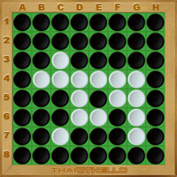Illustration 2: Game End

System overview
The game system follows the client-server model. There are two basics entities with this model, one of them acting as the client and the other acting as the server.
The server receives the actions from the users, handles the results of these actions on the current game and then sends the game updates to the clients. The server is able to handle multiple games sessions, having multiple pairs of players connected and playing simultaneously.
In the client side, the GUI displays the current state of the game and also receives the user input and notifies about them to the Logic, then the Logic sends those actions to the server and receives the game updates from the server.
All communications are handled by the TCP/IP [TCP] protocol.
If a server is running and listening for incoming client connections and two clients connect, a new game session is initiated as a child process and this child will be in charge of handling the game, and keeping the rules of the game followed.
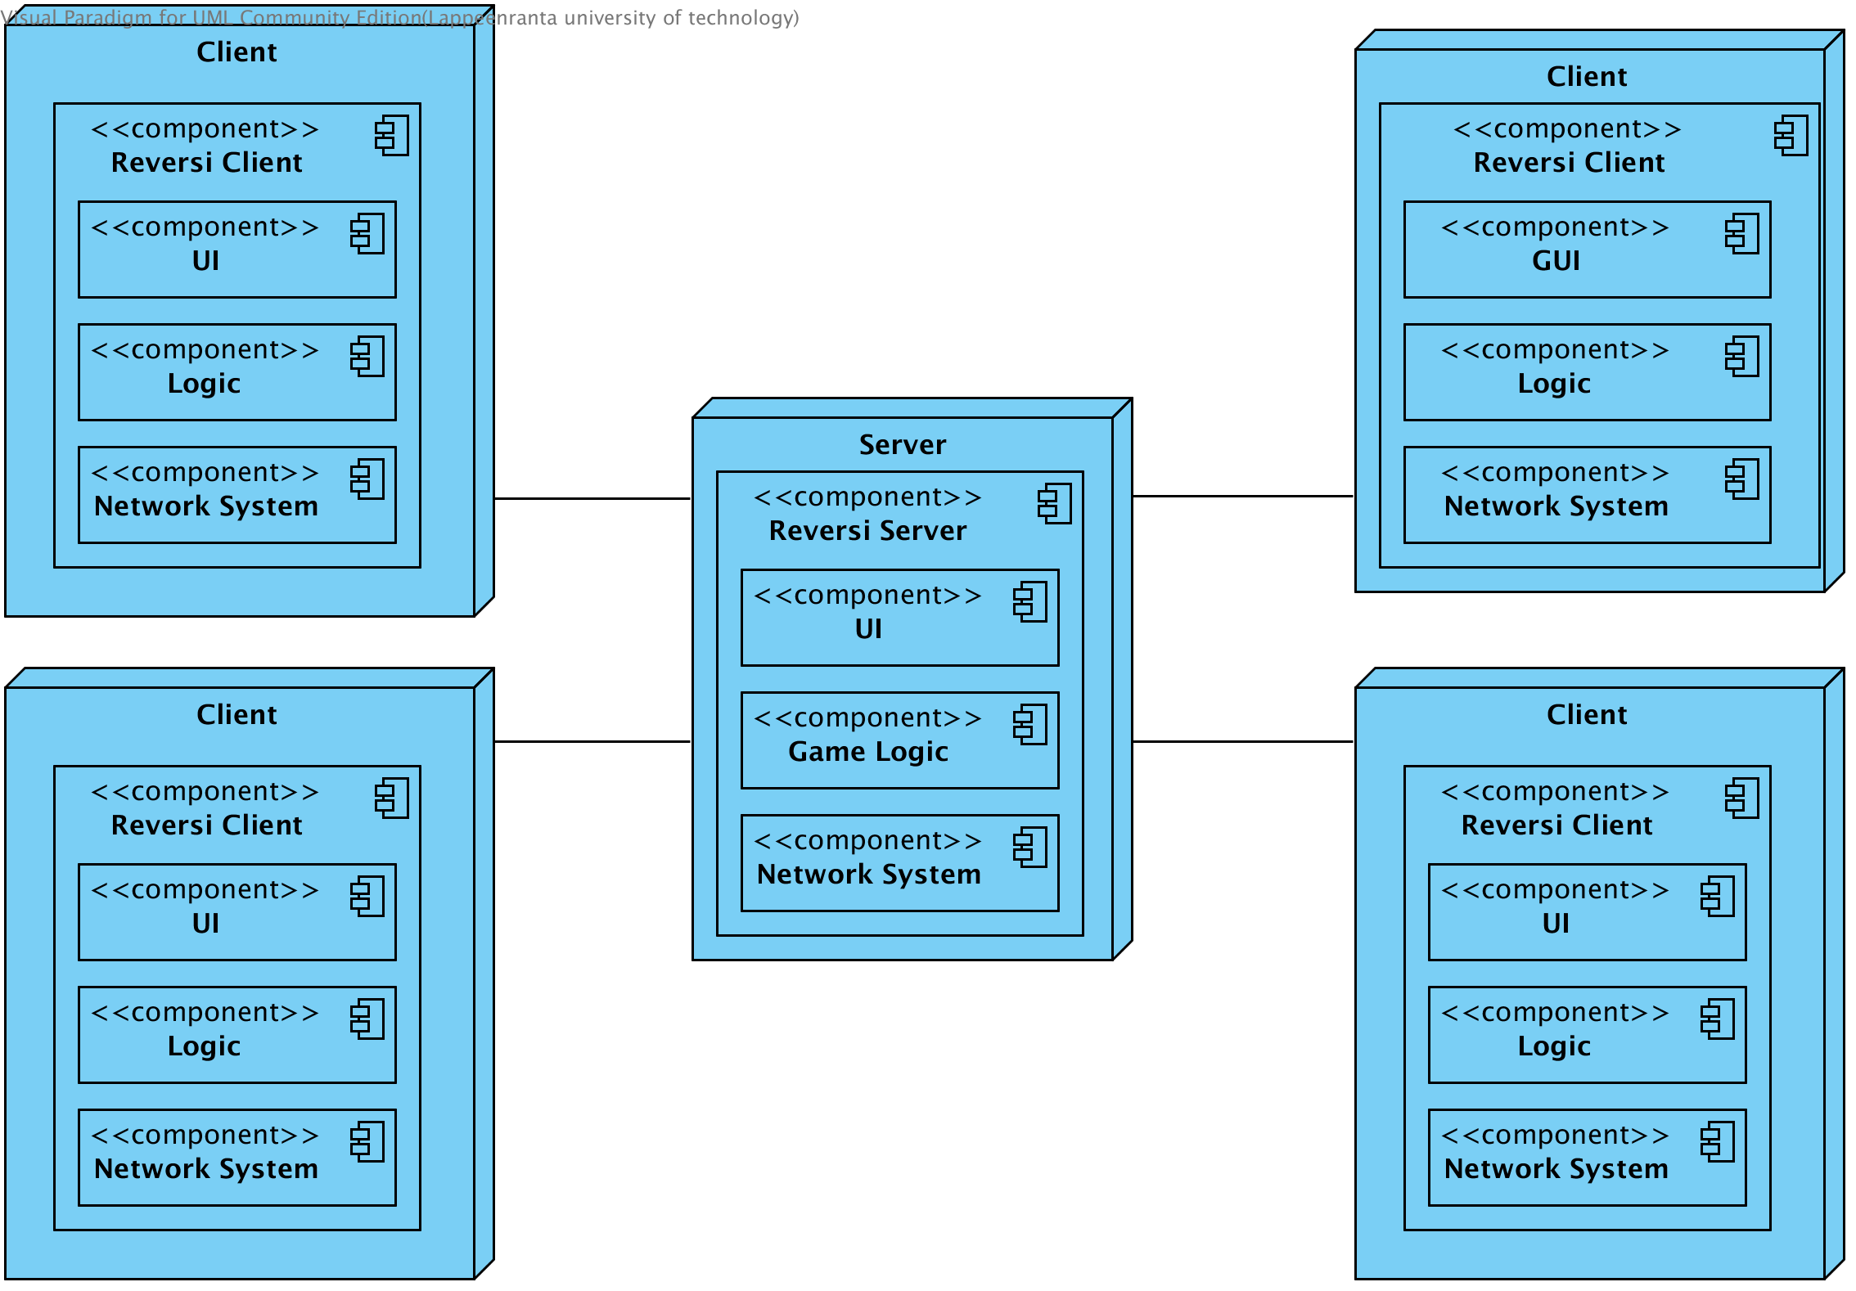Illustration 3: System Overview

Component description

Reversi Server

UI
A real UI is not implemented, just a few debug messages printed to STDOUT

Game Logic
This is where the game server is implemented, it contains the game logic, data structures and protocol realization necessary to manage games, It is the upper most layer of the server
This game layer uses the service provided by the below transport layer to establish communication between clients and servers.

Network System
The network system consists on the communication parts that are tied to the underlying TCP/IP protocol and the TCP/IP primitives.

Reversi Client

UI
Client GUI displays the current state of the game it also acts as the interface between the user and the program logic.

Logic
Client side logic keeps the state of the connection, allowing user to make actions according to that state, for example clients can't disconnect if they are not connected.

Network System
Same as server-side network system

Game Protocol
The game protocol is implemented on both sides, Its responsibility is to package and handle all the messages between clients and the server

Layer model

Layer diagram
This communication Architecture Diagram specifies the entities communicating within the game layer and the transport layer. It shows the entities of each layer and the communication channels between them.
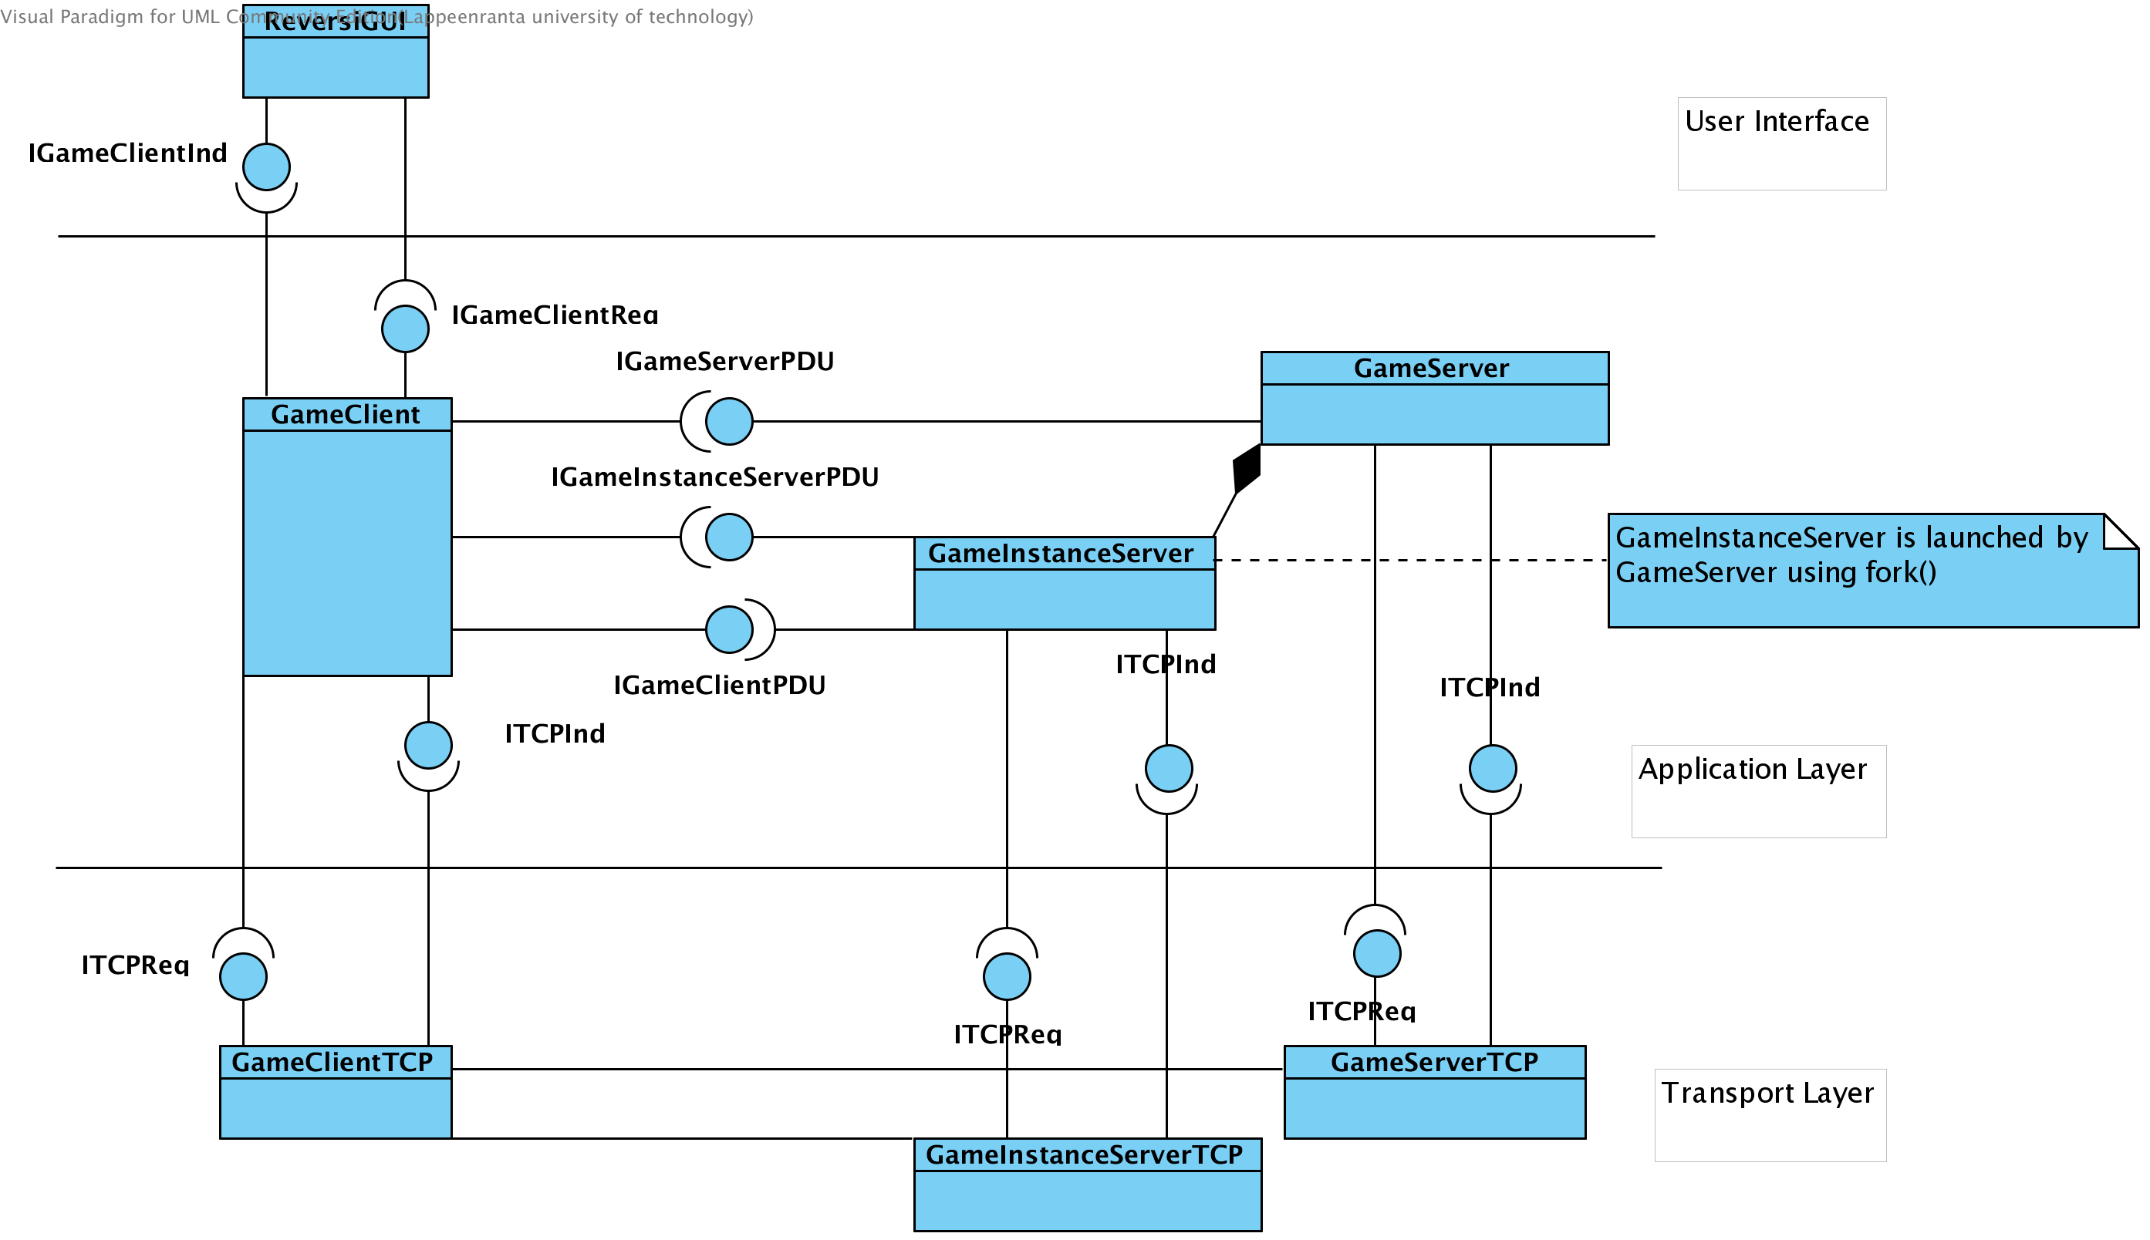Illustration 4: Layer Model

Layers description

Game Layer
This layer is in charge of keeping the games running, ensuring games are played following game's rules and maintaining the client state in consistent state, it implements all the behavior of both client and server sides

Network Layer
Network layer is composed by all the components that are closely tied to the underlying TCP/IP protocol.

Layer interfaces
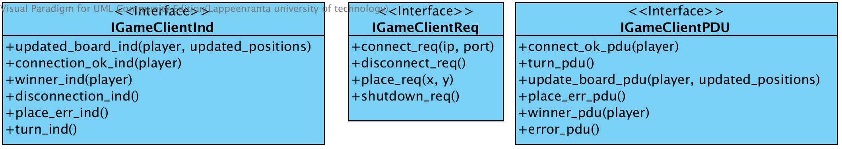Illustration 5: Client interfaces
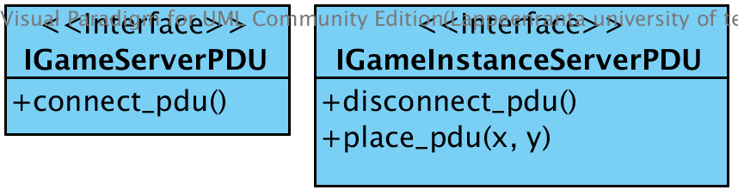Illustration 7: Server interfaces
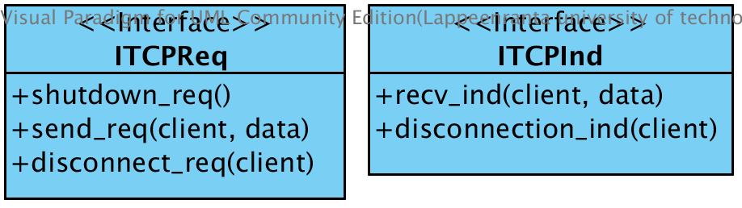Illustration 6: TCP interfaces

Protocol data units

Abstract Message Definitions
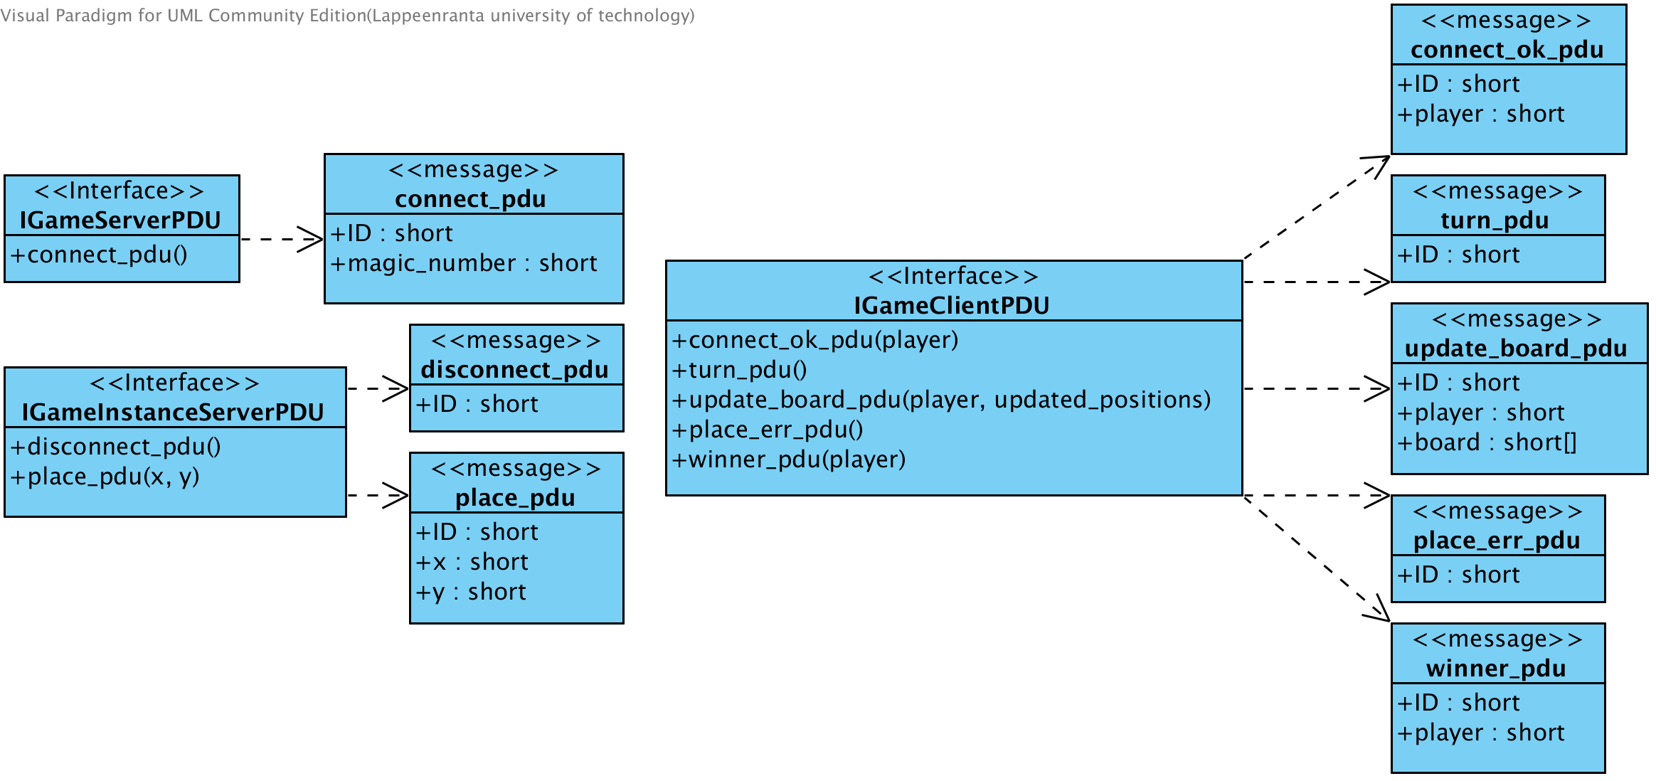Illustration 8: Abstract PDUs

Concrete Message Definitions

NOTE: type of msg_size and player are type short

error_pdu
 | 0..7 | 8..15 | 16..23 | 24..31
0 | msg_size | msg_size | ID | ID

connect_pdu
 | 0..7 | 8..15 | 16..23 | 24..31
0 | msg_size | msg_size | ID | ID

connect_ok_pdu
 | 0..7 | 8..15 | 16..23 | 24..31
0 | msg_size | msg_size | ID | ID

disconnect_pdu
 | 0..7 | 8..15 | 16..23 | 24..31
0 | msg_size | msg_size | ID | ID

place_pdu
 | 0..7 | 8..15 | 16..23 | 24..31
0 | msg_size | msg_size | ID | ID
1 | x | x | y | y

turn_pdu
 | 0..7 | 8..15 | 16..23 | 24..31
0 | msg_size | msg_size | ID | ID

update_board_pdu
 | 0..7 | 8..15 | 16..23 | 24..31
0 | msg_size | msg_size | player | player
1 | x | x | y | y
2 | x | x | y | y
3 | … | … | … | …
4 | … | … | … | …
5 | … | … | … | …
6 | … | … | … | …
7 | … | … | … | …
8 | … | … | … | …
9 | … | … | … | …
10 | … | … | … | …
11 | … | … | … | …
12 | … | … | … | …
13 | x | x | y | y

place_error_pdu
 | 0..7 | 8..15 | 16..23 | 24..31
0 | msg_size | msg_size | ID | ID

winner_pdu
 | 0..7 | 8..15 | 16..23 | 24..31
0 | msg_size | msg_size | ID | ID
1 | player | player

Message IDs enum
Messages IDs | Value
ERROR | -1
CLIENT_CONNECT | 0
CLIENT_CONNECT_OK | 1
CLIENT_QUIT | 2
TURN | 3
PLACE | 4
PLACE_ERROR | 5
UPDATE_BOARD | 6
WINNER | 7

Player IDs enum
Player | Value
EMPTY | 0
WHITE | 1
BLACK | 2

Type catalog
Name | Type | Bit length
short | integer | 16

State machine diagrams
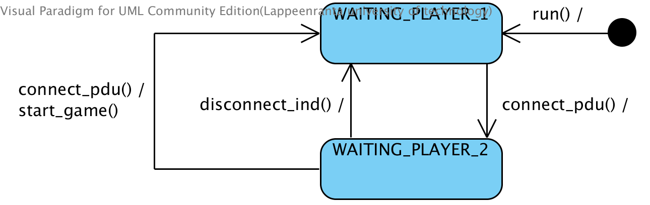Illustration 9: GameServer state machine diagram
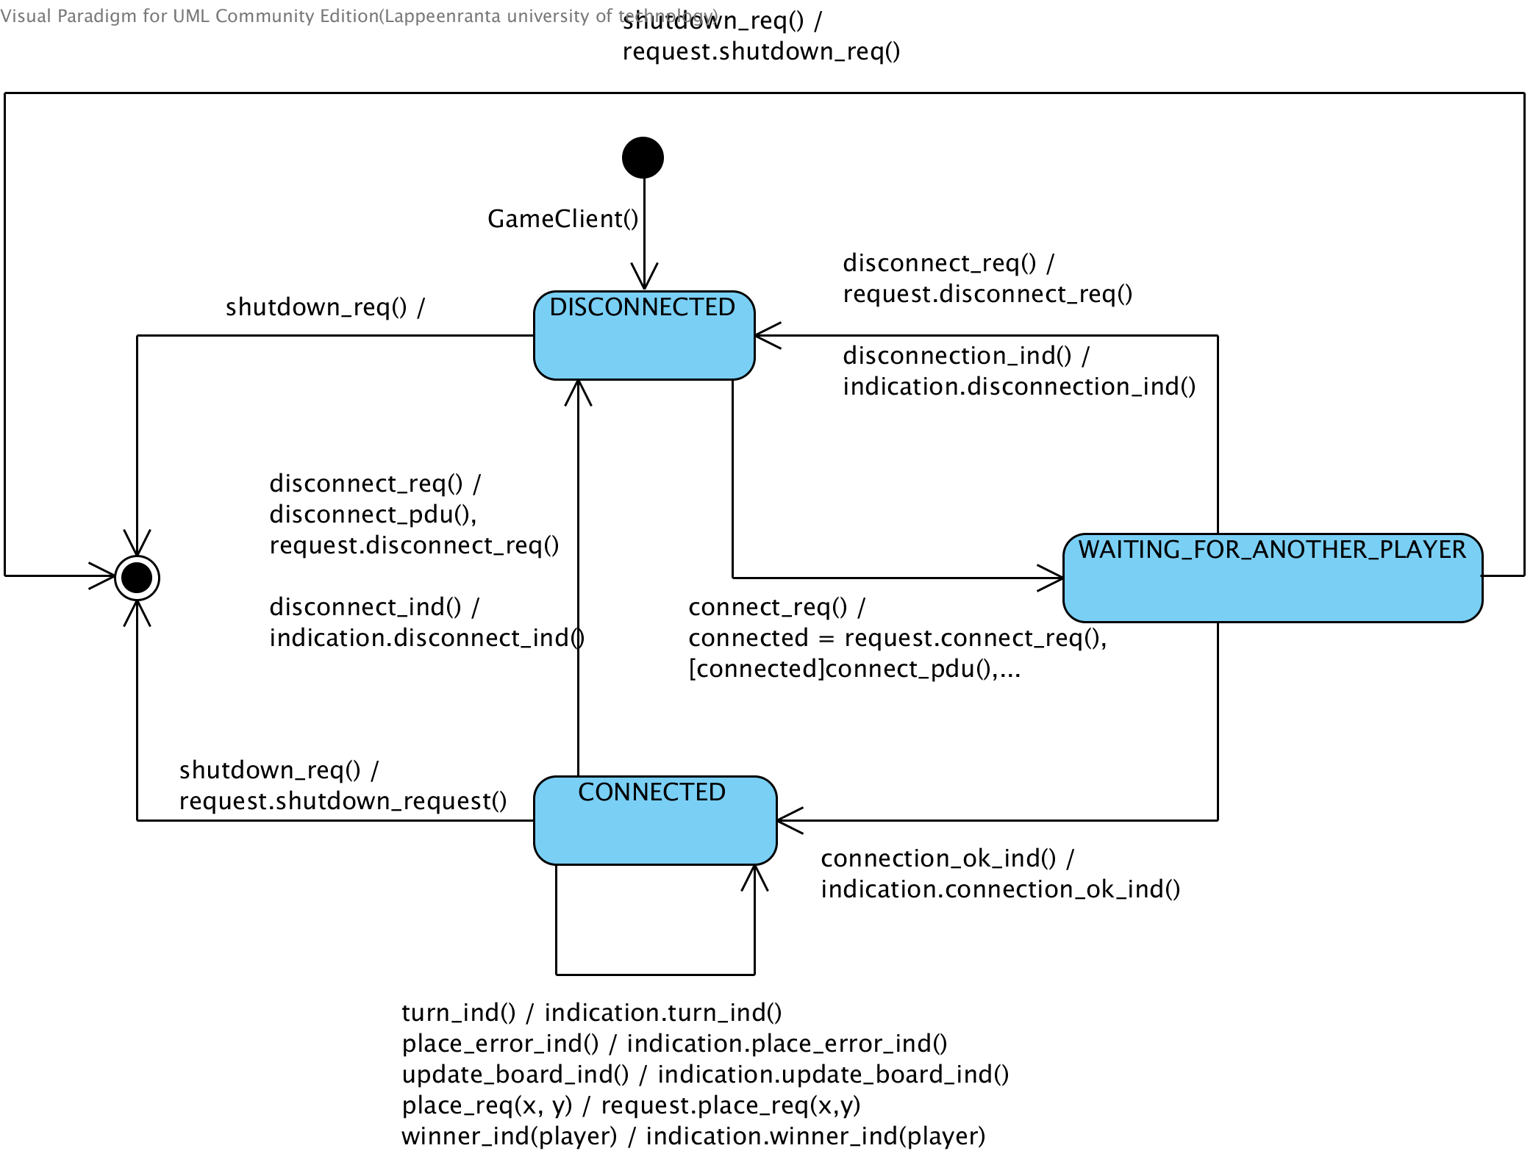Illustration 10: GameClient state machine diagram
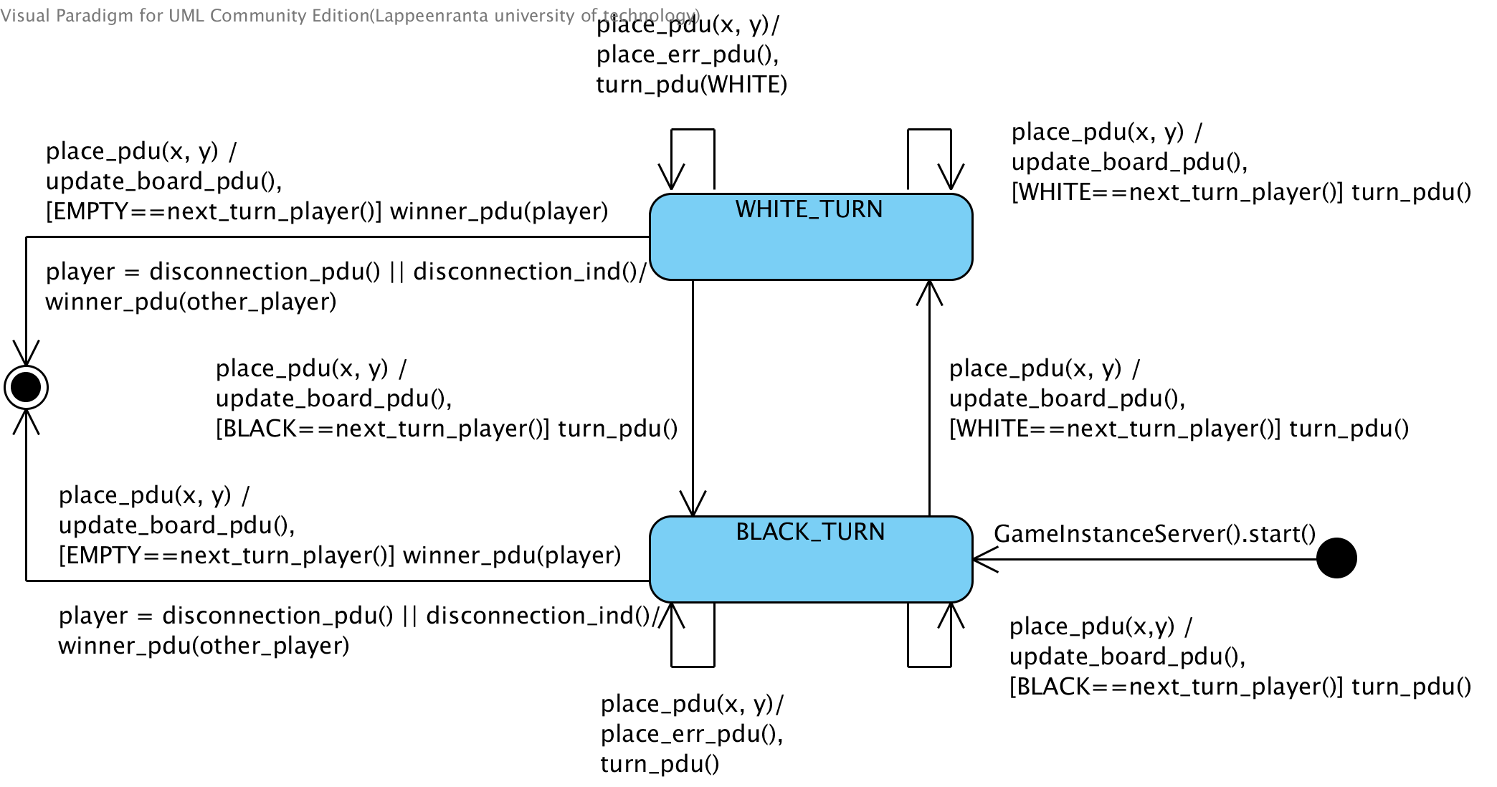Illustration 11: GameServerInstance state machine diagram

Use Case model

Requirements

Use Case diagram
ID | Requirements
RC1 | Use TCP to transfer game messages
RC2 | Connect to server
RC3 | Make move
RC4 | End game
RC5 | Quit game
Table 1: Game Protocol Requirements
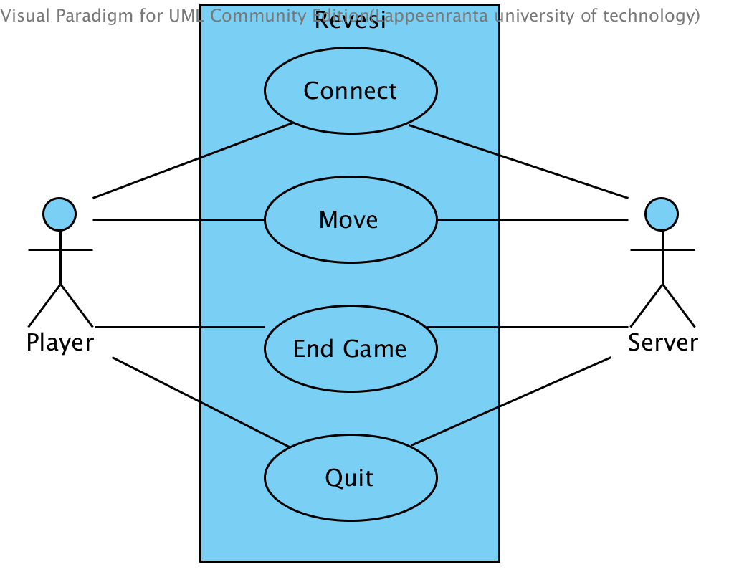Illustration 12: Use case diagram

Use case sequence diagrams
Use case diagrams are located in Appendix 1

References:

[TCP] RFC 793 http://www.ietf.org/rfc/rfc793.txt (as retrieved on 2013)
[WOF] World Othello Federation http://www.worldothellofederation.com/rules_english.asp (as retrevied on 2013)

Appenix 1: Use case sequence diagrams
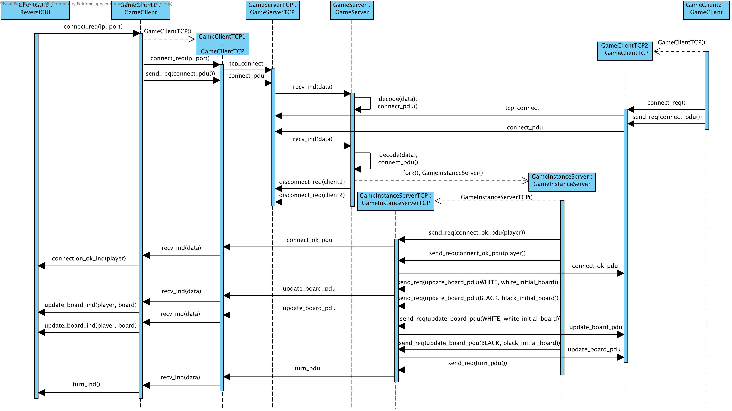Illustration 13: Connect use case
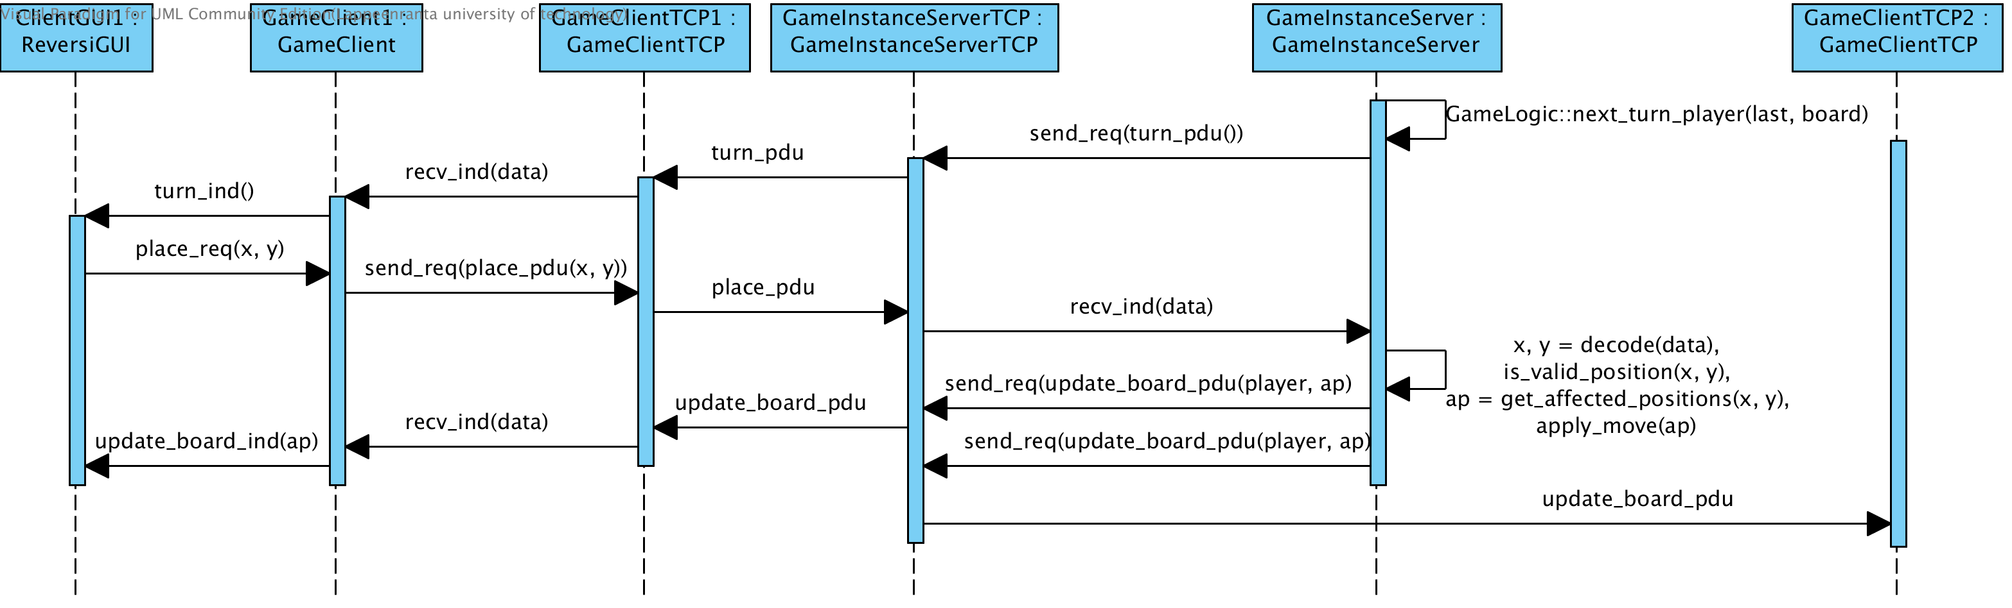Illustration 14: Move OK use case
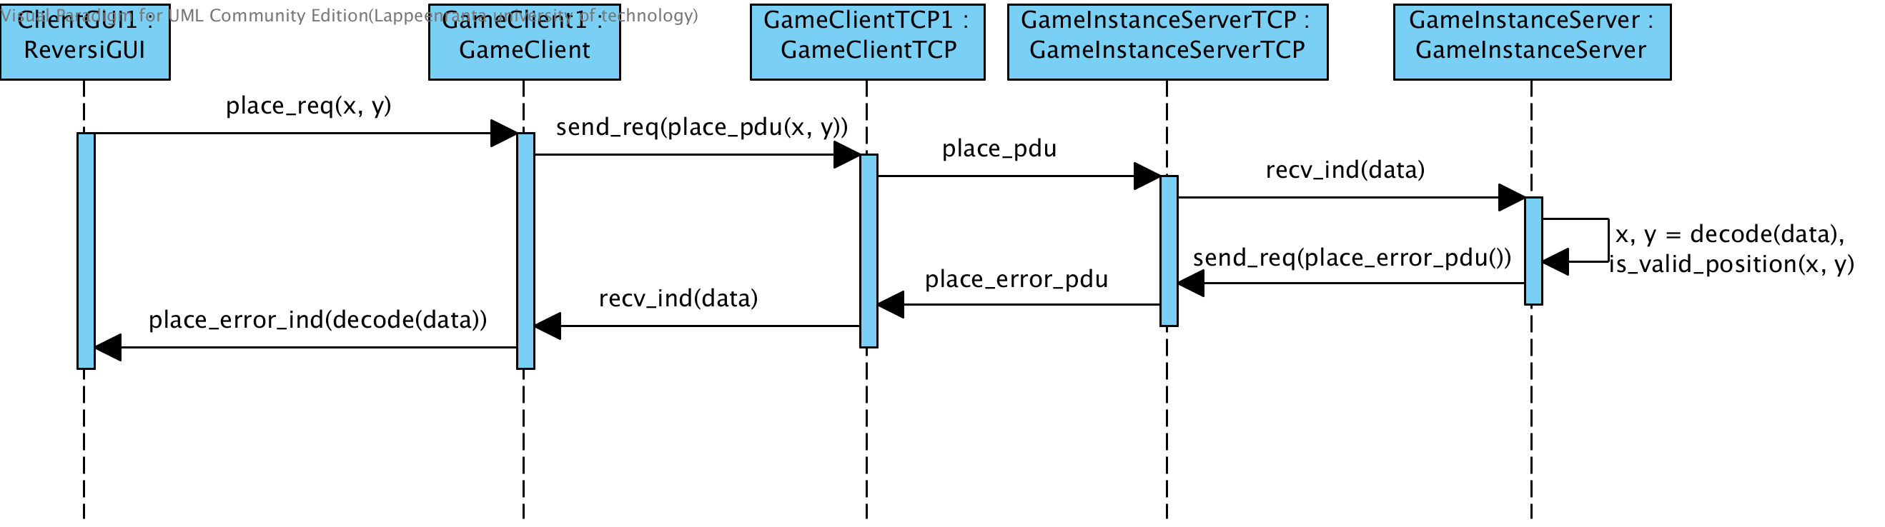Illustration 15: Move error use case

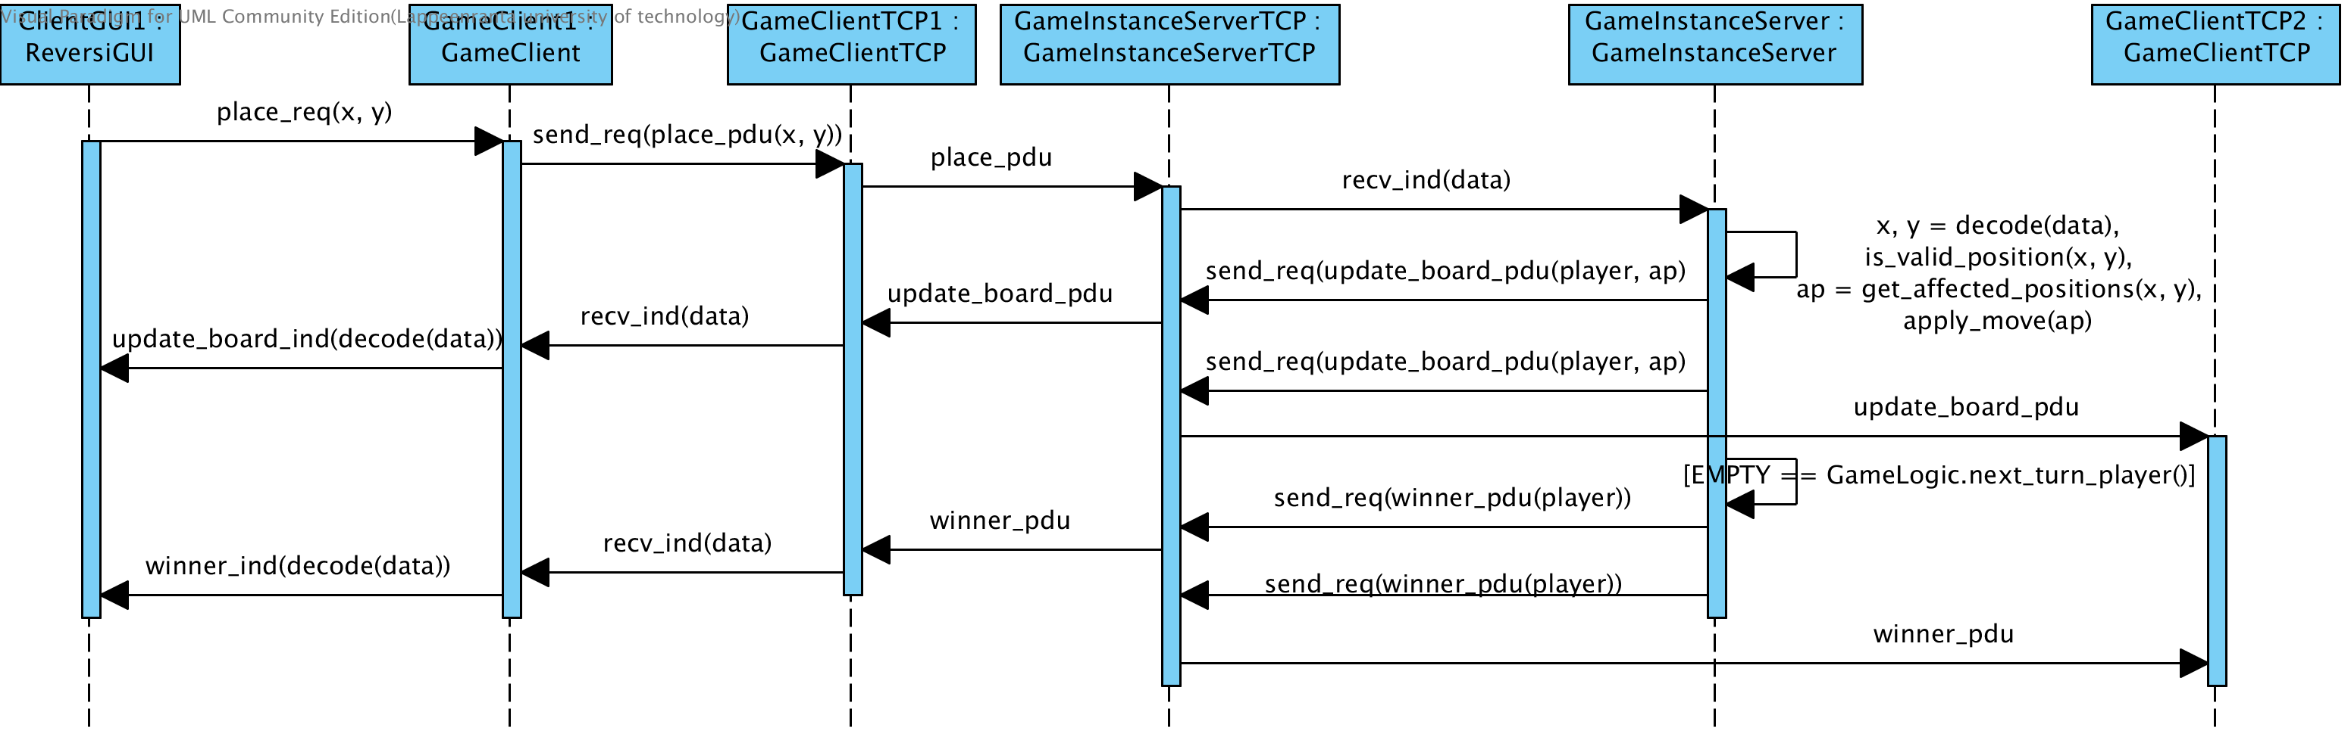Illustration 16: End game use case
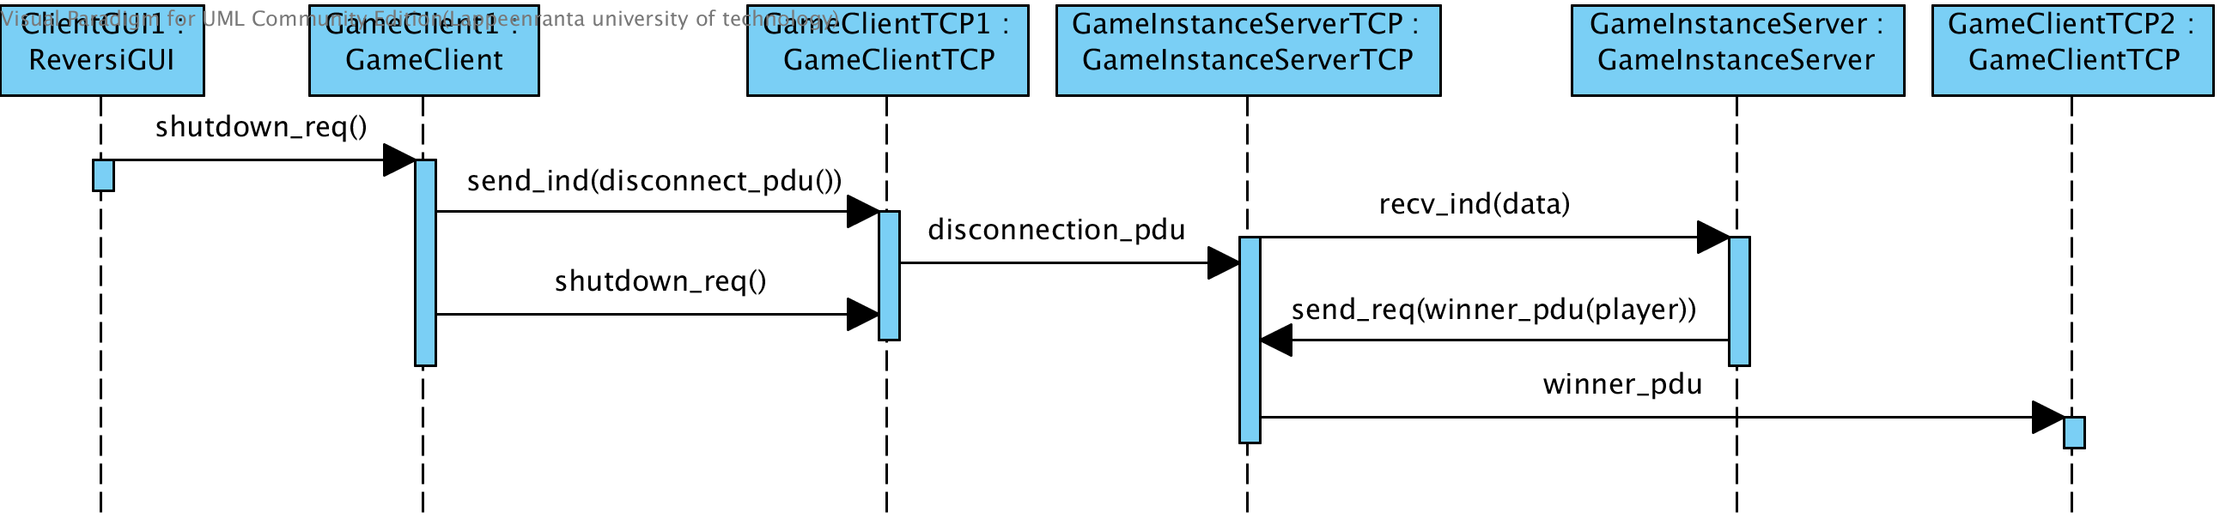Illustration 17: Quit use case

