# Fall’19-20

# Mid-Term Examination- Laboratory

# Course: Computer Graphics Section: C

|  |
| --- |
| **Instruction:**   1. Write down your executable code, Output screen shot in single Microsoft Word/Word-pad file. 2. File name format: Serial_Section 3. Write your **Serial**, **Name**, **ID**, **section** and **date** on top of file (First Page is attached Next)   ***Imp: Take Close screenshot of output window only. Otherwise image size will exceed file size limit.*** |

***Implement Below Problem:***

Draw The kite/Reverse Kite using Bressenham’s Line Drawing algorithm.

Even Serial number: Draw Kite with color Red. Reference Image1

Odd Serial Number: Draw Reverse Kite with Color Green. Reference Image2

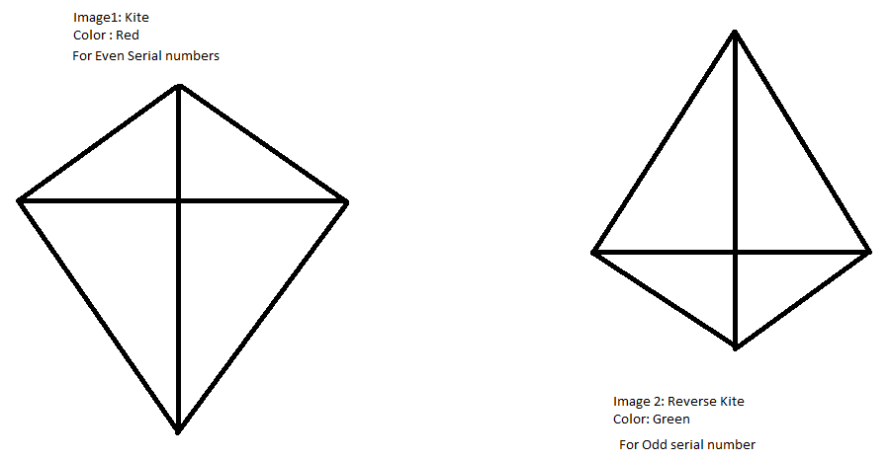

|  |  |
| --- | --- |
| MID-TERM Fall 2019-20Computer Graphics Lab-Exam | |
| **Name:** | **ID:** |
| **Course:** | **Section:** |
| **Faculty Name:** | **Serial No:** |
| **Date:** | |

## Source Code:

*[Paste Your Code]*

## Output:

*[Paste Output Screenshot]*