*JOB RECRUITMENT SERVICE SYSTEM*

***PROPOSE*** : Job Recruitment Service system is a program which is designed to manage the recruiting process.

It can be reached throughout various organizations and for job applicant. This system can be used as an overall process to get job in a systematical way.

***ADVENTURES*** *:*

The program component provides the best data management that is offered to job recruitment service, examination’s appropriate answer, restore instructions of various profile information. Through this system, any organizations will be able to take written exam of the job applicant.

***OVERVIEW:*** Overall description consists of background of the entire specific reqruitment. It also gives the explanation about actor and function which is used.

***MODULES:***

Authority-Creator:

They act as admin in this software system. They have full access to all the modules of this system. They appoint the applicant after taking an exam. According to the result points, job seeker gets their required job.

Job-applicant:

They have restricted access i.e. job applicant has access to some of the modules only. Every job applicant has their own profile with proper Curriculum Vitae (CV). They gets notified while there is any vacancy in any particular job organization or company. If they are interested and qualified, they can give the exam. After being published the result, they will be notified.

***FEATURES:***

* Log in as ( Authority-creator / Job-seeker )
* Registration with Image and email account.
* View total offered post of any institution with deadline.
* Having written exam with multiple choice question.
* Examine the paper with marks.
* Can choose eligible applicant.
* Give a notification to the applicant.

***STRUCTURE***

Job Recruitment Service System

Log In

* Authority- creator - Job-applicant
* Create post offer * View post offer
* Update post * Apply
* View result * Give exam
* Inform applicant * See notification

With a message.

***GOALS:***

* To provide an organized system to have a job.
* Having proper exam with fair marking system.
* To reduce various types of difficulties which job-applicant had to face off as well as various companies.
* To have a digital process or system in job sector.

***DIFFERENCE FROM OTHER SYSTEM:***

* The cost and time which we had to spend in analog process, will be reduced.
* Fair marking system will make the process nore robust.
* Easy to use for both job applicant and authority.

***Why people will use this system:***

* Previous analog system which needed a very long time to complete this procedure. In this system, they will be able to overcome this problem.
* Easy user interface.
* Cost-effective.
* Applicant can get updated if there any kind of job vacancy.
* It is an organized system to get contact with companies without spending a lot of time and money.

***AUTHENTICATION:***

Functions:

* User interface for the authority-creator.
* Interface for the applicant to have information.
* Handling validations.
* Tracing the update in the offered post.

***Functional Description:***

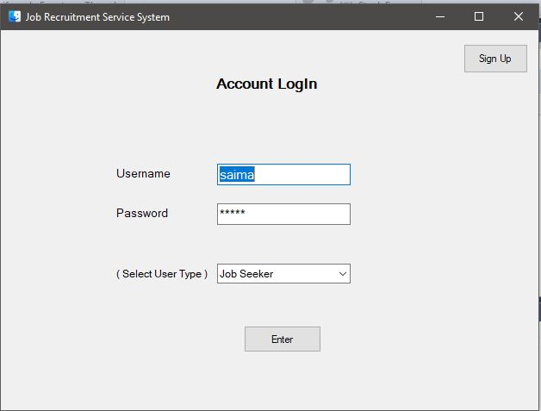

Here, log in frame will be used as selection profile. User can be logged in as 2 catagories. Such as, authority-creator and job applicant.

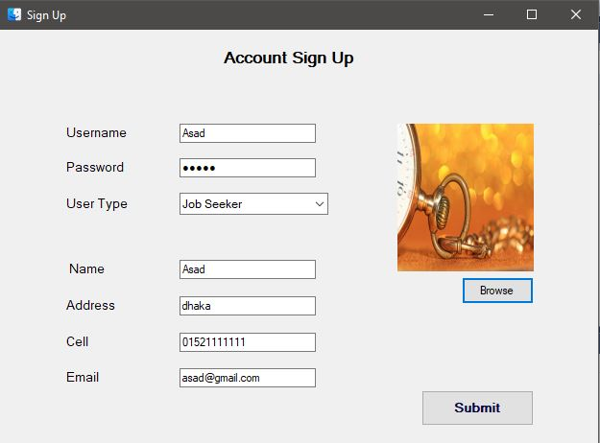

After registration, an applicant have their own profile with image and email account.

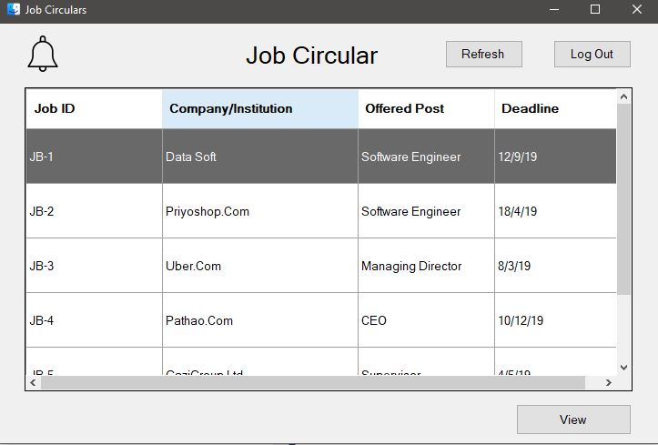

Here, an applicant can see the job vacancy post. If he wants to see the details, view button wll show him the job details.

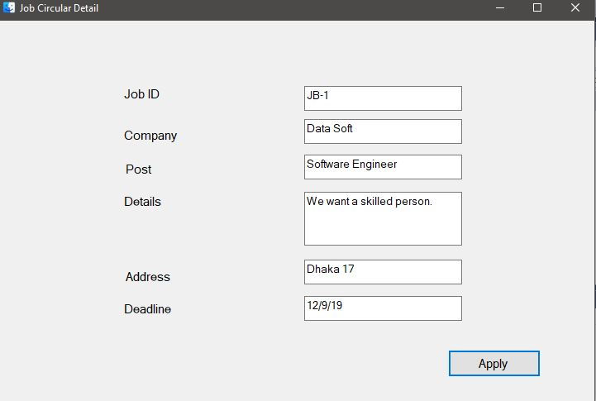

To apply for any post, every candidate will have to go through a test.

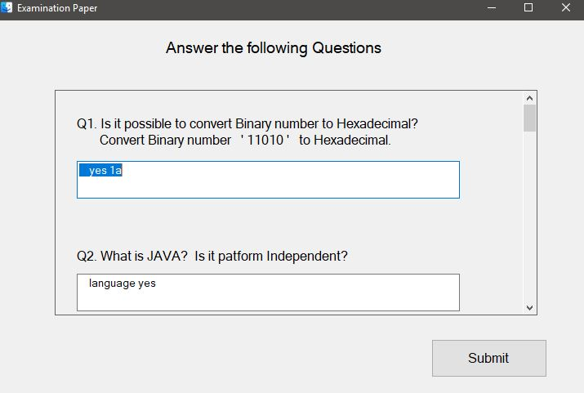

In this exam paper, there will be written part as well as multiple choice question part. There will be fair marking system.

After answering all the questions, the candidate will get his marks immediately. He will also be notified, if he is eligible or not for the interview call. If the candidate acquire 70% marks in the exam, he will be eligible for the interview.

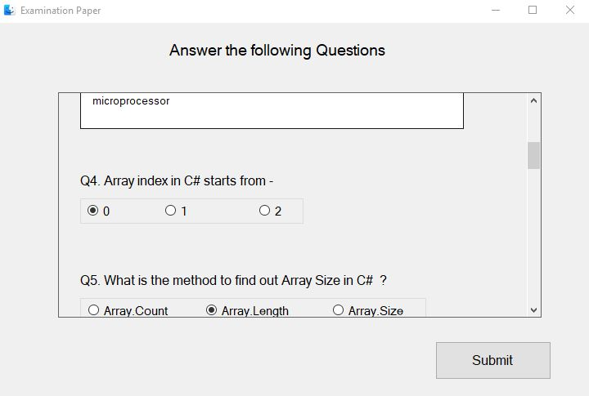

Exam paper includes multiple choice question too.

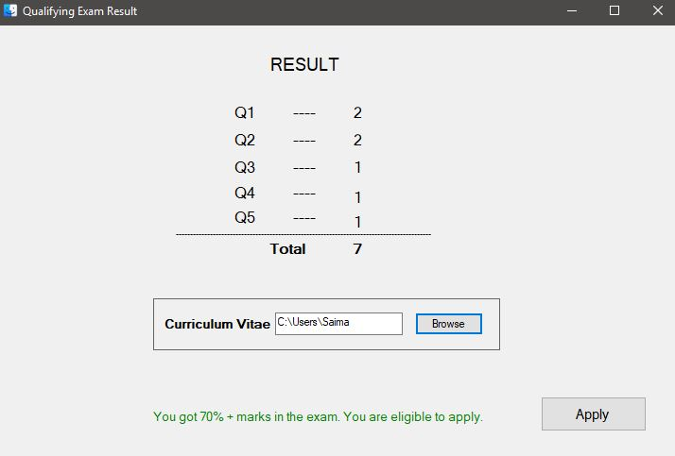

The candidate will have to include his Curriculum Vitae properly to apply for the post.

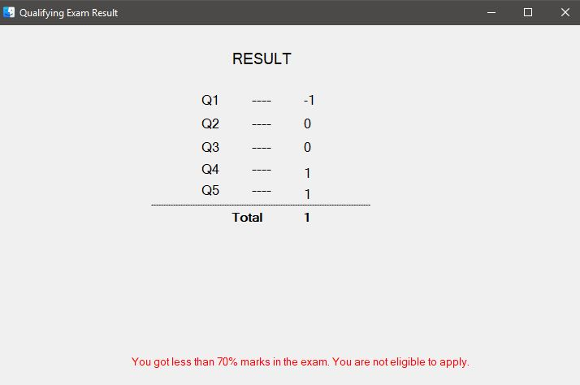

Result will be immediately published to the applicant.

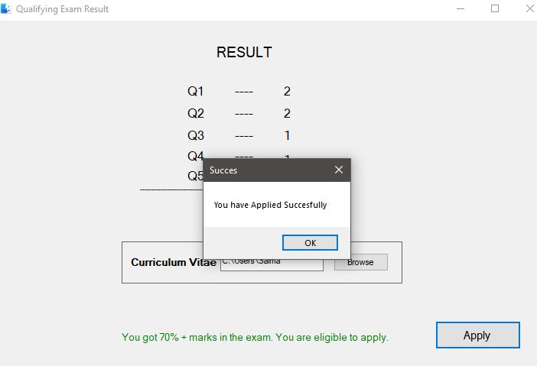

Once the applicant successfully applied for the post, it will be notified.

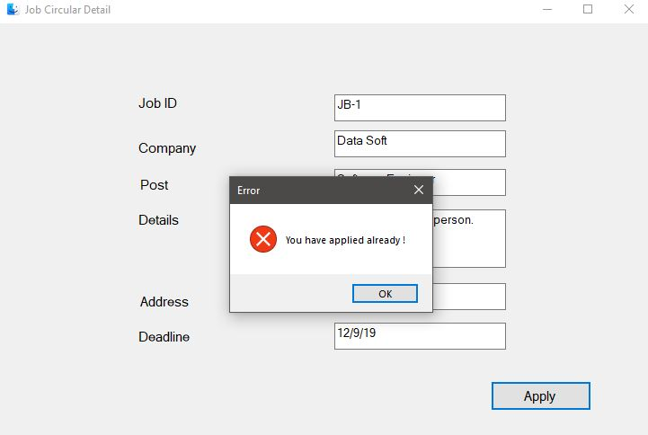

If he further tries to apply for the post, he can not. As he have already applied for it.

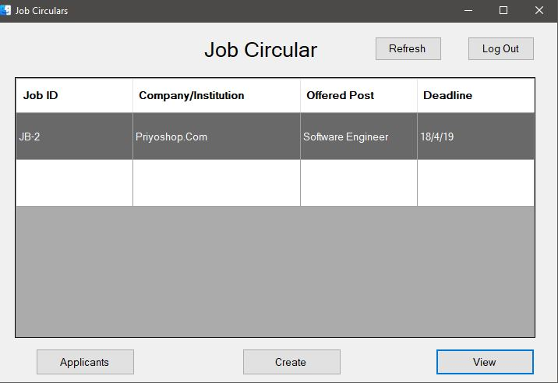

Any company will be able to create or update a job vacancy post. When any candidate applies for the post, authorities will be able to check out the list of the applicants who are eligible for the post as they gets above 70% marks in the test.

After watching the CV, they can choose the applicants for the interview part. And then the applicants gets notified for the desired interview call.

***USECASE DIAGRAM:***

Applicant

Authority

***. .***