**Networking Terminal Command Understanding**

Jubair Ahammad Akter_59

August 28, 2025

**Ping**  
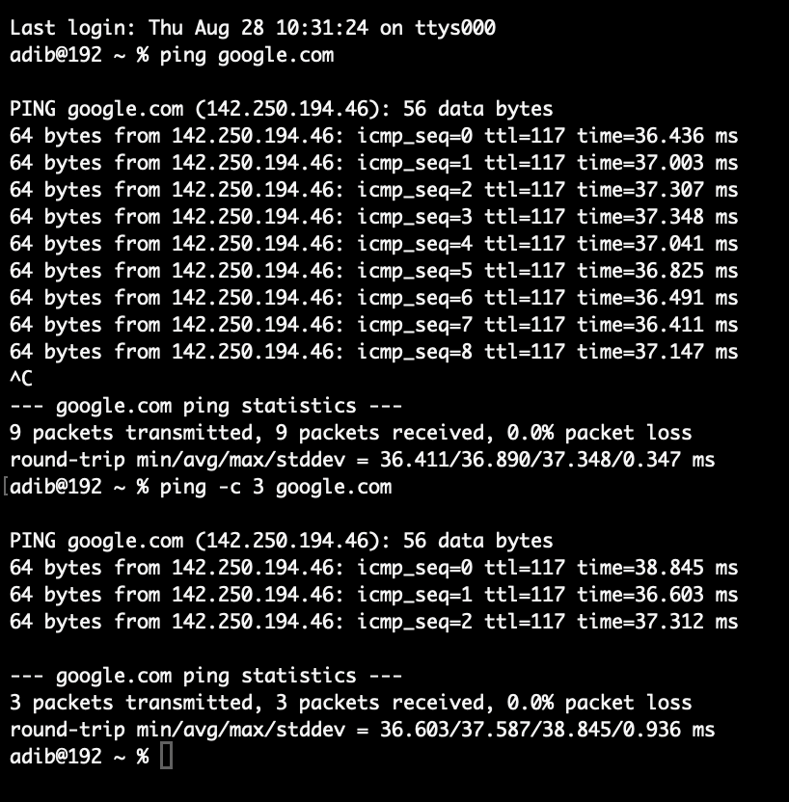

Tested network connectivity and round-trip time (also called latency) between my device and a remote server.

**Traceroute**

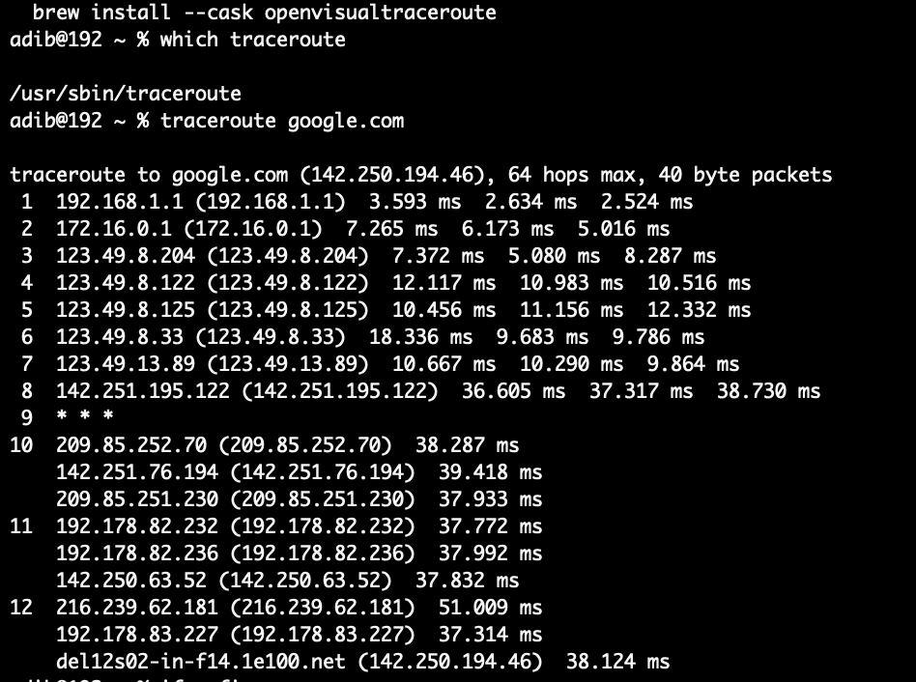  
  
Observed how many packets travel through multiple routers/hops to reach a destination server.

**Ifconfig**

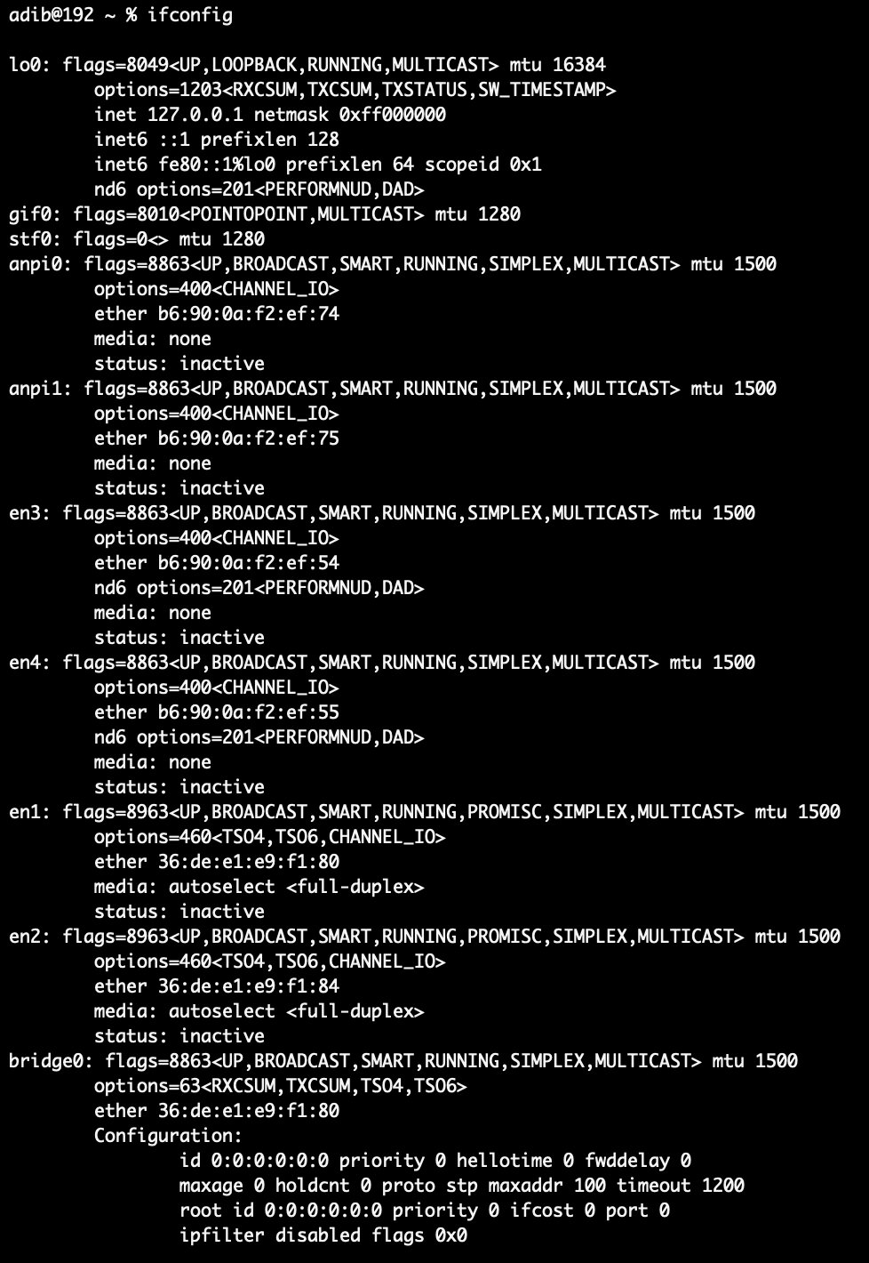

We can check network interface details, as well as IP address, subnet mask, and MAC address.

**ARP**

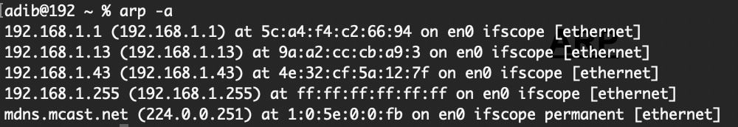

Understood how IP addresses are mapped to MAC addresses within the local network.  
  
**RARP**

Learned that Reverse ARP maps a MAC address back to its corresponding IP address, though it’s mostly replaced by DHCP today.

**NSLOOKUP**

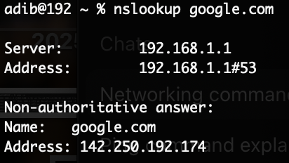

Practiced resolving domain names into IP addresses using a DNS server.

**NETSTAT**

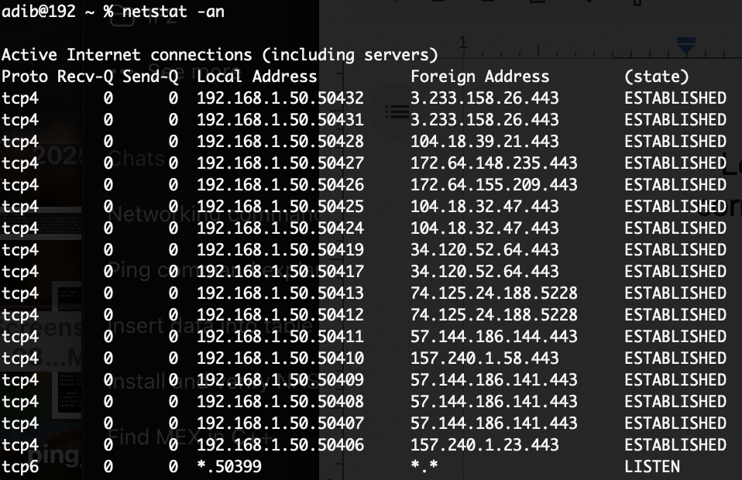

active connections, listening ports, and ongoing network sessions