**Development Instutute of Technical Education and Skill(DITES)**

**Vision**  
Transform workforce through technical education and skills development,

**Mission**  
Execute programs geared to ensure and include technical education and skills development, spread applicable standards and certification system.

**Values**   
Having personal commitment, demonstrated competence, institutional integrity, and culture of innovativeness.

**Organizational Chart**

**President**

**Administration Academics Students**

**HR Department Heads**

**Finance Teachers**

**IT**

**Utilities**

**Marketing**

**Network Logical Topology and Design**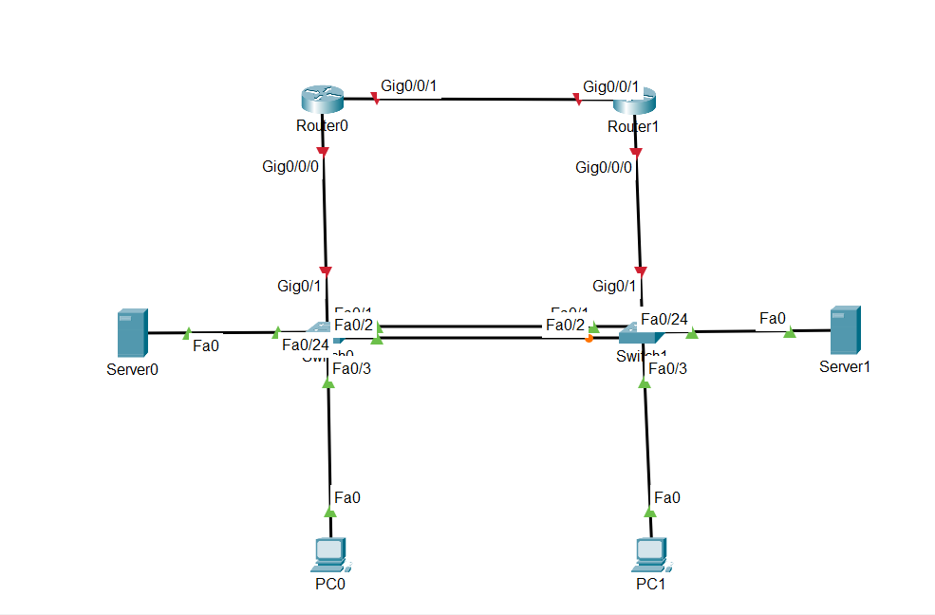

**IP Addressing Scheme**

