**Development Institute of Technical Education and Skill (DITES)**

**By Ernest, Jubair, Mackenzie and Tolu**

Our company DITES (Development Institute of Technical Education and Skill) comes from a background of young technology enthusiasts who believe there is not enough options in early education to prepare for a career in IT. Our goal is to provide early education to high school age students who are eager to get a jump start on learning about the technology that helps us all in our daily lives. We have realized that early education institutes do not provide adequate options for these students and hope to be able to fill that void. We would like to give these students proper knowledge and training in these fields so that they may go on to succeed in further education and have fulfilling careers.

We plan to offer courses to high school students that serve to be an intro for university level courses in the same subject, whether they are sure of their decision to go down this career path or if they just want to experiment and decide if IT is the career for them. With smaller class sizes we aim to provide unique attention to students needs as well as answer any questions and concerns they may have. This is all done in an attempt to transform the future workforce through technical education and skill development of our youth. We want to spread the practice of proper standards in order to create a safer and more secure future of the field.

We would like to provide our students with all the tools they need to succeed. These tools include but are not limited to; Local Network Access, Internet Access, WIFI, Web Site with a student portal for assignments and testing, Outlook accounts for all students and staff with Exchange Hybrid integration, Personal Storage Pools, Remote access through VPN services and proper security measures to ensure the safety of student and staff information. Any services we later deem necessary can still be added in the future.

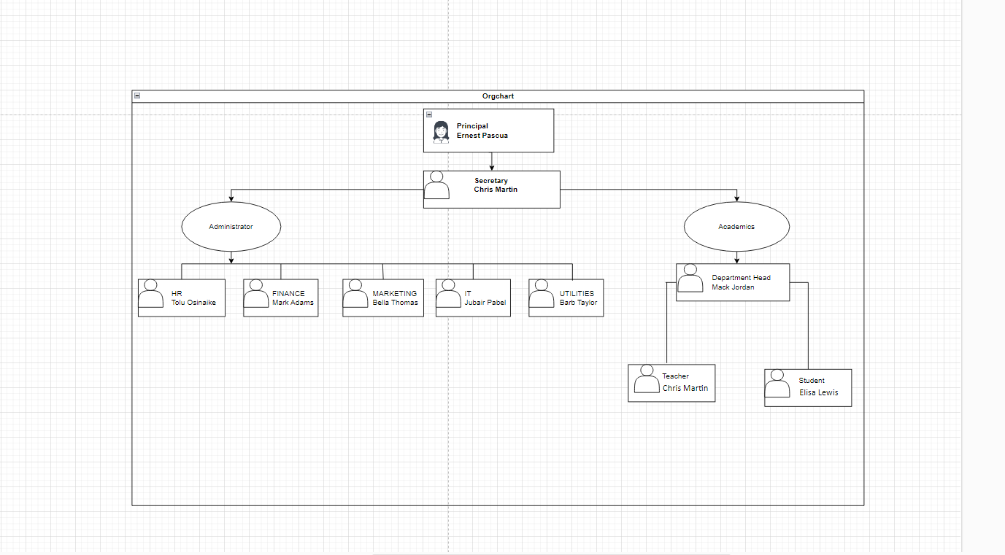Organizational Chart

Network Logical Topology

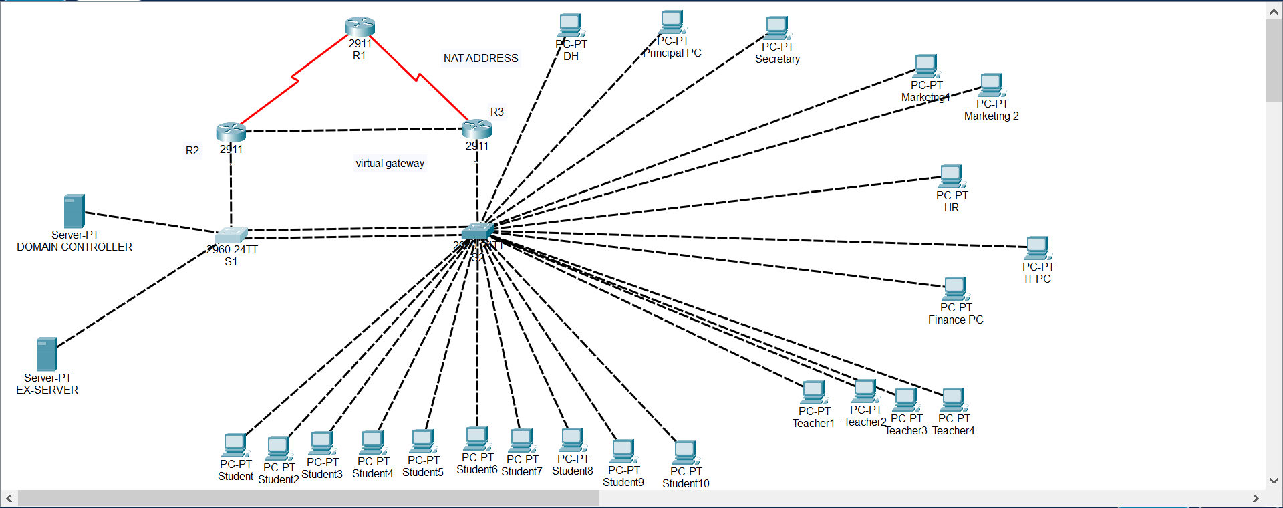

IP Addressing Scheme

