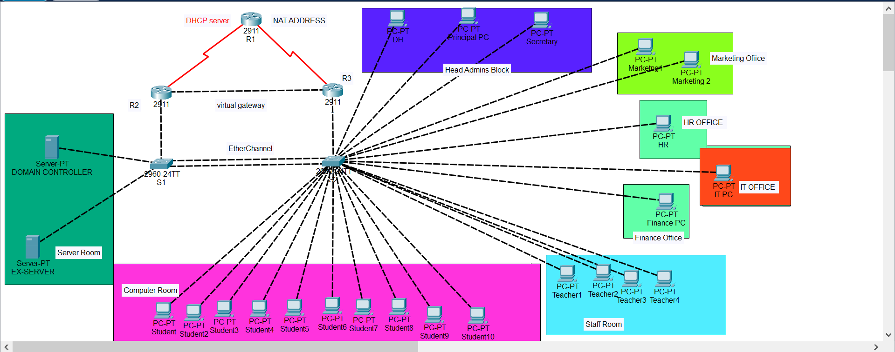

The Logical Topology shows the school network with segmented and its segmented VLANs. The switches are connected via an Ethernet port channel “P01” and are trunked to send information to each other. Routers R2 and R3 are linked through HSRP. Inter-VLAN routing is configured so each segment can talk to one another. In a full production system, we would have WLANs would have been enabled to accommodate more devices but the topology shows a fixed set of devices.

The school system server is going to have a fully containerized mail system meaning mail addresses with the school domain name would not be able to reach the outside network. ACL’s will be configured to restrict pings to the server, but the server would be allowed to ping out. R1 would have a dynamic NAT with overload so all devices in the network would be able to reach the outside networks from the public address.

The Interface and VLAN configuration information can be found in the tables below. All networks have been implemented on packet tracer.

**Full list of Services we plan to Provide:**

**Local Network Access**

Access to Internet (NAT)

HRSP

DHCP and DNS services

DHCP Relay

Network Segmentation through VLANS

Etherchannel Configuration for Student Network to Increase Bandwidth

Router Protocol Authentication

Switch and Router Security (Portfast, BPDU Guard, MAC Filtering and ACL Services)

Virtual Gateway for Redundancy

Monitoring

**School Web Site**

School Portal for Uploading and Accessing Results

Exchange Online Access

**Server Administration**

DNS

Appropriate Permissions and Restrictions

WDS for easy deployment of Resources

Organizational Structure in ADDS

Storage Pool for Files

Remote access through VPN

**Exchange Server**

Mailboxes for Staff and Students

Resource Mailboxes (Conference Rooms, IT Labs, Switch and Router rental)

Share Folders for Departments and Homerooms

|  |  |  |  |  |  |  |
| --- | --- | --- | --- | --- | --- | --- |
| **Devices** | **Interface** | **IP address** | **Subnet** | **Default Gateway** | **VIrtual Address** | **Vlan** |
| **R1** | **S0** | **172.16.1.177** | **255.255.255.252** | **N/A** | **N/A** |  |
|  | **S1** | **172.16.1.181** | **255.255.255.252** | **N/A** | **N/A** |  |
|  |  |  |  |  |  |  |
| **R2** | **S0** | **172.16.1.178** | **255.255.255.252** | **N/A** | **N/A** |  |
|  | **G0/0** | **172.16.1.185** | **255.255.255.252** | **N/A** | **N/A** |  |
|  | **G0/1.2** | **172.16.0.2** | **255.255.255.0** | **N/A** | **172.16.0.3** | **Vlan 2** |
|  | **G0/1.3** | **172.16.1.2** | **255.255.255.224** | **N/A** | **172.16.1.3** | **Vlan 3** |
|  | **G0/1.4** | **172.16.1.34** | **255.255.255.224** | **N/A** | **172.16.1.35** | **Vlan 4** |
|  | **G0/1.5** | **172.16.1.66** | **255.255.255.224** | **N/A** | **172.16.1.67** | **Vlan 5** |
|  | **G0/1.6** | **172.16.1.98** | **255.255.255.224** | **N/A** | **172.16.1.98** | **Vlan 6** |
|  | **G0/1.7** | **172.16.1.130** | **255.255.255.240** | **N/A** | **172.16.1.131** | **Vlan 7** |
|  | **G0/1.8** | **172.16.1.146** | **255.255.255.240** | **N/A** | **172.16.1.147** | **Vlan 8** |
|  | **G0/1.9** | **172.16.1.162** | **255.255.255.248** | **N/A** | **172.16.1.163** | **Vlan 9** |
|  | **G0/1.10** | **172.16.1.170** | **255.255.255.248** | **N/A** | **172.16.1.171** | **Vlan 10** |
|  | **G0/1.99** | **N/A** |  |  | **172.16.1.99** | **Vlan Native** |
|  |  |  |  |  |  |  |
| **R3** | **S0** | **172.16.1.182** | **255.255.255.252** | **N/A** | **N/A** |  |
|  | **G0/0** | **172.16.1.186** | **255.255.255.252** | **N/A** | **N/A** |  |
|  | **G0/1.2** | **172.16.0.1** | **255.255.255.0** | **N/A** | **172.16.0.3** | **Vlan 2** |
|  | **G0/1.3** | **172.16.1.1** | **255.255.255.224** | **N/A** | **172.16.1.3** | **Vlan 3** |
|  | **G0/1.4** | **172.16.1.33** | **255.255.255.224** | **N/A** | **172.16.1.35** | **Vlan 4** |
|  | **G0/1.5** | **172.16.1.65** | **255.255.255.224** | **N/A** | **172.16.1.67** | **Vlan 5** |
|  | **G0/1.6** | **172.16.1.97** | **255.255.255.224** | **N/A** | **172.16.1.98** | **Vlan 6** |
|  | **G0/1.7** | **172.16.1.129** | **255.255.255.240** | **N/A** | **172.16.1.131** | **Vlan 7** |
|  | **G0/1.8** | **172.16.1.145** | **255.255.255.240** | **N/A** | **172.16.1.147** | **Vlan 8** |
|  | **G0/1.9** | **172.16.1.161** | **255.255.255.248** | **N/A** | **172.16.1.163** | **Vlan 9** |
|  | **G0/1.10** | **172.16.1.169** | **255.255.255.248** | **N/A** | **172.16.1.171** | **Vlan 10** |
|  | **G0/1.99** | **N/A** |  |  | **172.16.1.99** | **Vlan Native** |
| **S1** | **Vlan 10** | **N/A** | **N/A** | **N/A** | **N/A** |  |
| **S2** | **Vlan 10** | **N/A** | **N/A** | **N/A** | **N/A** |  |
| **DC** | **NIC** | **172.16.1.172** | **255.255.255.248** | **172.16.1.171** | **172.16.1.171** | **Vlan 10** |
| **EX** | **NIC** | **172.16.1.174** | **255.255.255.248** | **172.16.1.171** | **N/A** | **Vlan 10** |
| **Test StudentPC** | **NIC** | **DHCP** | **DHCP** | **DHCP** | **DHCP** | **Vlan 2** |
| **Test TeacherPC** | **NIC** | **DHCP** | **DHCP** | **DHCP** | **DHCP** | **Vlan 3** |

|  |  |  |  |
| --- | --- | --- | --- |
| **NAME** | | **VLAN** | |
| **Student** | | **2** | |
| **Teacher** | | **3** | |
| **Finance** | | **4** | |
| **HR** | | **5** | |
| **Department Head** | | **6** | |
| **Marketing** | | **7** | |
| **IT** | | **8** | |
| **Principal** | | **9** | |
| **Servers** | | **10** | |
| **Native** | | **99** | |
| **Management** | | **20** | |
| **VLAN** | | **Network ADD** | | **R3 ADDRESS** | | **R2ADDRESS** | **VIRTUAL ADDRESS** | **IP RANGE**  **START** | **IP RANGE**  **FINISH** | **Subnet** |
| **STUDENT2** | | **172.16.0.0** | | **172.16.0.1** | | **172.16.0.2** | **172.16.0.3** | **172.16.0.4** | **172.16.0.254** | **.0** |
| **Teacher 3** | | **172.16.1.0** | | **172.16.1.1** | | **172.16.1.2** | **172.16.1.3** | **172.16.1.4** | **172.16.1.30** | **.224** |
| **Finance 4** | | **172.16.1.32** | | **172.16.1.33** | | **172.16.1.34** | **172.16.1.35** | **172.16.1.36** | **172.16.1.62** | **.224** |
| **HR 5** | | **172.16.1.64** | | **172.16.1.65** | | **172.16.1.66** | **172.16.1.67** | **172.16.1.68** | **172.16.1.94** | **.224** |
| **DepartmentHead 6** | | **172.16.1.96** | | **172.16.1.97** | | **172.16.1.98** | **172.16.1.99** | **172.16.1.100** | **172.16.1.126** | **.224** |
| **Marketing 7** | | **172.16.1.128** | | **172.16.1.129** | | **172.16.1.130** | **172.16.1.131** | **172.16.1.132** | **172.16.1.142** | **.240** |
| **IT 8** | | **172.16.1.144** | | **172.16.1.145** | | **172.16.1.146** | **172.16.1.147** | **172.16.1.148** | **172.16.1.158** | **.240** |
| **Principal/Secretary9** | | **172.16.1.160** | | **172.16.1.161** | | **172.16.1.162** | **172.16.1.163** | **172.16.1.164** | **172.16.1.166** | **.248** |
| **SERVER 10** | | **172.16.1.168** | | **172.16.1.169** | | **172.16.1.170** | **172.16.1.171** | **172.16.1.172** | **172.16.1.174** | **.248** |
| **R1 and R2** | | **172.16.1.176** | |  | |  |  | **172.16.1.177** | **172.16.1.178** | **.252** |
| **R1 and R3** | | **172.16.1.180** | |  | |  |  | **172.16.1.181** | **172.16.1.182** | **.252** |
| **R2 and R3** | | **172.16.1.184** | |  | |  |  | **172.16.1.185** | **172.16.1.186** | **.252** |

**VLAN Table & Address Ranges**

**Connection Information**

|  |  |  |  |
| --- | --- | --- | --- |
| **Device** | **Interface(s)** | **Vlan** | **Connection** |
| S2 | F0/15-24 | Student | N/A |
|  | F0/11 - 14 | Teacher | N/A |
|  | F0/9 | Finance | N/A |
|  | F0/3 | Department Head | N/A |
|  | F0/4 | Principal | N/A |
|  | F0/6 - 7 | Marketing | N/A |
|  | F0/10 | IT | N/A |
|  | F0/5 | Secretary | N/A |
|  | F0/8 | HR | N/A |
|  | F0/1 - 2 | N/A | S1 |
| S1 | G0/1 | N/A | R2 |
|  | F0/1 - 2 | N/A | S2 |
| R1 | S0/1/0 | N/A | R2 |
|  | S0/1/1 | N/A | R3 |
| R2 | S0/2/0 | N/A | R1 |
|  | G0/0 | N/A | R3 |
| R3 | S0/1/0 | N/A | R1 |
|  | G0/0 | N/A | R2 |