**EAST WEST UNIVERSITY**

**Project on**

**Making a Game Using Object Oriented Program**

**Fall 2017**

**Course title:** Object Oriented Programming

**Course Code:** CSE107

**Section:** 01

|  |  |
| --- | --- |
| **Submitted by:** |  |
| **Name** | **ID** |
| SYED MD. ASIF HOSSAIN | 2017-1-60-086 |
| Mohammad Mehedi Hasan | 2017-1-60-085 |
| MD.Jubayer Hossain Abir | 2017-1-60-084 |

**Submitted to:**

Dr. Ahmed Wasif Reza

Associate Professor

Department of CSE

East West University

**Date of Submission:** 05th December, 2017

**CSE107 – Object Oriented programming**

**Project Evaluation Rubrics**

|  |  |  |  |  |
| --- | --- | --- | --- | --- |
|  |  | **Max.** |  | **Awarded** |
|  | |  |  |  |
| **A. Report** | |  |  |  |
|  |  |  |  |  |
| i. | Introduction / Problem statement |  |  |  |
|  |  |  |  |  |
| iv. | System Design |  |  |  |
|  |  |  |  |  |
| v. | Program output (Screen shots) |  |  |  |
|  |  |  |  |  |
| vi. | Source code |  |  |  |
|  | |  |  |  |
| vii. Disk/CD neatly attached (Y/N) | |  |  |  |
|  | |  |  |  |
|  | |  |  |  |
| **B. Source Code** | |  |  |  |
|  |  |  |  |  |
| i. | Style |  |  |  |
|  |  |  |  |  |
|  | Indentation |  |  |  |
|  |  |  |  |  |
|  | Self-documentation |  |  |  |
|  |  |  |  |  |
| ii. | Modularity (small size functions) |  |  |  |
|  |  |  |  |  |
| iii. | Error reporting capabilities |  |  |  |
|  |  |  |  |  |
| iv. | Code efficiency, strategy, and originality |  |  |  |
|  | |  |  |  |
|  | |  |  |  |
| **C. Program Execution** | |  |  |  |
|  |  |  |  |  |
| i. | Compile without errors |  |  |  |
|  |  |  |  |  |
| ii. | User friendly |  |  |  |
|  |  |  |  |  |
| iii. | Error free during runtime |  |  |  |
|  |  |  |  |  |
| iv. | Program output |  |  |  |
|  | |  |  |  |
|  | |  |  |  |
| **D. Presentation and Demonstration [Psychomotor Domain]** | |  |  |  |
|  | |  |  |  |
| i. Presentation and communication skills (**Soft skill)** | |  |  |  |
|  | |  |  |  |
|  | |  |  |  |
| **E. Bonus** | |  |  |  |
|  |  |  |  |  |
| i. | Extra significant features |  |  |  |
|  |  |  |  |  |
|  | **TOTAL** |  | **10** |  |
|  |  |  |  |  |

**CSE107 – Object Oriented Programming**

**Project Declaration**

**(Student 1)**

**Student ID 2017-1-60- 086**

**Name** SYED MD. ASIF HOSSAIN

**Session 2017**

**Project No. 01**

**Date submitted 05th December, 2017**

**Deadline of the project 7th December, 2017**

**My contribution in doing this 33.33%**

**project (in percentage) in the group**

**Description of my contribution in this designing the whole infrastructure of the game**

**and creating shape to make the game more**

**project in the group understandable and creating features**

**Number of hours I spent in doing this 3 weeks**

**project**

**(Student 2)**

**Student ID 2017-1-60-085**

**Name** Mohammad Mehedi Hasan

**Session 2017**

**Project No. 01**

**Date submitted 05th December, 2017**

**Deadline of the project 07th December, 2017**

**My contribution in doing this 33.33%**

**project (in percentage) in the group**

**Description of my contribution in this dealing with the whole restart and quit option**

**And allowing the game to take any number and**

**In some cases** taking any key

**project in the group**

**Number of hours I spent in doing this 3 weeks**

**project**

**(Student 3)**

**Student ID 2017-1-60-084**

**Name MD. Jubayer Hossain Abir**

**Session 2017**

**Project No. 01**

**Date submitted 05th December, 2017**

**Deadline of the project 07th December, 2017**

**My contribution in doing this 33.33%**

**project (in percentage) in the group**

**Description of my contribution in this Calculation of the whole logic part, calculation**

**Of the final result and creating the score board**

**project in the group of every player in the game**

**Number of hours I spent in doing this 3 weeks**

**project**

**We hereby certify that this project represents the work done by all our group members with our contribution clearly stated above without copying from any other resources. We declare that no part of our work has been copied from or by other groups, and that no collusion has taken place with any other persons or groups.**

**We certify that any disks submitted with this project have been virus checked and have no viruses on them.**

(1) Signature: …………………………… Date: ........................................

(2) Signature: …………………………… Date: ........................................

(3) Signature: …………………………… Date: ........................................

**Introduction**

**Defintion:** First of all,4 player is needed to play this game. Each player has to choose a number from the range of 1 to 4 to see whether the player is babu or police or chor or dakat. The player who finds babu will be remained safe and get 100 points. But the rest of the players are not safe. The player who gets the police will have to choose between the chor and dakat. If the police is able to catch the chor the police will get 80 points otherwise chor and dakat will get 40 and 60 points respectively. The game will continue to be like this and all the points achieved by the player will to their previous point respectively.

At the end whoever has the maximum point will be declared as the first winner and others will be declared as second,third and ladduguddu according to their points. Therefore the game will be completed and will be completely shut down. The game provides features like,

~ Every possible outcome of the game

~ Various type of shape to make the game more

Understandable

~ Restarting the game as much as one wants

~ Even one can quit the game at any moment and

Still show the result if the game was played for

even once

~ Playing the game for infinite times as one

likes

~ There is an option in the starting of the game

Where one can quit the game and never enter

The game or can create a new game as one

Likes

**Sample Output:**

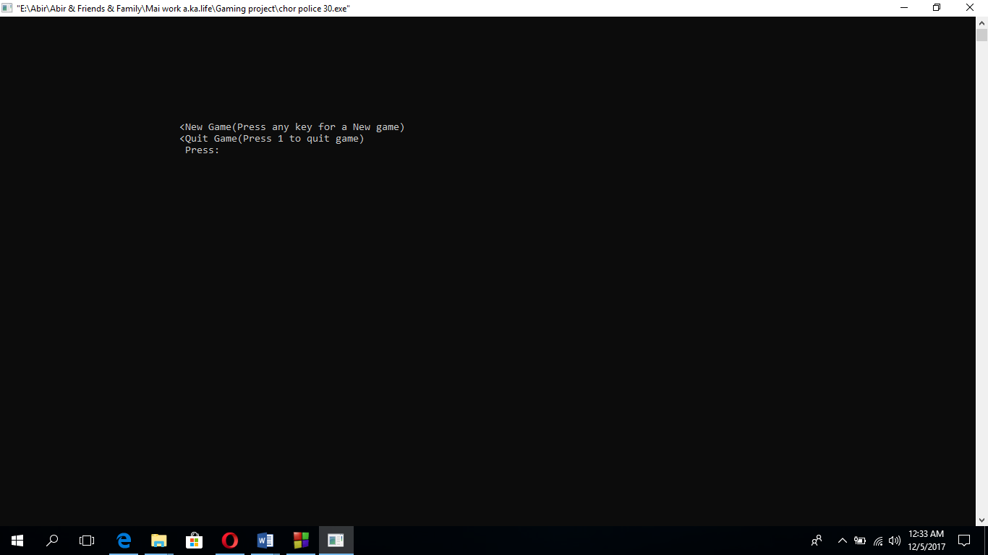

**Sample Output:**

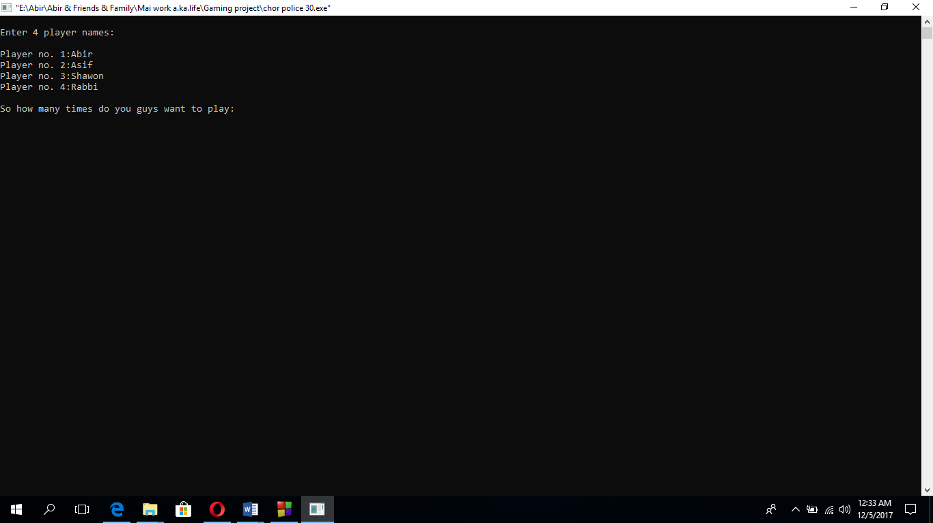

**Sample Output:**

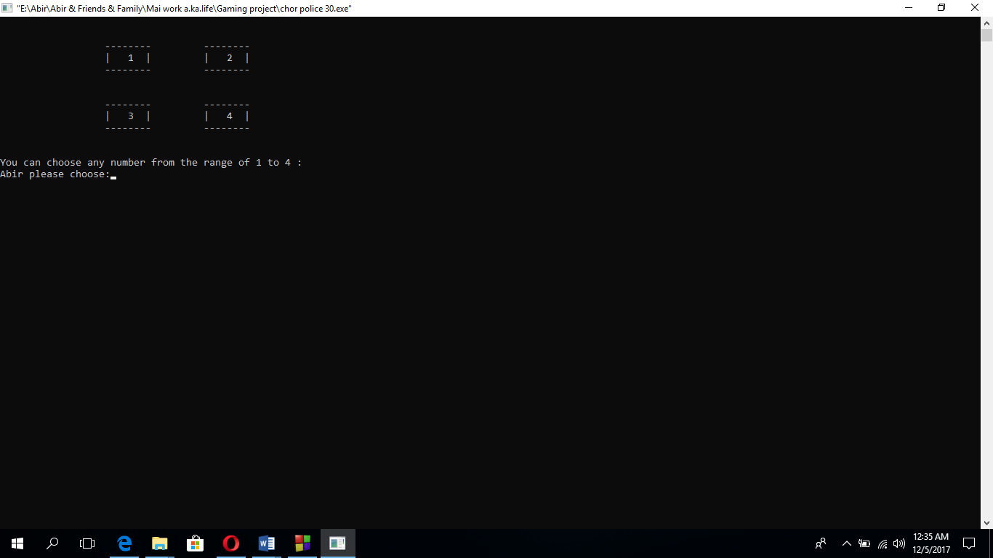

**Sample Output:**

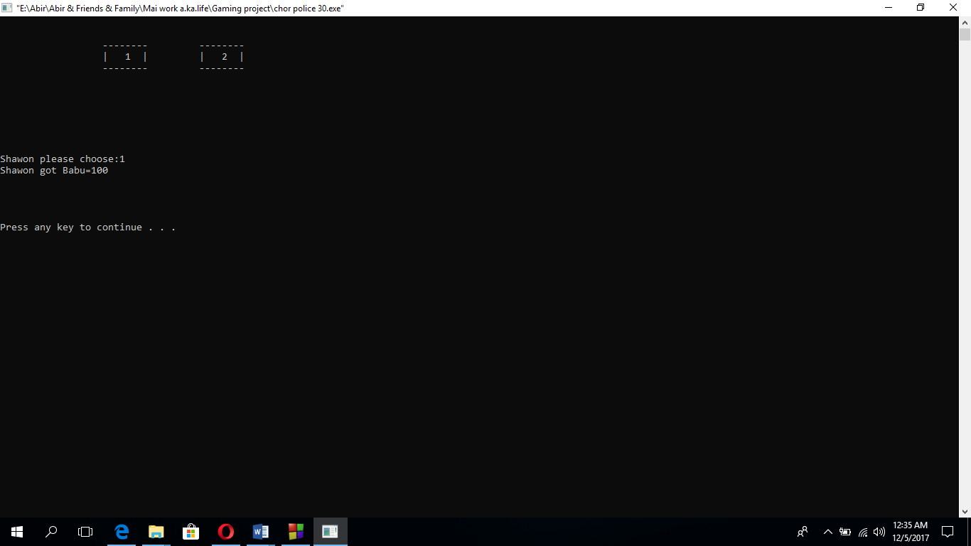

**Sample Output:**

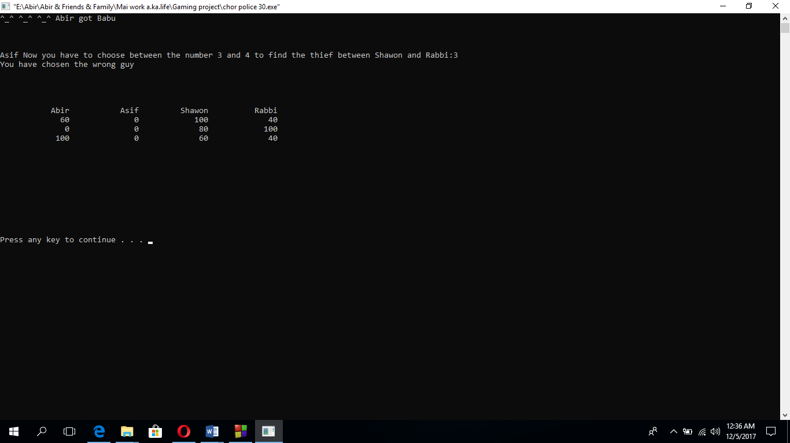

**Sample Output:**

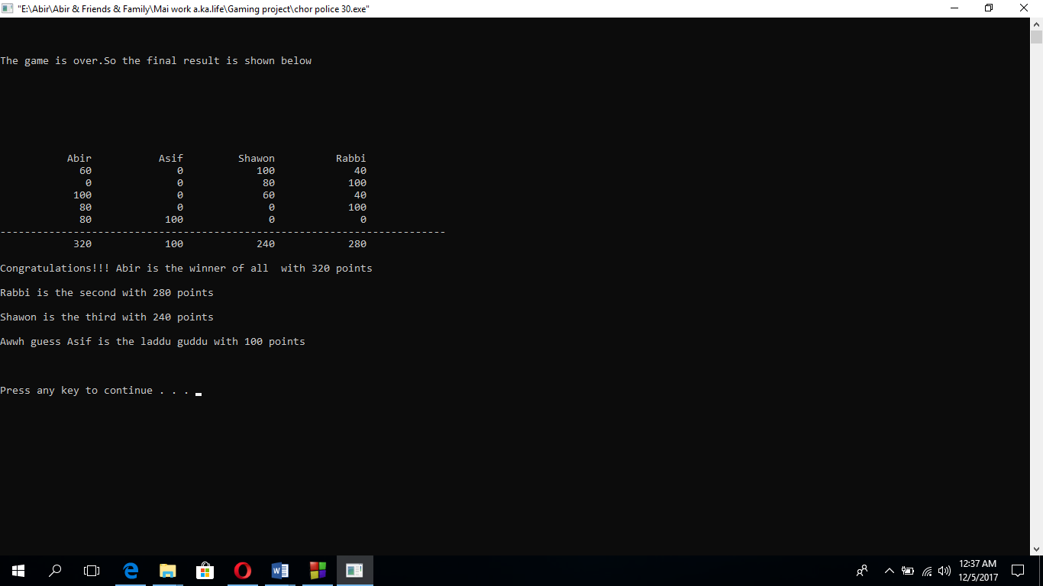

**Sample Output:**

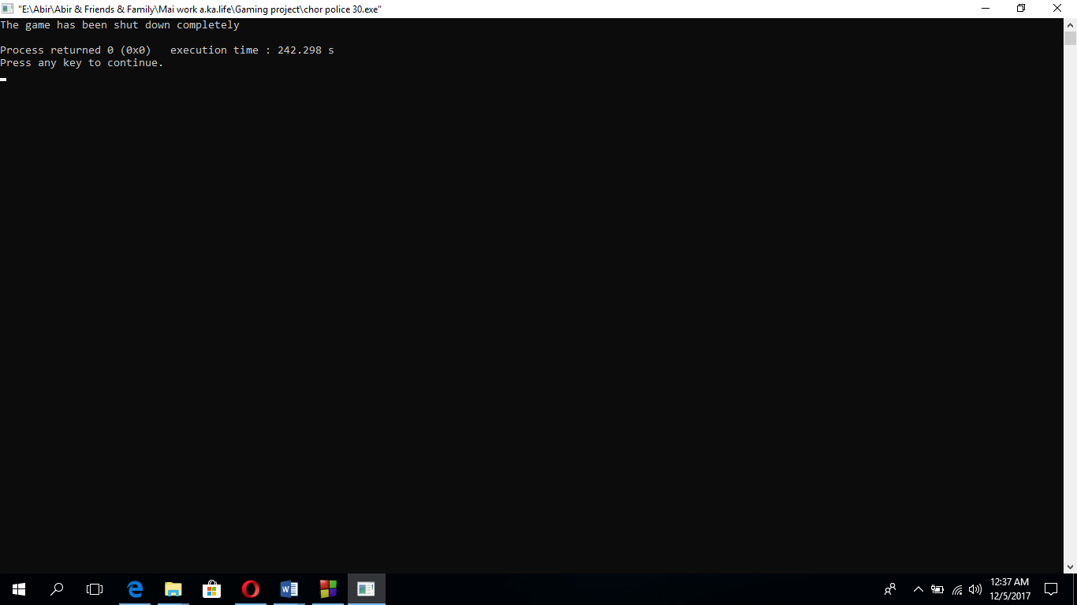

Limitations of this code:

1. The program can not take where any type of character or string where it is asked to take a number.
2. When a single game is over the game shut downs completely but rather it should have asked the player if the player wants to play the game or not.
3. At some point it should have taken the name instead of any number
4. Due to the features it has become a very lengthy game and has to press a lot of numbers which makes it kind of boring

**Appendix (Source Code):**

A C++ object oriented Program for this project that -

* We use effective modularity.
* It is well-formatted using appropriate indentation and style.
* It has a good user interface.
* It is user-friendly.
* It is error-free.

Thank You