
East West University
Project Report
Semester: Spring-2026
Course Title: Machine Learning
Course Code: CSE475
Sec: 02
Group No: 02

Group Members:
Name | ID
Md. Jubayer Hasan | 2022-2-60-042
Sonia Bente Siraj | 2022-2-60-087
Pollob Nath | 2022-3-60-223
Redwan Ahmed | 2022-3-60-155

Submitted to-
Dr. Raihan Ul Islam
Associate Professor,
Department of Computer Science & Engineering
East West University

Image-focused EDA

(i) Color & Intensity Analysis
- RGB & HSV Histograms: Pixel distributions in RGB space show high frequency in lower intensities (background) with a steady mid-tone distribution for brain tissue. HSV analysis reveals that the Value (Brightness) channel carries the most significant structural information, while Saturation remains low, indicating near-grayscale characteristics.
- Statistics: Mean brightness and standard deviation (contrast) were calculated per image. Class-wise analysis (AD, CN, MCI) shows consistent average intensity, ensuring no significant brightness bias between diagnostic categories.
- Clipping: Minimal saturation clipping was observed, confirming that the input images retain detail in both highlights and shadows.
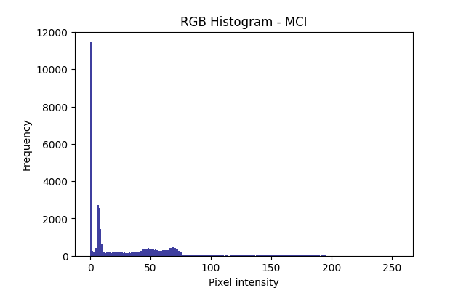
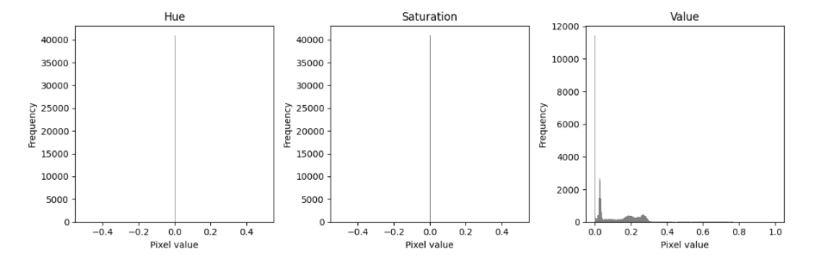

(ii) Geometry & Resizing Strategy
- Resolution & Aspect Ratio: The dataset consists of various resolutions, but the majority maintain a consistent aspect ratio.
- Strategy: To prevent geometric distortion of brain structures, a resize-and-pad strategy is recommended over simple stretching. This ensures that the spatial relationships of the hippocampal and cortical regions remain intact across all samples.

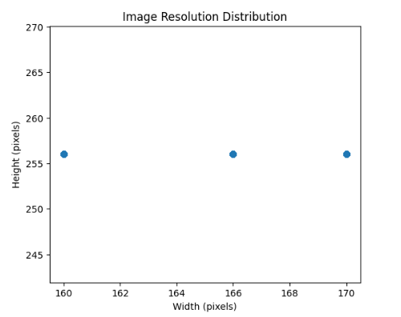

(iii) Quality: Sharpness & Noise
- Sharpness: Laplacian variance was used as a metric for focus. Most images show a high variance (sharp edges), though a small subset of MCI samples exhibited lower variance, indicating potential motion blur or lower resolution.
- Noise: A light noise proxy (pixel variance in homogeneous regions) indicates a clean signal-to-noise ratio, suggesting that aggressive denoising is not required.
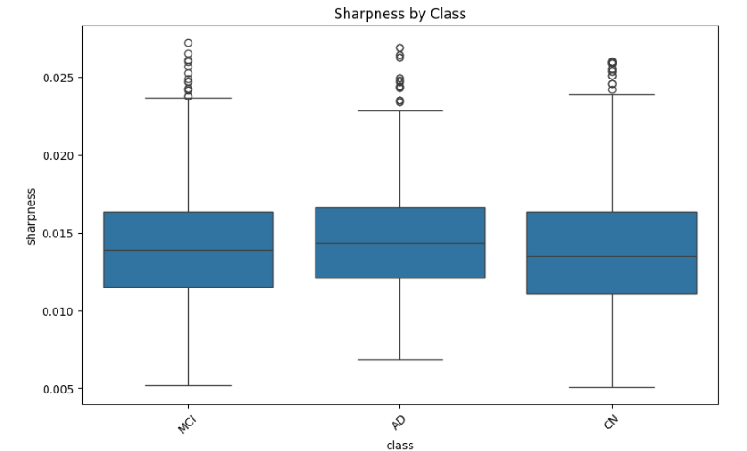

(iv) White-Balance Check
- Gray-World Sanity: A check of $R$, $G$, and $B$ channel means shows they are nearly equal. This confirms the images are properly white-balanced and lack any unnatural color casts that could confuse the CNN.
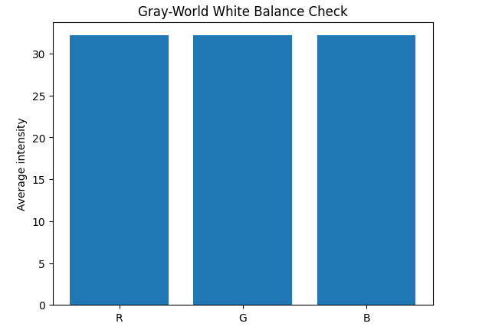

(v, vi, vii) Data Integrity & Leakage
- Duplicate Detection: Using Perceptual Hashing (PHash), 1,516 near-duplicate images were identified.
- Leakage: A critical finding revealed 461 images leaking from the Train set into the Test set. These must be removed to ensure valid evaluation.
- Class Balance: The dataset is distributed across AD (Normal), CN (Control), and MCI (Mild Cognitive Impairment), with MCI being the largest class. Class weighting or oversampling is recommended during training.

Augmentation Probe: Safe vs. Harmful
A small-scale probe was conducted to evaluate transformation impacts:
- Safe: Horizontal Flip (brain symmetry holds) and Color Jitter (robustness to brightness/contrast variations).
- Harmful: Heavy Gaussian Blur (removes crucial edge details for atrophy detection) and Aggressive Cropping (may remove peripheral cortical regions essential for diagnosis).
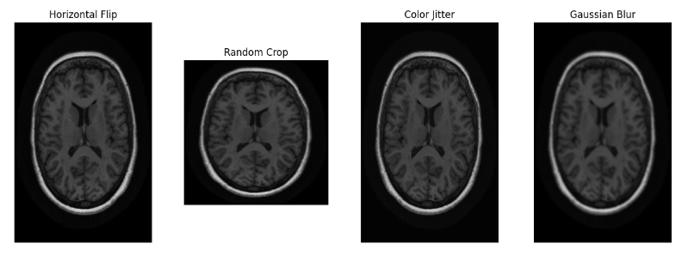

EDA https://github.com/Jubayerhasan75/CSE_475/tree/main/project_code

Related Work

Title | Dataset Name & URL | Dataset Description | Methods Name | Accuracy of the model | Pros | Cons | Citation
Self-Supervised Attentive Feature Learning for Alzheimer's Disease Detection | Kaggle Alzheimer's Dataset (KACD)  https://www.kaggle.com/datasets/ marcopinamonti/alzheimer-mri- 4-classes-dataset | * Total Samples: 6,400 MRI scans.  * Splits: 5,121 Train / 1,279 Test.  * Classes: Non-Demented (3200), Very Mild (2240), Mild (896), Moderate (64). | SSA-Net: SimCLR framework using ResNet-50 backbone with Attentive Activation (AttAct) replacing ReLU. | 99.72% (SSA-Net). | * High accuracy with limited labeled data.  * Attentive activation focuses on relevant biomarkers.  * Residual learning avoids vanishing gradients | * Severe class imbalance (only 64 Moderate Demented images).  * High computational complexity for training.  * Study limited to axial plane scans. | Elmannai, H., Saleem, N., Bourouis, S., & Alkanhel, R. I. (2025). IJIMAI, 9(5), 119-127.

Research Summary: Alzheimer's Disease Detection
The research paper titled "Self-Supervised Attentive Feature Learning for Alzheimer's Disease Detection" introduces an advanced diagnostic framework known as SSA-Net to classify various stages of Alzheimer’s Disease (AD) using Magnetic Resonance Imaging (MRI) scans.
- Dataset and Classification: The study utilizes the Kaggle Alzheimer's Classification Dataset (KACD), consisting of 6,400 axial plane MRI scans. The images are categorized into four distinct stages: Non-Demented (3,200 samples), Very Mild Demented (2,240 samples), Mild Demented (896 samples), and Moderate Demented (64 samples). The data is split into 5,121 images for training and 1,279 for testing.

- Methodological Framework: The proposed SSA-Net leverages the SimCLR (Simple Framework for Contrastive Learning of Visual Representations) framework for self-supervised learning. This allows the model to learn high-quality visual representations from unlabeled MRI scans. The architecture uses a ResNet-50 backbone where the standard ReLU activation is replaced with an Attentive Activation (AttAct) module. This modification enables the neural model to adaptively focus on the most relevant spatial features and biomarkers associated with neurodegeneration.

- Performance Metrics: Experimental results demonstrate that the SSA-Net achieved a superior classification accuracy of 99.72%. In comparison, a traditional ResNet-50 model achieved 98.1% accuracy, while other models like MobileNetV2 and AlexNet reached lower performance levels of 98.74% and 83.75%, respectively.

- Strengths and Limitations: The primary advantage of this approach is its ability to achieve high accuracy even with limited labeled training data through the use of self-supervised pre-training and attention mechanisms. However, the study identifies a significant class imbalance in the dataset, particularly within the Moderate Demented category. Additionally, the self-supervised training process involves higher computational complexity compared to standard supervised learning

