

Hybrid Fuzzy Logic & Machine Learning Based
Expert System Value Estimator
Case study: Medical Appointment Time Estimation

Prepared by (sorted alphabetically):
Ismail Aljubbah
Muhammad Altabba

Instructor:
Eng. Ammar Al-Nahas

Special Thanks to:
Dr. Muhammad Yasser Sabouni

Table of Contents
1. Introduction 3
1.1 Document Purpose 3
1.2 Project Scope 3
2. System Features 4
2.1 Functional 4
2.1.1 Flexibility and Customizability: 4
2.1.2 Generality: 4
2.2 Nonfunctional: 5
2.2.1 Web base application: 5
2.2.2 High Performance: 5
2.2.3 Friendly interface 5
3. Implementation Details: 6
3.1 Database: 6
3.2 Class Diagram: 7
3.2.1 System main classes: 7
3.2.2 Machine Learning Classes: 7
3.2.3 ID3 Algorithm Classes: 7
3.2.4 Communication with the Fuzzy Clips Inference Engine: 8
3.2.5 Facilitator Class: 8
3.3 Web Inferences: 9
3.3.1 Home Page: 9
3.3.2 Define Factors: 10
3.3.3 Edit Factor Page: 11

Introduction

Document Purpose
This report is for the benefit of the lab of the Fuzzy Logic course. It describes the work done in the project requested by the lab instructor.

Project Scope
The system is a web enabled expert system that estimate values based on facts (or factors). It uses Fuzzy Logic System to make inference based on fuzzy values. The fuzzy rules are auto generated from the statistical data that is the factors values and the actual output performed. As a case study, the data of the system is dedicated to help doctors in estimating the time required for patient’s treatment.

System Features

Functional

Flexibility and Customizability:
The system facilitates the addition of any factor the knowledge expert (or the advanced user) may like to add. He/she can simply enter the factor name, range and units and its fuzzy membership functions. When a new case instance is entered the system facilitates entering its factors values within the ranges in accordance to the early specified factors and there ranges.
The system takes a machine learning approach because it automatically generates the fuzzy rules of inference; in accordance to the statistical data.
An example for our case study could be like that:
- If a doctor likes to add as a factor "how much the illness is chronic". He could enter a factor to describe chronicity degree and call it “Chronic” that ranges from 0 to 10 and enter the membership function of it like: none (range from 0 to 2), low (range from 1 to 4) , medium (range from 3 to 8) , high (range from 7 to 10).
- After that, for every patient who want to have an appointment, the doctor (or secretary) will enter the patient information. Among the information entered the "Chronic" degree will be entered; either as range from 0 to 10, or as linguistic term, like: "slightly high".
- When the patient comes to the clinic and finishes his treatment, the real time passed during the appointment is entered to be used later for learning.
- Later on, learning is performed according to the actual values needed for the appointment for each patient in relevance to their (or their illness) features, attributes, and properties early defined and entered. For or Chronic example a rule like: if Chronic is high the patient will stay for four time sluts.

Generality:
The system is general for any estimation takes where cases have facts (or factors) and those factors impress the estimated values. While, the data entered is for clinical appointment time estimation, the system could be used for anything like the possible latency in patient arrival to the clinic. Or like the amount of stocks that must be held or sold according to the stock market factors.
Certainty Choices mapped
Just the same way MYCIN does

Nonfunctional:

Web base application:
The aim of using web based application is to protect doctor data from any lose; adding new feature to the system will be automatically added to all the doctors registered in the system. Furthermore, this gives the ability to allow doctors to reach their data outside the clinic.
ASP.Net web application linked with Fuzzy CLIPS Inference Engine.

High Performance:
Using native Fuzzy CLIPS Inference Engine (fzclipscmd.exe) make the response time almost immediately.

Friendly interface
The system hopefully will have a friendly user interface where everything is clear to the user as possible and jobs are shown at a clear area.

Implementation Details:

Database:
Data is stored in XML files. However, each time the data is modified and saved, both XML files and Clips files are saved and rendered. While, data is to be read just from XML file, the Clips files is used by Fuzzy Clips engine to assert facts and make inference.

Class Diagram:

System main classes:
Classes used for holding the defined factors and cases instance information.
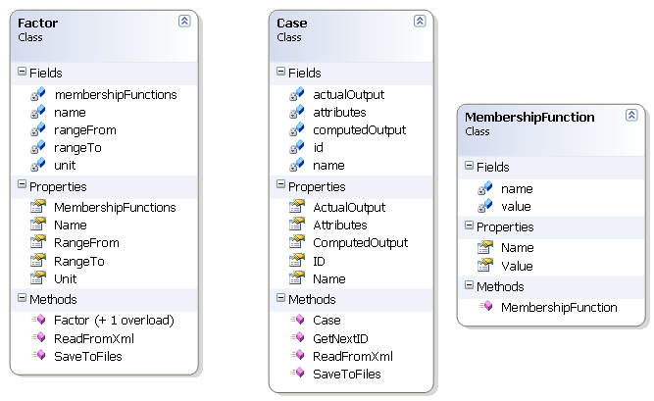

Machine Learning Classes:
Classes those generate fuzzy rules.
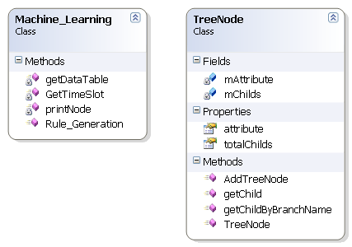

ID3 Algorithm Classes:
Classes contain implementation of ID3 algorithm. (Code from www.codeproject.com)
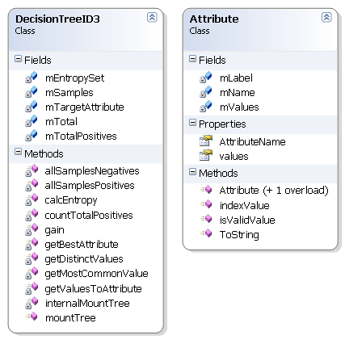

Communication with the Fuzzy Clips Inference Engine:
Class holds pipelining communication with Fuzzy Clips.
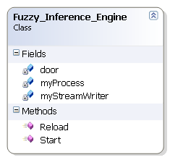

Facilitator Class:
Classes hold constants values which are saved at "web.config" file.
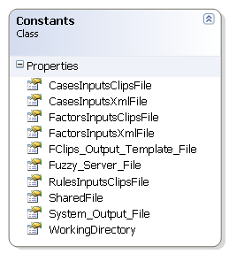

Web Inferences:
This section contains some of the user interfaces.

Home Page:
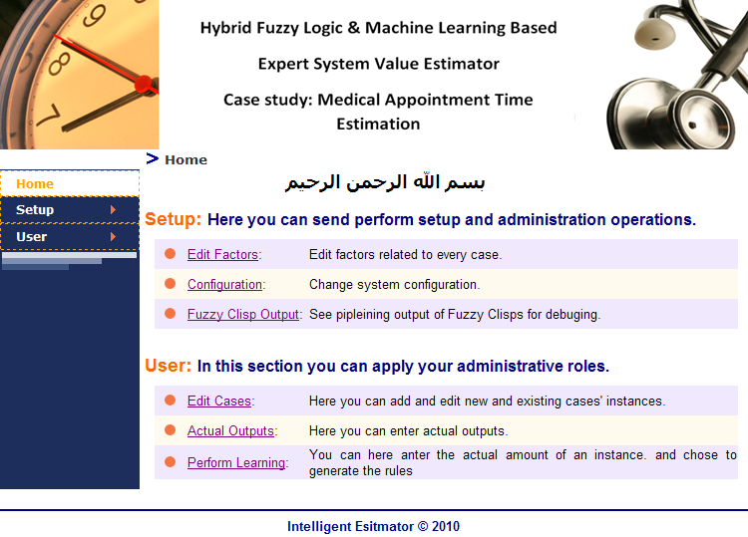

Define Factors:
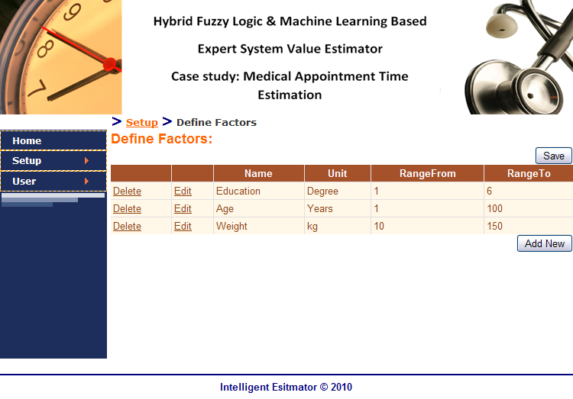

Edit Factor Page:
