# CS 255 System Design Document Template

## UML Diagrams

### UML Use Case Diagram

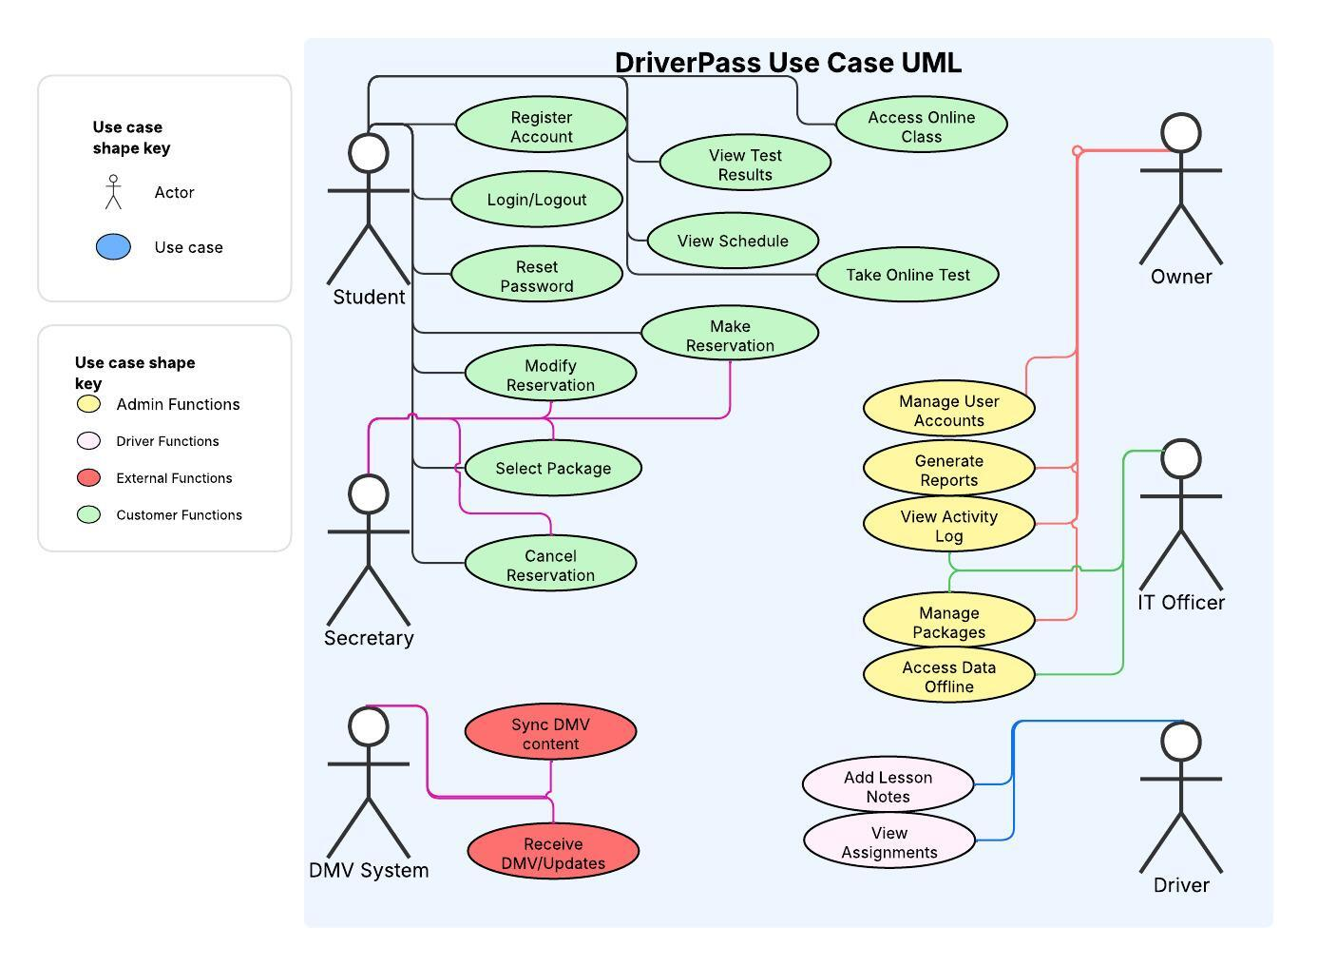

### UML Activity Diagrams

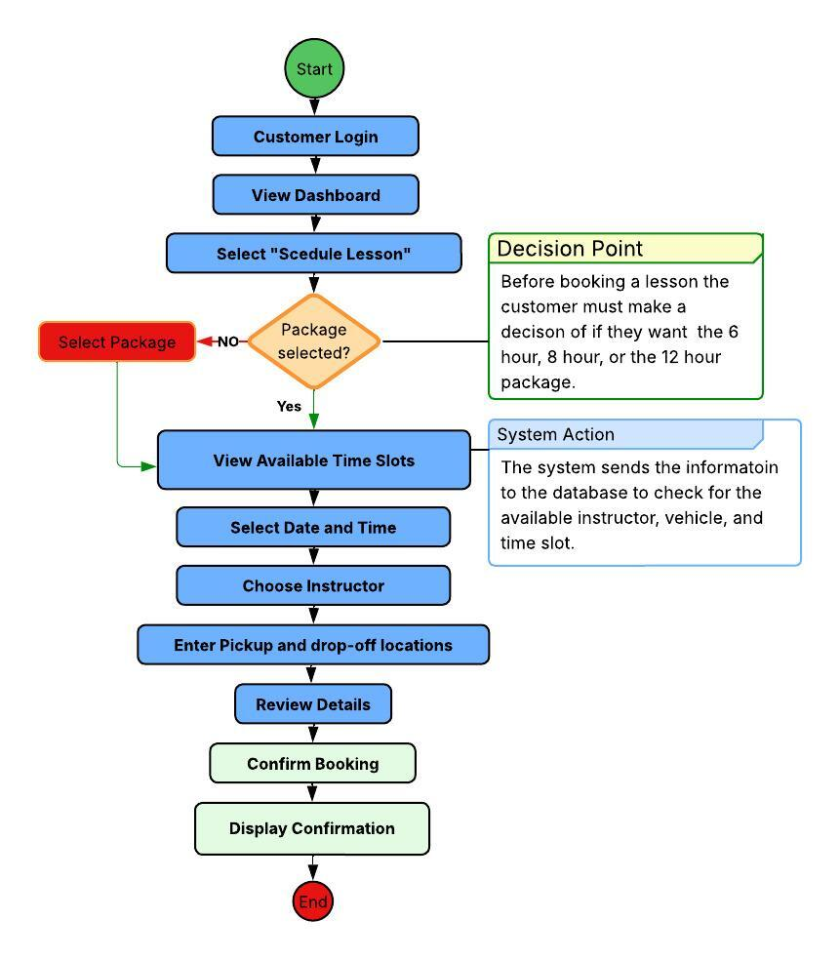

### UML Sequence Diagram

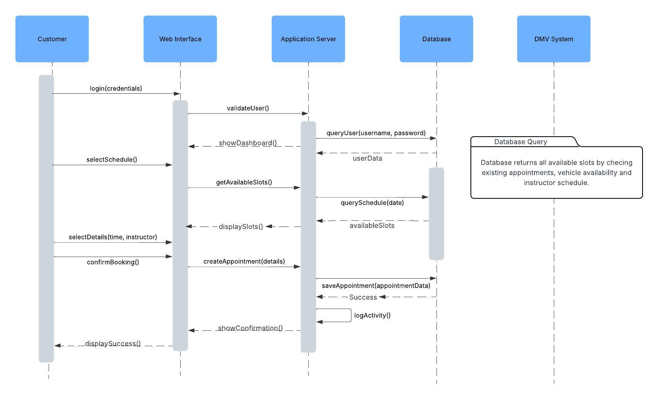

### UML Class Diagram

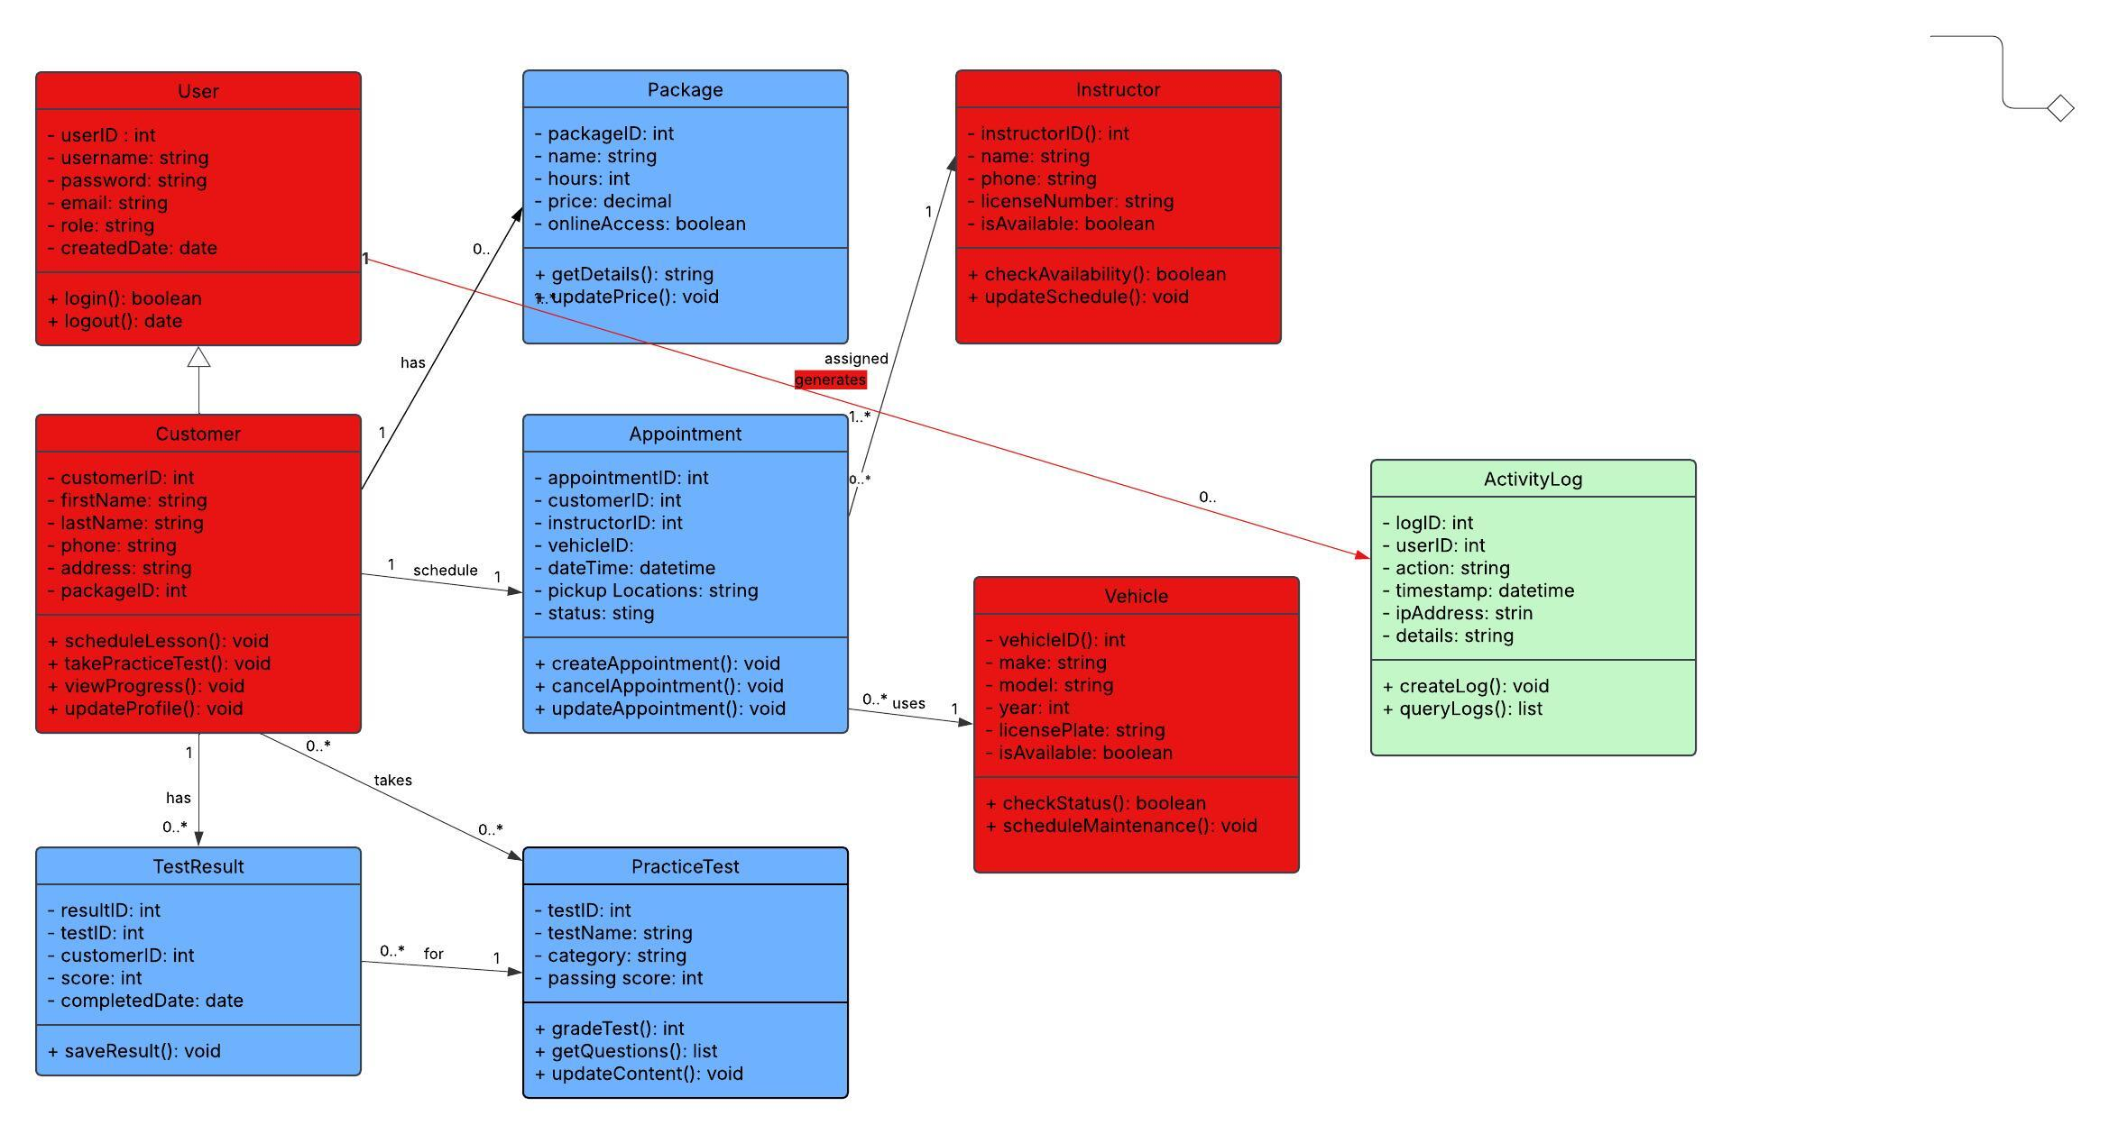

## Technical Requirements

DriverPass System technical requirements base on use case, sequence, and class diagrams.

1. Cloud integration
   1. AWS is recommended
      1. Reliable
      2. Scalable
      3. Requested by client
2. Web Server
   1. Nginx
      1. Fast
      2. Efficient
      3. Can handle multiple connections
3. Backend
   1. Node.js + Express
      1. Modern and fast
      2. JavaScript ecosystem
4. Database
   1. MySQL 8.0
      1. Reliability
      2. Supports all data needs
5. Frontend
   1. React + Bootstrap
      1. Modern UI
      2. Responsive and easy to maintain
6. Cache
   1. Redis
      1. Fast data access
      2. Session management
7. Payments
   1. Stripe
      1. Secure
      2. Easy integration
      3. PCI compliant
8. Version Control
   1. Git + GitHub
      1. Industry standard
      2. Good CI/CD tools
9. CDN
   1. CloudFront
      1. Fast global delivery
10. Monitoring and Email
    1. New Relic
       1. Comprehensive system monitoring
    2. SendGrid
       1. Reliable delivery and good templates