Laboratory Activity 1

Orpilla, Christopher Jiovanni A.

1. Read the following instructions and apply the correct code using [SQL Tryit Editor v1.6 (w3schools.com)](https://www.w3schools.com/sql/trysql.asp?filename=trysql_asc). Press the screenshot button and paste it below the questions.

NOTE: This is progressive, and reloading the website means you have to start again from number 1.

* 1. 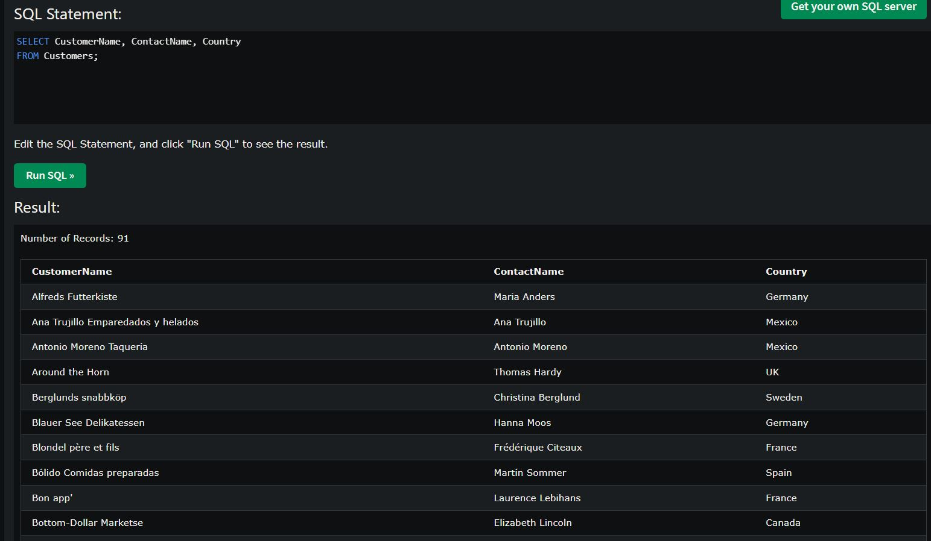SELECT CustomerName, ContactName and Country of Table Customer.
  2. DELETE Customers that has lives in UK.

// I first scanned and tried to find the ‘UK’/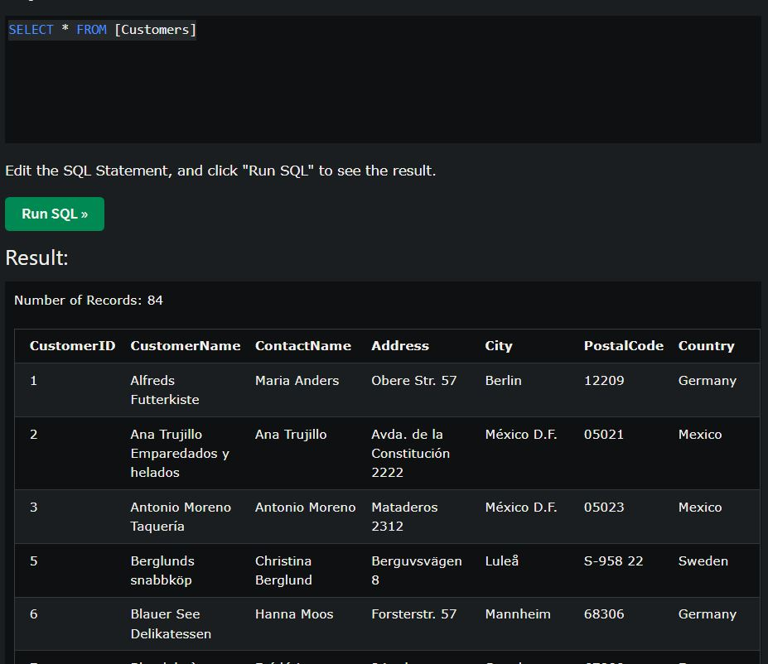

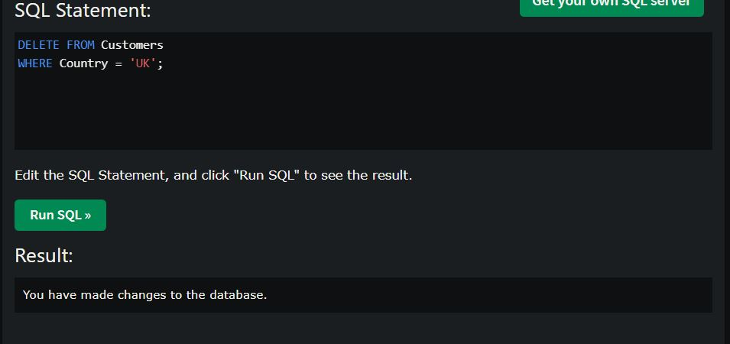

//I can’t Find the country ‘UK’? so I can’t delete it.

* 1. INSERT your information on the Customer table according to the available columns on the result.

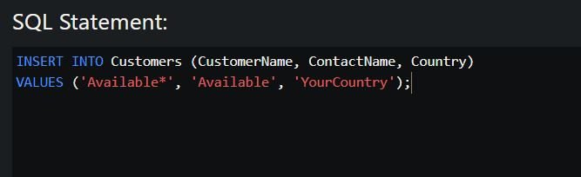

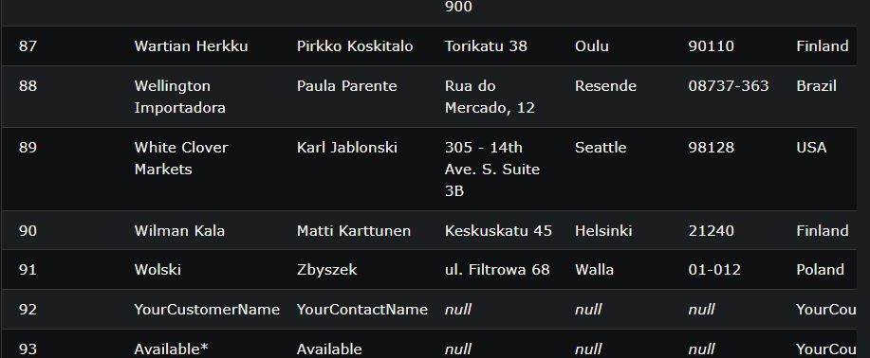

* 1. UPDATE CustomerName “B's Beverages” into ampere on Customer Table.

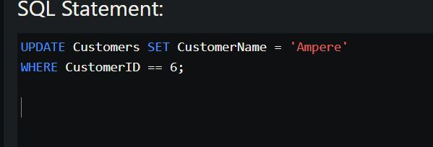

// I was not able to find the Costumer Name “B's Beverages”.

// random Costumer Name changed into ‘Ampere’

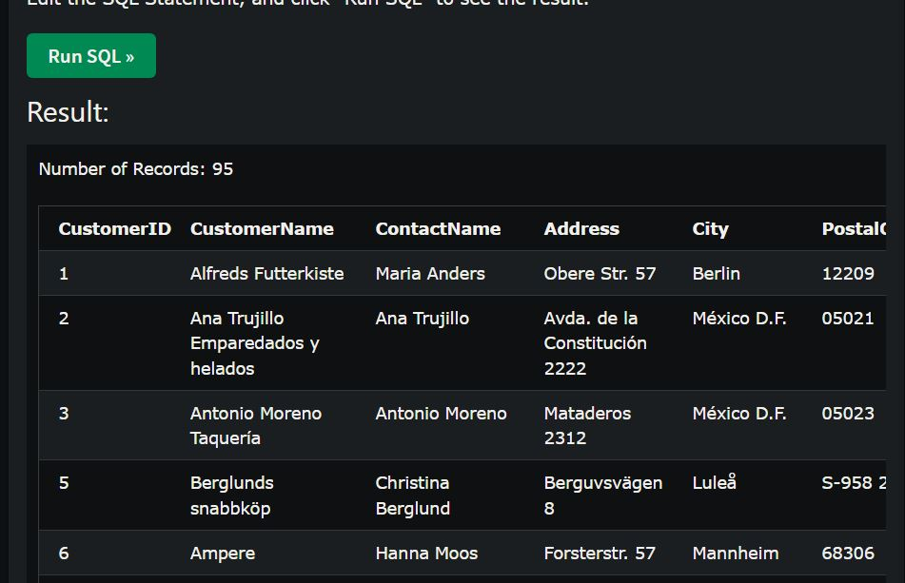

Reload or create a new tab of SQL-editor for this part. Read and follow the instructions and answer the following questions.

* 1. SELECT ProductName, Unit and Price of Products Table ORDER BY ProductName in Ascending Order. What is the product name of row 10 from the table

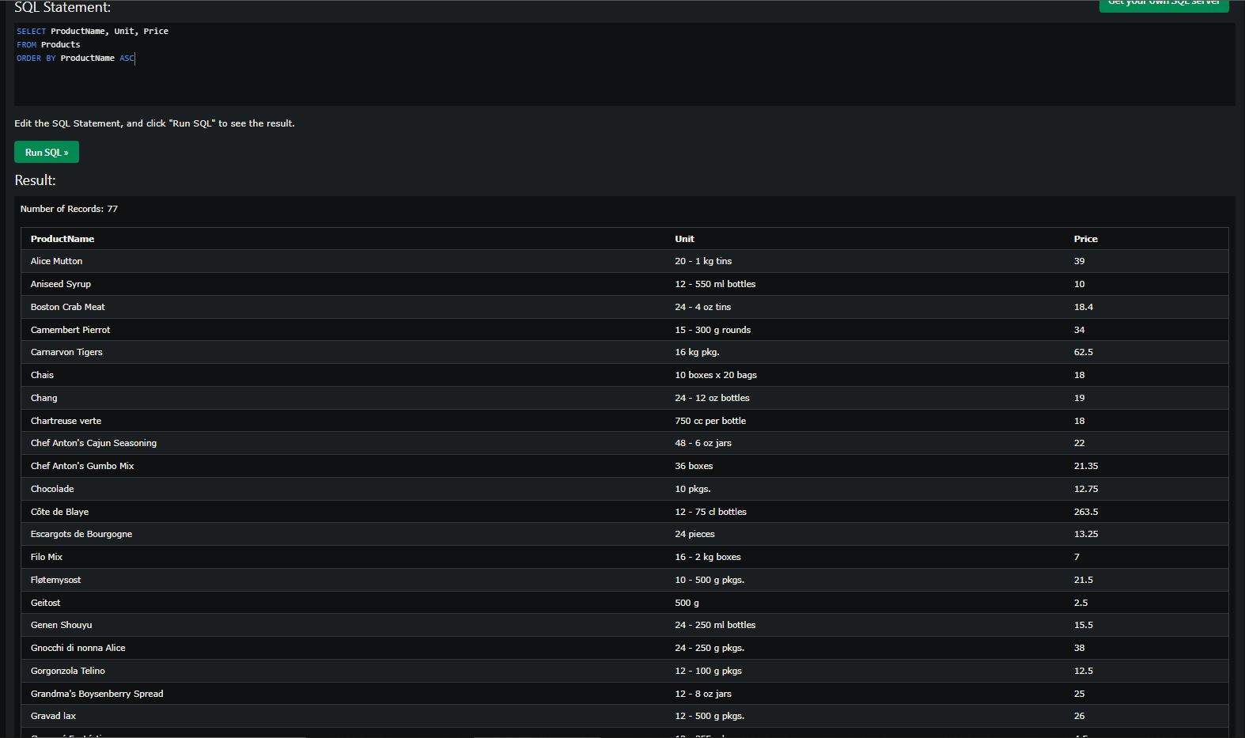

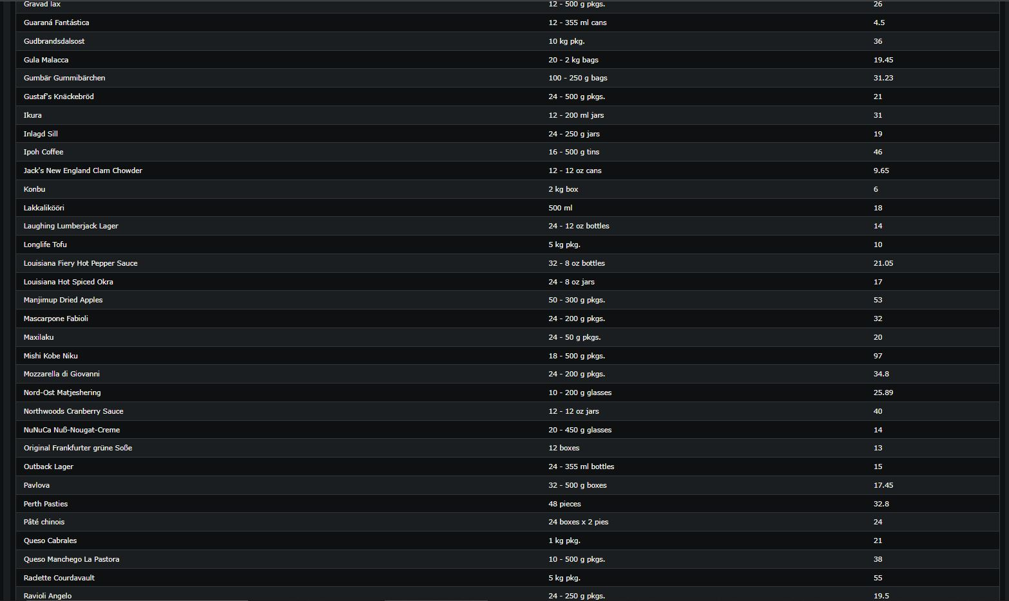

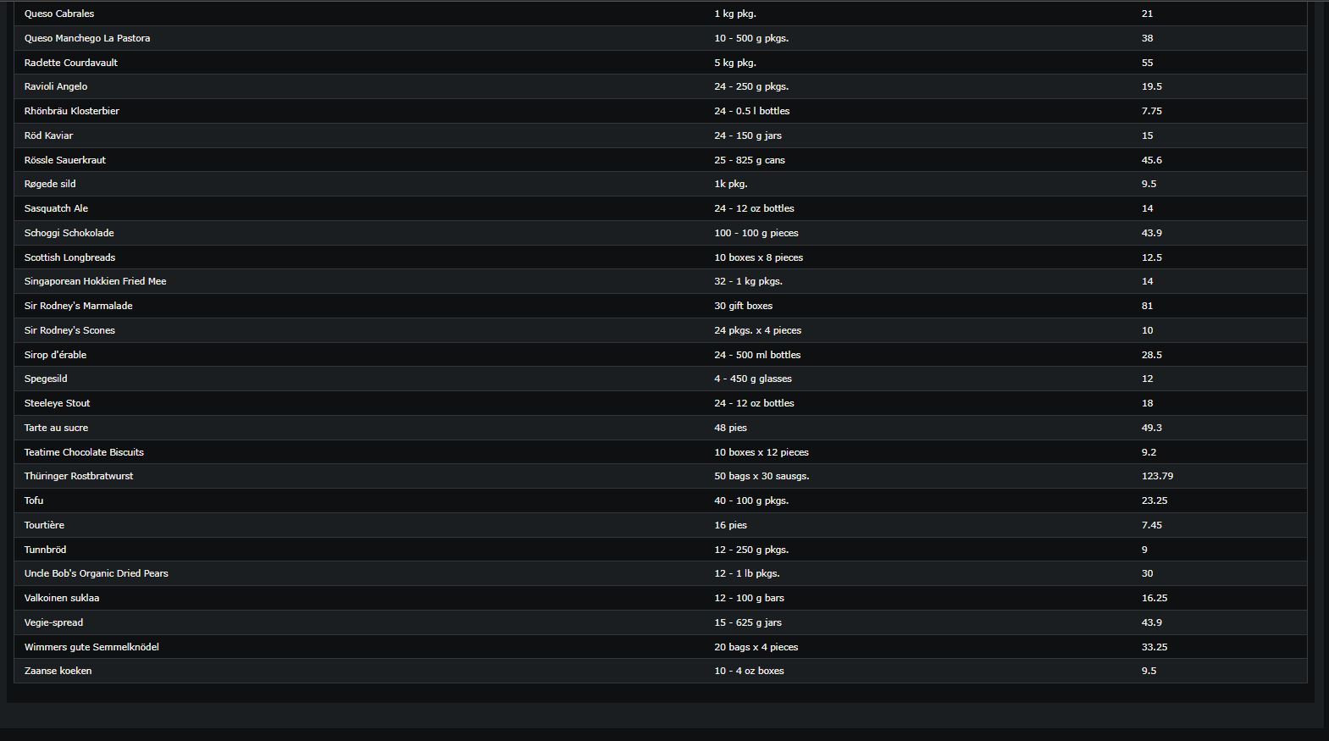

* 1. 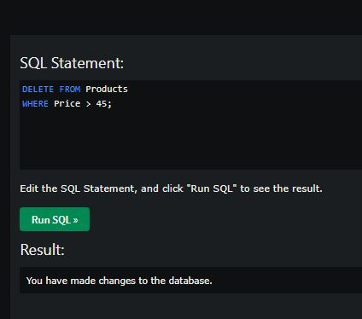DELETE all record that has a price of greater than 45. How many records were deleted?

// I believe I did something but online SQL editor does not let me?