E-commerce Analytics with MongoDB
Course-end Project 1
Description

You are the data analyst for a rapidly growing e-commerce store Technet. Your company uses MongoDB to store product information, order details, and customer data. Recently, your CEO has requested in-depth product performance reports.

Objective:
Using aggregation framework to perform complex data processing and
summarization, such as calculating totals and averages, and finding top products
Task to be Performed:
- Start the MongoDB shell
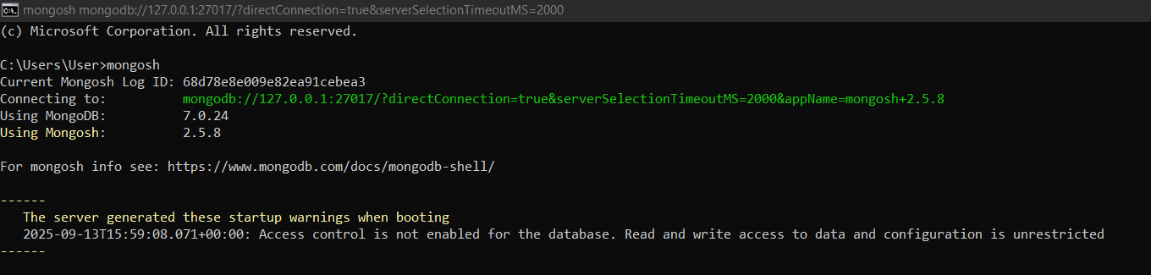

- Create and connect to a database

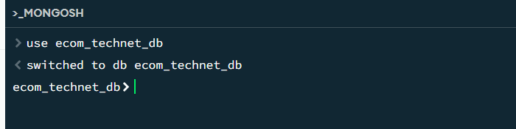

- Create a collection and add documents to the collection
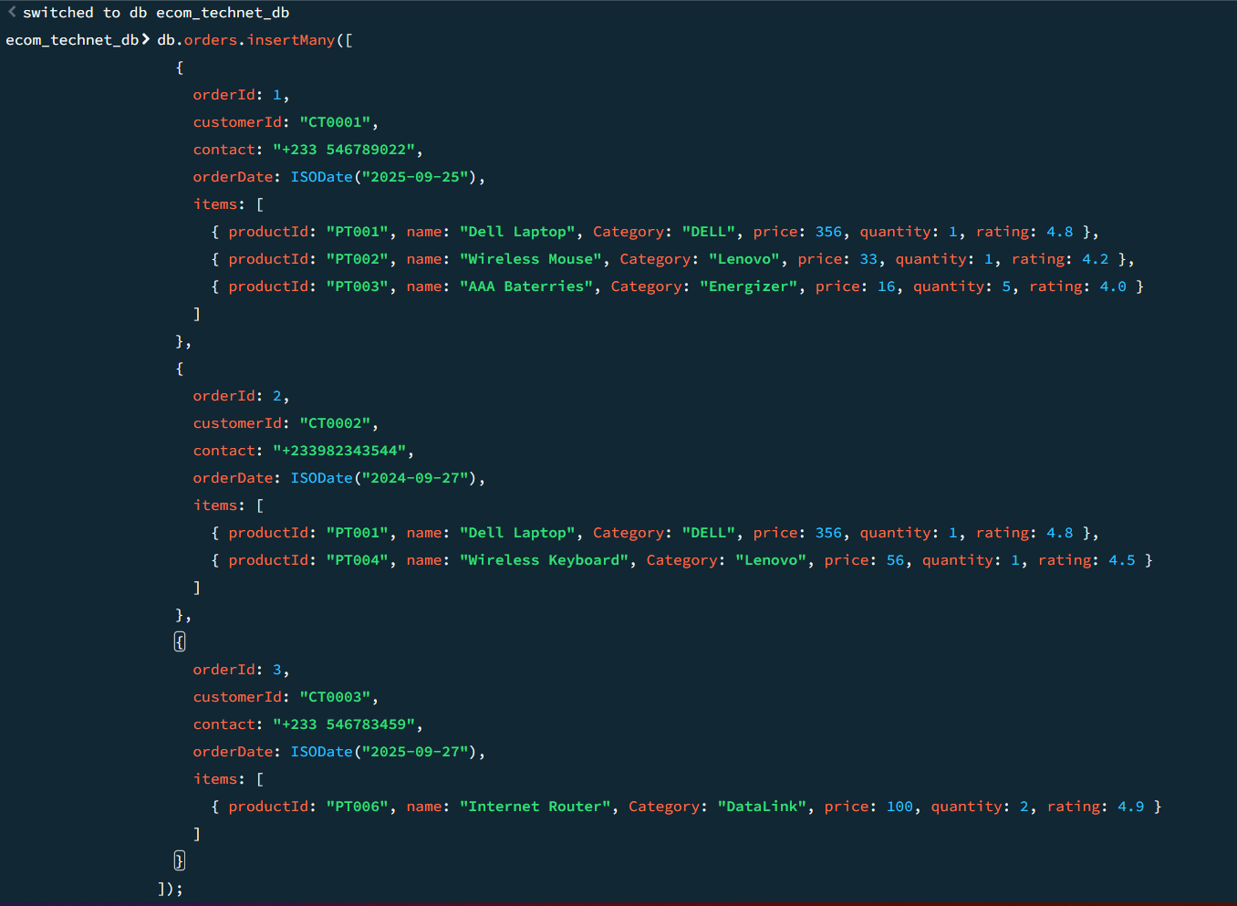
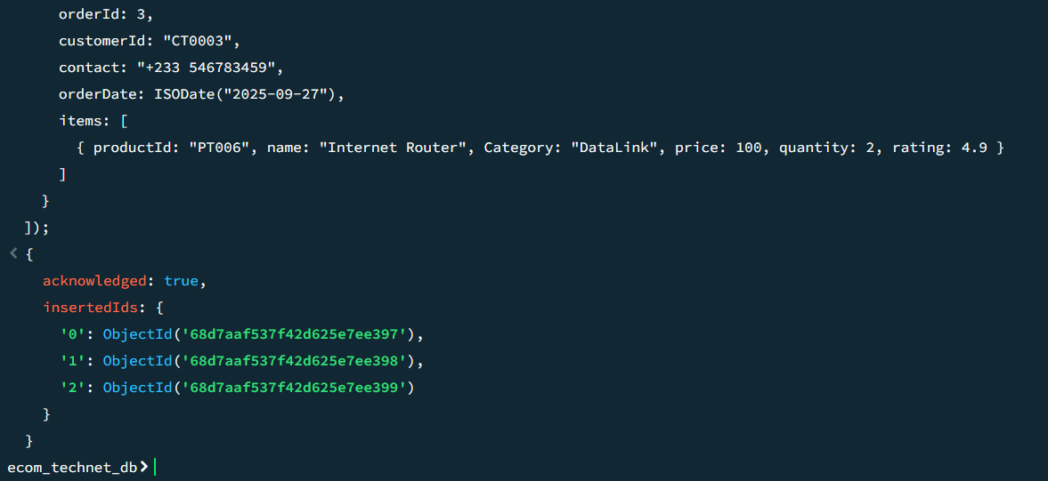

- Find the total revenue generated by each product category (such as clothing and electronics) for the past year
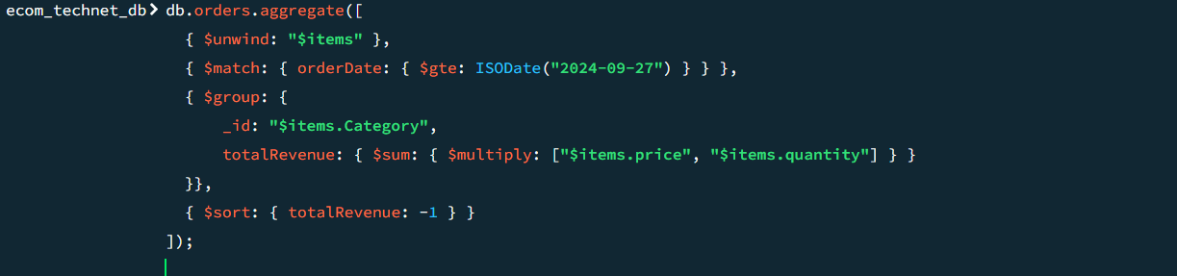

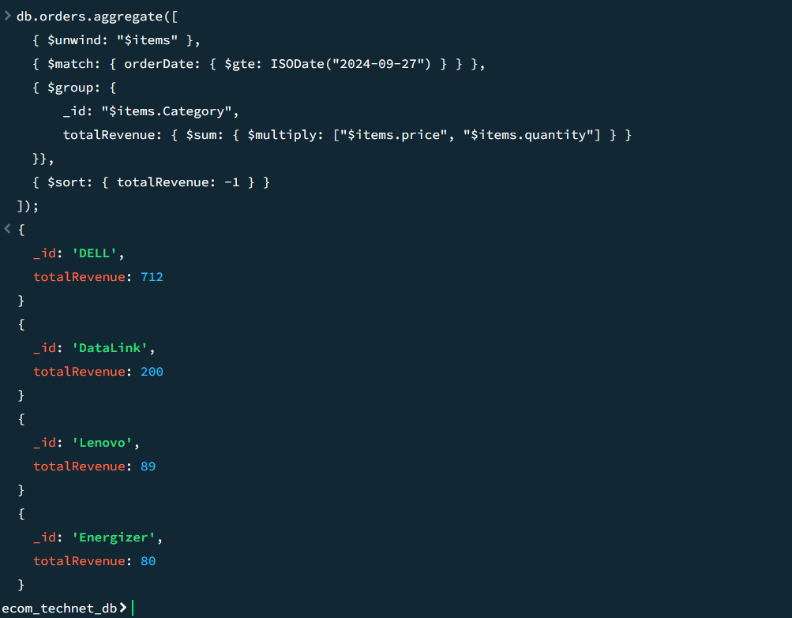

- Find the top 10 most popular products (by units sol) for the past quarter, along with their average rating

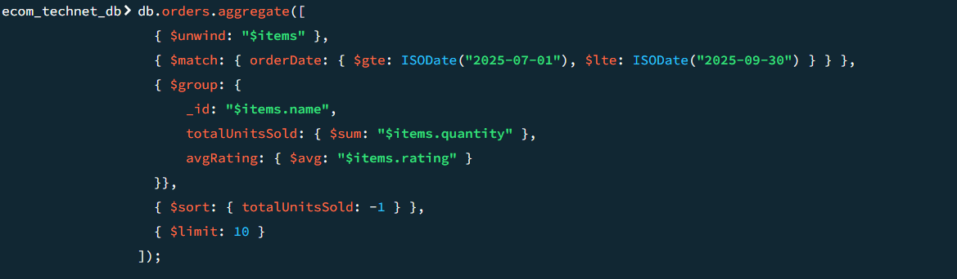

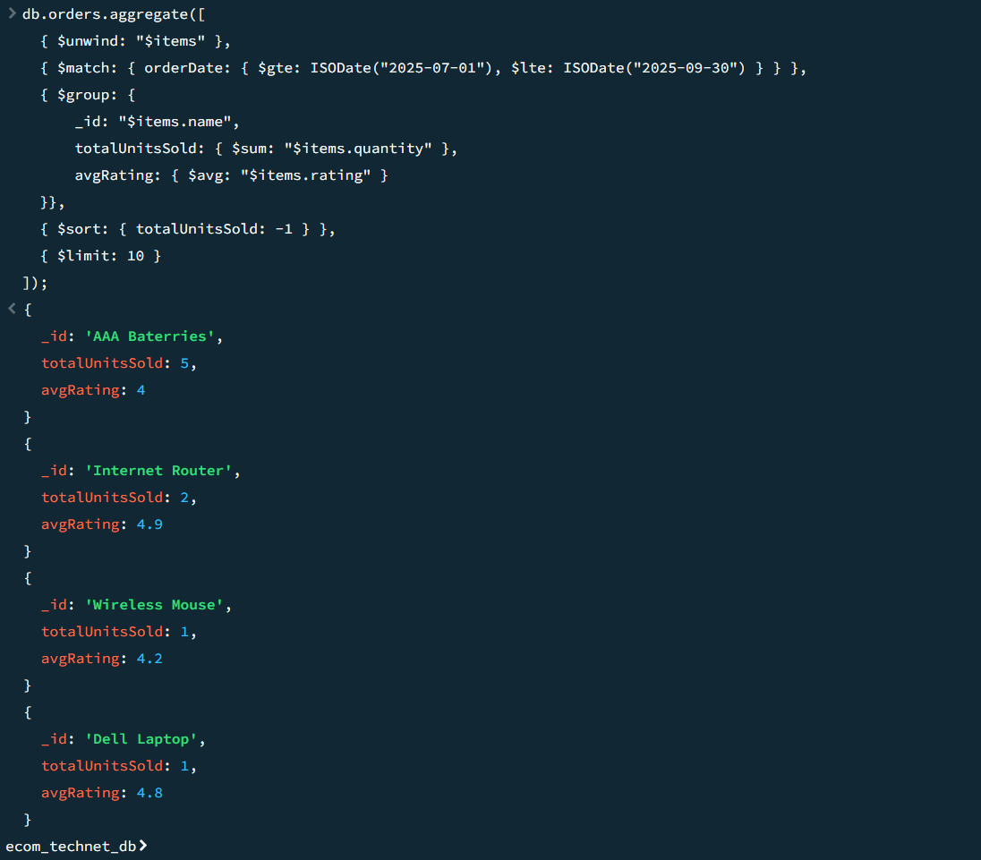

- Find the total number of orders
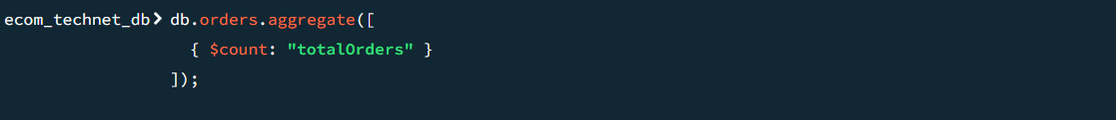

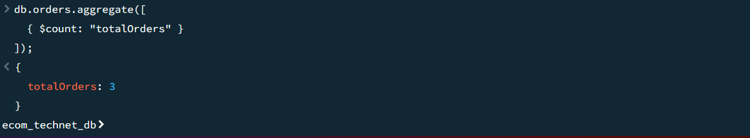

- Find the average order quantity

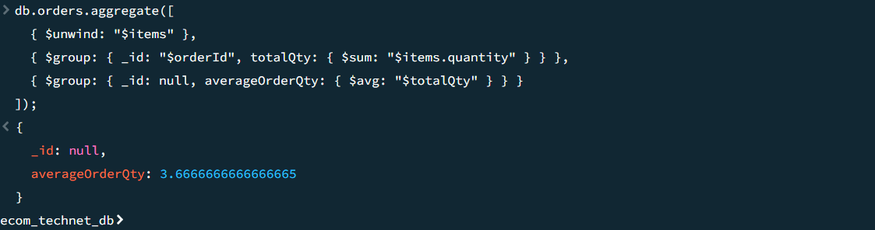

- Find the most frequently purchased product (all-time)

