**Q 1.6**

**CA**

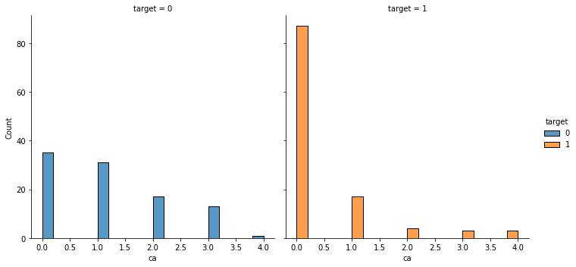

|  |  |  |  |  |  |
| --- | --- | --- | --- | --- | --- |
| Target | 0 | 1 | 2 | 3 | 4 |
| 0 (No heart disease) | 35 | 31 | 17 | 13 | 1 |
| 1(Heart disease) | 87 | 17 | 4 | 3 | 3 |

The histogram above and table below show the number of cases in both patients with heart disease and patients with no heart disease.

From the histogram and table above most of about 70% of people with ca value of 0 have heart disease.

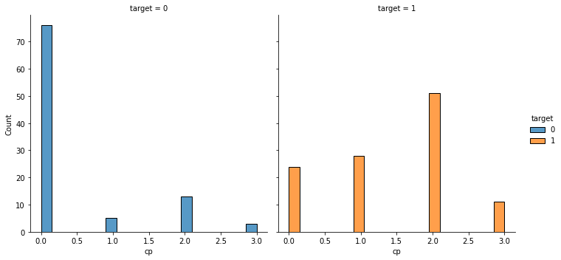**CP**

|  |  |  |  |  |
| --- | --- | --- | --- | --- |
| Target | 0 | 1 | 2 | 3 |
| 0 (No heart disease) | 76 | 5 | 13 | 3 |
| 1(Heart disease) | 24 | 28 | 51 | 11 |

The histogram above and table below show the number of cases in both patients with heart disease and patients with no heart disease.

From the table and the plot, most of the people without heart disease have an Asymptomatic angina chest pain type.

**SLOPE**

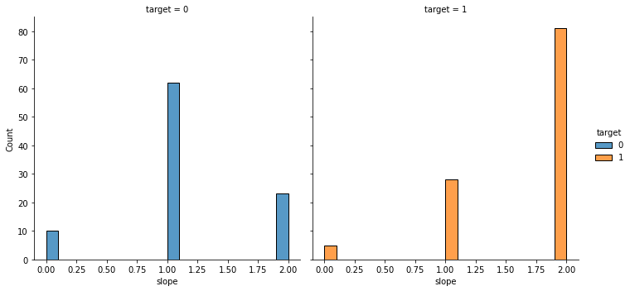

.

|  |  |  |  |
| --- | --- | --- | --- |
| Target | 0 | 1 | 2 |
| 0 (Heart Disease) | 5 | 28 | 81 |
| 1 (No Heart Disease) | 10 | 62 | 23 |

The histogram above and table below show the number of cases in both patients with heart disease and patients with no heart disease.

From the table and the plot, very few people have a downslope in slope of peak exercise. 77% of the patients with a flat slope have heart disease.

**THAL**

The histogram below shows the values of thal in both targets.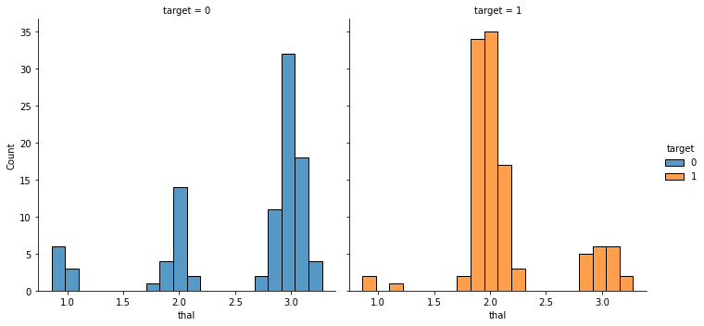

From the thal histogram plot, most of the people with a normal thalium stress test result have heart disease while most people with a reversible defect thalium stress test result do not have heart disease.

**THALACH**

The histogram below shows the values of thal in both targets.

