Json template/Triggering the persona Engine

{

"table_name": "PERSONA_CUSTOMER_DETAILS_TEMP4",

"schema_name": "curation_corp_dev"

"staging_table": "PERSONA_FUZZY_OUTPUT_1"

"staging_schema": "curation_corp_dev"

}

Step1:

Dag name: **ds-persona-matching**

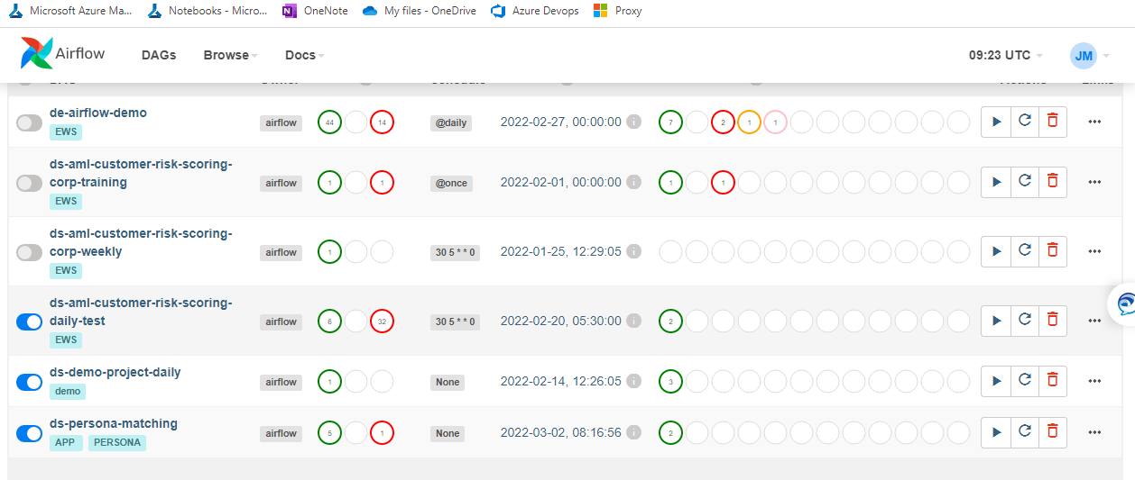

Step 2: Click on arrow(run) button, and click on Trigger DAG w/config

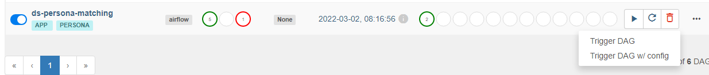

Step 3: Pass the parameters, and click on Trigger

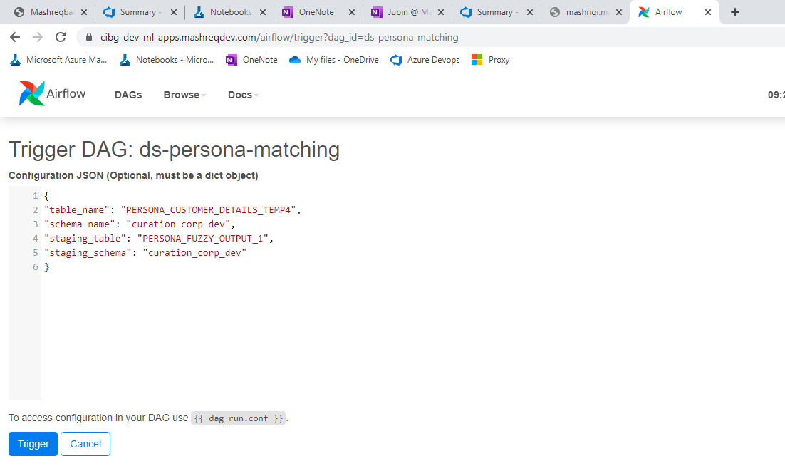

Step 4: Go to the graph view, and click on the process **generate_matches** to view the logs, if you wish for.

