j,j,

**Cowboy Hotel**

**Conference Room Booking System**

**Final Deliverable**

ISDS 406

Professor Hunt

December 17, 2020

Prepared by:

Group 5 (The Quarantiners)

Lannon Khau

Joseph Ntwali

Sina Siadat

Jubin Taghdir

**Table of Contents**

**Executive Summary...................................................................................................................... 3**

**System Request.............................................................................................................................. 5**

**Project Work Plan......................................................................................................................... 6**

**Feasibility Analysis........................................................................................................................ 7**

Cost/Benefit Analysis.......................................................................................................... 7

Economic............................................................................................................................. 7

Technical............................................................................................................................. 8

Organizational..................................................................................................................... 8

**Requirements Definition Document............................................................................................. 8**

**Use Cases...................................................................................................................................... 10**

UML Use-Case Diagram…………………………………………………..……………..10

UC-1: Create Customer Account....................................................................................... 10

UC-2: Create Caterer Account........................................................................................... 11

UC-3: Create Room Record............................................................................................... 12

UC-4: Create Room Reservation....................................................................................... 13

UC-5: Modify Room Reservation...................................................................................... 14

**Physical Process Models….......................................................................................................... 15**

Context.............................................................................................................................. 15

Level 0............................................................................................................................... 16

Level 1: Process 1 – Login................................................................................................. 17

Level 1: Process 2 – Create Customer Account................................................................. 17

Level 1: Process 3 – Create Room Record..........................................................................18

Level 1: Process 4 – Create Caterer Account..................................................................... 18

Level 1: Process 5 – Create Room Reservation ..................................................................19

Level 1: Process 6 – Modify Room Reservation ................................................................19

**Physical Data Model…………………………………………………….………………………20**

**Hardware/Software Specification…………………………………….………………………..21**

**User Interface………………………………………………...…………………………………22**

Interface Structure Diagram………………………………….…………………………..22

Example Dashboard Screen Wireframe…………………………………………………..22

Example Master Calendar Screen Wireframe………………………….…………………23

**Appendix...................................................................................................................................... 24** Interview Report................................................................................................................ 24

**Executive Summary**

This document is a proposal for a new conference room booking and event planning system for the Cowboy Hotel and contains an aggregation of work produced during its development.

Preliminary information was used in the creation of the System Request and it revealed that the manual booking process currently employed is not sufficient to handle anticipated capacity and results in too many costly errors such as double bookings. Furthermore, the current booking software used to book bedrooms and suits is not suitable for the booking of conference rooms. A new efficient, user-friendly, and streamlined system is required to realize the full profit potential of the new conference rooms.

The main business requirements identified include having two additional computers in the conference room scheduling office running the system and enabling the computer in the manager’s office to use the new system. The specific functionalities embody management of customer, caterer, and conference room information and enabling the Booking Specialist to create, modify, and view conference room reservations.

Initial estimates showed that this new system would generate an $80,000 increase in revenue from conference room bookings during the first year and a $100,000 increase by the end of the third year. In addition, the event attendees would increase hotel room reservations and, thus, increase revenues another $20,000 annually.

Keeping the project duration to a minimum is critical to realize these added values as soon as possible. With that in mind, the Project Work Plan was created to outline the work breakdown structure. Essential tasks were clearly defined, tasks were assigned to team members, and the time estimations were constructed. To date, all task deadlines through the Planning, Analysis, and Design phases have been met with no delays. If this trajectory continues, installation of the new system is estimated to begin on December 19th. The entire project will be completed by January 1st of next year.

Approval of the System Request led to a formal Feasibility Analysis which included economic, technical, and organizational feasibility. The budget constraint of $40,000 is sufficient to cover the development costs of the system. After adding specific hardware and software, the projected year-three Return on Investment (ROI) is 36.5% and net profits $88,290.

Since the current hotel room booking system is very similar to proposed new conference room booking system, the staff will be familiar with the technology implemented and can easily adapt to the workflow of the new system when trained. This system will work alongside, but independent, of the current systems in place at the hotel so compatibility does not pose an issue. All this coupled with the small scope and size of this project makes it technologically feasible.

This project is organizationally feasible given its added benefits and welcomed improvements to the booking process. The Booking Specialist will be empowered with new and improved functionality, the Marketing department will be able to analyze and forecast using data the new system produces, and the organization will be able to accomplish its strategic objective of increasing revenues while reducing the costs due to errors.

To further clarify what the system must do and define its scope, the Requirements Definition Document was created to list the functional and nonfunctional requirements. The main functional requirements were grouped into six categories: Employee Authentication, Customer Account Management, Caterer Account Management, Room Information Management, Reservation Management, and Report Management.

A set of casual Use Cases, and corresponding UML diagram, was developed to detail how employees would carry out core activities. They describe the who the case pertains to, what triggers the activity, preconditions that must be in place, the normal course of action, postconditions, any anticipated exceptions, and the outputs produced.

To describe the various pieces of information that would need to be stored and the relationships between then, a Physical Entity Relationship Data Model was created. It contains the tables and attributes necessary in the back end to facilitate the processes in the DFDs, which depicts them as data stores. We found that a database with five tables, Employees, Customers, Caterers, ConferenceRooms, and Reservations, would be sufficient to perform the functions required by each process.

Based on our analysis, system proposal and the nonfunctional requirements of the system, the most appropriate acquisition strategy is outsourcing. As the business need is not critical, is common and there are suitable solutions available that fit our requirements furthermore, the data used on the system are not going to be sensitive in terms of security or privacy. This strategy will reduce our costs and allow for a quick delivery of the system and lower the risk of possible project failure. The software vendor will provide maintenance and updates for our system and provide help for the employees concerning system support without the need to be physically present. Furthermore, as the conference room booking system is independent of the current system in use for the bookings there is no need for integration via costume development, customization, or workarounds.

Since we are using the prepackaged software on our systems as well as Software as a service (SaaS) we need to ensure our hardware meets the minimum requirements for timely word processing, maintain speed with multiple users on the network and support in-time data transmission to achieve minimal error rate. Furthermore, the system must support optimal data processing as we need to operate the pre-packaged Microsoft office on our system. Also, in choosing the configurations we considered the non-functional security requirements to ensure system capability to support most up to date antivirus and firewalls for the foreseeable future updates. Therefor the appropriate hardware specifications are proposed.

On the Hardware/Software Specifications it will inform that an outside software will be purchased from Event Booking Engine and MySQL. This explains that by purchasing this software it will allow for updates and fixes to be made with less difficulty. This will also provide online support and training for employees to easily learn and adapt to the new software.

Inspired by the Event Booking Engine software the Interface Structure Diagram was created. This depicts how the website software will physically appear on the computer screen and where the information will be transferred to going through the booking process. There are also two Wireframe examples of some of the screens that will be seen by the employees and managers while making a reservation.

We are now ready to move into the final implementation stage and facilitate delivery of the Conference Room Booking system.

**System Request**

|  |
| --- |
| **System Request - Room Booking & Events Planning Project** |
| **Project Sponsor:** Jaime Bradson, Hotel Manager, Cowboy Hotel |
| **Business Need:** This project has been initiated to design a booking and events planning software to handle bookings of the newly constructed conference rooms at Cowboy Hotel. Currently,   * The conference rooms are not being advertised yet because there is no system to handle the anticipated booking volume. * The entire booking process is handled manually which takes more time and results in more errors (e.g., double bookings). * The booking software used to book bedrooms and suits was not designed to handle booking of conferences and events and does not meet their needs. * The conference room scheduling office only has one computer, with Windows 10 and MS Office Pro 2016, being utilized only for word processing tasks. |
| **Business Requirements:** The conference room scheduling office requires two additional computers to allow more staff systems to perform bookings. With the new software installed on all the systems, staff will be able to book conference rooms quickly and easily. The specific functionality that the systems should have includes the following:   * Automated/streamlined booking of conference rooms * Store/view/edit data pertaining to event scheduling (e.g., customers, venues, etc.) * View past, present, and future reservations * Access the system and its functions remotely (manager only) |
| **Business Value:** We expect that the booking software will increase sales by allowing a larger volume of reservations to be made quicker and with fewer mistakes. Advertising of the rooms can begin, since the system will make handling the volume possible, and all the rooms can be filled. The increase in conference room bookings will also lead to an increase of hotel room and suite bookings since people attending events and conferences will need a place to stay.  Conservative estimates of tangible value to the company include the following:   * $80,000 in revenues from conference room bookings by the end of the first year * $100,000 in revenues from conference room bookings by the end of the third year * $20,000 annual increase in revenue from additional hotel room reservations by event attendees. |
| **Special Issues or Constraints:**   * A budget constraint of $40,000 is imposed on the upfront payment * The current manual booking method is time-consuming, costly, and results in sub optimal capacity utilization. Therefore, swift implementation of the new system is imperative. |

**Project Work Plan**

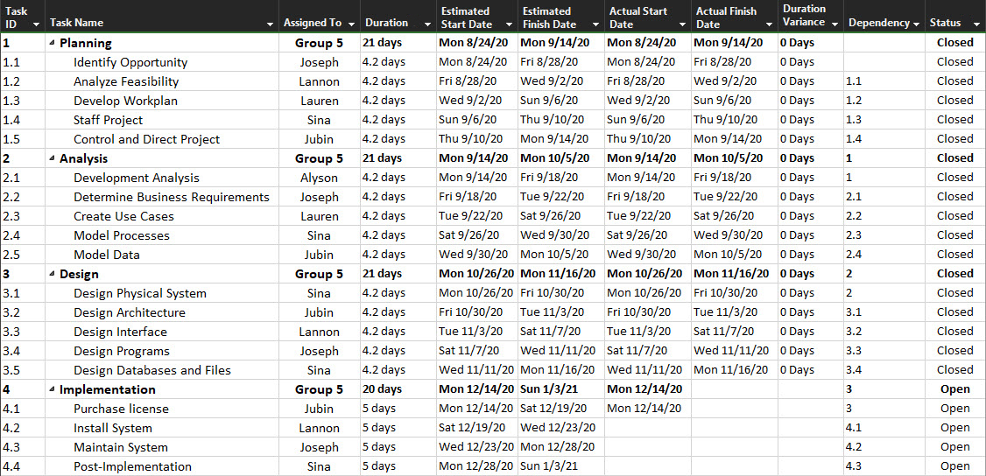

**Feasibility Analysis**

**Cost/Benefit Analysis (simple cash flow method):**

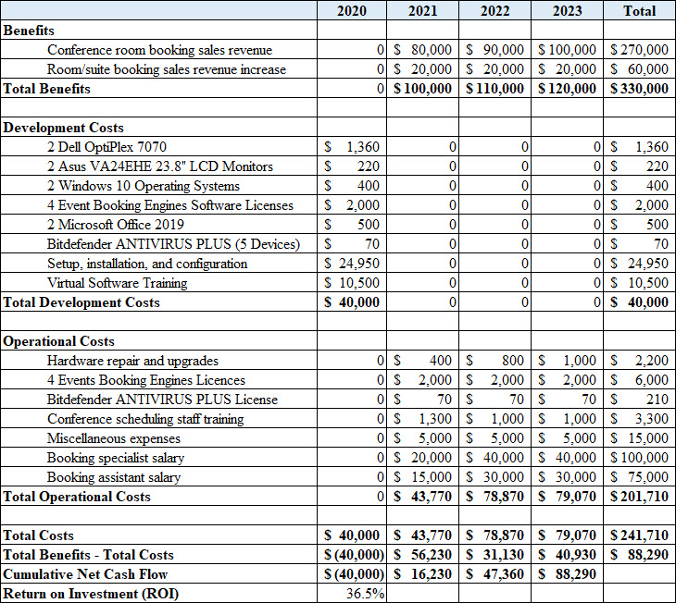

**Economic Feasibility**

The initial system development will require hardware and software that consumes the entire $40,000 USD budget. Three years after launch, this new system is predicted to have a 36.5% Return on Investment (ROI) and provide net profits of $88,290. First-year operational costs are less given the fact that the employee salaries, the largest portion of operational expenses, do not start until mid-year. The following years represent the true annual operational costs of around $80K. A positive ROI indicates that this project is economically feasible and should be pursued especially if the actual benefits realized are more than anticipated.

**Technical Feasibility**

The technical architecture of Cowboy Hotel relies heavily on strategic operations in joining software development workplans that are needed in designing technology. In the coming months, we expect to see more customers transactions booking hotel rooms as well as conference rooms with catering services that complement our existing technology implementation. Our current infrastructure requires two new Dell Optiplex 7070 computers valued at $1360 USD each. Both enterprise computers will operate on Windows 10 with Microsoft Office 2019 packages. The infrastructure technology design is scheduled to meet the demands of internal work for the next four-year operational period, specified during the Planning Phase. The conference room scheduling office requires these two additional computers in order to meet the business requirements of streamlined booking of alternative services. Our development allows employees to acquire data, store information, and implement tasks pertaining to scheduling of customers and venues. It is also adequate in minimizing risks in double booking and quickly adapting to room cancelation in real time. This functionality opens more avenues of revenue to meet the cost benefit analysis document.

**Organizational Feasibility**

Currently, the Cowboy Hotel is manually inputting customer bookings and information which has resulted in mistakes such as double bookings and unintended room cancellations. Our organizational infrastructure requires new computer system that can help manage bookings for their recently acquired conference rooms as well as more staff to run the operations. This new system will prevent double bookings and collect customer information for future references. It will also provide information of caterers that are reserved for different conference rooms. As of now, The Cowboy Hotel does not have enough computers to support the new system so they will need to purchase two more computers as well as a Microsoft Office Package for both. Over time there will be a need for new employees. It is recommended, that by 2021 the Cowboy Hotel should employ another Booking Specialist and Booking Assistant to keep up with the predicted demands for their conference and hotel rooms.

**Requirements Definition Document**

|  |
| --- |
| **Functional Requirements** |
| 1. **Employee Authentication** 2. The system will allow users to log in with a username and password |
| 1. **Customer Account Management**   2.1The system will enable users to create customer account  2.2 The system will allow users to view customer account information  2.3 The system will record customer account information in Customers datastore |
| 1. **Caterer Account Management**    1. The system will enable users to create caterer account    2. The system will allow users to view caterer account information    3. The system will record caterer account information in Caterers datastore |
| 1. **Room Information Management**    1. The system will allow users to store information about conference rooms    2. The system will allow users to view information about conference rooms    3. The system will record conference room information in the Conference Rooms datastore    4. The system will calculate and store usage and revenue statistics for each conference room |
| 1. **Reservation Management**    1. The system will enable users to create new reservation    2. The system will allow users to view current and past reservations    3. The system will allow users to modify reservations    4. The system will allow users to invalidate reservations with manager approval    5. The system will organize and display all reservations into a master calendar    6. The system will allow users to apply a discount on a reservation    7. The system will record reservations in Reservations datastore |
| 1. **Report Management**    1. The system will enable users to create reports from information in datastores    2. The system will allow users to view past and newly generated reports    3. The system will allow users to send reports to other departments    4. The system will store reports in the Reports datastore |
| **Nonfunctional Requirements** |
| 1. **Operational**    1. The system should run on Windows 10    2. The system should work alongside, but independent of, the current systems    3. There are no portability requirements since we are only using Windows 10 on the desktop PCs    4. The system will have the ability to accept periodic updates to fix bugs or add features |
| 1. **Performance**    1. All data stores will be updated in real-time    2. The system should be available from 7am to 7pm daily    3. The system should be able to handle at least 12 bookings a day    4. The system should be able to accommodate at least 3 users simultaneously    5. The system should store data in datastores indefinitely |
| 1. **Security**    1. The system is not mission critical, but a system outage is estimated to cost $23 an hour in lost revenue    2. A complete loss of the system is estimated to cost $370,000    3. Employees are required to authenticate using a username and password    4. Only managers can authorize the cancellation/invalidation of a reservation    5. Only the manager can use the system remotely    6. Passwords, and other sensitive information, will be encrypted in the data stores using AES-256    7. Data in transit to and from data stores will be encrypted and hashed using Transport Layer Security (TLS)    8. Each computer running the system will have virus protection via Bitdefender anti-virus software |
| 1. **Cultural and Political**     1. The system will operate in English    2. The system will use MM/DD/YYYY format for date and ‘$’ sign for transaction amounts    3. The Privacy Act of 1974 (5 U.S.C. § 552a) protects personal information held by the federal government by preventing unauthorized disclosures of such information    4. Information from European Union customers is subject to all regulations outlined in the General Data Protection Regulation (GDPR) and, thus, cannot be stored indefinitely without unambiguous consent |

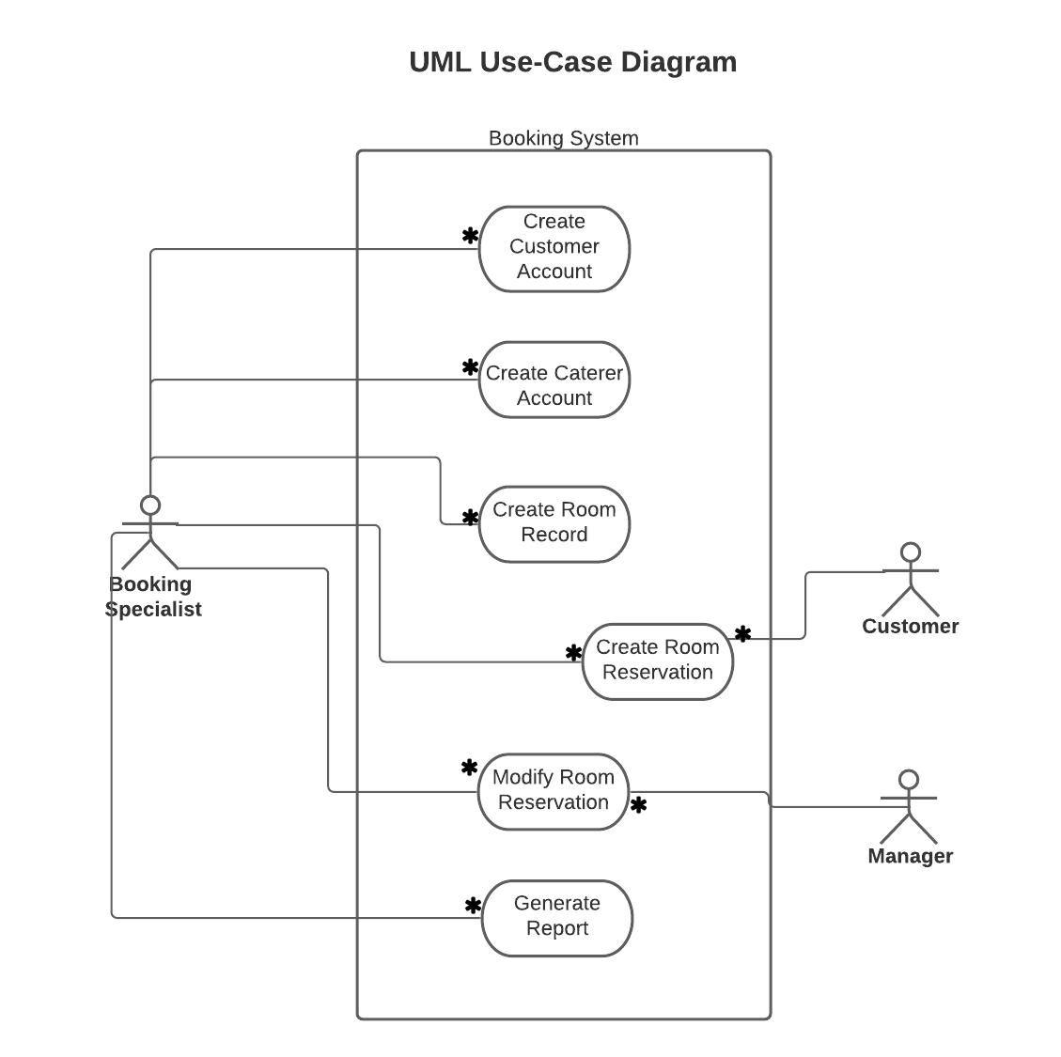

**Use Cases**

**UC-1: Create Customer Account**

|  |  |  |
| --- | --- | --- |
| **Use Case Name:** Create Customer Account | **ID:** UC-1 | **Priority:** High |
| **Actor:** Booking Specialist | | |
| **Description:** This use case describes how the Booking Specialist creates a customer account. | | |
| **Trigger:** A new customer provides information to the hotel to create an account. | | |
| **CheckmarkType:** External Temporal | | |
| **Preconditions:**   1. Customers data store is available and on-line. 2. Booking Specialist is logged-in/authenticated to the system. 3. Customer has provided the Booking Specialist with all information needed to create a record of the new account. | | |
| **Normal Course:**   1. The Booking Specialist selects the Create New Customer button 2. The system opens the New Customer Creation window to display the Customer Information fields 3. The Booking Specialist inputs the new customer’s information and selects the Create button when finished 4. The system stores the new customer information in the Customers data store | | |
| **Postconditions:**   1. The new account record is stored in the Customers data store. | | |
| **Exceptions:**  E1: The Booking Specialist has entered invalid information or customer record already exists  (occurs at Step 3)   1. The system displays appropriate error message 2. The system asks the Booking Specialist if they want to correct information or cancel   3a. The Booking Specialist selects to correct information  4a. The system returns to Step 2  3b. The Booking Specialist asks to cancel  4b. The system terminates the use case | | |

**UC-2: Create Caterer Account**

|  |  |  |
| --- | --- | --- |
| **Use Case Name:** Create Caterer Account | **ID:** UC-2 | **Priority:** Medium |
| **Actor:** Booking Specialist | | |
| **Description:** This use case describes how the Booking Specialist creates a caterer account. | | |
| **Trigger:** A new caterer has been approved for event assignments and an account needs to be made. | | |
| **CheckmarkType:** External Temporal | | |
| **Preconditions:**   1. Caterers data store is available and on-line. 2. Booking Specialist is logged-in/authenticated to the system. 3. The catering vendor has provided the Booking Specialist with all information needed to create a record of the new account. | | |
| **Normal Course:**   1. The Booking Specialist selects the Create New Caterer button 2. The system opens the New Caterer Creation window to display the Caterer Information fields 3. The Booking Specialist inputs the new caterer’s information and selects the Create button when finished 4. The system stores the new caterer’s information in the Caterers data store | | |
| **Postconditions:**   1. The new account record is stored in the Caterers data store. | | |
| **Exceptions:**  E1: The Booking Specialist has entered invalid information or caterer record already exists  (occurs at Step 3)   1. The system displays appropriate error message 2. The system asks the Booking Specialist if they want to correct information or cancel   3a. The Booking Specialist selects to correct information  4a. The system returns to Step 2  3b. The Booking Specialist asks to cancel  4b. The system terminates the use case | | |

**UC-3: Create Room Record**

|  |  |  |
| --- | --- | --- |
| **Use Case Name:** Create Room Record | **ID:** UC-3 | **Priority:** High |
| **Actor:** Booking Specialist | | |
| **Description:** This use case describes how the Booking Specialist creates a record of a conference room. | | |
| **Trigger:** A record of a conference room and its details need to be stored in the system. | | |
| **CheckmarkType:** External Temporal | | |
| **Preconditions:**   1. Conference Rooms data store is available and on-line. 2. Booking Specialist is logged-in/authenticated to the system. | | |
| **Normal Course:**   1. The Booking Specialist selects the Create New Room button 2. The system opens New Room Creation window to display the Room Information fields 3. The Booking Specialist inputs the new room’s information and selects the Create button when finished 4. The system stores the new room information in the Conference Rooms data store | | |
| **Postconditions:**   1. The new room record is stored in the Conference Rooms data store. | | |
| **Exceptions:**  E1: The Booking Specialist has entered invalid information or room record already exists  (occurs at Step 3)   1. The system displays appropriate error message 2. The system asks the Booking Specialist if they want to correct information or cancel   3a. The Booking Specialist selects to correct information  4a. The system returns to Step 2  3b. The Booking Specialist asks to cancel  4b. The system terminates the use case | | |

**UC-4: Create Room Reservation**

|  |  |  |
| --- | --- | --- |
| **Use Case Name:** Create Room Reservation | **ID:** UC-4 | **Priority:** High |
| **Actor:** Booking Specialist | | |
| **Description:** This use case describes how the Booking Specialist creates a conference room reservation. | | |
| **Trigger:** A customer would like to reserve one or more conference rooms. | | |
| **CheckmarkType:** External Temporal | | |
| **Preconditions:**   1. Customers, Caterers, Conference Rooms, and Reservations data stores are available and on-line. 2. Booking Specialist is logged-in/authenticated to the system. 3. Customer has an account in the Customers data store. 4. Conference room information has been stored in the Conference Rooms data store. 5. Customer has provided the Booking Specialist with room requirements and event details. | | |
| **Normal Course:**   1. The Booking Specialist selects the Create New Reservation button 2. The system prompts the Booking Specialist for a date and time 3. The system returns a list of available rooms and caterers based on information in the Reservations data store 4. The Booking Specialists selects the desired conference room(s) and the reservation duration 5. If the event requires a caterer, 6. The Booking Specialists assigns an available caterer 7. The Booking Specialist associates the customer’s account information with the reservation 8. The system stores the new reservation in the Reservations data store 9. The system asks the Booking Specialist if they want a printed copy of the confirmation or to send it to the customer’s email on record 10. If a printout is requested, 11. The system prints a copy of the reservation confirmation for the customer   Otherwise,   1. The system sends a copy of the reservation confirmation to the customer’s email | | |
| **Postconditions:**   1. The new reservation record is stored in the Reservations data store. 2. The customer is given a reservation confirmation. | | |
| **Exceptions:**  E1: There are no available conference rooms for the data and time specified (occurs at Step 3)   1. The system displays error “No conference rooms available” 2. The system asks the Booking Specialist if they want to enter another date and time or cancel   3a. The Booking Specialist selects to enter another data and time  4a. The system returns to Step 2  3b. The Booking Specialist asks to cancel  4b. The system terminates the use case  E2: The customer’s email is not on record (occurs at Step 9)   1. The system displays error “No customer email on record” 2. The system asks the Booking Specialist if they want to enter an email manually or cancel the email request   3a. The Booking Specialist selects to enter an email manually  4a. The system updates the Customers data store with the newly provided email  5a. The system returns to Step 9  3b. The Booking Specialist asks to cancel the email request  4b. The system terminates the use case | | |

**UC-5: Modify Room Reservation**

|  |  |  |
| --- | --- | --- |
| **Use Case Name:** Modify Room Reservation | **ID:** UC-5 | **Priority:** High |
| **Actor:** Booking Specialist | | |
| **Description:** This use case describes how the Booking Specialist makes a modification to a reservation. | | |
| **Trigger:** A customer has requested a change to their reservation. | | |
| **CheckmarkType:** External Temporal | | |
| **Preconditions:**   1. Reservations data store is available and on-line. 2. Booking Specialist is logged-in/authenticated to the system. 3. When needed, the Manager is logged-in/authenticated to the system. 4. The customer’s reservation is stored in the Reservations data store. | | |
| **Normal Course:**   1. The Booking Specialist selects the Modify Reservation button. 2. The system prompts the Booking Specialist to enter the reservation number 3. The Booking Specialist enters the reservation number 4. The system retrieves the reservation record from the Reservations data store 5. If the customer desires to cancel their reservation, the Booking Specialist is prompted to obtain authorization from the Manager 6. The Manager authorizes the cancellation 7. The Booking Specialist marks the reservation as invalidated 8. The Booking Specialists makes the desired modifications to the reservation and selects the Submit button 9. The system updates the Reservations data store with the modified reservation | | |
| **Postconditions:**   1. The modified reservation is stored in the Reservations data store. 2. The Manager notifies the Caterer if there has been a cancellation. | | |
| **Exceptions:**  E1: The Booking Specialist enters an invalid reservation number (occurs at Step 2)   1. The system displays “Invalid reservation number” 2. The system asks the Booking Specialist if they want to try again or cancel   3a. The Booking Specialist selects to try again  4a. The system returns to Step 2  3b. The Booking Specialist asks to cancel  4b. The system terminates the use case  E2: The Manager does not authorize the reservation cancellation (occurs at Step 4)   1. The Booking Specialist is forced to cancel the reservation modification and informs the customer 2. The system terminates the use case | | |

**Physical Process Models**

**Context**

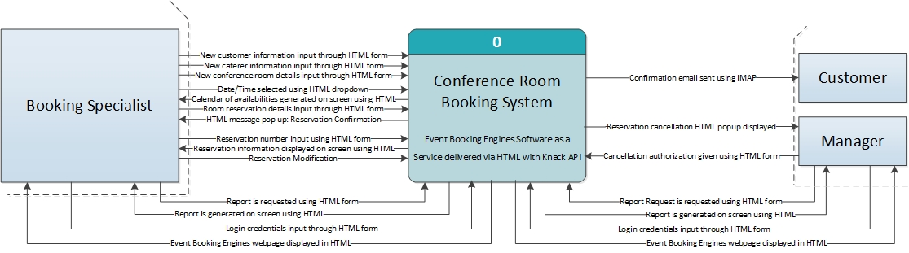

**Level 0**

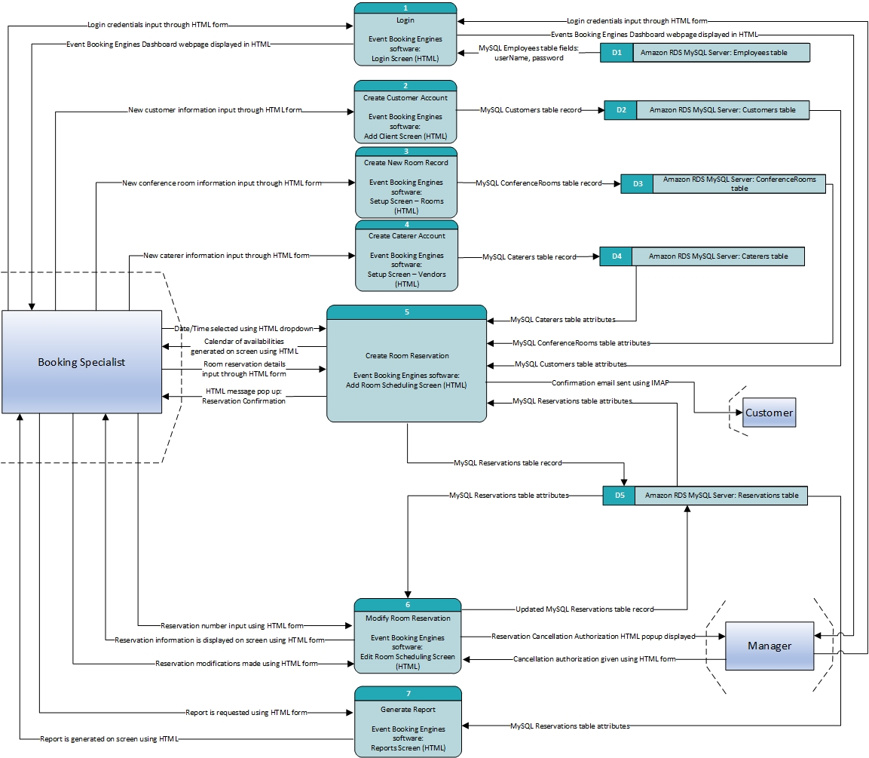

**Level 1: Process 1 – Login**

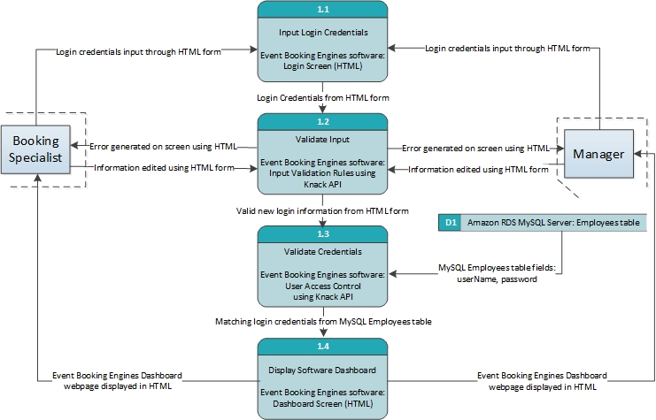

**Level 1: Process 2 - Create Customer Account**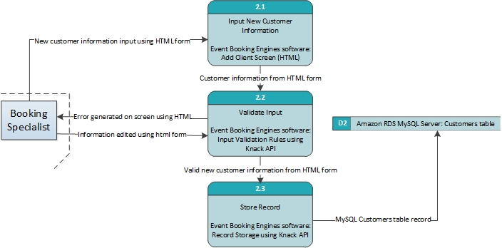

**Level 1: Process 3 – Create Room Record**

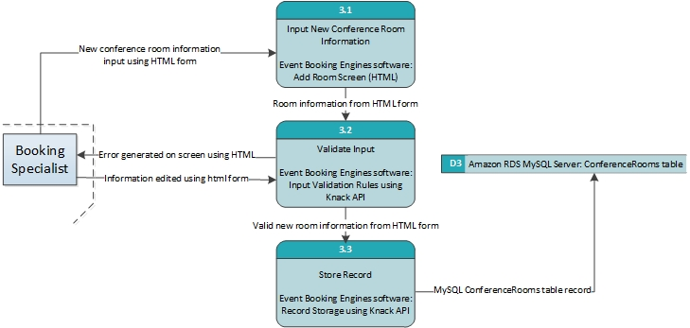

**Level 1: Process 4 – Create Caterer Account**

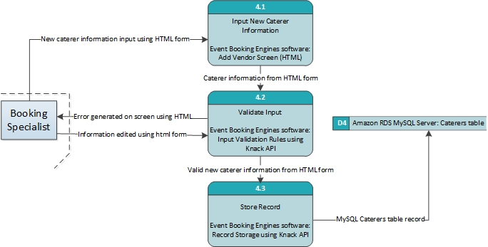

**Level 1: Process 5 – Create Room Reservation**

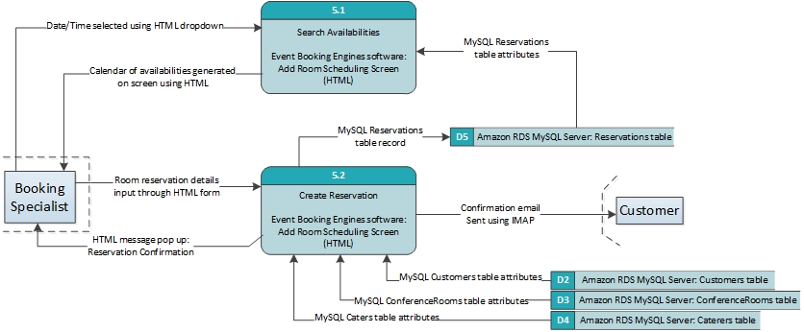

**Level 1: Process 6 – Modify Room Reservation**

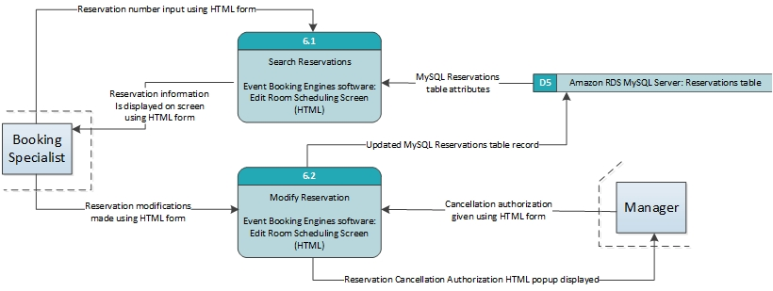

**Physical Data Model** 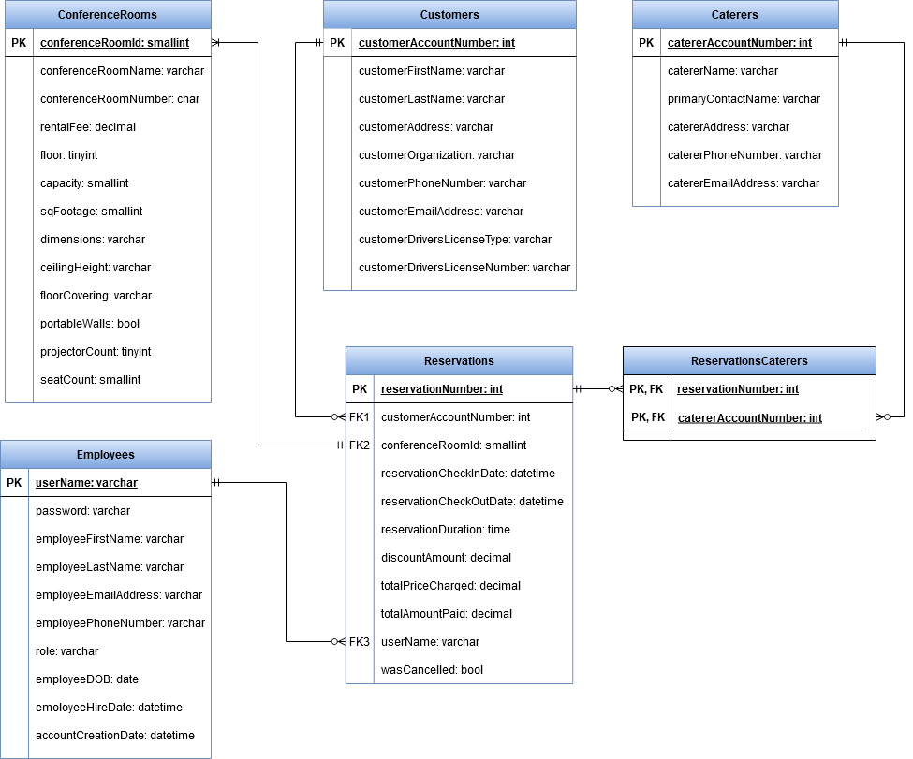

**Hardware/Software Specification**

|  |  |  |
| --- | --- | --- |
|  | **Standard Client** | **Standard Server** |
| **Operating System** | * Microsoft Windows 10 Professional (64-bit)   (https://www.microsoft.com/en-us/p/windows-10-pro/df77x4d43rkt?rtc=1&activetab=pivot%3aoverviewtab) | * Amazon RDS   (https://aws.amazon.com/rds/) |
| **Special Software** | * Google Chrome web browser   (https://www.google.com/chrome/)   * Microsoft Office 2019   (https://www.microsoft.com/en-us/microsoft-365/get-started-with-office-2019#office-ContentAreaHeadingTemplate-eri5pno)   * Adobe Acrobat Reader DC   (https://get2.adobe.com/reader/)   * Bitdefender ANTIVIRUS PLUS   (https://www.bitdefender.com/solutions/antivirus.html) | * Event Booking Engines   (https://www.eventbookingengines.com/)   * MySQL   (https://aws.amazon.com/rds/mysql/) |
| **Hardware** | * Dell OptiPlex 7070   (https://www.newegg.com/dell-optiplex-7070-business-desktops-workstations/p/1VK-0001-5CDY9?Item=9SIAF9SBY24086)   * Intel Core i5-9500T 6-Core 2.30-3.70 GHz * 16 GB 2666MHz DDR4 Memory * 256 GB Solid State Drive * Bluetooth 5 * 5 x USB Type-A (3.1/3.2 Gen 1), 1 x USB 3.2 Type-C * Integrated Intel UHD Graphics 630, 2 x DisplayPort 1.2, VGA * Wired mouse and keyboard * Asus VA24EHE 23.8” Full HD LED LCD Monitor   (https://www.newegg.com/asus-va24ehe-23-8-full-hd/p/1FR-000R-00024) | * 2.5 GHz Intel Scalable Processor: 1 Core, 2 vCPU with Intel AVX, AVX2, and Intel Turbo   (https://aws.amazon.com/rds/instance-types/)   * 8 Gibibyte (GiB)   (https://aws.amazon.com/rds/instance-types/) |
| **Network** | * 1 x RJ45 LAN @ 1000 Mbps (Gigabit Ethernet) * Intel Wireless-AC 9560, Dual-b and 2x2 802.11ac Wi-Fi | * Up to 5 Gbps   (https://aws.amazon.com/rds/instance-types/) |

**User Interface**

**Interface Structure Diagram**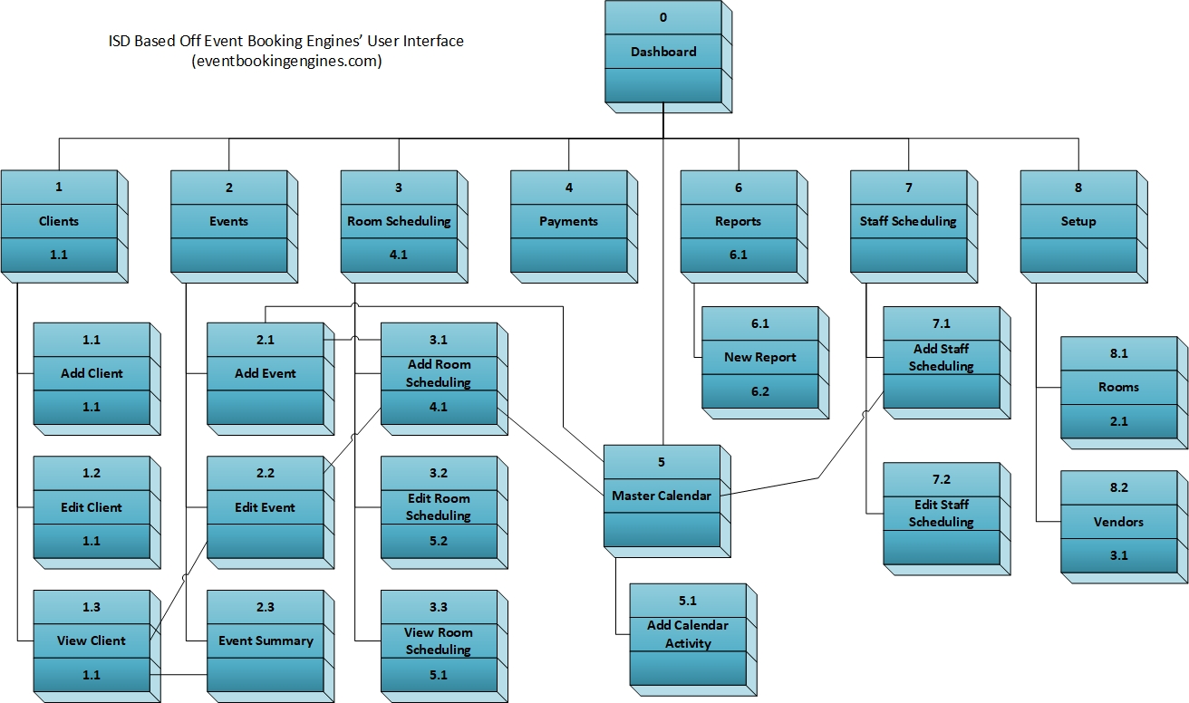

**Example Dashboard Screen Wireframe**

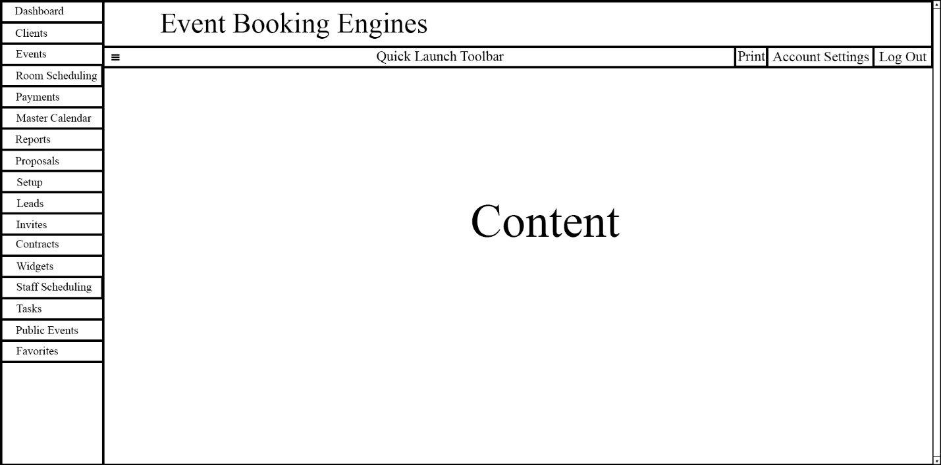

**Example Master Calendar Wireframe**

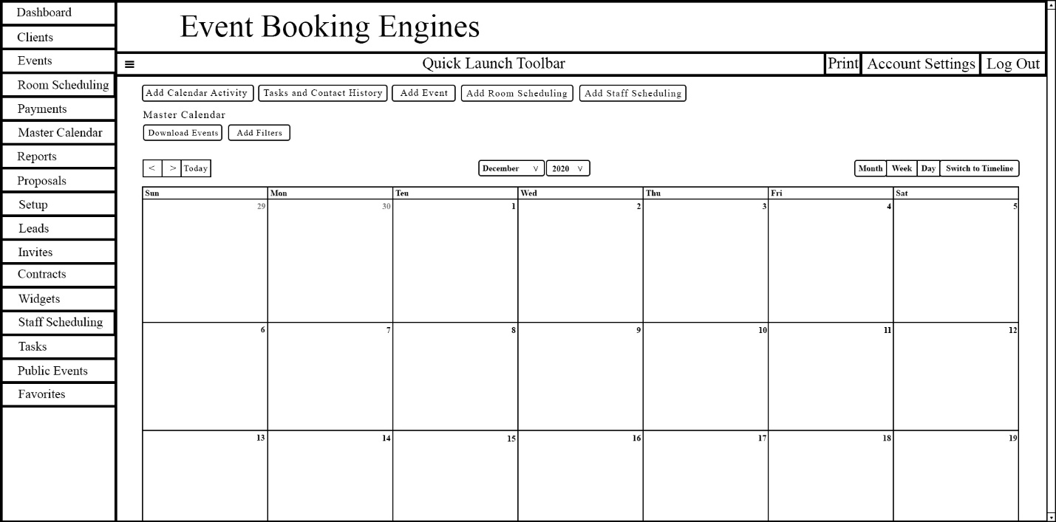

**Appendix**

**Interview Report**

|  |
| --- |
| Interview Notes Approved by: Jaime Bradson |
| **Person Interviewed:** Jaime Bradson, Hotel Manager, Cowboy Hotel  **Interviewers:** The Quarantiners  **Purpose of Interview:**   * Confirm root cause of problems that arise during manual conference room booking process. * Gather requirements for new booking system. * Discuss any new developments that need to be considered.   **Summary of Interview:**   * In addition to double bookings, data entry errors occur (incorrect date/update errors) during the manual booking process. A streamlined system will remedy the root cause of the issues. * The **functional requirements** of the system include: * System must capture/store customer information   (Name, organization, address, phone number, email address, etc.).   * System must capture/store conference room/venue information   (Name, rental fee, size, capacity, etc.).   * Rental fee = $75-$100/hour but discounts for multiple rooms and other promotions possible if demand is low. * There are 15 – 20 rooms (check posted document). * System must capture/store information about caterers   (Name, phone number, email address, event assigned to, etc.).   * System must capture/store information about the room reservations   (customer, room, date/time, total price charged, remaining balance, payment information, etc.).   * System must be able to create, change, and view conference room reservations. * System must be able to invalidate reservations with the authorization of a manager. * System will use a master calendar to organize all bookings. * System will produce reports (marketing department, etc.). * Records must be kept indefinitely and will be stored on a remote server for on demand access. * System must include each customer and all the reservations they have made. * System must include total monthly revenues for each room. * System must include daily and weekly room usage reports. * The **non-functional requirements** of the system include: * System will run on Windows 10. * System will work alongside current systems (reservations, payment, etc.) but will be independent of them. * System must be able to support multiple users, including at least one manager. * System must be able to handle at least 12 bookings a day. * System should be available from 7am to 7pm daily. * Users will login using a username and password * Only the manager has remote access capabilities to the system.   **Open Items:**   * Retrieve and review floorplan document from Titanium   **Follow-up Question(s):**   * What are the legal requirements of storing customer information?   **Detailed Notes:** A transcript of the interview and a list of the questions asked is attached. |