**Birzeit University**

**ENCS, Computer Systems Engineering department**

**ENCS3330, DIGITAL INTEGRATED CIRCUITS**

**H.W 3**

**Prepared by:**

**Jubran Khoury - 1201264**

**Instructor: Dr.** **Khader Mohammad**

**Section: 2**

**Date of submission: 26 April 2024**

**1) 3-Input NAND gate**

**Schematic**

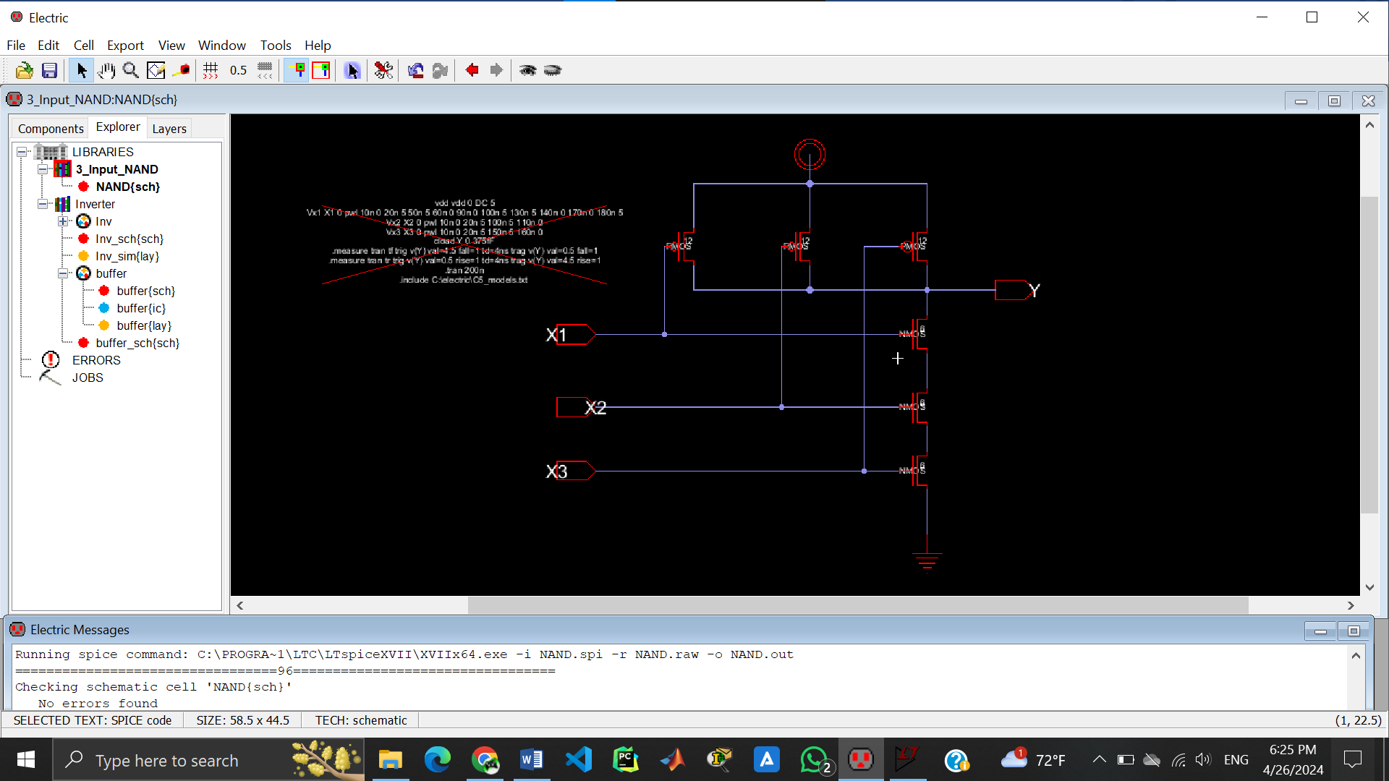

**Simulation**

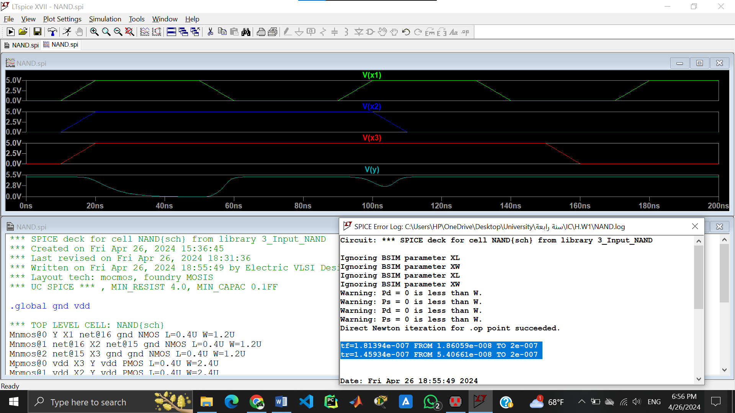

As shown above, the 3-input NAND gate works correctly.

Also, tf & tr is shown above.

**Symbol view**

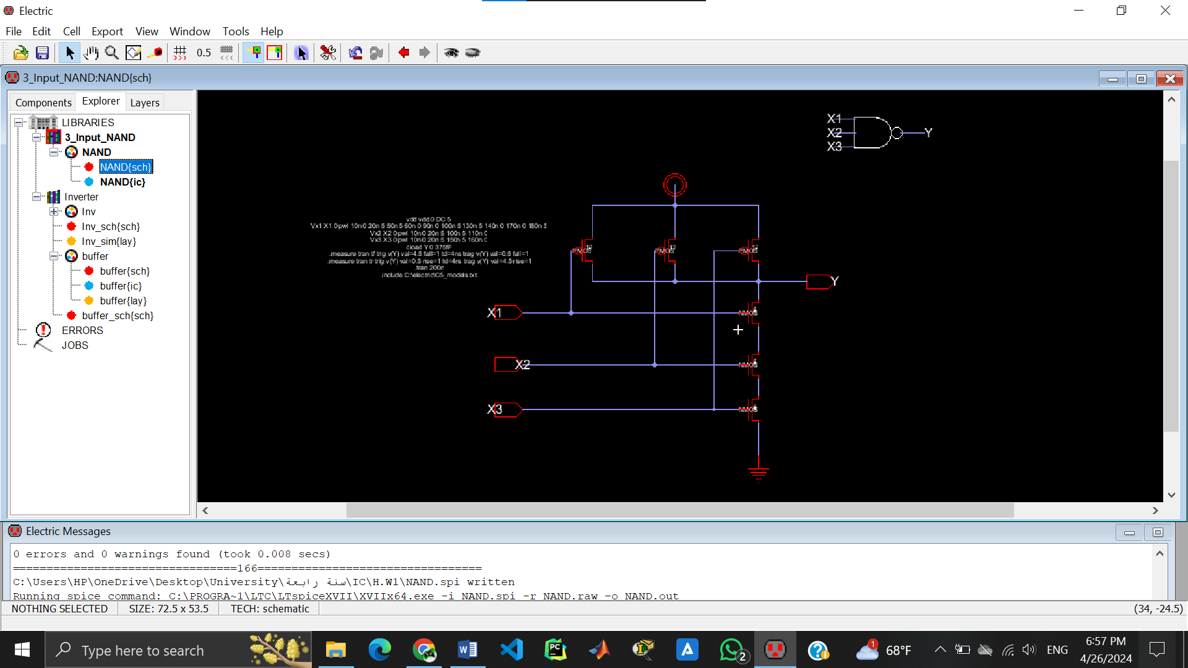

**Layout   
  
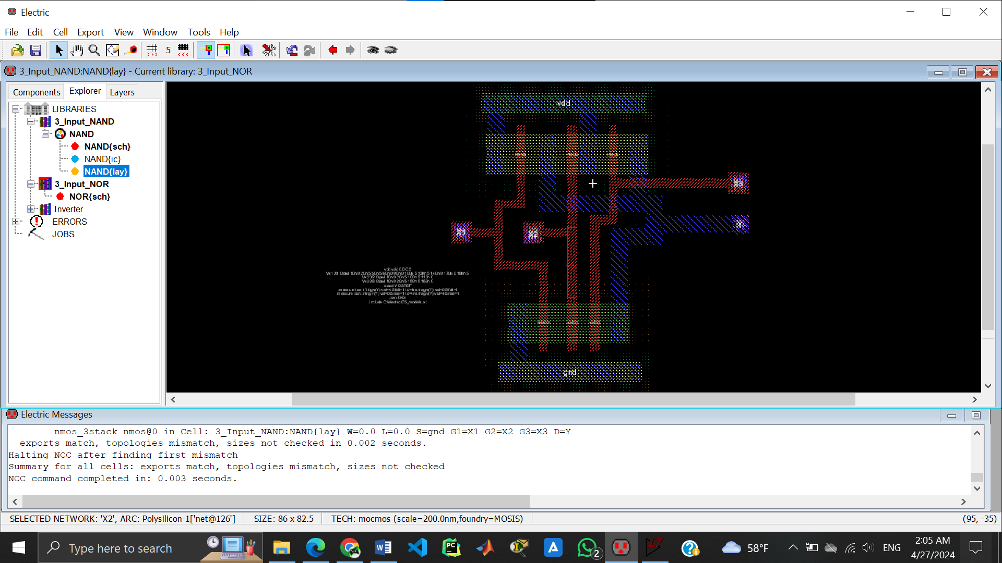**

DRC (successfully completed, no errors).

NCC command completed (as shown above).

No Well errors found.

**Simulation**

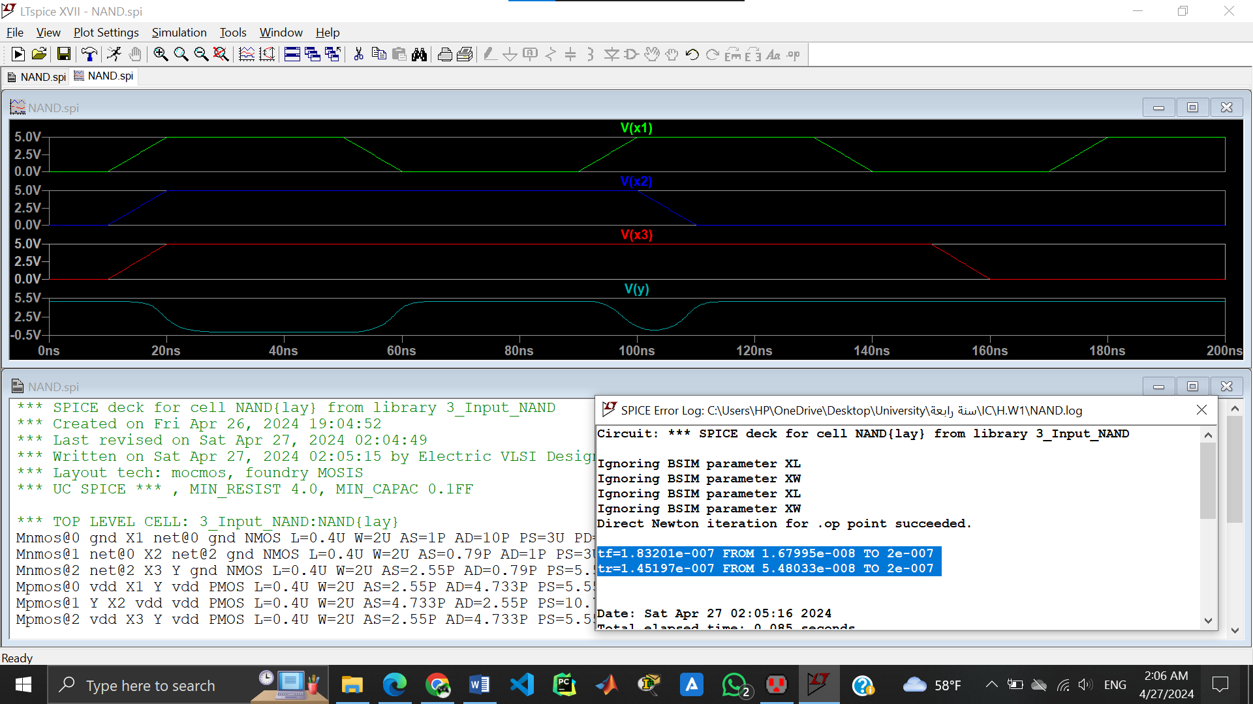

As shown above the simulation is correct and identical to schematic simulation.

**2) 3-Input NOR gate**

**Schematic**

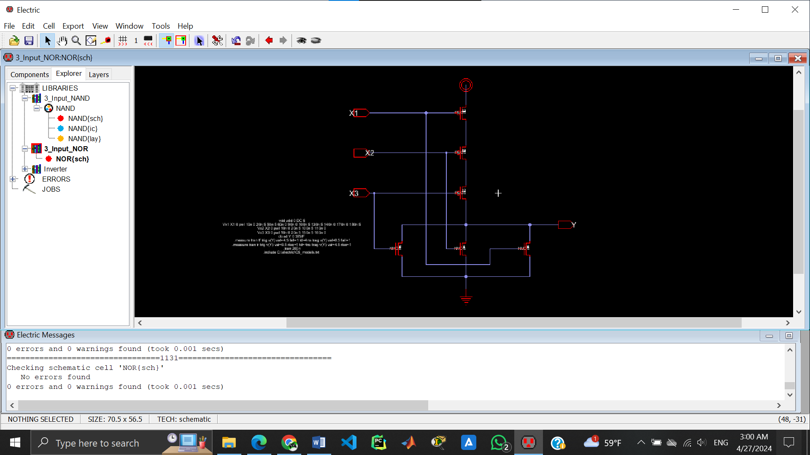

**Simulation**

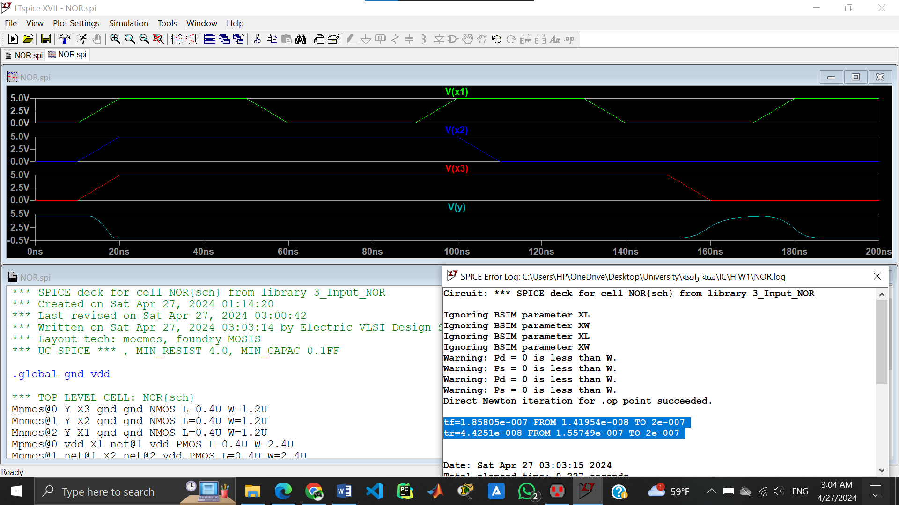

As shown above, the 3-input NOR gate works correctly.

Also, tf & tr is shown above.

**Symbol view**

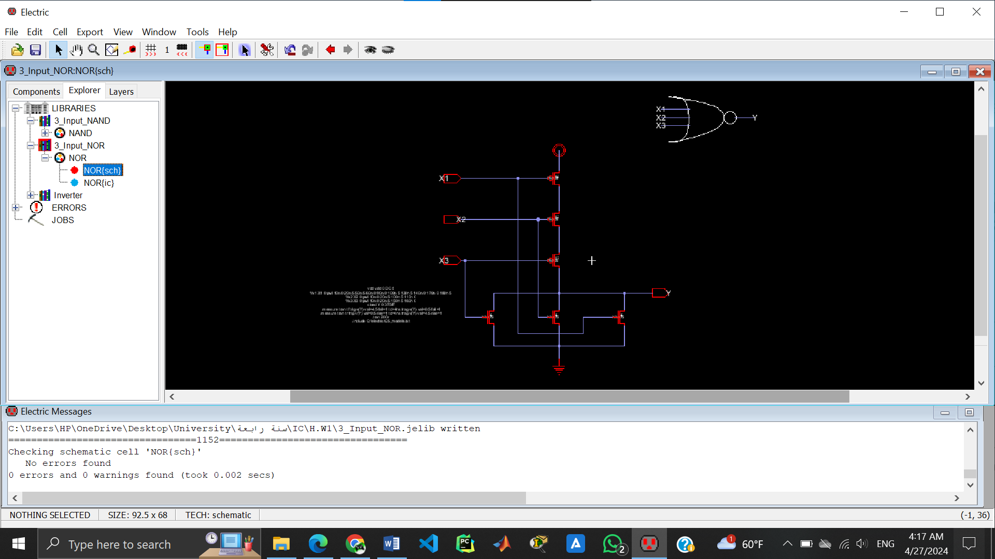

**Layout**

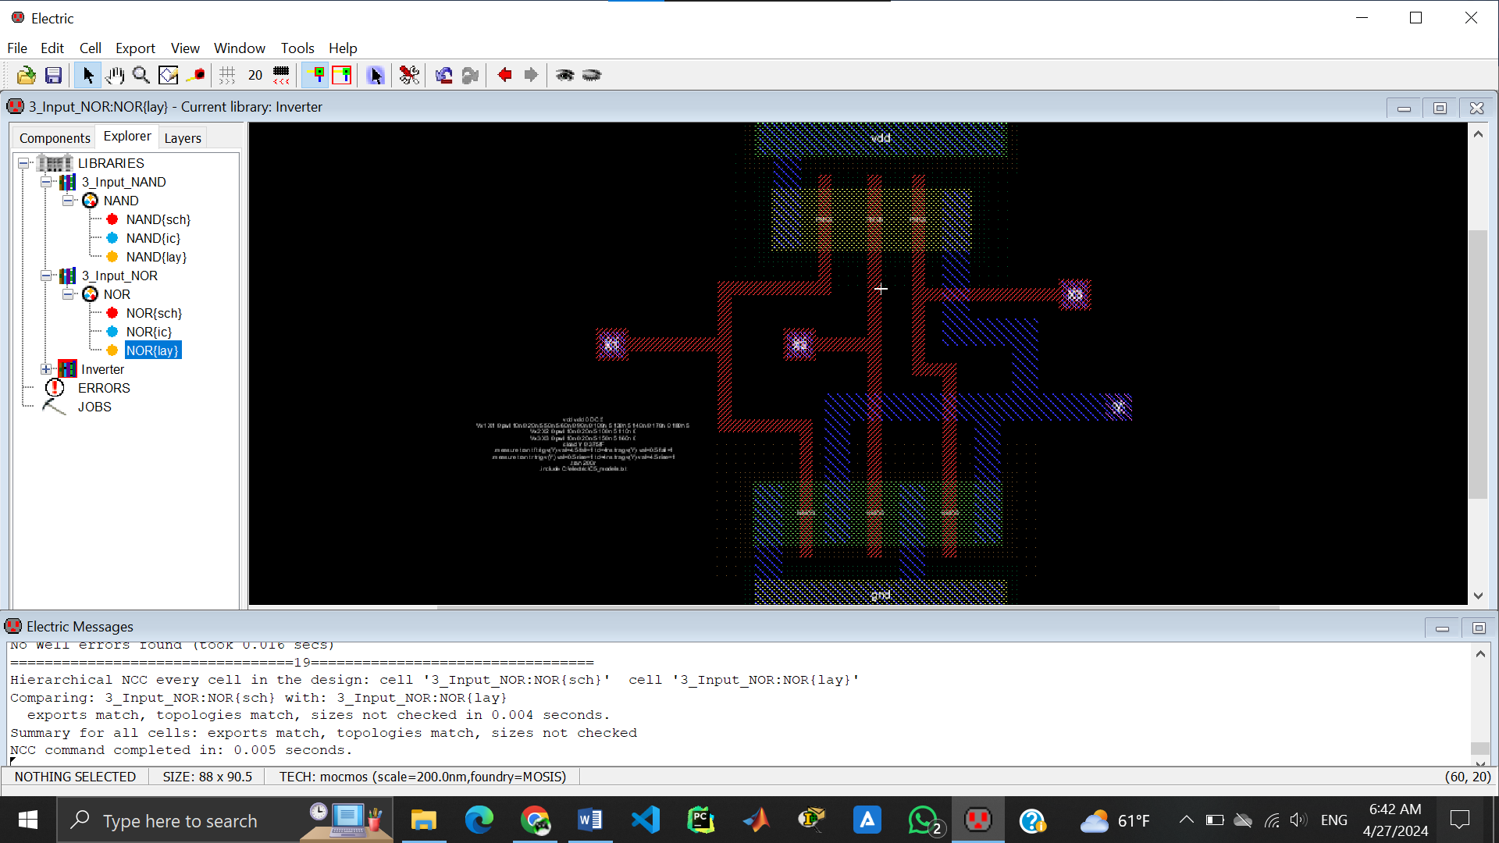

DRC (successfully completed, no errors).

NCC command completed (as shown above).

No Well errors found.

**Simulation**

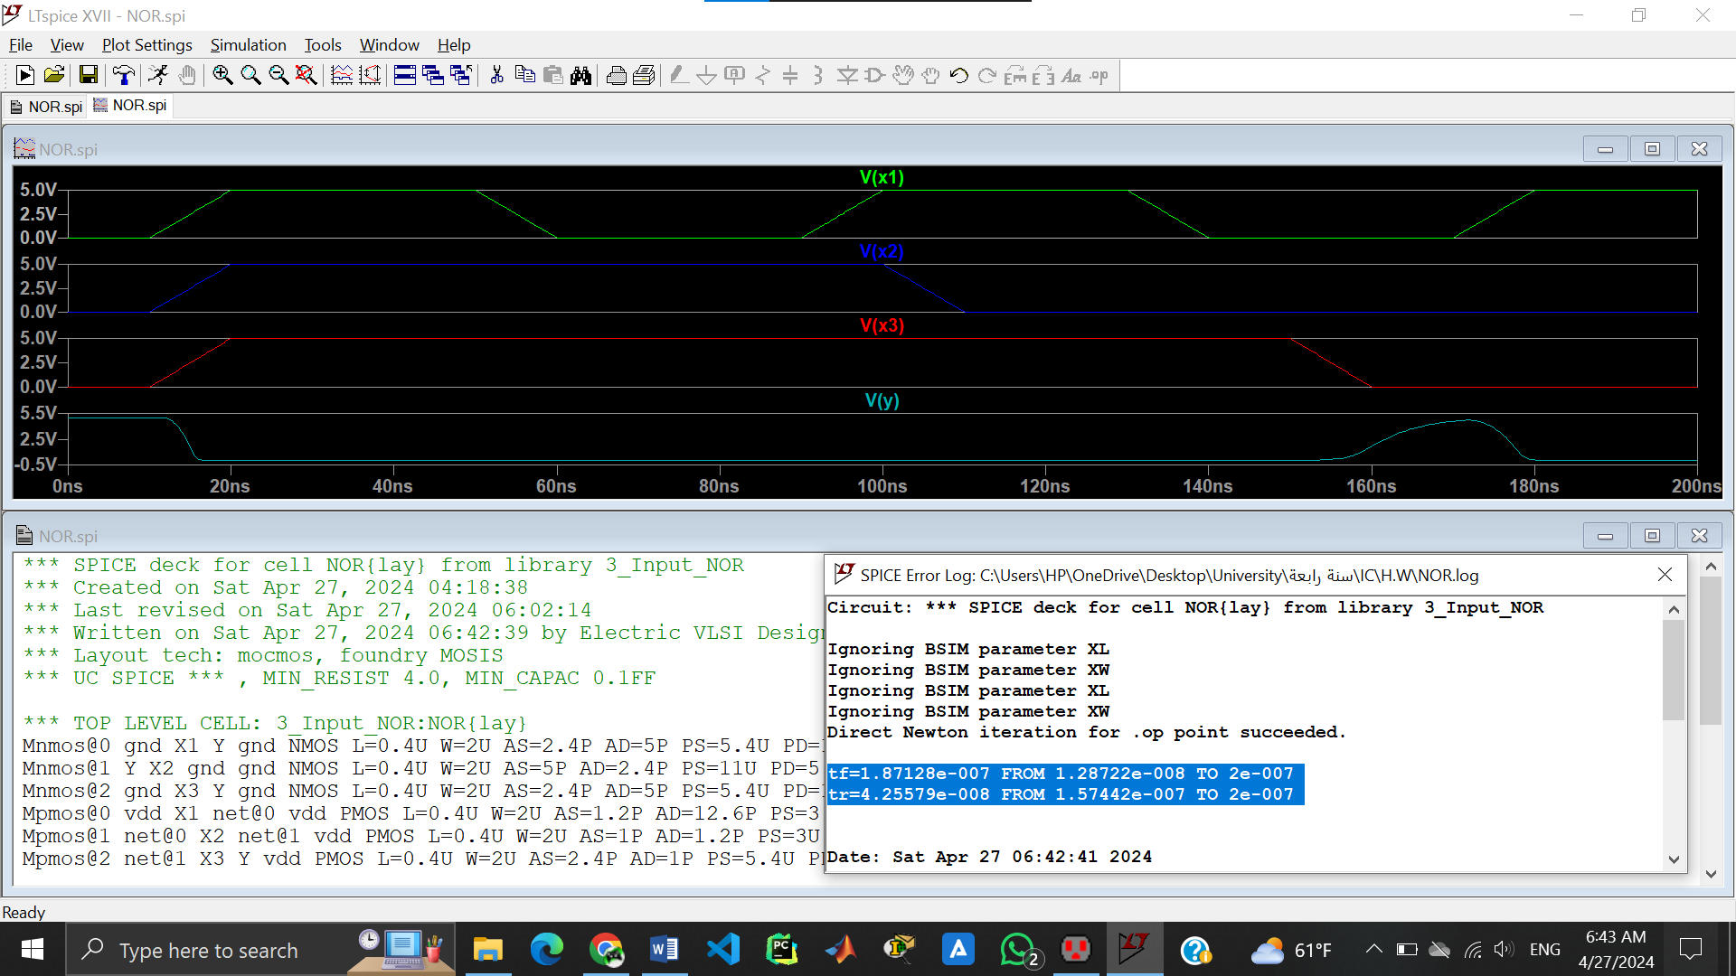

As shown above the simulation is correct and identical to schematic simulation.