Resolvent Global
Proprietary Technologies Page — Web Developer Instructions
New major website page | NDA-protected technology portfolio | Premium global-company presentation

1. Main Instruction
Create a new major top-navigation page titled Proprietary Technologies. This should not be treated as a sub-page under Projects or Services.
Navigation placement: Place Proprietary Technologies immediately before Contact. Contact must remain the last major navigation item.
Recommended main navigation order
Home | About | Services | Industries | Projects | Training | Proprietary Technologies | Contact

2. Page Positioning and Design Direction
The Proprietary Technologies page should present Resolvent Global as an innovation-driven global engineering company with protected technology platforms. The tone should be premium, credible, commercially restrained and IP-safe.
- Use the attached visual direction as the preferred design reference.
- Use a premium green, white and deep-teal visual system with gold accents.
- Present the page as a major website page, not a minor sub-section.
- Avoid overly technical diagrams, process routes, operating conditions or engineering drawings.
- Emphasise protected innovation, partnership readiness and NDA-controlled disclosure.

3. Preferred Visual Reference
Use the attached/preferred mockup direction as the visual benchmark for the page layout. The final webpage does not need to copy the mockup pixel-for-pixel, but should preserve the clean structure, premium technology feel, portfolio cards, engagement pathways and NDA-focused footer CTA.
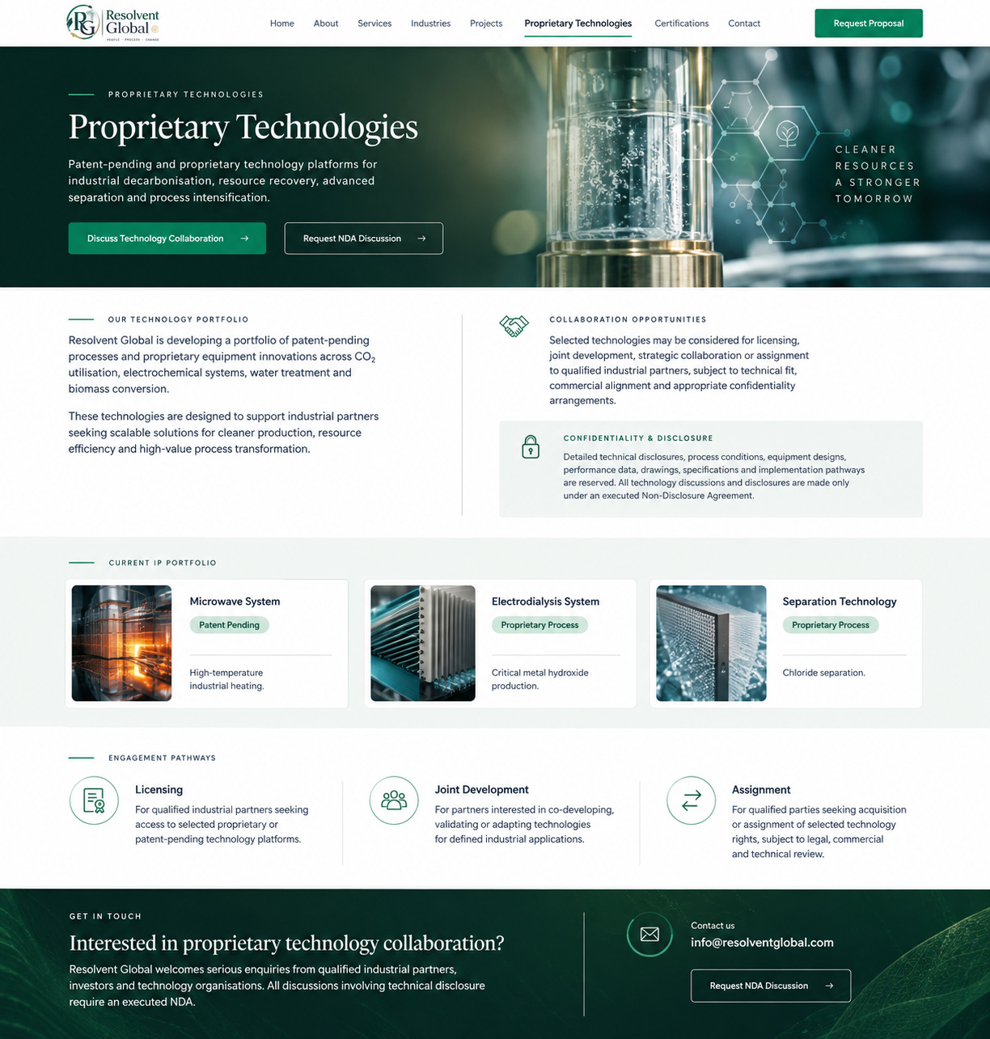

4. Recommended Website Content

Page title
Proprietary Technologies

Hero caption
Patent-pending and proprietary technology platforms for industrial decarbonisation, resource recovery, advanced separation and process intensification.

Main page copy
Resolvent Global is developing a portfolio of patent-pending processes and proprietary equipment innovations across CO₂ utilisation, electrochemical systems, water treatment and biomass conversion.
These technologies are designed to support industrial partners seeking scalable solutions for cleaner production, resource efficiency and high-value process transformation.
Selected technologies may be considered for licensing, joint development, strategic collaboration or assignment to qualified industrial partners, subject to technical fit, commercial alignment and appropriate confidentiality arrangements.

5. Confidentiality and Disclosure Note
Detailed technical disclosures, process conditions, equipment designs, performance data, drawings, specifications and implementation pathways are reserved. All technology discussions and disclosures are made only under an executed Non-Disclosure Agreement (NDA).

6. Current IP Portfolio
Technology Area | IP Status | Public Positioning
Microwave System | Patent Pending | High-temperature industrial heating
Electrodialysis System | Proprietary Process | Critical metal hydroxide production
Separation Technology | Proprietary Process | Chloride separation

7. Engagement Pathways
Licensing: For qualified industrial partners seeking access to selected proprietary or patent-pending technology platforms.
Joint Development: For partners interested in co-developing, validating or adapting technologies for defined industrial applications.
Assignment: For qualified parties seeking acquisition or assignment of selected technology rights, subject to legal, commercial and technical review.

8. Recommended CTA Section
Interested in proprietary technology collaboration?
Resolvent Global welcomes serious enquiries from qualified industrial partners, investors and technology organisations. All discussions involving technical disclosure require an executed NDA.
Contact: info@resolventglobal.com

9. Web Developer Implementation Fields
Website Field | Instruction / Content
Navigation label | Proprietary Technologies
URL slug | /proprietary-technologies
Main navigation placement | Immediately before Contact; Contact remains the final major navigation item
Page title | Proprietary Technologies
Hero caption | Patent-pending and proprietary technology platforms for industrial decarbonisation, resource recovery, advanced separation and process intensification.
Primary CTA | Discuss Technology Collaboration
Secondary CTA | Request NDA Discussion
Contact email | info@resolventglobal.com
Disclosure rule | No technical disclosure without executed NDA

10. Do Not Publish / Do Not Add
- Do not publish detailed technical process routes.
- Do not publish process conditions, operating windows, or equipment design details.
- Do not publish drawings, schematics, material specifications or performance data.
- Do not publish claims that have not been cleared by Resolvent Global or IP counsel.
- Do not add extra technology descriptions beyond the approved public positioning.
- Do not imply commercial deployment, guaranteed performance or regulatory approval unless separately confirmed.

11. Additional Recommendations
- Keep the page concise and confidence-building. The objective is to create qualified enquiries, not to explain the technology.
- Use high-level icons and premium industrial/science imagery rather than technical drawings.
- Use consistent badge styling for IP status: Patent Pending and Proprietary Process.
- Make the NDA requirement visible near the technology portfolio and again near the contact CTA.
- Before publication, final wording should be reviewed by Resolvent Global and, where appropriate, an IP advisor or patent attorney.

12. Short Final Instruction for Web Developer
Please create “Proprietary Technologies” as a major page in the main navigation and place it immediately before “Contact.” Contact should remain the final major navigation item. Use the attached design direction for the page layout and maintain high-level, NDA-protected technology wording only.

