Windows Server 2025
Active Directory, DNS & Group Policy Lab
GitHub Portfolio Project | JJADAMS IT Lab

Project Summary
Deployed and administered a two-VM Microsoft domain lab using Hyper-V, Windows Server 2025 and Windows 11 Enterprise. The project demonstrates networking, AD DS, DNS, domain joining, OU/user/group administration, PowerShell, Group Policy, validation and troubleshooting.

Environment
System | Role | IPv4 | DNS
DC01 | Domain Controller / DNS | 10.20.30.10/24 | Local DNS
C01 | Windows 11 domain client | 10.20.30.20/24 | 10.20.30.10
Domain: jjadamslab.local | Hyper-V switch: Lab01-Internal | Subnet: 10.20.30.0/24

Implementation Highlights
- Configured static IPv4 and DNS and validated connectivity between DC01 and C01.
- Installed AD DS and DNS and promoted DC01 into a new jjadamslab.local forest.
- Joined C01 to the domain and validated the Active Directory computer object.
- Deployed OUs for Users, Computers, Groups, IT, Sales and HR.
- Provisioned jsmith and managed membership in GG-IT-Users.
- Deployed and linked an IT Department User Policy GPO.
- Validated domain authentication, group membership, DNS and AD operation with PowerShell.
- Documented troubleshooting involving DNS, firewall, PowerShell syntax, domain join, AD placement and GPO processing.

Portfolio Evidence

01. DC01 static IP and DNS
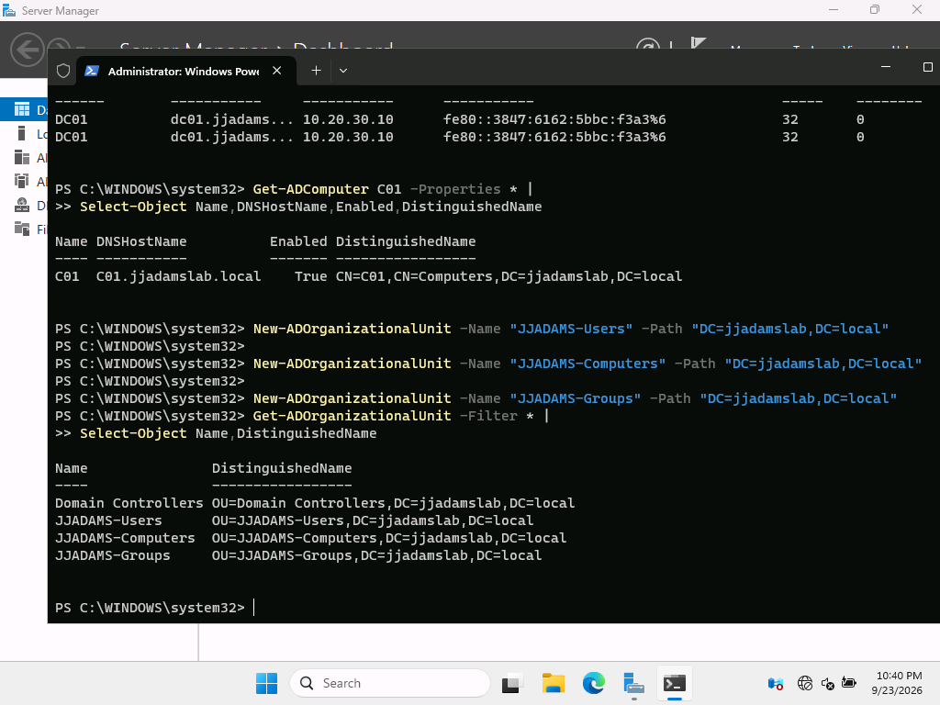

02. C01 static IP and DNS
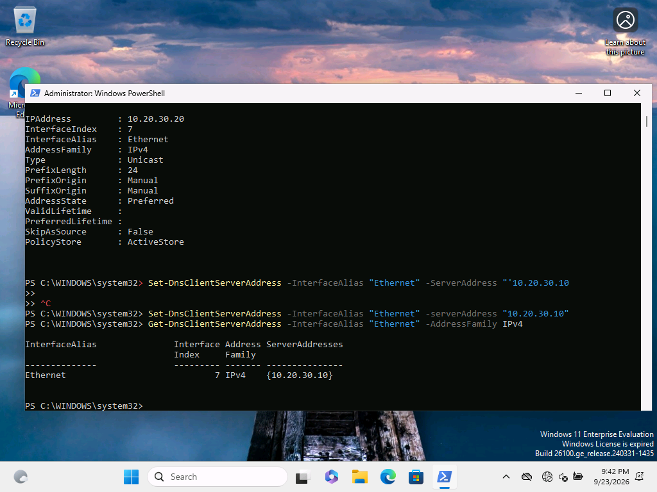

03. Connectivity from C01 to DC01
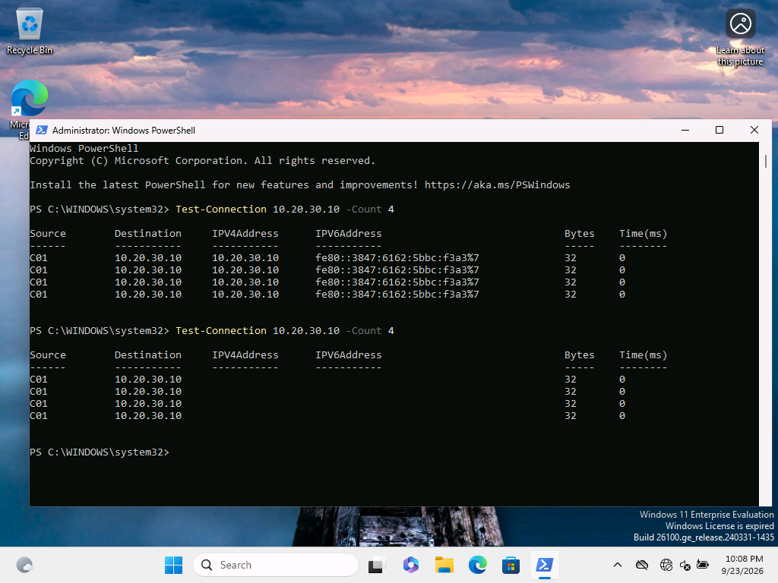

04. Forest and service health
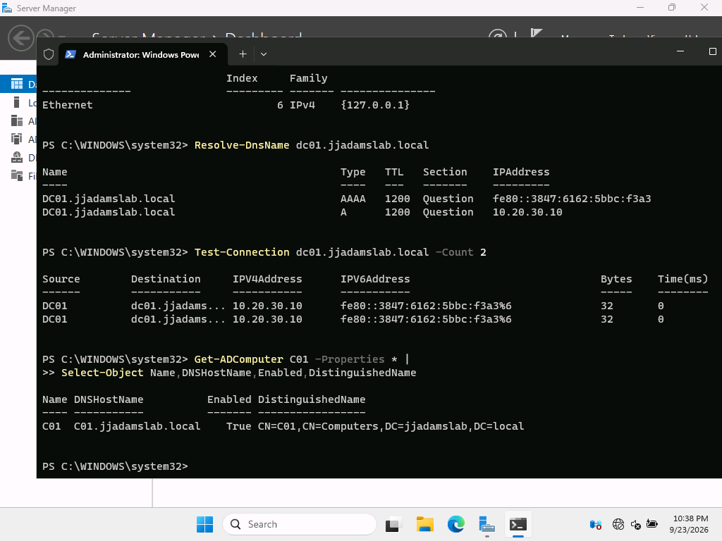

05. DNS resolution and the C01 computer object
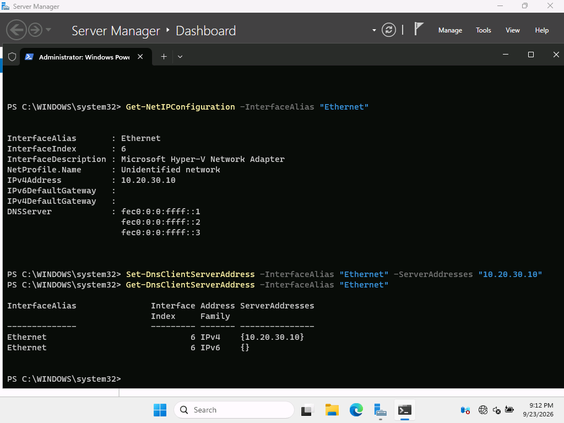

06. Top level OU structure
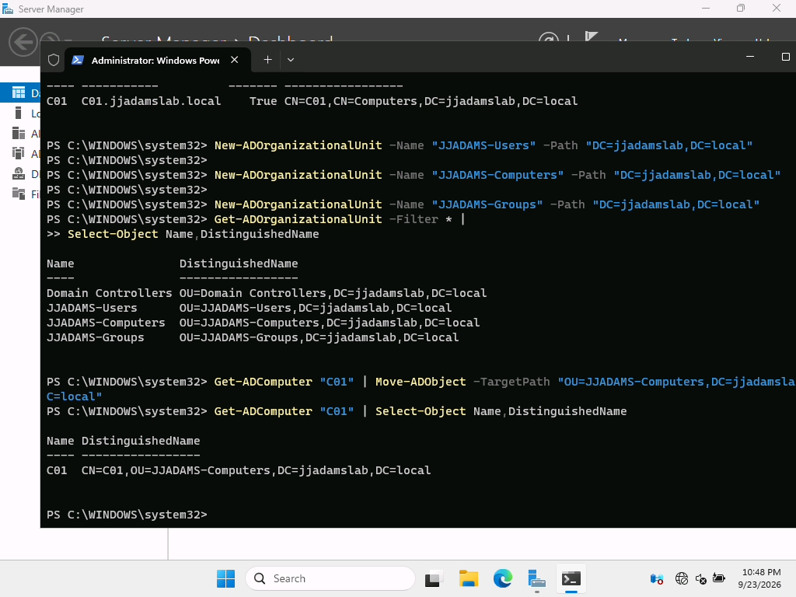

07. C01 moved into the managed OU
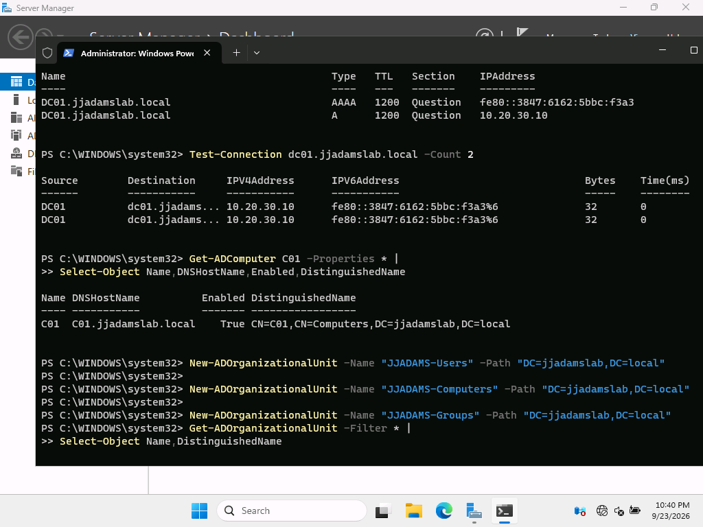

08. Department OUs
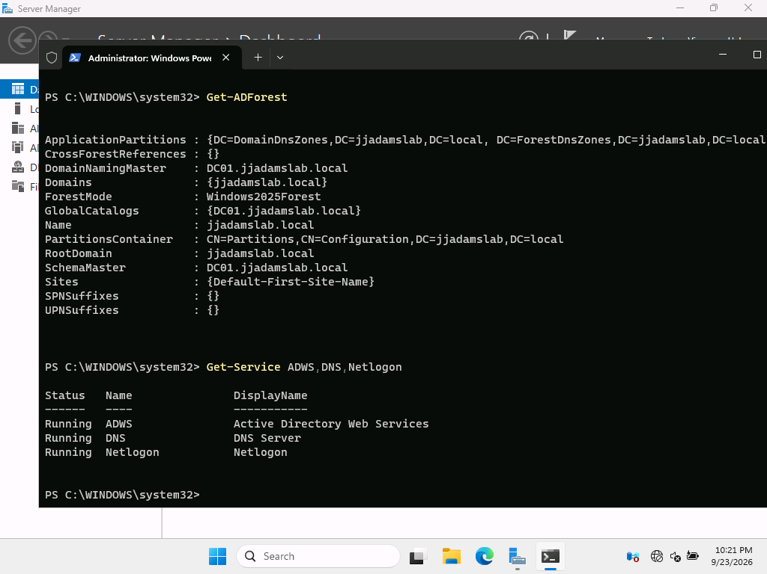

09. Domain sign in and group membership
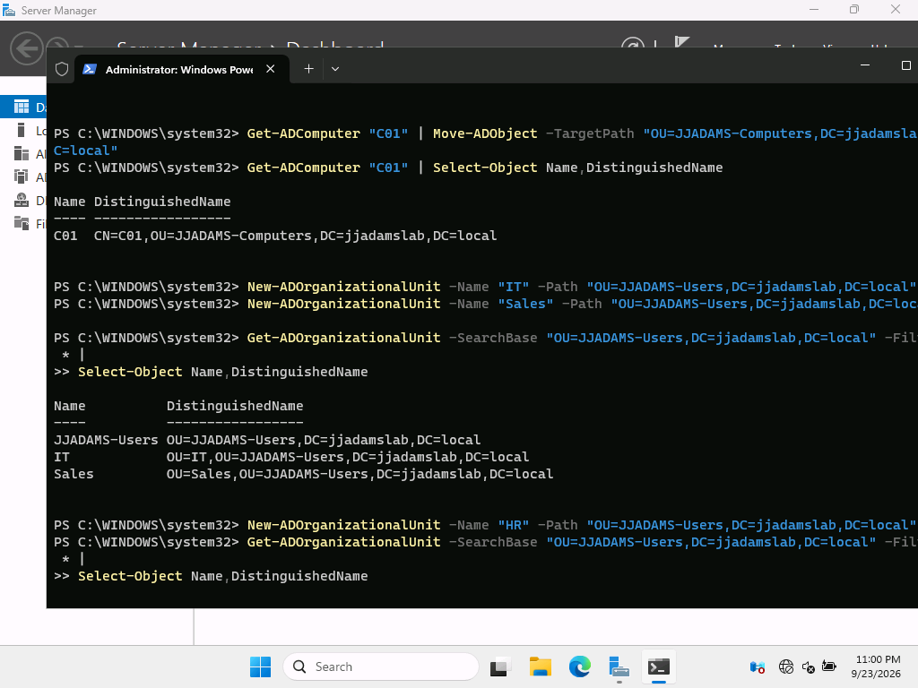

10. Group Policy Management console
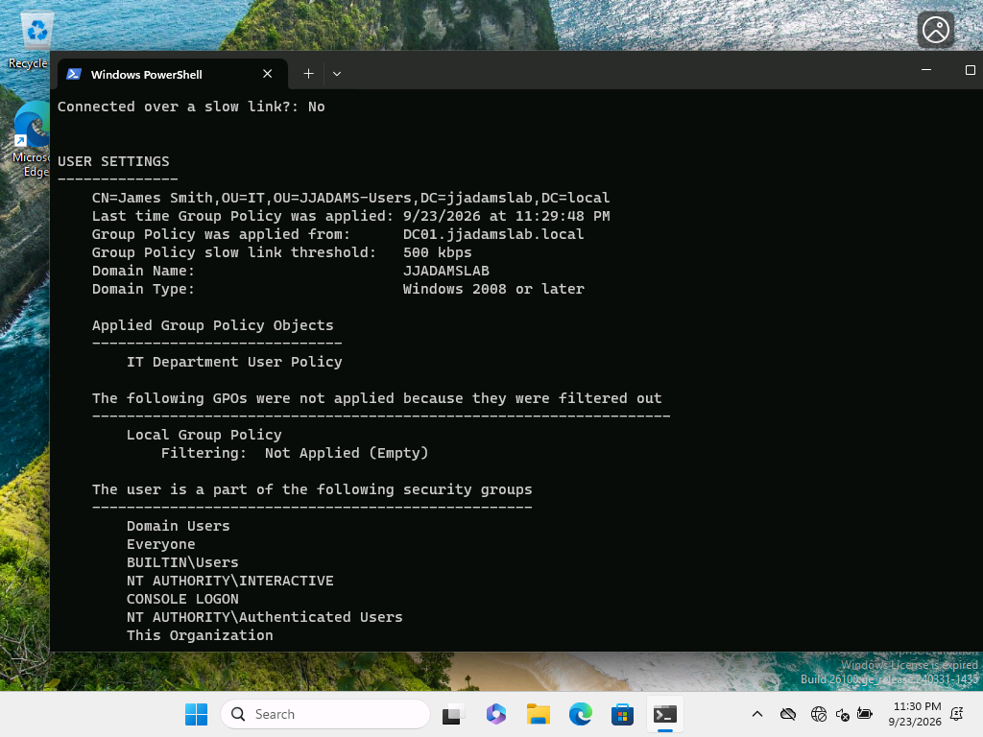

11. Group Policy result
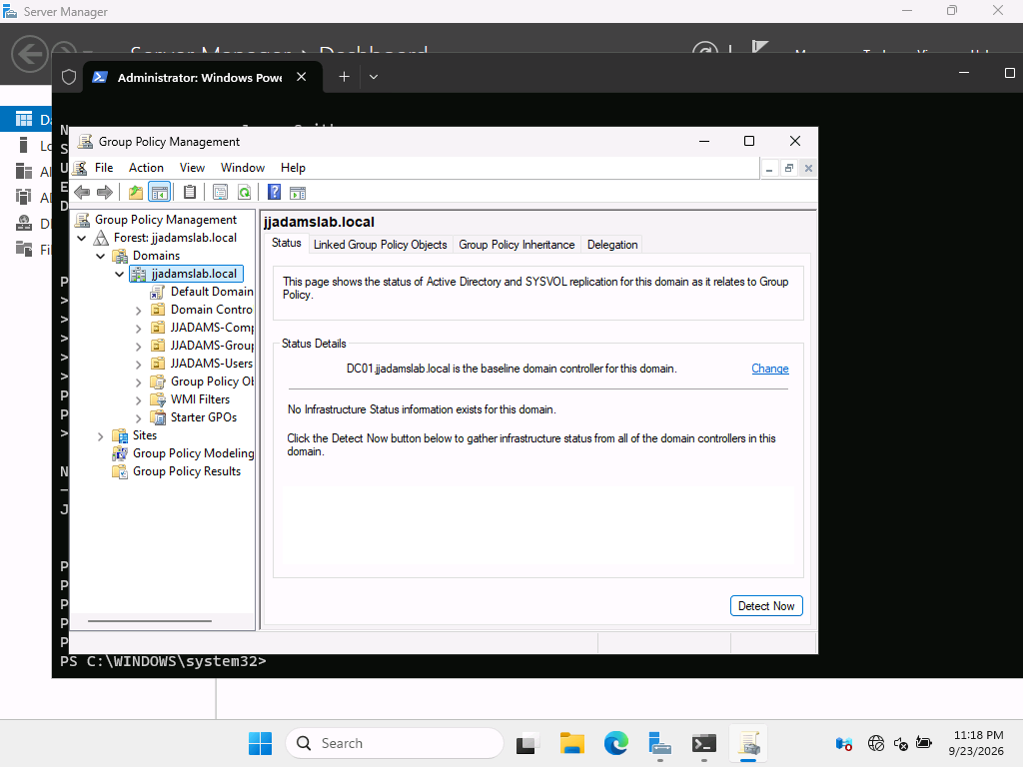
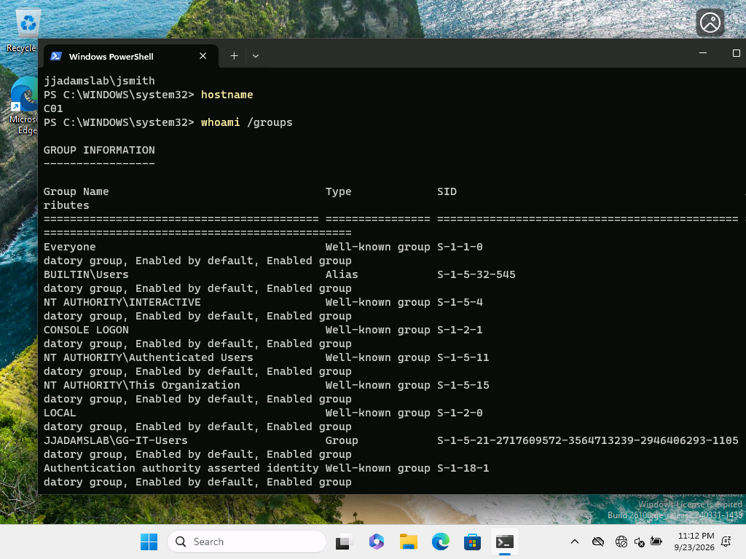

Skills Demonstrated
Windows Server 2025 • Active Directory • DNS • Group Policy • Hyper-V • Windows 11 • PowerShell • TCP/IP • User & Group Administration • Troubleshooting • Technical Documentation

Repository Structure
README.md — GitHub project landing page
screenshots/ — 11 curated project evidence images
docs/ — portfolio document and complete Standard Operating Procedure

Next Phase
DHCP, SMB file shares, NTFS permissions, mapped drives through Group Policy Preferences, printer deployment, account policies and additional troubleshooting scenarios.

