1.The following table shows the favourite sports of 300 students of a school.
(i) Create a bar chart with appropriate label and titles
(ii) Set the color of bar as red and width .2
(iii) Display the description of graph
Sports Cricket Football Hockey Badminton Swimming Tennis
No. of Students 80 40 20 30 45 75
code

import matplotlib.pyplot as plt
import numpy as np

x = np.array(["cricket", "football", "Hockey", "Badminton","Swimming","Tennis"])
y = np.array([80,40,20,30,45,75])

plt.title("favourite sports of 300 students of a school")
plt.xlabel("sports")
plt.ylabel("no of students")

plt.bar(x,y,width=.2,color='r')
plt.show()
output

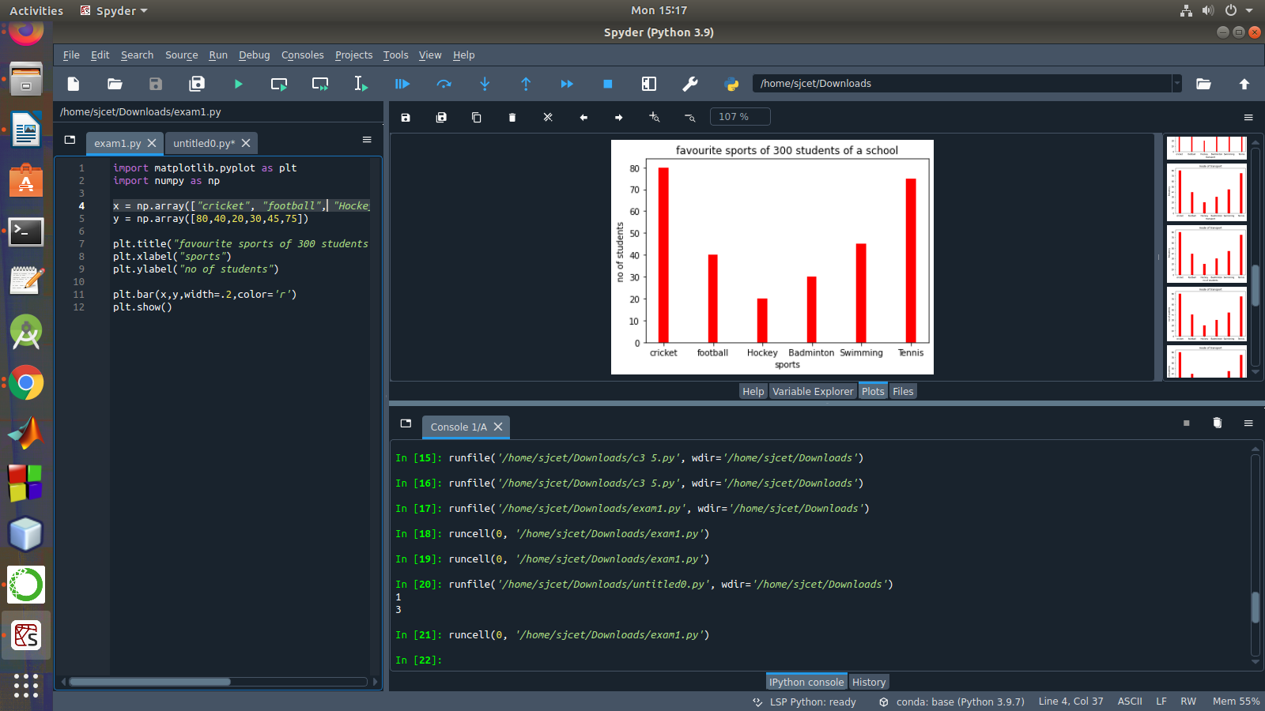

2. Write a Python program that accept a positive number and subtract from this number
the sum of its digits and so on. Continues this operation until the number is positive.
Code

def repeat_times(n):
s = 0
n_str = str(n)
while (n > 0):
n -= sum([int(i) for i in list(n_str)])
n_str = list(str(n))
s += 1
return s
print(repeat_times(9))
print(repeat_times(21))

output
