**VIẾT TRUY VẤN TRONG MÔI TRƯỜNG SQOOP**

**- Sắp xếp:**

**Theo giá đồ ăn**

sqoop eval \

--connect jdbc:mysql://localhost/QuanLyQuanAn \

--username sqoopdb \

--password 'Abc123456!@#' \

--query "SELECT * FROM DOAN ORDER BY price;"

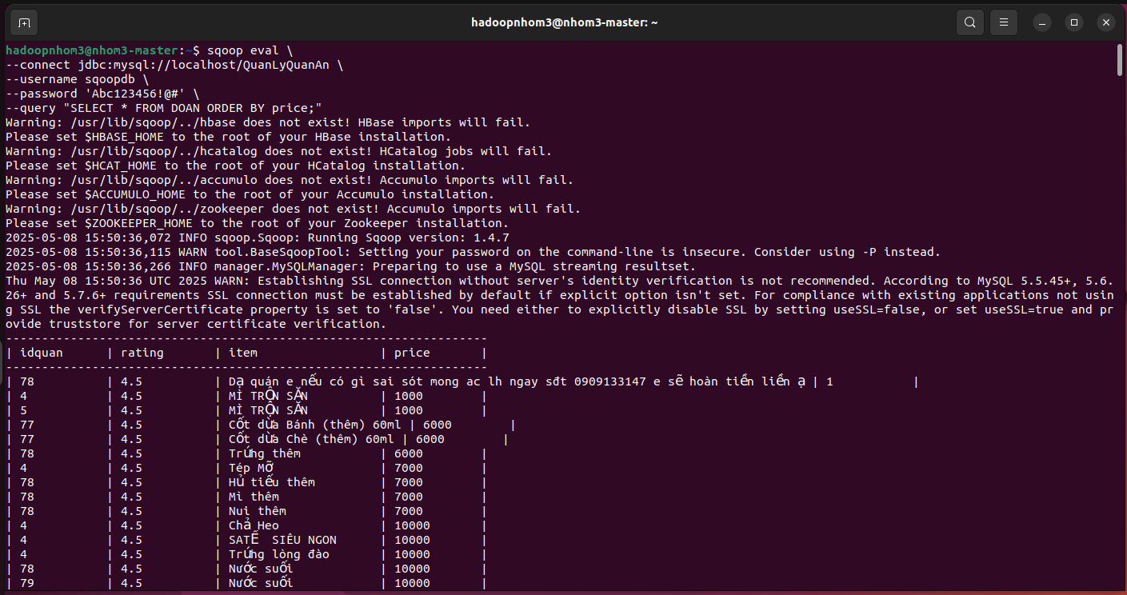

**Theo tên đồ ăn**

sqoop eval \

--connect jdbc:mysql://localhost/QuanLyQuanAn \

--username sqoopdb \

--password 'Abc123456!@#' \

--query "SELECT * FROM DOAN ORDER BY item;"

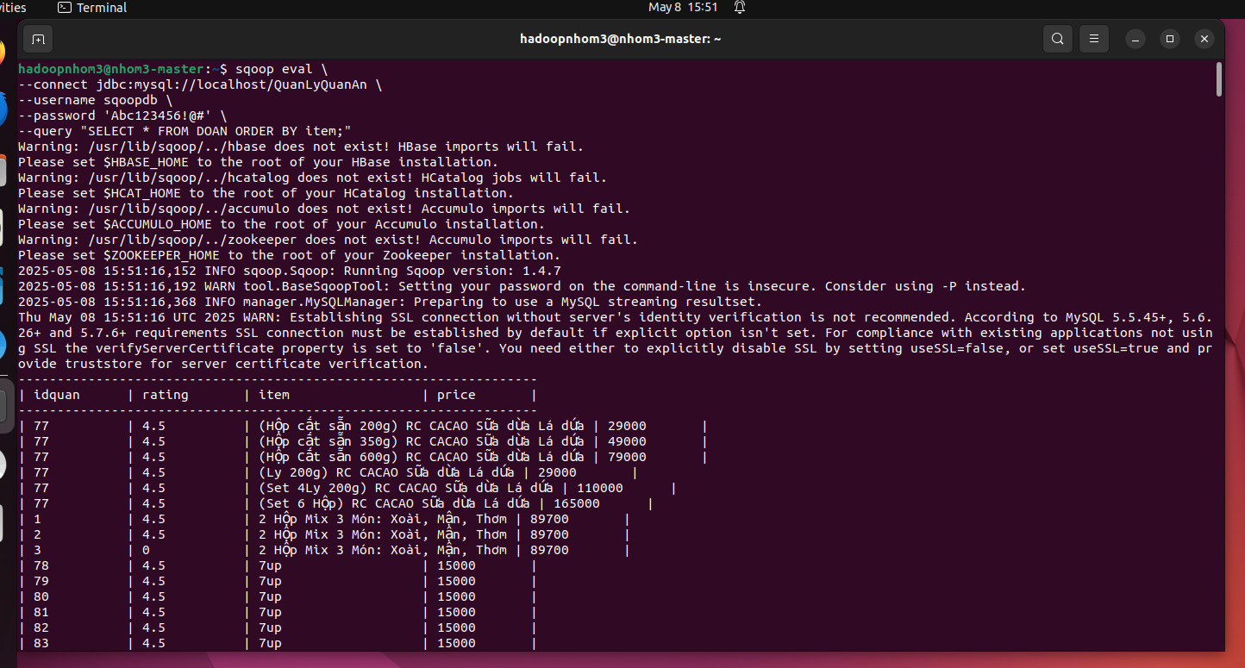

**Theo địa chỉ quán**

sqoop eval \

--connect jdbc:mysql://localhost/QuanLyQuanAn \

--username sqoopdb \

--password 'Abc123456!@#' \

--query "SELECT * FROM QUANAN ORDER BY diachi;"

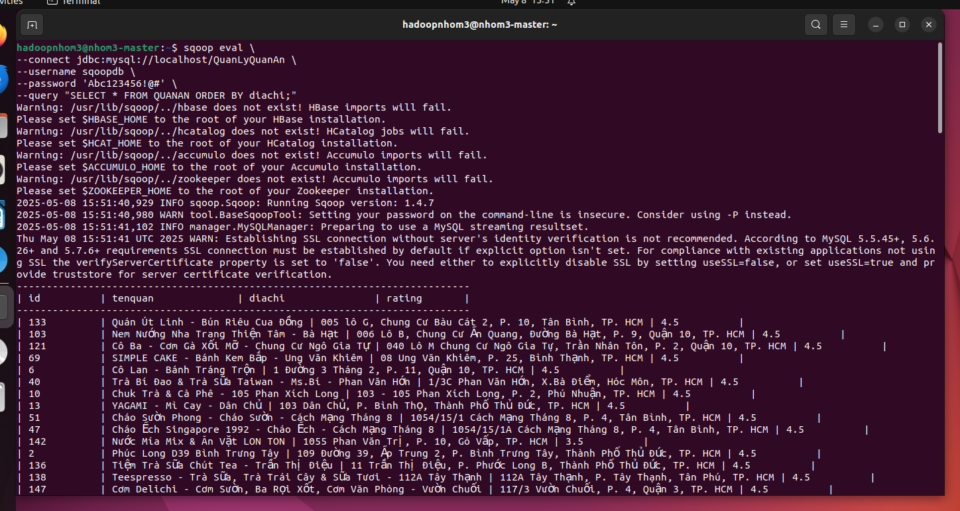

**Theo đánh giá**

sqoop eval \

--connect jdbc:mysql://localhost/QuanLyQuanAn \

--username sqoopdb \

--password 'Abc123456!@#' \

--query "SELECT * FROM QUANAN ORDER BY rating DESC;"

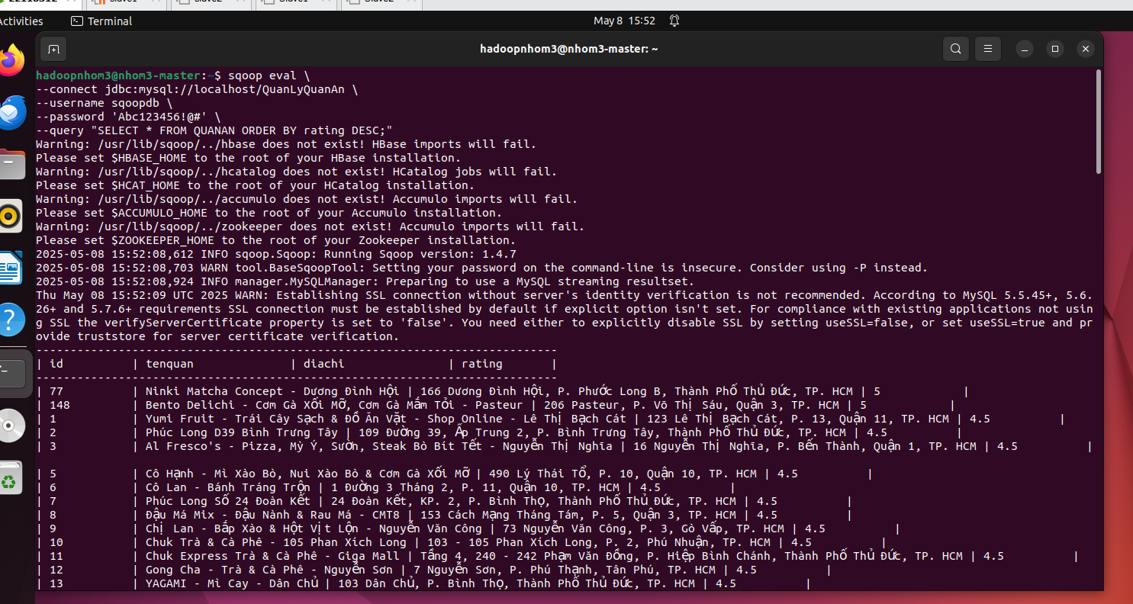

**- Create:**

**Insert dòng mới trong bảng quanan**

sqoop eval \

--connect jdbc:mysql://localhost/QuanLyQuanAn \

--username sqoopdb \

--password 'Abc123456!@#' \

--query "INSERT INTO QUANAN (id, tenquan, diachi, rating)

VALUES (151, 'Tên Quán Mới', 'Địa chỉ mới, Quận X, TP.HCM', 4.2);"

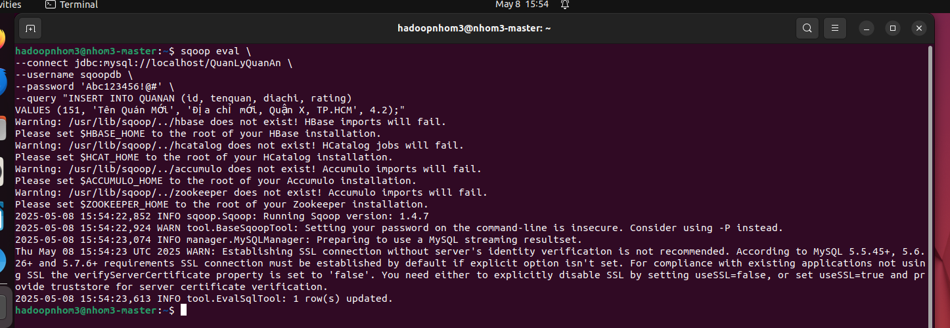

**Insert dòng mới trong bảng doan**

sqoop eval \

--connect jdbc:mysql://localhost/QuanLyQuanAn \

--username sqoopdb \

--password 'Abc123456!@#' \

--query "INSERT INTO DOAN(idquan, rating,item, price)

VALUES (150, 4.2, 'Món Ăn Mới', 35000);"

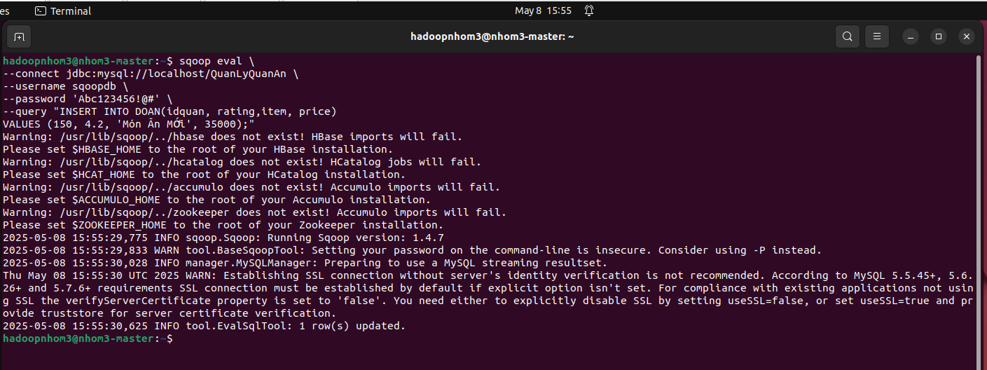

**- Read:**

**Hiện bảng quanan;**

SELECT * FROM QUANAN ;

sqoop eval \

--connect jdbc:mysql://localhost/QuanLyQuanAn \

--username sqoopdb \

--password 'Abc123456!@#' \

--query "SELECT * FROM QUANAN ;"

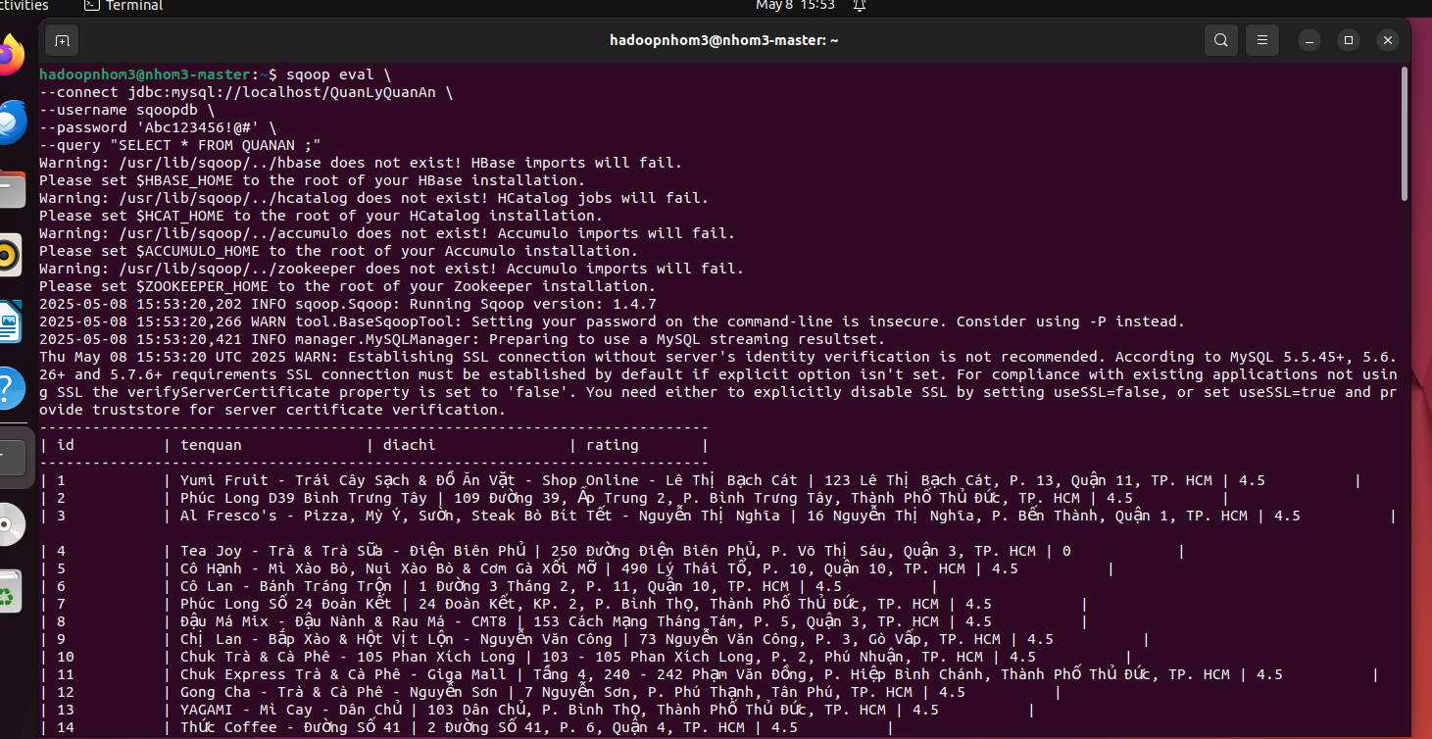

**Hoặc**

SELECT q.id AS MaQuanAn, q.ten_quan AS TenQuanAn, q.diachi AS DiaChiQuanAn, q.rating AS DanhGiaQuanAn,

d.ten_do_an AS TenDoAn, d.gia AS GiaDoAn

FROM QUANAN q

JOIN DOAN d ON q.id = d.idquan;

sqoop eval \

--connect jdbc:mysql://localhost/QuanLyQuanAn \

--username sqoopdb \

--password 'Abc123456!@#' \

--query "SELECT q.id AS MaQuanAn, q.tenquan AS TenQuanAn, q.diachi AS DiaChiQuanAn, q.rating AS DanhGiaQuanAn,

d.item AS TenDoAn, d.price AS GiaDoAn

FROM QUANAN q

JOIN DOAN d ON q.id = d.idquan;"

