Justice Clark

Dr. Pawar

Introduction to Biostatistics

4 February 2024

Comparing Standard Deviation and Variance

1. Standard Deviation
   1. Is a statistical test that tells you the “average amount of variability in your data set” (Pawar Slide 3).
      1. This test compares how far apart the data is from the mean value.
   2. Measured in their original units (minutes, meters, etc.)
   3. Formula = Square root of the Variance
      1. 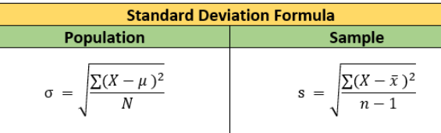
      2. For the Population Standard Deviation here are the variables:
         1. X = The individual value in the data you’re analyzing
         2. μ = Population Average or Mean
         3. N = Total number of observations or values
         4. σ = Standard Deviation of a population
      3. For the Sample Standard Deviation Formula here are the variables:
         1. X = The value in the data you’re analyzing
         2. x = Sample Average or Mean
         3. n = Total number of observations or values
         4. s = Standard Deviation of a sample
2. Variance (ANOVA):
   1. Is a statistical test used to assess group differences between populations ( ≥ 2).
      1. These tests assess whether populations significantly differ from each other.
   2. Formula;
      1. 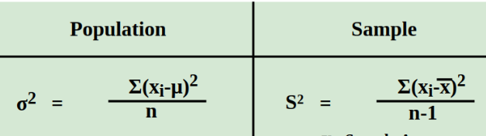
      2. For the Population Variance Formula here are the variables:
         1. xi = The individual population value in the data you’re analyzing
         2. μ = Population Average or Mean
         3. n = Total number of observations or values
         4. σ^2 = Population variance of a population
      3. For the Sample Variance Formula here are the variables:
         1. xi = The individual value in the data you’re analyzing
         2. x = Sample Average or Mean
         3. n = Total number of observations or values
         4. S^2 = Variance of a sample
   3. Measured in much larger units (m^2)
      1. Squares the original units of the standard deviation
3. Both of these tests analyze variability and differ based on the amount of populations they are analyzing.