 | NILE JOURNAL OF COMPUTING  Volume 1, Issue 1, 2026

Intelligent Hostel Management System: Automated Complaint Triage and Escalation for University Hostels
Chidubem Barack-Judah Oka^{1*}, Abdullah Bukola Ahmad¹, Khalid Onimisi Jimoh¹, Tirzah Ubong Akpakip¹, Alerege Olumayowa Jude¹, Chukuladi Obowu¹, and Johnwendy C.N.¹
¹Department of Computer Science, Faculty of Computing, Nile University of Nigeria, Abuja, Nigeria
*Corresponding Author: Chidubem Barack-Judah Oka
ABSTRACT:
KEYWORDS: complaint escalation, complaint triage, FastAPI, hostel management system, maintenance management, multi-tier architecture, room allocation, student accommodation.
I. INTRODUCTION
Student accommodation is one of the services a university has to run well every semester. Each session, hostel staff register students and assign bed spaces across the blocks, and they deal with faults in rooms and bathrooms as residents report them. In many Nigerian institutions this work still runs on paper files and visits to the hall office. At the Federal School of Surveying, Oyo, hostel, room and student records were held in a manual file system until a web-based replacement was built (Diyaolu et al., 2024). At Babcock University, students waited an average of 45 minutes at the hall office to be given a room, and reporting a fault meant a walk to reception that took about 30 minutes (Adewuyi et al., 2026).
Manual handling causes familiar problems. Records get lost or duplicated and rooms are misallocated, while administrators cannot tell how many bed spaces remain at a given moment (Adebanjo et al., 2026; Azeeta et al., 2021). Maintenance complaints fare worst. A complaint written in a book or reported at the counter has no priority or deadline, and nobody in particular is responsible for it, so a burst pipe waits in the same queue as a squeaking door.
Web-based hostel management systems have begun to close some of these gaps. Recent systems automate registration and room allocation and show live occupancy to administrators (Adebanjo et al., 2026; Yusof et al., 2026), and one implementation at Babcock University cut the wait for a room from 45 to 8 minutes and the time needed to lodge a complaint from 30 to 5 minutes (Adewuyi et al., 2026). These gains sit at the front of the process. Once a complaint has been lodged, it is typically stored for an administrator to review and update by hand (Adewuyi et al., 2026), and Eweoya et al. (2025) observe that many hostel systems still fail to integrate maintenance tracking at all.
Current hostel administration therefore has four drawbacks. First, room allocation in many hostels is still handled at the counter, which creates queues at resumption and errors in bed-space records (Adewuyi et al., 2026; Diyaolu et al., 2024). Second, complaints are recorded without an urgency level, so urgent faults receive no more attention than minor ones (Eweoya et al., 2025). Third, even systems that classify complaints by urgency set no resolution deadline and notify staff only inside the application, so nobody is alerted when a complaint is ignored (Yusof et al., 2026). Fourth, because occupancy and complaints are kept in separate paper records, administrators have no single view of either.
This study is guided by three research questions. How can a computerised system be applied to manage student hostel accommodation in universities? What methods have been used to allocate hostel rooms and to record hostel occupancy and complaints? What intelligent features can improve room allocation, maintenance handling and reporting in hostel management systems?
The aim of this study is to design and implement a web-based Intelligent Hostel Management System (IHMS) that automates room allocation and escalates unresolved maintenance complaints according to their urgency.
The aim is pursued through three objectives. The first objective is to design the four-tier architecture of the system, its relational database schema and role-based interfaces for students, maintenance officers, hall wardens and administrators. The second objective is to implement the student, staff and administrator portals, the five logic-tier modules (user management, room allocation, complaint management, complaint triage and escalation, and reporting) and the email notification and report export services. The third objective is to test the system's allocation rules, triage accuracy and escalation timing against representative hostel scenarios.
The main contribution of this work is a Complaint Triage and Escalation Engine. It gives every complaint a category, an urgency level, a responsible maintenance unit and a resolution deadline, then alerts the hall warden and, later, Student Affairs when that deadline passes. Section II reviews existing hostel management systems and identifies the gap this engine fills. Section III presents the research design and the system architecture.
II. RELATED WORKS
Research on computerised hostel administration falls into three groups: systems that digitise records and allocate rooms by rule, systems that optimise allocation with algorithms or machine learning, and systems that handle complaints and maintenance. The studies reviewed here were retrieved through Consensus using the three research questions, and each was checked against its published record. They are compared on five variables: system architecture, core features, technology stack, problem solved and unaddressed gap.
2.1 Record Digitisation and Rule-Based Allocation
Diyaolu et al. (2024) replaced the manual file system of Olayinka Hostel at the Federal School of Surveying, Oyo, with a web application built in HTML, CSS, PHP and MySQL. The system stores hostel, room and student records and supports hall allocation behind access control, but its scope ends at record keeping. Azeeta et al. (2021) went further at Covenant University, allocating students to halls and rooms automatically against defined constraints, again on PHP and MySQL, and reported that management could see the occupancy of every room at any time. Adebanjo et al. (2026) built a comparable allocation system for Babcock University on Django and SQLite. Their three-tier design enforces gender, category-eligibility and accessibility constraints, keeps audit logs and presents occupancy on a live dashboard. The authors leave AI-driven allocation optimisation to future work.
Together, these systems show that rule-based allocation is now an established feature, but none of them describes how a fault reported by a resident is prioritised or followed up. Eweoya et al. (2025), whose own Babcock system covers registration, allocation, maintenance and reporting on React, ASP.NET Core and SQL Server, note that many hostel systems still fail to integrate maintenance tracking.
2.2 Optimisation-Based Allocation
A second group treats allocation as a matching problem. M (2025) describes a web application that allocates rooms with a genetic algorithm according to student preferences, and generates barcodes that students scan at the hostel gate and in the mess. Kumar et al. (2026) implemented a system on the MERN stack (MongoDB, Express.js, React and Node.js) in which a Random Forest model recommends room assignments from historical occupancy, student preferences and complaint records. It reached an allocation precision of 94.2% with a mean API response time of 80 ms under a simulated load of 5,000 users. Heda et al. (2025) report 92% student satisfaction with room allocation in simulation tests of DHMS (Digital Hostel Management System), which combines allotment with a campus chatbot and predictive maintenance planning.
These approaches aim at better matches, but the machine-learning ones depend on data that an institution leaving paper records does not yet have. The model of Kumar et al. (2026) must be trained on historical occupancy and complaint data, and Heda et al. (2025) state that their system still needs testing across multiple hostel blocks, under load and with users before campus-wide deployment.
2.3 Complaint and Maintenance Handling
The third group addresses what happens after a resident reports a problem. Adewuyi et al. (2026) built a three-tier system on Next.js, Express and MongoDB in which students lodge complaints online, where they are stored for administrators to review and update. The 83.33% saving they report is for lodging a complaint, which fell from 30 minutes on foot to 5 minutes online; the abstract describes this figure as complaint resolution time. Gnanagurusubbiah et al. (2026) route maintenance complaints to the responsible department and show students live status updates in their MERN-based StudentConnect system, alongside late-permission requests and QR gate passes. StudentConnect does not handle room allocation.
Two systems go further. StaySmart classifies each maintenance complaint into one of five issue types and assigns an urgency level of Urgent, Normal or Low using keyword rules, reaching 93.3% category accuracy and 86.7% priority accuracy on 15 test complaints (Yusof et al., 2026). The urgency level does not set a deadline, however, and administrators still update statuses by hand. Notifications appear only inside the application, and the authors list external notifications as future work. HostelHQ, built on Django and SQLite, includes a chatbot that answers common questions, accepts complaints and has an escalation process that passes unresolved issues to wardens or managers (Kusalkar et al., 2025). The escalation is described as a function of the chatbot, and the system reports no urgency levels or resolution deadlines for complaints.
2.4 Cross-Cutting Limitations
The clearest limitation shared by these systems is that complaint handling stops at intake. They make complaints easier to submit but leave follow-up to staff who must remember to check (Adewuyi et al., 2026; Eweoya et al., 2025). Where urgency is assigned, it carries no consequence: none of the reviewed systems reports tying urgency to a resolution deadline or escalating a complaint automatically once that deadline passes (Kusalkar et al., 2025; Yusof et al., 2026). The evidence itself is also thin in places, since much of it comes from simulations or small usability tests rather than live hostel operation (Heda et al., 2025; Yusof et al., 2026).
2.5 Summary of Audited Systems
TABLE I: Summary of Related Systems Audited Across the Five Project Variables
Study & Year | Architecture | Core Features | Tech Stack | Problem Solved | Unaddressed Gap
Azeeta et al. (2021) | Web client–server | Constraint-based hall and room allocation; occupancy statistics | PHP, MySQL | Slow manual allocation | No complaint or maintenance handling
Diyaolu et al. (2024) | Web client–server | Hostel, room and student records; hall allocation | HTML, CSS, PHP, MySQL | Manual file records | Record keeping only; no complaint workflow
Eweoya et al. (2025) | Web client, REST API, relational database | Registration, allocation, maintenance, reporting | React, ASP.NET Core, SQL Server | Fragmented hostel operations | No complaint prioritisation or escalation described
Kusalkar et al. (2025) | Web, role-based access | Chatbot queries and complaints; escalation of unresolved chatbot issues; fees; attendance | Django, SQLite | Delays and errors in manual records and complaints | Escalation is a chatbot function; no urgency levels or deadlines reported
Heda et al. (2025) | Modular web, cloud and AI services | Allotment, grievances, gate passes, chatbot, predictive maintenance | Web, AI, cloud | Fragmented communication and delays | Simulation only; deployment testing outstanding
M (2025) | Web application | Genetic-algorithm allocation by preference; barcode entry, exit and mess scanning; cleaning requests to warden | Web application, genetic algorithm | Manual hostel workload | Cleaning requests sent to the warden with no priority or follow-up reported
Adebanjo et al. (2026) | Three-tier | Constraint allocation, occupancy dashboard, audit logs | Django, SQLite, Plotly | Misallocation and poor records | Allocation only; no complaint escalation
Adewuyi et al. (2026) | Three-tier | Room requests, online complaint lodging, events, room checks | Next.js, Express, MongoDB | Queues for rooms and for lodging complaints | Complaints reviewed manually; no priority or deadline
Gnanagurusubbiah et al. (2026) | MERN web | Complaint routing with live status; late permissions; QR gate pass | MongoDB, Express, React, Node.js | Paper approvals; uncontrolled complaint logs | No allocation; no urgency or deadline
Kumar et al. (2026) | MERN with ML model | Random Forest room assignment; real-time dashboards; facility tracking | MERN, Random Forest | Inefficient allotment; low facility visibility | Needs historical training data
Yusof et al. (2026) | Three-tier, role-based access | Gender-constrained allocation; keyword complaint classification with urgency | PHP, MySQL, HTML, CSS, JavaScript | Inconsistent manual processes | Urgency without deadline or escalation; in-app alerts only

2.6 Proposed Improvement and Value-Add Delta
The reviewed systems provide registration, rule-based room allocation and complaint logging, and one of them adds urgency classification. None turns that classification into a deadline the system enforces. The proposed IHMS keeps the established features and adds a Complaint Triage and Escalation Engine. The engine classifies each complaint and sets a deadline from its urgency, then escalates the complaint automatically if the deadline passes. Table II compares existing practice with the proposed contribution.
TABLE II: Value-Add Comparison (Existing Practice vs. Proposed IHMS)
Functional Area | Existing Practice | Proposed IHMS Contribution (Value-Add Delta)
Room allocation | Counter queues and paper registers; rule-based in some systems | Automatic bed-space assignment checked against fee clearance, gender, level and vacancy
Complaint intake | Paper book or counter visit; online forms where the student picks a category | Keyword triage sets category, urgency and responsible maintenance unit at submission
Complaint follow-up ★ | Staff review complaints manually; no deadline; in-app notice at best | Deadline set by urgency; overdue complaints escalated by email to the hall warden, then to Student Affairs
Occupancy and reporting | Spreadsheets; occupancy dashboards in some systems | Live bed-space dashboard with overdue counts, resolution times and recurring-fault rooms

Because the engine works from keyword and time rules, it needs no historical training data, and it records when each person was alerted about a complaint.
III. METHODOLOGY
3.1 Research Design
This study follows Design Science Research (DSR), the paradigm used in information systems when the main output of a study is an artefact built to solve a practical problem (Hevner et al., 2004). Behavioural research seeks to explain or predict how people and organisations act; design science instead extends what they can do by building and evaluating new artefacts (Hevner et al., 2004). Wieringa (2014) describes this work as a cycle between two activities: designing an artefact that improves something for its stakeholders, and investigating how that artefact performs in its context. Figure 3.1 shows the cycle as applied to the IHMS.
The design activity takes its requirements from the literature audit in Section II. Its outputs are the architecture and modules in Sections 3.2 to 3.4, including the triage rules in Table IV. The investigation activity tests each module and the escalation behaviour against hostel scenarios (Section 3.7), and its findings feed back into the design. In line with departmental guidelines, the architecture is fully specified before implementation begins. Every module that is built can then be traced back to a component in the architecture and to a gap in the literature.
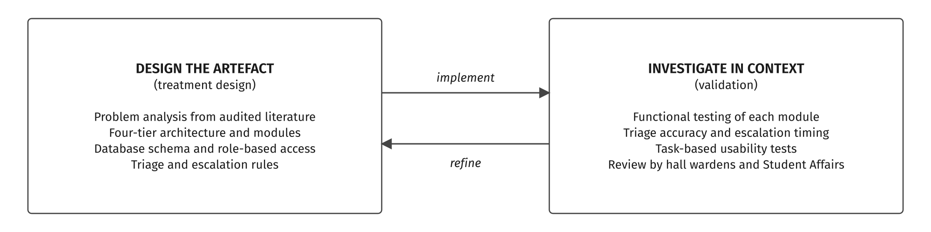
Figure 3.1: Wieringa's (2014) Design Science Research Cycle Applied to the IHMS
3.2 System Architecture
The IHMS uses a four-tier architecture that separates presentation, business logic, data storage and outbound services (Table III, Figure 3.2). Each tier can be changed without redesigning the others, and access rules are enforced on the server, so no portal can reach data its role does not permit.
TABLE III: Architectural Tiers and Component Allocation
Tier | Responsibility | Components
Client Tier | User interaction | Student Portal, Staff Dashboard, Admin Dashboard
Logic Tier | Business rules and workflow | User Management, Room Allocation, Complaint Management, Complaint Triage and Escalation Engine, Reporting
Data Tier | Persistence | PostgreSQL relational database; complaint history and audit log
Output Tier | Notifications and reports | Email notification service; CSV and printable report export

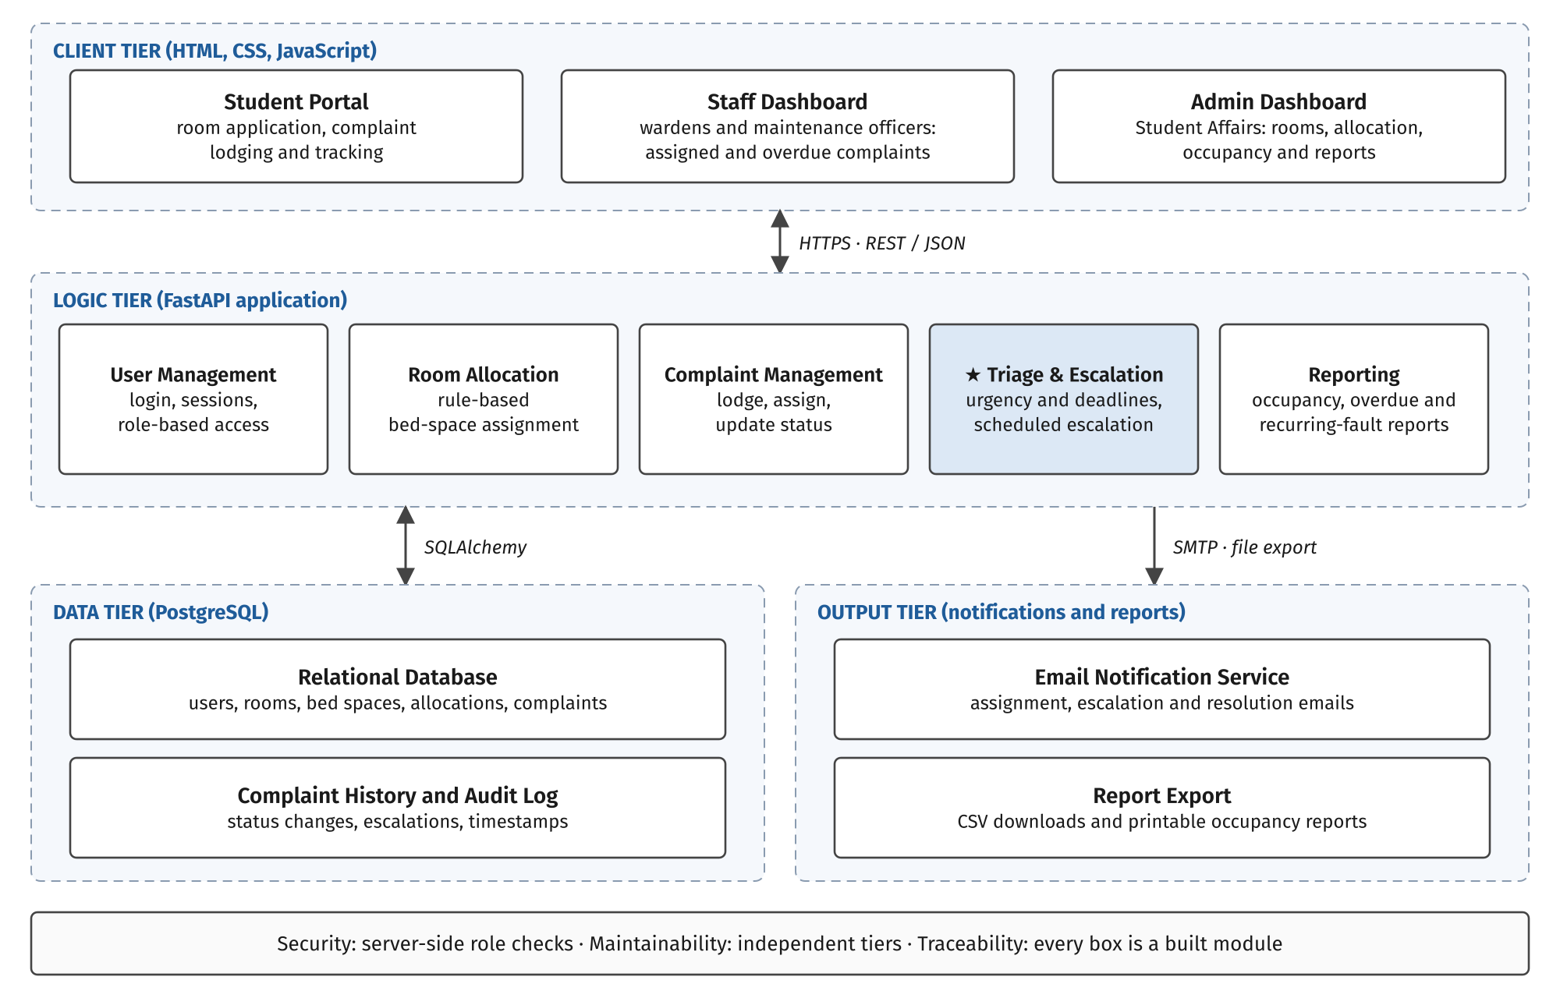
Figure 3.2: Four-Tier System Architecture of the IHMS
3.3 Functional Modules
Client Tier. The three portals are HTML, CSS and JavaScript pages that call the logic tier through REST endpoints. The Student Portal lets a student apply for a bed space, view the allocation, lodge a complaint about their room and follow its status. The Staff Dashboard shows hall wardens and maintenance officers the complaints assigned to their unit, ordered by deadline, with overdue items highlighted. The Admin Dashboard gives Student Affairs control of hostels, rooms and allocation rounds, and access to occupancy and complaint reports.
Logic Tier. The User Management module registers users, hashes passwords, issues session tokens and enforces four roles: student, maintenance officer, hall warden and administrator. The Room Allocation module assigns bed spaces automatically. An applicant becomes eligible once the bursary has marked their fees as cleared, and is then placed in a vacant bed in a block that matches their gender and level. The Complaint Management module records each complaint against a room, assigns it to a maintenance unit and tracks its status from Open through Assigned and In Progress to Resolved. The Reporting module computes occupancy by block, average resolution time by urgency, overdue counts and rooms with recurring faults, defined as three or more complaints of the same category in one room within 30 days.
The Complaint Triage and Escalation Engine is the value-add module. When a complaint is submitted, the engine matches its description against keyword lists to set a category (plumbing, electrical, carpentry, sanitation or other) and an urgency level, following the keyword approach evaluated by Yusof et al. (2026). The urgency level fixes the resolution deadline d shown in Table IV. A scheduled job runs every 15 minutes and computes the escalation level L of each open complaint from the time t elapsed since it was submitted:
L = 0 if t < d; L = 1 if d ≤ t < 2d; L = 2 if t ≥ 2d (1)
At level 1 the hall warden is emailed. At level 2 Student Affairs is emailed and the complaint is flagged on the Admin Dashboard. Every escalation is written to the audit log, so the time at which each person was alerted can be checked later.
Keyword rules have a known weakness: they fail when students describe a fault in words the list does not contain, or mix languages, which Yusof et al. (2026) report as the main limitation of their classifier. A viable alternative for the triage step is Jev, a "System One" classification model from TypeSafe. Instead of generating text, Jev answers a typed question about the input it is given. For a Choice question, the triage module sends the complaint description as the state, an instruction such as "Which maintenance category does this complaint belong to?", and a short description of each category; Jev returns the selected category, a probability for every category and a confidence score (TypeSafe, 2026b). A second Choice question over the same complaint returns the urgency level, and both questions are evaluated in parallel in one request. Because Jev reads the description as language rather than matching fixed words, a complaint such as "water dey drip from ceiling since morning" can still be placed under plumbing without that phrase appearing in any keyword list. Low-confidence results can fall back to the keyword rules or to a warden's review, so the escalation deadlines in Table IV still apply.
The cost is low enough for a university hostel. Jev is billed at US$0.042 per million input tokens, and output is free (TypeSafe, 2026a). A complaint with its two questions comes to roughly 500 input tokens, so 10,000 complaints in a semester would use about 5 million tokens and cost about US$0.21. The trade-off is a dependence on an external API and an internet connection, so the IHMS keeps the keyword rules as the default and treats Jev as a configurable option for the triage step.
TABLE IV: Urgency Levels, Deadlines and Escalation Targets
Urgency | Example Keywords | Deadline (d) | Level 1 (t ≥ d) | Level 2 (t ≥ 2d)
Urgent | burst, flood, spark, exposed wire, no water, broken lock | 24 hours | Hall warden | Student Affairs
Normal | leaking tap, faulty socket, broken bed, blocked drain | 72 hours | Hall warden | Student Affairs
Low | paint, loose handle, squeaking door | 7 days | Hall warden | Student Affairs

Data Tier. PostgreSQL stores users, hostels, rooms, bed spaces, allocations and complaints in related tables. A unique constraint on the active allocation of each bed space prevents double allocation at the database level. A separate complaint history table records every status change and escalation with a timestamp, and also supplies the data for resolution-time reports.
Output Tier. The Email Notification Service sends messages over SMTP when an allocation is confirmed and when a complaint is assigned, escalated or resolved. The Report Export service produces CSV files and printable occupancy reports for Student Affairs.
3.4 Data Flows
Four flows connect the users, the logic tier and the data tier. They are summarised in Table V and drawn in Figure 3.3.
TABLE V: System Operational Data Flows (F1 to F4)
Flow | Actor | Process | System Response
F1: Room Allocation | Student | Submits a room application | Checks fee clearance, gender, level and vacancy; assigns a bed space and emails confirmation
F2: Complaint Triage | Student | Lodges a complaint with room and description | Sets category, urgency, maintenance unit and deadline; emails the maintenance officer
F3: Overdue Escalation | Scheduler | Checks open complaints every 15 minutes | Emails the hall warden after the deadline and Student Affairs after twice the deadline; logs each escalation
F4: Resolution and Reporting | Maintenance officer, administrator | Marks the complaint resolved; opens reports | Notifies the student; updates resolution times, overdue counts and the recurring-fault list

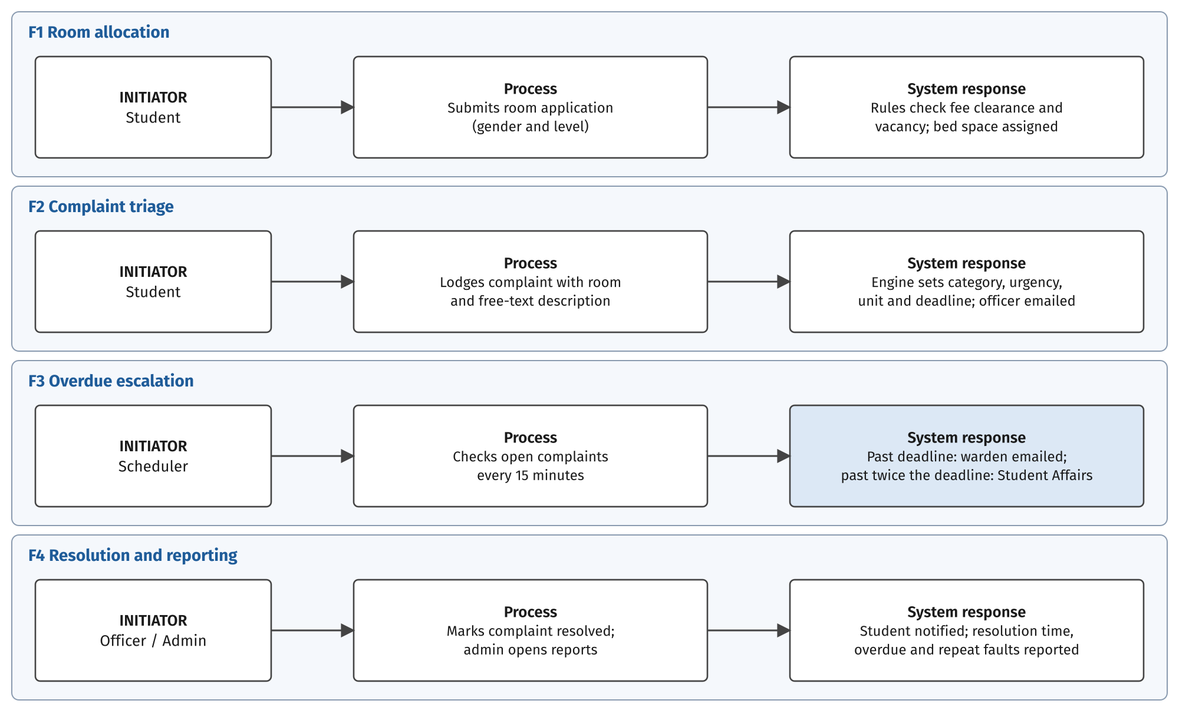
Figure 3.3: End-to-End System Operational Data Flows
3.5 Technology Stack
The course scope for this project fixes FastAPI for the backend, a relational database and plain HTML, CSS and JavaScript for the frontend. Within that scope, each choice was judged on how well it suits its tier and how easily the group can build and maintain it.
TABLE VI: Technology Selection and Rationale
Layer | Technology | Rationale
Frontend | HTML, CSS, JavaScript (Fetch API) | Runs in any browser with no build step; the portals are forms, tables and status lists
Backend | FastAPI (Python) with Pydantic | Validates every request and generates interactive API documentation, which speeds up endpoint testing
Database | PostgreSQL with SQLAlchemy | Relational integrity for allocations; unique constraints prevent double allocation; time-zone-aware timestamps for deadlines
Triage classifier (optional) | TypeSafe Jev API | Reads free-text complaints beyond a fixed keyword list; returns category, urgency and probabilities at US$0.042 per million input tokens
Scheduling | APScheduler | Runs the 15-minute escalation check inside the FastAPI process without a separate server
Notifications | SMTP email | Works with existing university email accounts at no per-message cost
Security | Bcrypt password hashing; JSON Web Tokens | Well-supported session handling for role-based access

3.6 Design Traceability
Each major design decision answers a limitation identified in Section II. Keyword triage at submission responds to complaints being logged without priority (Adewuyi et al., 2026; Eweoya et al., 2025), and reuses the approach that Yusof et al. (2026) showed could classify complaints with 93.3% accuracy. Urgency-based deadlines and two-level escalation respond to the absence of enforced follow-up in the reviewed systems (Kusalkar et al., 2025; Yusof et al., 2026). Email notification responds to StaySmart's reliance on in-application notices, which reach staff only when they open the application (Yusof et al., 2026). Rule-based allocation was chosen over machine-learning allocation because a hostel moving off paper records has no historical data to train a model (Kumar et al., 2026), while constraint rules have already worked in Nigerian institutions (Adebanjo et al., 2026; Azeeta et al., 2021). The unique bed-space constraint responds to the misallocation reported under manual systems (Adebanjo et al., 2026).
3.7 Evaluation Plan
Following DSR practice (Hevner et al., 2004; Wieringa, 2014), the IHMS will be evaluated in four ways. Unit and integration tests will check each module, including the allocation rules and an attempt to allocate a bed that is already occupied. For triage accuracy, hostel staff will label a set of sample complaints, and the categories and urgency levels the engine assigns will be compared with those labels.
Escalation timing will be tested by creating complaints with past submission times and confirming that level 1 and level 2 alerts fire at d and 2d and appear in the audit log. Finally, students, maintenance officers and hall wardens will complete task-based usability sessions, followed by a structured walkthrough with Student Affairs staff to judge how well the system fits current hostel procedures.
REFERENCES
Adebanjo, A. S., Kelechi, J. S., Adebanjo, O. A., Awoniyi, A. O., & Adewuyi, O. J. (2026). Design and implementation of a hostel allocation system. Global Journal of Engineering and Technology Advances, 28(2), 193–207. https://doi.org/10.30574/gjeta.2026.28.2.0171
Adewuyi, J. O., Kazeem, S., Ibukun, E., Ajao, A. O., Udosen, A. A., Adediran, O., & Daramola, C. J. (2026). Design and implementation of automated secure web-based hostel management system with automated room allocation and complaint tracking. Global Journal of Engineering and Technology Advances, 26(2), 72–83. https://doi.org/10.30574/gjeta.2026.26.2.0345
Azeeta, A., Misra, S., Odusami, M., Peter, O. U., & Ahuja, R. (2021). An intelligent student hostel allocation system based on web applications. In P. K. Singh, Y. Singh, M. H. Kolekar, A. K. Kar, J. K. Chhabra, & A. Sen (Eds.), Recent innovations in computing (pp. 779–791). Springer. https://doi.org/10.1007/978-981-15-8297-4_62
Diyaolu, A. M., Abodunrin, O. B., Adedamola, A. A., Ogunode, R. S., & Omoloba, O. (2024). Development of an e-based hostel management system. International Journal of Innovative Science and Research Technology, 1000–1009. https://doi.org/10.38124/ijisrt/IJISRT24JUN147
Eweoya, I., Awoniyi, A., Adeniyi, O., Okesola, K., Udosen, A., Adigun, T., Fatade, O., & Amusa, A. (2025). Development of web-based hostel management system. British Journal of Computer, Networking and Information Technology, 8(1), 30–41. https://doi.org/10.52589/BJCNIT-45VTYPQO
Gnanagurusubbiah, S., Manivannan, D., & Kumar, A. S. (2026). StudentConnect: A digital solution for managing late permissions and maintenance complaints in hostels. Premier Journal of Science. https://doi.org/10.70389/PJS.100215
Heda, R., Singh, S., Yasir, U., Jaiswal, T., & Mokhade, A. (2025). DHMS: A digital hostel management system integrating campus chatbot, predictive intelligence, and real-time automation (arXiv:2507.17759) [Preprint]. arXiv. https://doi.org/10.48550/arXiv.2507.17759
Hevner, A. R., March, S. T., Park, J., & Ram, S. (2004). Design science in information systems research. MIS Quarterly, 28(1), 75–105. https://doi.org/10.2307/25148625
Kumar, J. M. S. V. R., Charishma, B., Prasanna, K., Srija, D. A., Neelima, D., & Harshitha, B. (2026). Hostel management system with ML-based room vacancy prediction and real-time facility tracking for fresher. In 2026 International Conference on Data Science, Agents and Artificial Intelligence (ICDSAAI) (pp. 1–6). IEEE. https://doi.org/10.1109/ICDSAAI69492.2026.11505108
Kusalkar, S., Kamble, A., Kadam, S., & Patil, D. (2025). HostelHQ: An intelligent hostel management system. International Journal of Scientific Research in Engineering and Management, 9(10), 1–9. https://doi.org/10.55041/IJSREM52870
M, A. (2025). Automated hostel management system. International Journal of Scientific Research and Engineering Trends, 11(1), 818–825. https://doi.org/10.61137/ijsret.vol.11.issue1.170
TypeSafe. (2026a). Models [Technical documentation]. Retrieved October 7, 2026, from https://docs.typesafe.ai/models
TypeSafe. (2026b). Choice [Technical documentation]. Retrieved October 7, 2026, from https://docs.typesafe.ai/primitives/choice
Wieringa, R. J. (2014). Design science methodology for information systems and software engineering. Springer. https://doi.org/10.1007/978-3-662-43839-8
Yusof, N., Nizan, N. H. A. S., Ibrahim, N. K., Othman, Z., & Yusof, A. S. (2026). StaySmart: A web-based hostel management system for student accommodation. International Journal of Research and Innovation in Social Science, 10(3), 436–444. https://doi.org/10.47772/IJRISS.2026.100300027

