Lab #2: Class Construction

*Judah Wilson*

*09/16/2024*

**Algorithm**

**\*\*\*\*\*\*\*\*\*\*\*\*\*\*\*\*\*\*\*\*\*\*\*\*\*\*\*\*\*\*\*\*\*\*\*\*\*\*\*\*\*\*\*\*\*\*\*\*\*\*\*\*\*\*\*\*\*\*\*\*\*\*\*\*\*\***

**PaintDriver.cpp**

* This will hold the least amount of code and work with the information from the “Room.h” and “Room.cp”
* roomone.calcVolume(); - This function will calculate the volume of the room sing the given variables (Area, Width, Height)
* roomone.calcPaintedArea(); - This function will calculate the surface that needs to be painted and return the total number of gallons needed to be able to paint the room with the given rooms
* roomone.printResults(); - This function will print the results of the given information and the calculated information requested by the user

**\*\*\*\*\*\*\*\*\*\*\*\*\*\*\*\*\*\*\*\*\*\*\*\*\*\*\*\*\*\*\*\*\*\*\*\*\*\*\*\*\*\*\*\*\*\*\*\*\*\*\*\*\*\*\*\*\*\*\*\*\*\*\*\*\*\*\*\*\*\*\*\*\*\*\*\*\*\***

**Room.h & Room.cpp**

* Room.cpp holds the most code as it calculates the and works with the input given by the user
* Room::Room() – This function holds the variables for the room.h
* void Room::calcVolume() - This function calculates the volume of the room
* void Room::calcPaintedArea() – This function calculates the total surface area that needs to be painted
* void Room::printResults() const – This function will print the results and be kept constant so it cant be changed
* float Room::setLength() – This function will be used to ask the user to input the room length and later return the information (which will be kept constant)
* float Room::setHeight() - This function will be used to ask the user to input the room height and later return the information (which will be kept constant)
* float Room::setWidth() – This function will be used to ask the user to input the room width and later return the information (which will be kept constant)

**\*\*\*\*\*\*\*\*\*\*\*\*\*\*\*\*\*\*\*\*\*\*\*\*\*\*\*\*\*\*\*\*\*\*\*\*\*\*\*\*\*\*\*\*\*\*\*\*\*\*\*\*\*\*\*\*\*\*\*\*\*\*\*\*\*\*\*\*\*\*\*\*\*\*\*\*\*\***

**Screen-Shots of Running Program**

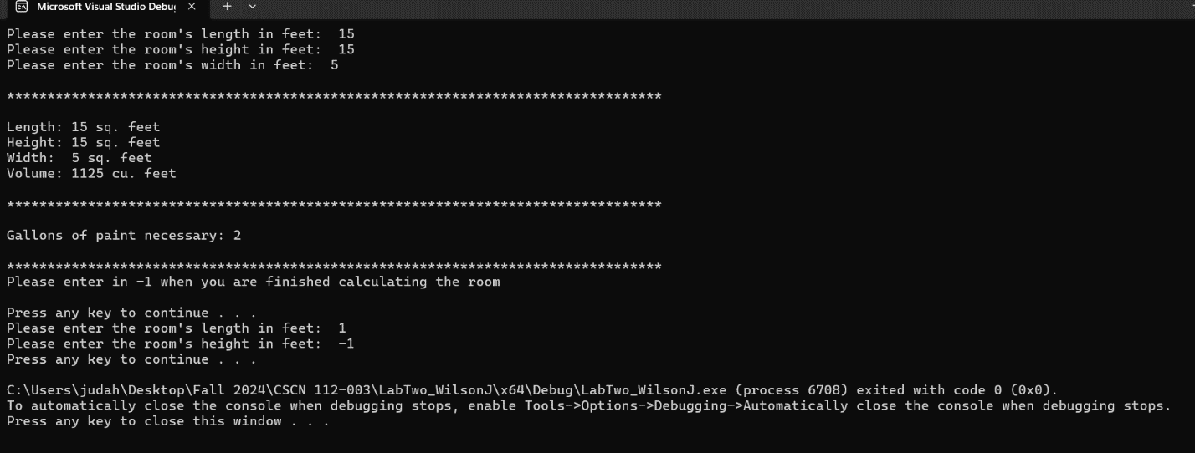

**Integrity Statements**

* I have not shared the source code in my program with anyone other than the pre-approved human sources.
* I have not used source code obtained from another student, or any other unauthorized source, either modified or unmodified.
* If any source code or documentation used in my program was obtained from another source, such as the course textbook or course notes, that has been clearly noted with a proper citation in the comments of my program.
* I have not knowingly designed this program in such a way as to defeat or interfere with the normal operation of any machine it is graded on or to produce apparently correct results when in fact it does not.