# Register:

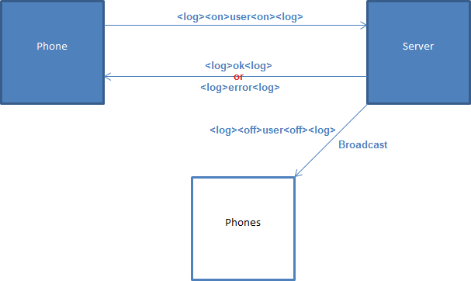

# Login:

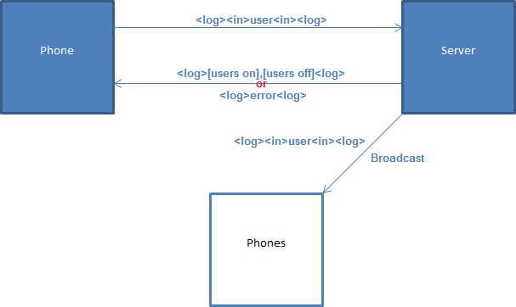

List example:

-<log><on>user0<on><on>user1<on><on>user2<on><off>user3<off><off>user4<off><log>

# Logoff:

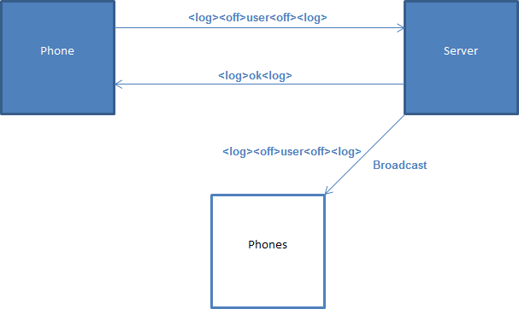

# Call:

