Design and Evaluation of a Lightweight Behavioural Intrusion Detection System for Resource-Constrained Networks
Author(s): [To be completed] | Department: [To be completed] | Institution: [To be completed]
Supervisor: [To be completed] | Email: [To be completed]

Abstract
This study benchmarks signature-based Snort 3 (4,026 Community Rules) against lightweight behavioural ML models (Random Forest, XGBoost, small MLP) on CICIDS2017-derived features for resource-constrained networks. On the Friday held-out test subset (n=123,161), XGBoost achieved F1=0.9981 (FPR=0.00169), RF F1=0.9962, MLP F1=0.9822, while correlated-flow Snort achieved F1=0.5038 (Precision=0.6906, Recall=0.3966, FPR=0.09881). Under emulated 1-core constraints, ML batch inference was efficient (XGB ~134k flows/s, ~333 MiB; MLP ~542k flows/s); Snort offline processed the 8.84 GB Friday PCAP in 595.44 s (14.16 MB/s, ~201 MiB peak RSS). Results support lightweight behavioural IDS for constrained deployments, with hybrid potential.

Fig. 7. ML vs Snort 3 on Friday Held-out Test Subset
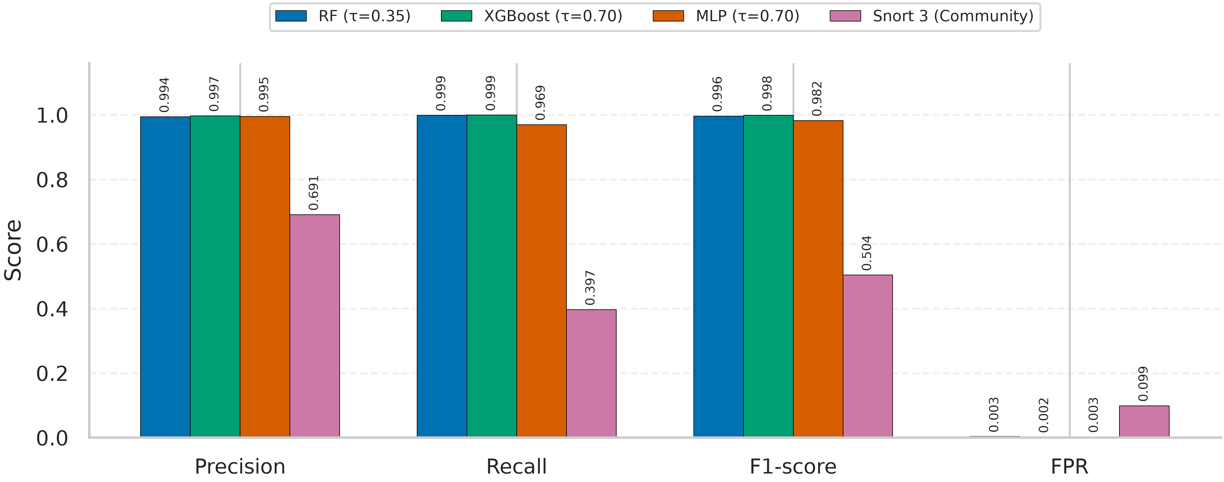
Fig. 7. Detection performance (Precision, Recall, F1-score, FPR) for RF (τ=0.35), XGBoost (τ=0.70), MLP (τ=0.70), and Snort 3 Community Rules (correlated-flow) on CICIDS2017 Friday held-out test subset (n=123,161). Snort correlation: +61,260 s offset, ±300 s window; packet alerts mapped to flow 5-tuples (imperfect mapping documented).

Key Resource Efficiency (Table VI, emulated 1-core)
System | Wall (s) | Throughput | Latency/flow | Peak RSS (MiB) | Notes
Random Forest | 2.249 | 54,767 flows/s | 0.0183 ms | 351.9 | Batch, 123,161 flows
XGBoost | 0.919 | 134,023 flows/s | 0.00746 ms | 332.5 | Batch, 123,161 flows
Small NN (MLP) | 0.227 | 542,020 flows/s | 0.00184 ms | 329.4 | Batch, 123,161 flows
Snort 3.12.2.0 (Community) | 595.44 | 14.16 MB/s (PCAP) | N/A | 200.59 | Offline Friday PCAP 8.84 GB, taskset -c 0

Reproducibility Artifacts
Full IEEE draft: reports/Project_Report_Draft_IEEE.md. Summary: reports/final_comparison_summary.json. Snort correlation: reports/snort_friday_evaluation_final.json. Snort resource: reports/benchmark_snort_constrained_pi4_1core.json. Figures: reports/figures/*.png and *.pdf (generated by src/plot_ieee_figures.py).

IEEE Template Note
The provided template at /media/sf_OdinShare/Conference_Template/conference-template-IEEE.docx could not be opened by python-docx due to missing officeDocument relationship in this environment. Use this generated DOCX as a filled reference, or copy/paste sections and insert figures (prefer the PDF versions of figures 01–07 for print quality) into the official IEEE template. Pandoc was not installed; LibreOffice is available if you need format conversion.

