MEMO

Lehtonen Leila 15.10.2022

FOR YOUR INFORMATION

Summary of the cost of the salaries by departments from the year 2021.

Best regards

Leila Lehtonen secretary

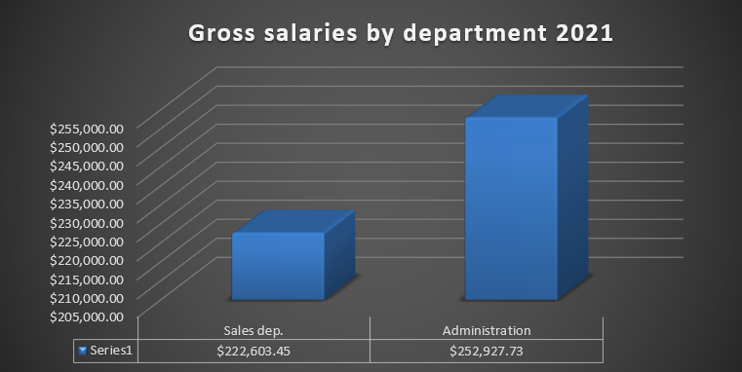



|  |  |  |
| --- | --- | --- |
| Company Oy | Phone +358 40 233 8600 | . |
| Kettukankaantie 87 | email [firstname.lastname@yritysoy.fi](mailto:firstname.lastname@yritysoy.fi) | VAT number 223456-5 |
| 92100 Iisalmi | Internet [www.yritysoy.fi](http://www.yritysoy.fi/) |  |