Links
1. https://github.com/Jude-njuee/database_retake_project
2. https://gismauniversity-my.sharepoint.com/:v:/g/personal/jude_njue_gisma-student_com/IQBQGo6_2NZpQImSof2CV6ROAVlkfWwNhR7LkvbdyBGCD6c?e=ETvStz

INTRODUCTION
In this project, a full relational database system for a University Management System is planned and implemented. This enables better management of structured data on students, instructors, courses, and enrollments at a higher education institution. The University Management System focuses on some of the issues that are faced by academic institutions in the world: Tracking student information and enrollment history, managing course offerings and instructor assignments, recording and monitoring student enrollments, generating reports on course popularity and student participation. The database was made using MySQL and implements the basic principles of relational data management which are: normalization, entity integrity using primary keys, referencing integrity through foreign keys and constraints. The system implements fundamental (Create, Read, Update, Delete) as well as special queries such as joins, aggregations, subqueries and stored procedures. The report will provide an overview of the entire development process – including the ER diagram, the implementation of MySQL, some samples of the queries that I used to produced the results, common challenges faced and recommended improvements.
The database structure is based on four primary entities representing the main components of the university management system:
Entities and their attributes:
- INSTRUCTOR :
instructor_id
first_name
last_name
department
hire_date

- STUDENT:
student_id
first_name
last_name
email
phone
enrol_date

3. COURSE:
course_id
course_name
course_no
instructor_id (FK)

4.ENROLLMENT:
enrollment_id
enrollment_date
student_id (FK)
course_id (FK)

Relationships:
INSTRUCTOR teaches COURSES hence (One-to-Many)
One instructor can teach many courses
Each course is taught by only one instructor
STUDENT enrolls in COURSE (Many-to-Many) also (fixed through ENROLLMENT)
One student can enroll in many courses
One course can have many enrolled students
The ENROLLMENT table acts as a junction table, storing extra information like enrollment date
COURSE has ENROLLMENT (One-to-Many)
One course can have many enrollment records
Each enrollment belongs to exactly one course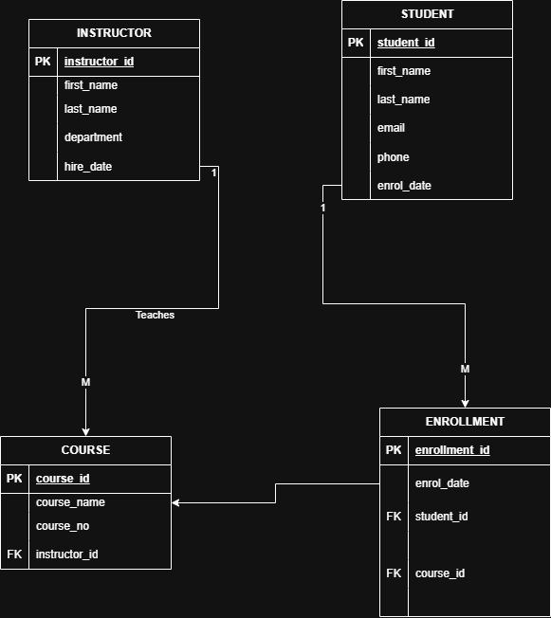

Normal Form Implementation
1NF (First Normal Form) - All attributes contain atomic values. No repeating groups exist.
2NF (Second Normal Form) - All non-key attributes depend on the entire primary key. In the ENROLLMENT table, enrolment_id is used as a surrogate primary key, with student_id and course_id as foreign keys, avoiding partial dependencies.

3NF (Third Normal Form) - No transitive dependencies exist. Instructor department information is stored only in the INSTRUCTOR table, not repeated in the COURSE table.

Constraints and Data Integrity
These constraints were applied to ensure data quality:
1.NOT NULL - first_name, last_name, email, enrol_date - Prevents incomplete data recording.
2.UNIQUE - email in STUDENT table - Prevents duplicate email addresses
3.ON DELETE CASCADE - Foreign keys in ENROLLMENT - Automatically removes enrollment records when a student or course is deleted.

THE IMPLEMENTATION
Number of Records.
INSTRUCTOR 5 records.
STUDENT 10 records.
COURSE 8 records.
ENROLLMENT 20 records.
The instructor data sample was based on 5 staff members at Computer Science, Business Administration, Engineering, and Mathematics departments. A total of ten students with a variety of enrollment patterns were included and eight courses across four departments were created. Twenty enrollment records link students to courses with specific enrollment dates.
CAUTION: The data I used in this project were generated with the assistance of AI. That includes the names of the students, emails, courses, etc.

The IMAGE above shows all four tables (INSTRUCTOR, STUDENT, COURSE, ENROLLMENT) which are successfully created in the UniversityManagementSystem database.
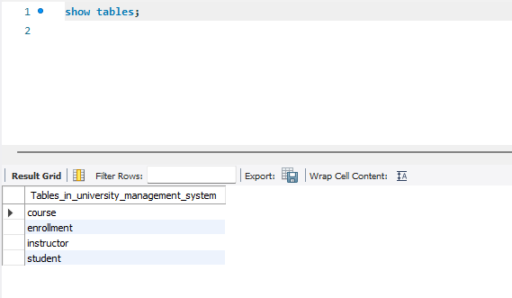
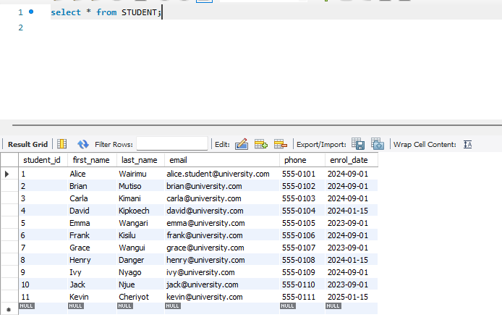

Ten students' records were entered successfully, where these are student_id, names, email, phone number and enrollment dates. The 11th is an additional.

There are eight courses located in multiple departments, with one unique course number assigned to each course and an assigned instructor.
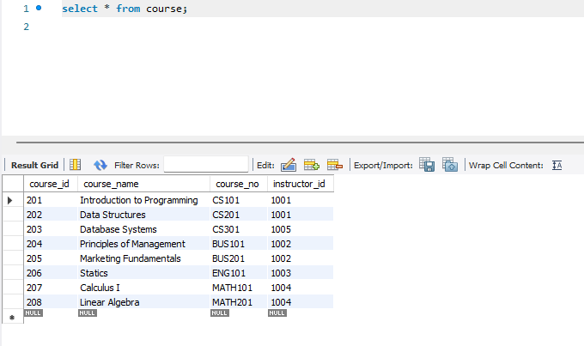
Other entries include the following:
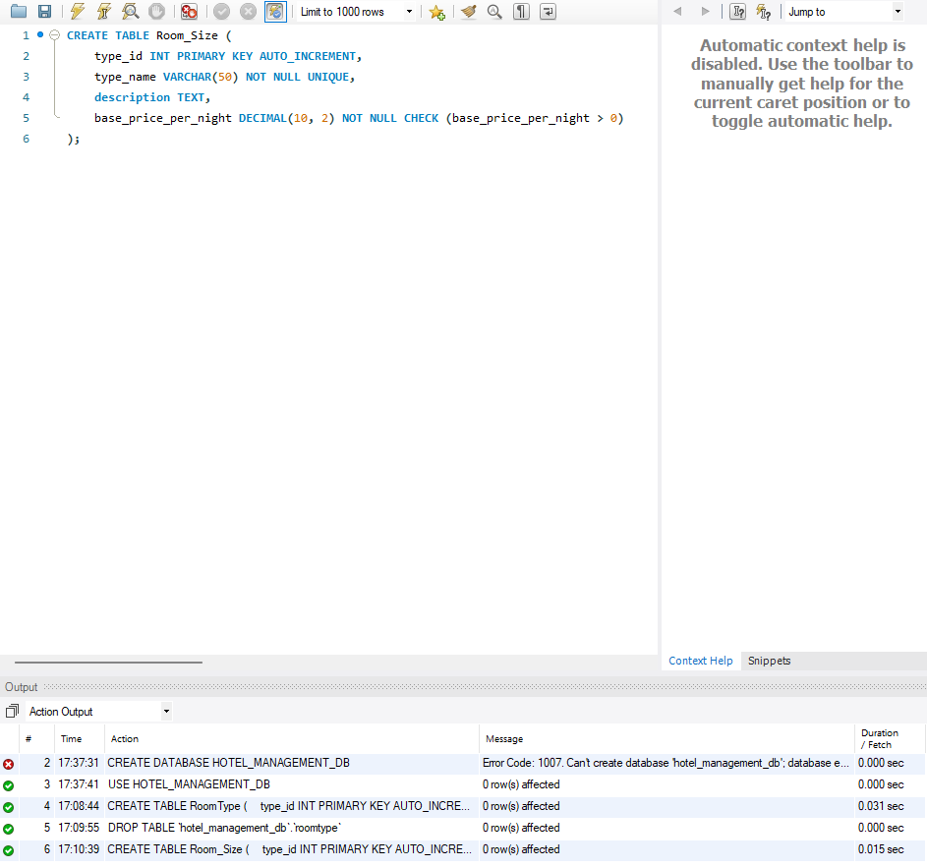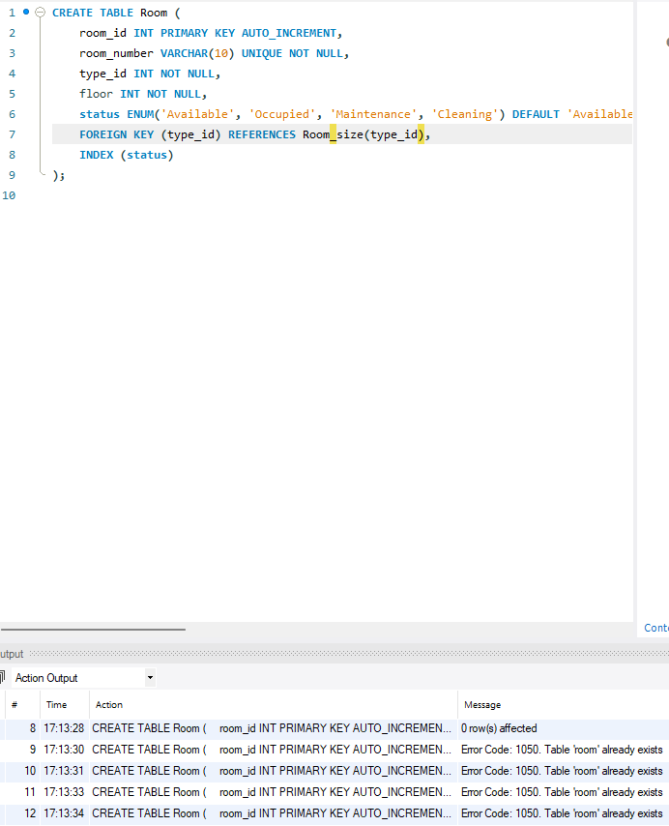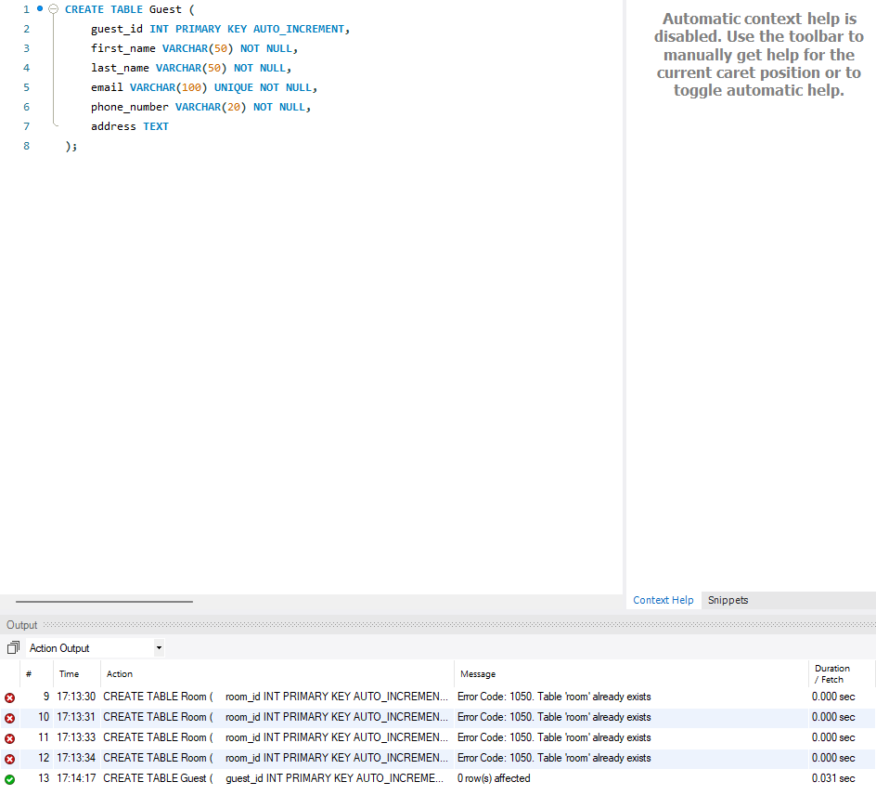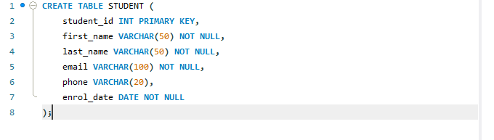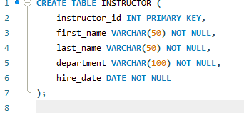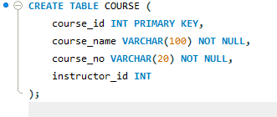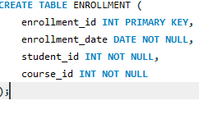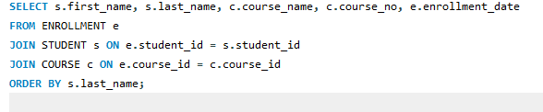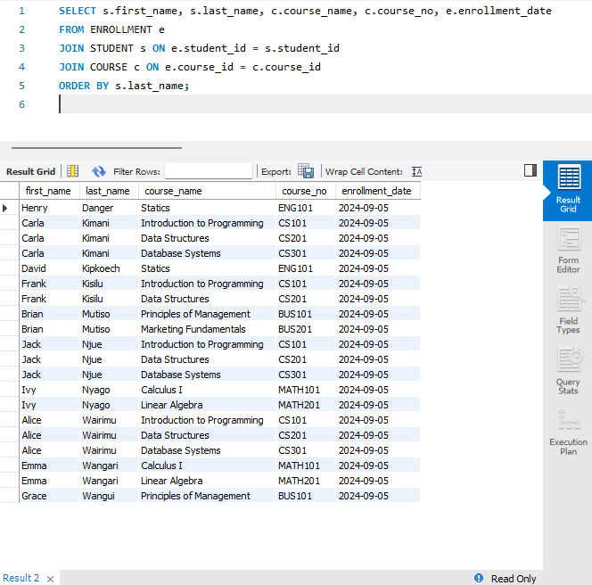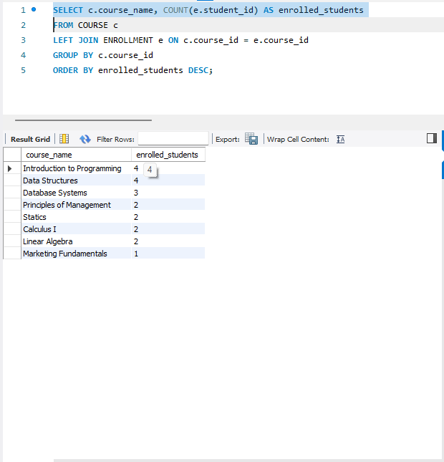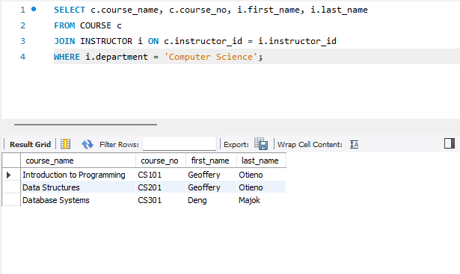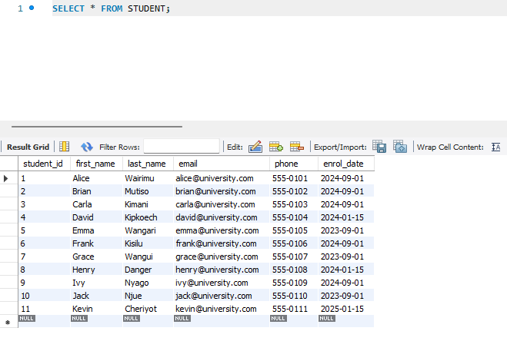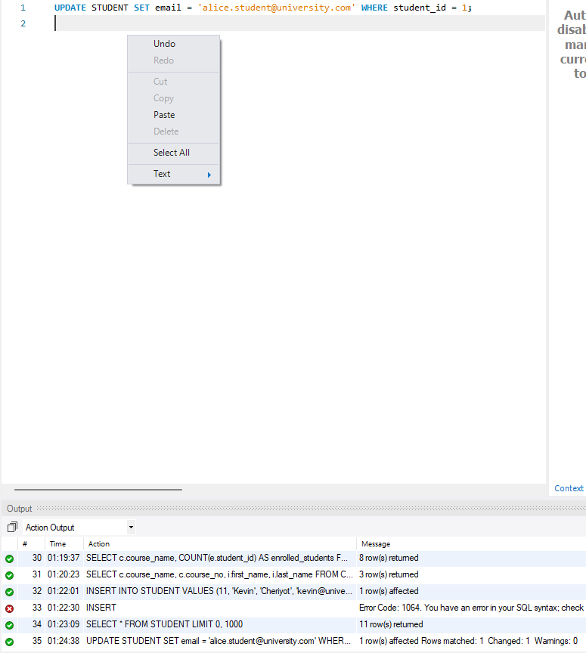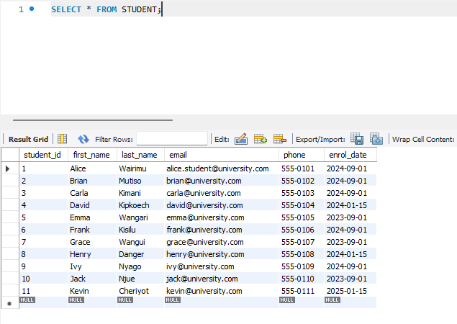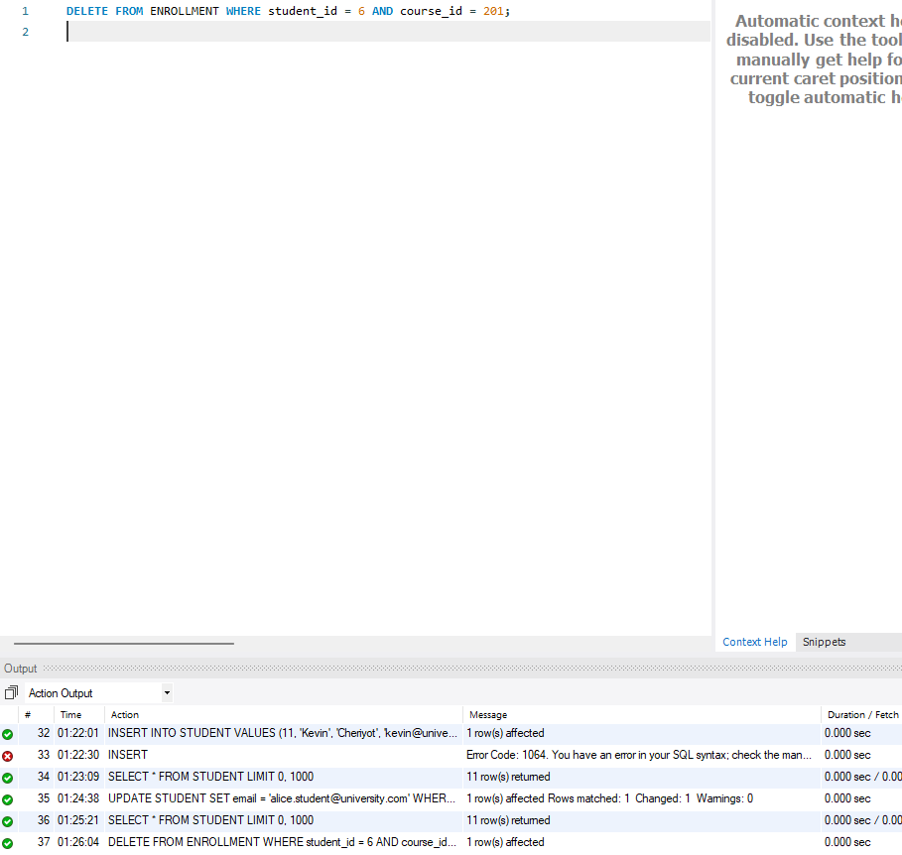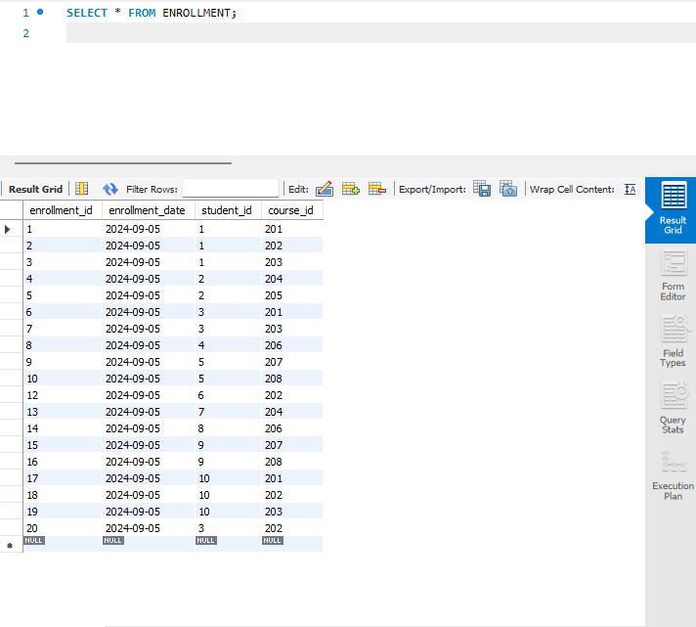

Difficulties and Remedies

Challenge 1: Errors that rely on foreign key constraints
Problem: The system would return an error when trying to insert enrollment records, because neither referenced Students nor Courses exists within their respective tables.
Solution: I reordered my INSERT statements, taking those that filled the parent tables instead of the child tables. And lastly, I created ON DELETE CASCADE which will preserve referential integrity and delete child records automatically when parent records are deleted.

Challenge 2: XAMPP MySQL Shutdown Error
XAMPP was running on MySQL, but that service unexpectedly closed with a message indicating corrupted data files. This meant access to the database would not be possible.
Solution: I fixed this by renaming the corrupted data folder to data_old, copying backup into a new data folder, and restoring my specific database folder. Running XAMPP as administrator stopped the same permission issues at every iteration.

Challenge 3: Preventing Duplicate Enrollments
Problem: The initial design allowed students to enroll in the same course multiple times, generating redundant records.
Solution: A stored procedure was created to check existing enrollment records before entering a new one. The procedure queries the ENROLLMENT table for matching student_id and course_id; no insertion occurs if a record already exists.

CONCLUSION
The current project was a complete program with a well-built relational database for a University Management System. The design fulfills all the specifications for this software:
1. Normalization to 3NF removes redundancy from data.
2.All data integrity is guaranteed by strict constraints (primary keys, foreign keys, NOT NULL, UNIQUE).
3. Full CRUD operations fulfill basic data management requirements.
4. Advanced queries illustrate JOINs, aggregations, subqueries, and stored procedures.
5. This simple system can be illustrated very well using a few examples (5 instructors, 10 students, 8 courses, 20 enrollments).
The database allows us to maintain core university processes that are essential to keeping track of student records, instructor assignments, courses offered, and enrollment tracking. The system serves as a strong platform for any educational institution wanting to adopt digital methods for academic record-keeping.
FUTURE ENHANCEMENTS
A few enhancements could extend the system:
1. Adding a grade column to track student performance.
2.Building a web interface for easier data entry.

References

Gisma University of Applied Sciences. B103 Databases & Big Data Assessment Brief. Potsdam: Gisma University of Applied Sciences. MySQL. MySQL 8.0 Reference Manual. Retrieved from Elmasri, R., & Navathe, S. B. (2016). Fundamentals of Database Systems (7th ed.). Pearson.

Declaration of Authorship.
I hereby declare that this submission is my own writing and that it does not, to the best of my knowledge and belief, contain material previously published or written by another person nor material that has been accepted for the award in any other degree or diploma of the university, or other institute of higher learning, except where due acknowledgment has been made in the text. Signature: Jude Githinji Njue

Course: B103 Databases & Big Data
Date: 02/07/2026
Name: JUDE GITHINJI NJUE
Student: ID GH1045858

