(2R)-3-Methyl-2-Butanol
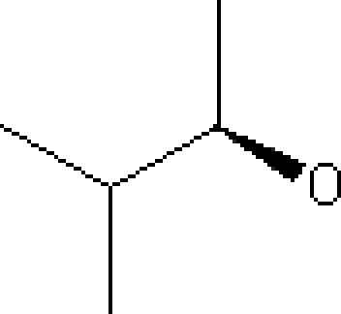
Main Function Group: Secondary Alcohol
- Common Name – (2R)-3-Methyl-2-Butanol
- IUPAC Name – (2R)-3-Methyl-2-Butanol
- Molecular Weight – 88.15 g/mol
- Melting Point – N/A
- Boiling Point – 112 °C

