(3R)-2-Methyl-2,3-Butanediol
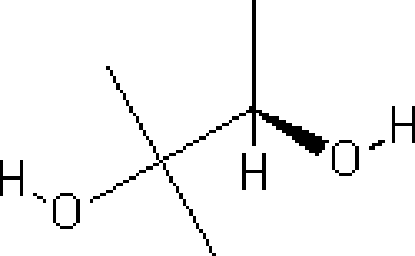
Main Function Group: Diol_{(Two alcohol groups)}
- Common Name – (R)-2-Methylbutane-2,3-diol
- IUPAC Name – (3R)-2-Methyl-2,3-Butanediol
- Molecular Weight – 104.15 g/mol
- Melting Point – N/A
- Boiling Point – 175 °C

