1-Methylbutyl acetate
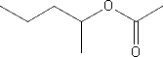
Main Function Group: Ester
- Common Name – 1-Methylbutyl acetate
- IUPAC Name – Pentan-2-yl acetate
- Molecular Weight – 130.18 g/mol
- Melting Point – -100.0 °C (173 K)
- Boiling Point – 130.5 °C (403.5 K)

