Instructions

Use the following guidelines when creating your agenda:
1. Create the agenda in list form, as shown in the image below.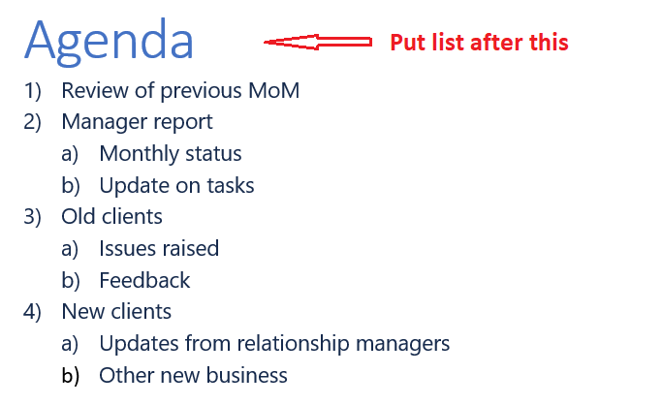
2. Put primary meeting activities into a numbered list.
3. Put each primary activity’s sub-activity using lowercase letters.
4. You do not need to match the numbering/lettering punctuation style shown in the image exactly, just make sure that numbers and lowercase letters are being used in the right places, regardless of punctuation.

Agenda

