OWL Predict AP2

Jude Dillon – B00737902  
BEng Software Engineering

# Abstract (500 Words)

The purpose of the abstract is to give a summary of the overall project, enabling the reader to gain an impression of the origins, aims, nature and final results of the work, without having to read the detail of later chapters. The abstract should not exceed 500 words.

# Acknowledgements/Dedication - (Optional)

Contents

Abstract (500 Words) 2

Acknowledgements/Dedication - (Optional) 2

1 Requirement Control Document & Modification of the Project Plan 5

1.1 Final List of Requirements 5

1.1.1 Functional Requirements 5

1.1.2 Non-Functional Requirements 5

1.2 Requirements Evolution 6

1.3 Modifications done to the project plan 6

1.3.1 Modified Gantt Chart 7

2 System Design 8

2.1 System Architecture Diagram 9

2.2 Interface Design 10

2.2.1 Wireframes 10

2.3 Data Support Design 11

2.3.1 Consideration of Security and Data Validation 11

2.3.2 ER Diagram 12

2.4 User Interaction Design 13

2.5 Additional Design Artefacts 14

3 System Implementation 14

3.1 Reflection on Implementation Plan 14

3.2 Tools and Languages Used 14

3.2.1 Python 14

3.2.2 Gitlab and git bash 14

3.2.3 VS Code 15

3.2.4 Mongo DB 15

3.2.5 PyMongo 15

3.2.6 Angular JS 15

3.2.7 Bootstrap 15

3.2.8 Overwatch League Stats Lab Data 15

3.3 Evidence of Version Control 16

3.4 Volume of Code Produced 17

3.5 System Walkthrough 17

3.6 Consideration of Security Implementation 21

4 System Verification 21

4.1 Reflection on Verification Plan 21

4.2 Verification Results 21

4.3 Other Evidence of Verification 21

4.4 Confirmation Statement of System Meeting Requirements 21

5 System Validation 21

5.1 Reflection of Validation Plan 21

5.2 Validation Results 21

5.3 Other Products Resulting from Validation 21

5.4 Consideration for Future Work 21

6 Conclusion and Reflection 21

6.1 Project Appraisal 21

6.2 Reflection of Project Plan 21

6.3 Reflection of Initial Time/Effort Estimation 21

6.4 Reflection of Software Methodology 21

7 References 21

8 Appendices 22

# 1 Requirement Control Document & Modification of the Project Plan

## Final List of Requirements

### 1.1.1 Functional Requirements

|  |  |  |  |
| --- | --- | --- | --- |
| ID | Requirement | Priority | Risk Level |
| F1 | User can select two different Overwatch League teams | Must Have | Low |
| F2 | System will predict team that will win using a Machine Learning Algorithm | Must Have | High |
| F3 | System will output team that it predicts to win | Must Have | Medium |
| F4 | System needs to be able to extract data used for predictions from the dataset | Must Have | Medium |
| F5 | System will provide accurate predictions (above 60% accuracy) | Should Have | Low |
| F6 | System will output a percentage stating how sure it is of its prediction | Should Have | Low |
| F7 | Users can tune the range of closest data points that the system uses to make decisions | Should Have | Low |
| F8 | Users can choose which season of Overwatch League will be used to make predictions in the system | Should Have | Medium |
| F9 | System will make prediction within 2 seconds [1] | Should Have | Medium |
| F10 | User can make predictions through an API | Could Have | Low |
| F11 | System will predict upcoming matches in advance | Won’t Have | Low |

Figure Functional Requirements

### 1.1.2 Non-Functional Requirements

|  |  |  |  |
| --- | --- | --- | --- |
| ID | Requirement | Priority | Risk Level |
| NF1 | System will be robust | Must Have | Medium |
| NF2 | System will be intuitive | Must Have | Low |
| NF3 | System will look visually appealing | Must Have | Low |
| NF4 | System must work on majority of browsers | Must Have | Medium |

Figure Non-Functional Requirements

## Requirements Evolution

During the development process some changes were made to the initial requirements that were created during the initial project planning.

F8 was changed from “Users can choose which data will be used to make predictions in the system” to “Users can choose which season of Overwatch League will be used to make predictions in the system”. The justification for this change was that although the initial plan was for the user to be able to change both the seasons used for predictions and be able to choose different predictors for the system to use for predictions the developer found that changing the predictors used for each prediction was much more difficult to implement than expected. As a result of this the Project Manager made the decision to instead just implement the selection of which season the data used for predictions would be gathered from so users would still be able to have a more specific prediction to their liking.

No other changes were made to the requirements because from discussions between the project manager and a focus group of target users the remaining requirements were all deemed sufficient for what members of the focus group expected from the product.

## Modifications done to the project plan

There were quite a number of modifications made to the project plan the developer decided to take a break over the Christmas season and instead of classifying more data for the use in KNN they decided to take the current initial implementation they had created at the end of AP1 and to convert it to work in the system before adding new functionality to it.

### 1.3.1 Modified Gantt Chart

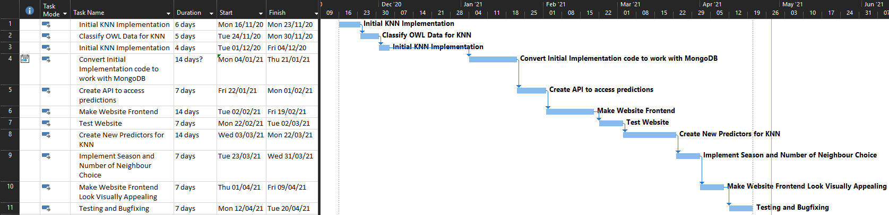

Figure Modified Gantt Chart

# 2 System Design

The approach to the design of the architecture of the system was to make it all flow in a way where it moved the data from the frontend, to the backend via an API call which would access the database to then calculate the prediction with the K Nearest Neighbour algorithm [2] which would then return the prediction from the original API call to the frontend.

The overall plan for the design of the system from a user standpoint was to make it as simple and intuitive for the users as possible so it was easy for them to use, this was achieved with the use of abstraction [3].

The visuals, in particular the colours of the system were inspired by Overwatch League [4] and the colour scheme used in it because it would be familiar to users of the system.

## 2.1 System Architecture Diagram

Figure System Architecture Diagram

The system architecture diagram in Figure 3 shows an overall view of OWL Predict, how the data flows through the system and how each section of the system communicates with each of the other sections.

The user opens the website and the webpage which is created via angular JavaScript will display the values the user needs to input to make a prediction.

When the user inputs and submits the required values, the frontend will make a call containing these values to the API which is created in python.

The API will then convert these values to a format ready for the K Nearest Neighbour Algorithm and then send them to the K Nearest Neighbour algorithm.

The K Nearest Neighbour algorithm will send these values to the mongo DB database to calculate the Predictors for the inputted data as well as calculate the predictors for stored data when using the users selected season.

When these values are all returned from the database the K Nearest Neighbour Algorithm will create a list of all the K nearest neighbours to the input data where K is the number of neighbours selected and submitted by the user.

The algorithm will then gather the responses from this list of nearest neighbours and if the outcomes of this game were a win or a loss for team 1, if more of the nearest neighbours predict the outcome as a win then the algorithm will return to the API that it predicts a win for team 1 and its percentage confidence in it which is calculated as the percentage of nearest neighbours where the outcome was a win and vice versa for a win for team 2.

The API will then return the result of this prediction to the frontend where it will be displayed to the user.

## 2.2 Interface Design

### 2.2.1 Wireframes

Figure Home page wireframe

Figure 4 Displays the home page. This page greets the user, displays the title of the system and if they would like to make a prediction, they can click the button which will then send them to the prediction page (Figure 5).

Figure Prediction page wireframe

Figure 5 displays the prediction page. This page allows the user to make a prediction by inputting their chosen values into the respective dropdown menus. The Team 1 and Team 2 dropdowns are mandatory and must not be left empty, if they are left empty or select the same teams or are not interacted with then the submit button will not appear and an error message will be displayed. When all values are valid and the submit button has been clicked then the system will make a prediction with the user’s selected inputs and will then populate the prediction output which will be visible to the user.

**Provide a narrative establishing your consideration for HCI and Usability/Accessibility of the User Interface.**

## 2.3 Data Support Design

### 2.3.1 Consideration of Security and Data Validation

### 2.3.2 ER Diagram

Figure ER Diagram

Figure 6, shown above is the ER diagram for the database being used in OWL Predict. The match_map_stats table was created directly from the Official Overwatch League Stats Lab data [5] where the developer downloaded their Map Stats dataset and imported it into mongo DB, it contains an entity for each round of each map played in Overwatch League games.

The developer then created the games table from this dataset to have data on an individual game basis and each game contains multiple maps thus the many to one relationship between the match_map_stats table and the games table.   
The developer originally created the dataset for this table with a python script adapted from the initial implementation in AP1 which would read in the match_map_stats.csv file and convert it into list format and it would then remove records with duplicate match_id’s and create a new csv file from this. The developer then simply removed unnecessary properties for predictions manually using excel and imported the dataset into mongo DB.

The player_stats table was like the match_map_stats table also created directly from the Overwatch League Stats Lab data where the developer downloaded each of their Player Stats datasets and imported them all into one mongo DB table.  
The table contains an entity for every individual player statistic for every player in each game of Overwatch league and as such there is a one to many relationship between the games table and the player_stats table.

## 2.4 User Interaction Design

Figure System flow diagram

Figure 7 shows the system flow diagram of the overall system making a prediction from a user’s input.

When the user inputs their choices for the prediction they are checked for validity, if invalid the user will not be able to submit them. If they are valid then upon submission the predictors will be recalculated with the constraint of the user’s chosen season and these new predictors will be stored in the database. These new predictors will then be used to create two lists of K nearest neighbours where K is selected from the user’s input and the two lists will each have the order of the user’s inputted teams swapped. The average results of both of these lists will then be used to predict which team is going to win as well as the percentage likelihood of them winning. This prediction will then be output to the user, at which point they can make another prediction if they would like to do so.

## 2.5 Additional Design Artefacts

Python script for games table  
  
KNN Algorithm

# 3 System Implementation

## 3.1 Reflection on Implementation Plan

Overall, with the Implementation plan the project manager made the decision of using Kanban which served the project well as there were a number of changes to both the order of the steps in the implementation plan as well as the duration spent on certain steps in the plan and Kanban allowed for flexibility in both of these. One thing in particular that could’ve been planned better in the implementation plan would’ve been the choice of predictors as they were unexpectedly difficult to create and calculate especially when implementing them at such a late date in the code and perhaps taking care to make the earlier code more scalable would also have helped with this too.

## 3.2 Tools and Languages Used

### 3.2.1 Python

Python was used by the developer due to the developer’s experience in using the language before overall as well as their experience in using the langue to create an API which was something the developer and project manager planned to have in their project from the beginning as a way to create the system. It was ideal in the creation of the system because it was very easy to manipulate the data in it through the use of dictionaries and the developer was able to create their own K nearest neighbour algorithm in python without the use of external libraries due to this. Although the developer was able to create this library themselves this also made things take more time than they may have otherwise and caused difficulties so it may have been more beneficial to use a python library for the K nearest neighbour algorithm, for example scikit learn [6] which may have made this easier but the developer may have lost some understanding of the algorithm if this had been used.  
Overall though the choice of python worked well for the development needs of the project and the developer was pleased with its performance even though it could have been better with the use of libraries.

### 3.2.2 Gitlab and git bash

Gitlab and git were used together for version control and maintaining a backup of the system code the developer used gitlab as opposed to other version control software due to the quite large amount of free storage a user gets and because they have over a year of experience using it in work and other projects. The reason they used git bash was also due to familiarity and it meant they were able to very quickly move work from their computer to git without having to learn. Although the IDE used also had a way to access git via a GUI the developer was inexperienced in using a GUI for git and due to time constraints did not think it was necessary to learn it but perhaps if the developer had taken the time to learn it they could’ve found it had a boost to their workflow speed rather than having to exit to a different program for git commits.

### 3.2.3 VS Code

VS Code was used by the developer as it is able to support a large number of different languages and as there were a number of different languages being using it meant they did not have to switch to different IDE’s to look at different parts of the system. VS Code is also quite lightweight and runs well on the developer’s system compared to some other IDE’s they have used and it has git integration so if the developer wanted to they could access git from a GUI within VS Code but even without accessing the GUI it shows lines that have been changed from the last git version which helps to keep track of exactly what work has been done.

### 3.2.4 Mongo DB

Mongo DB

### 3.2.5 PyMongo

PyMongo

### 3.2.6 Angular JS

Angular JS

### 3.2.7 Bootstrap

Bootstrap

### 3.2.8 Overwatch League Stats Lab Data

Overwatch League Stats Lab Data

## 3.3 Evidence of Version Control

Figure Git commit history

Figure 8 shows the git commit history. From the beginning of the initial implementation and throughout the development of the system the developer was using gitlab to maintain a backup of the system as well as for version control. This helped to mitigate any risk of hardware failure as if any system were to fail there would still be a recent backup available so that the whole system would not be lost. It also made it convenient for the developer to work on the system on multiple different systems which meant that they were able to move the work to a laptop and work elsewhere if necessary.   
Although there was integration between git and VS code (the IDE the developer used) which would allow the developer to use a GUI to access git, the developer preferred to use git bash command line to make pushes and pulls to and from gitlab because he had more experience using this and it allowed his workflow to move smoothly.  
As there was only one developer in this project there was no need to set up branch control but it would be useful to implement if in future the project manager would like to add more developers to this project and would ensure that all code added to the project was up to a high standard with the use of code reviews from peer developers.  
Overall GitLab’s version control was very useful to the project allowing the developer to rollback changes when needed and providing reassurance with the knowledge that if something were to go wrong there was an easily accessible way to either retrieve the code or undo a mistake.

## 3.4 Volume of Code Produced

|  |  |
| --- | --- |
| **Item** | **Amount** |
| Python Methods | 13 |
| API Calls | 2 |
| Angular Components | 6 |
| Mongo DB Queries | 9 |

Figure Volume of Code Produced

## 3.5 System Walkthrough

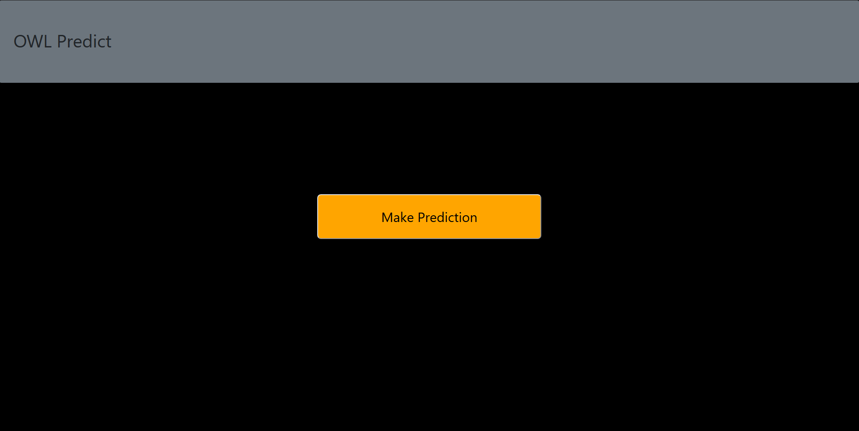

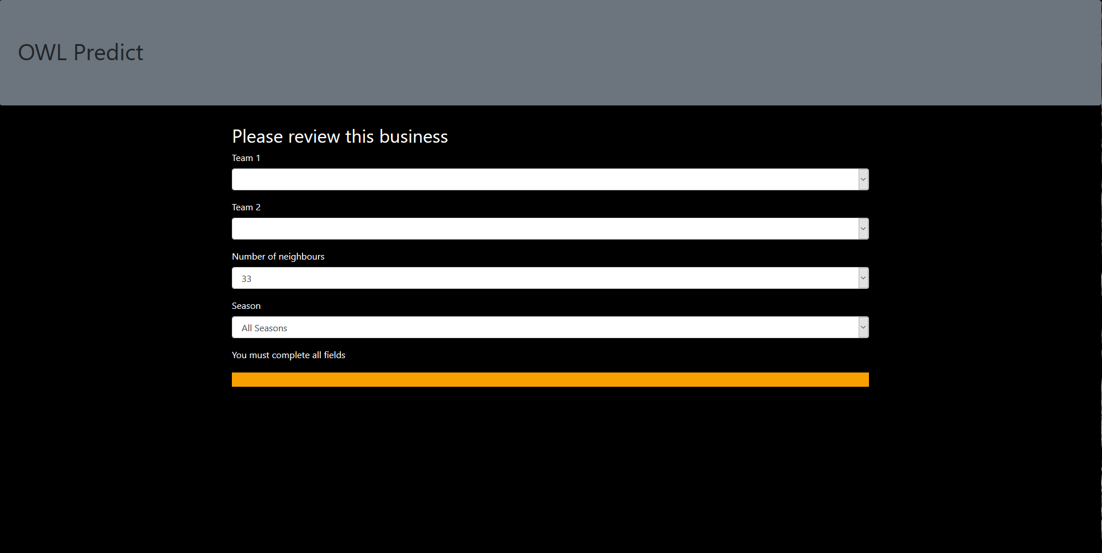

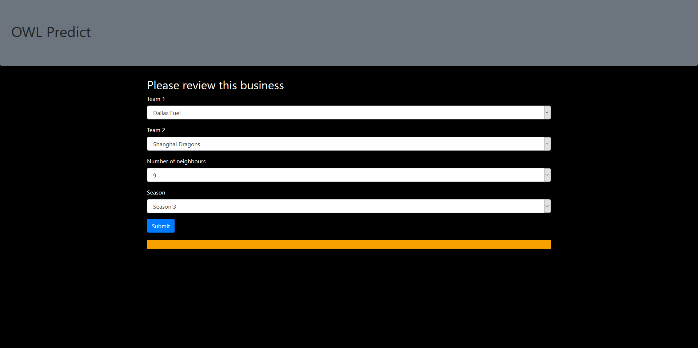

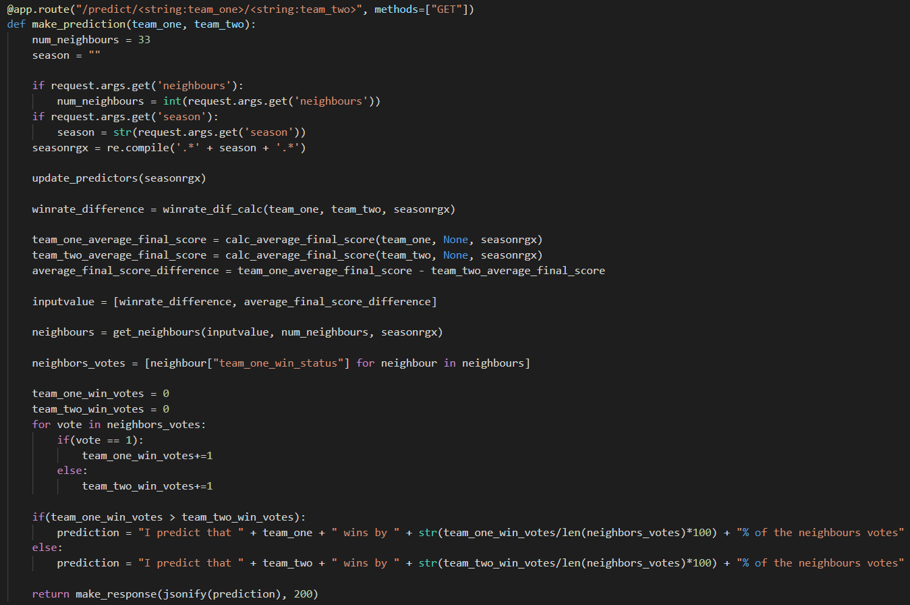

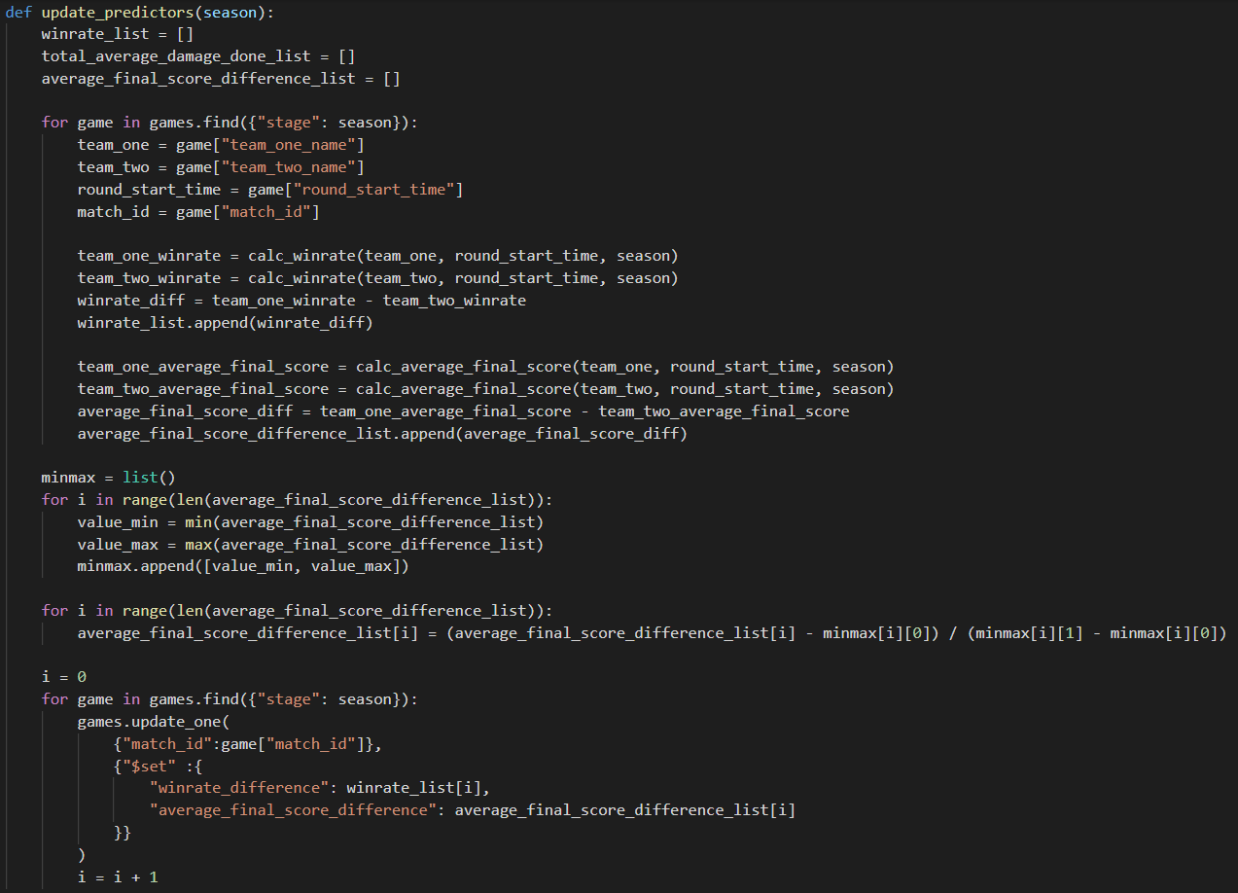

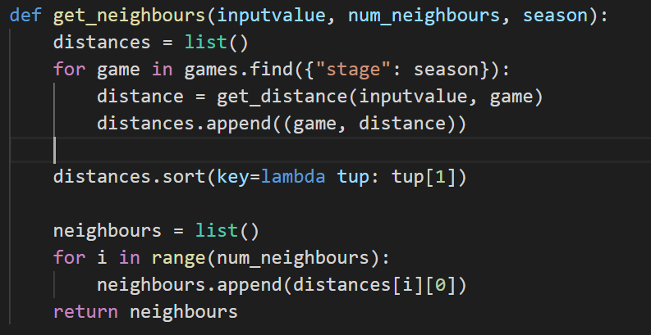

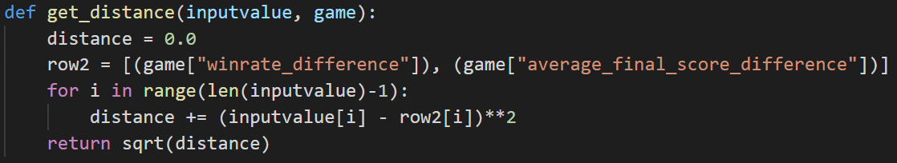

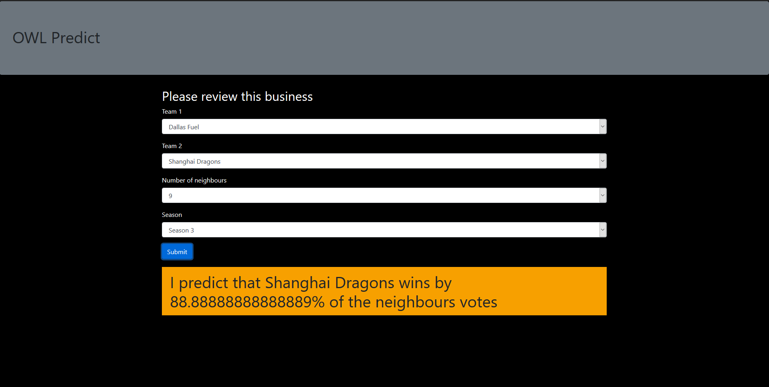

## 3.6 Consideration of Security Implementation

# 4 System Verification

## 4.1 Reflection on Verification Plan

## 4.2 Verification Results

## 4.3 Other Evidence of Verification

## 4.4 Confirmation Statement of System Meeting Requirements

# 5 System Validation

## 5.1 Reflection of Validation Plan

## 5.2 Validation Results

## 5.3 Other Products Resulting from Validation

## 5.4 Consideration for Future Work

# 6 Conclusion and Reflection

## 6.1 Project Appraisal

## 6.2 Reflection of Project Plan

## 6.3 Reflection of Initial Time/Effort Estimation

## 6.4 Reflection of Software Methodology

# 7 References

|  |  |
| --- | --- |
| [1] | F. F.-H. Nah, A Study on Tolerable Waiting Time: How Long Are Web Users Willing to Wait?, Association for Information Systems, 2003, p. 285. |
| [2] | N. S. Altman, “An Introduction to Kernel and Nearest-Neighbor Nonparametric Regression,” *The American Statistician,* vol. 46, no. 3, pp. 175-185, 1992. |
| [3] | Sharpened Productions, “Abstraction Definition,” TechTerms, 19 April 2019. [Online]. Available: https://techterms.com/definition/abstraction. [Accessed 26 04 2021]. |
| [4] | Wikipedia, “Overwatch League,” Wikipedia, 26 04 2021. [Online]. Available: https://en.wikipedia.org/wiki/Overwatch_League. [Accessed 26 04 2021]. |
| [5] | Overwatch League, “Overwatch League Stats Lab: Beta,” 26 04 21. [Online]. Available: https://overwatchleague.com/en-us/statslab. [Accessed 27 04 21]. |
| [6] | scikit-learn, “scikit-learn,” scikit-learn, [Online]. Available: https://scikit-learn.org/stable/. [Accessed 27 04 21]. |

# 8 Appendices