**Objective 1: Understand Mortality Distribution**

Distribution of Under-Five Mortality Rates

The distribution of under-five mortality rates across countries or regions was visualized using a histogram with a kernel density estimate (KDE). This provides insights into how mortality rates are distributed and helps to identify trends in global under-five mortality.

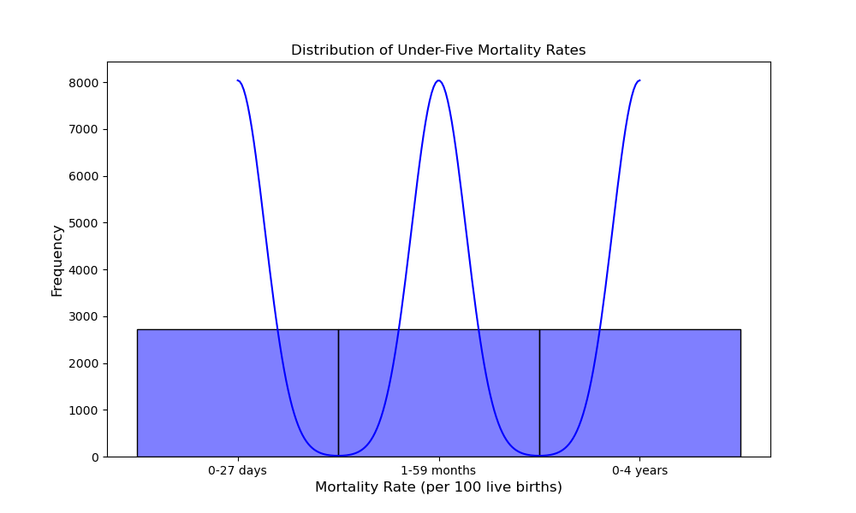

The distribution of infant deaths was also analyzed and visualized using a histogram with KDE. This analysis helps understand the frequency of infant deaths, which is a critical aspect of global health.

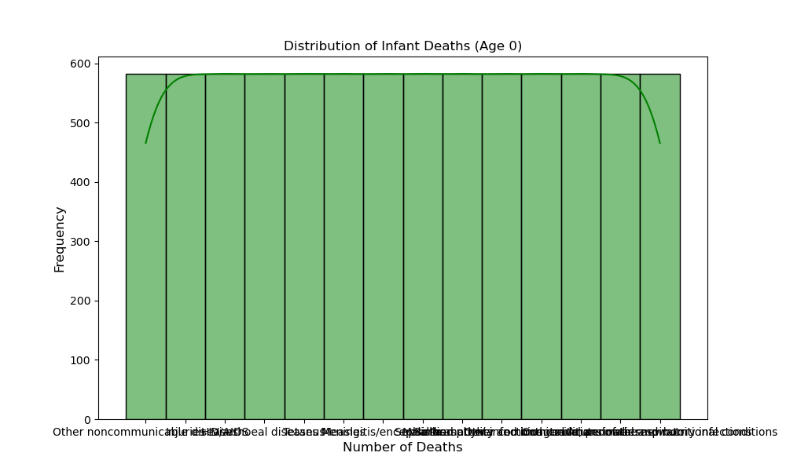

**Objective 2: Correlation Analysis**

Correlation Heatmap

A correlation matrix was computed to understand the relationships between different numeric variables in the dataset. The correlation heatmap visualizes these relationships, helping identify which factors are most closely associated with under-five mortality.

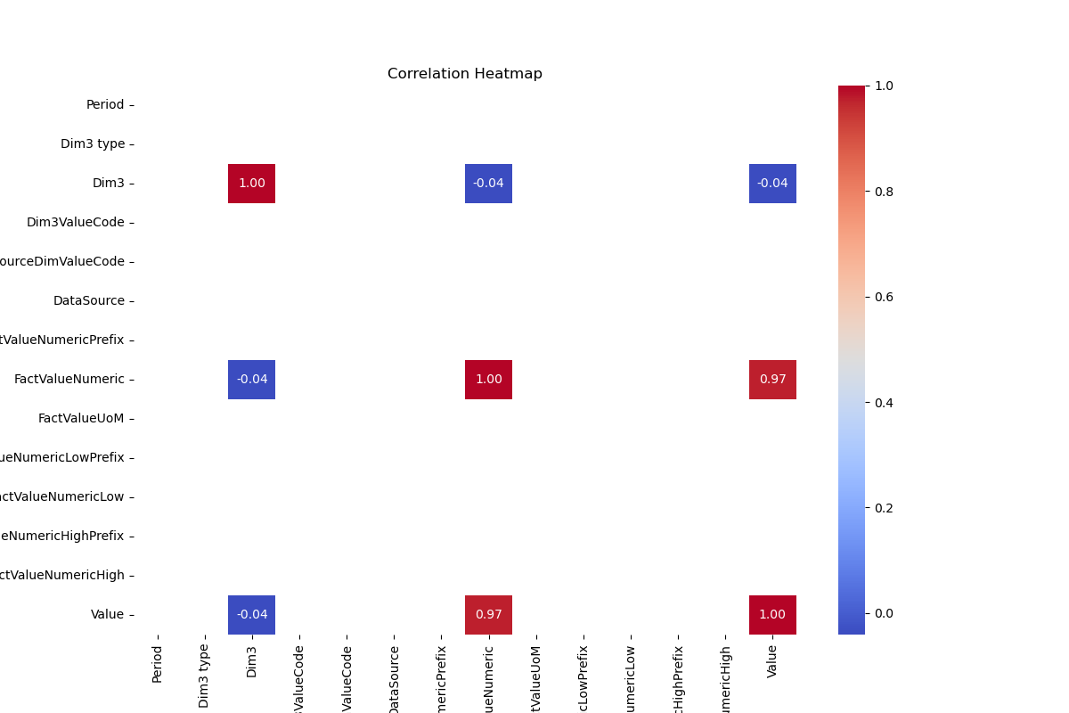

**Objective 3: Investigate Key Drivers**

Health Insurance Coverage vs Under-Five Mortality

The relationship between health insurance coverage and under-five mortality rates was examined through a scatterplot. Health protection coverage can play a significant role in reducing child mortality, and this analysis highlights any potential trends.

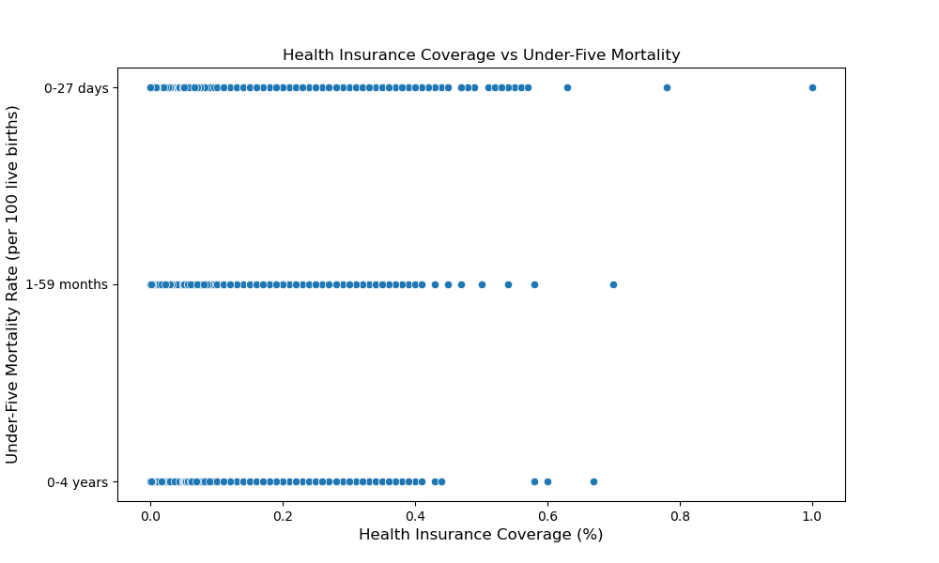

**Maternal Deaths vs Under-Five Mortality**

Finally, maternal deaths were compared with under-five mortality rates. Maternal health is closely linked to infant mortality, and understanding this relationship helps identify areas that require intervention.

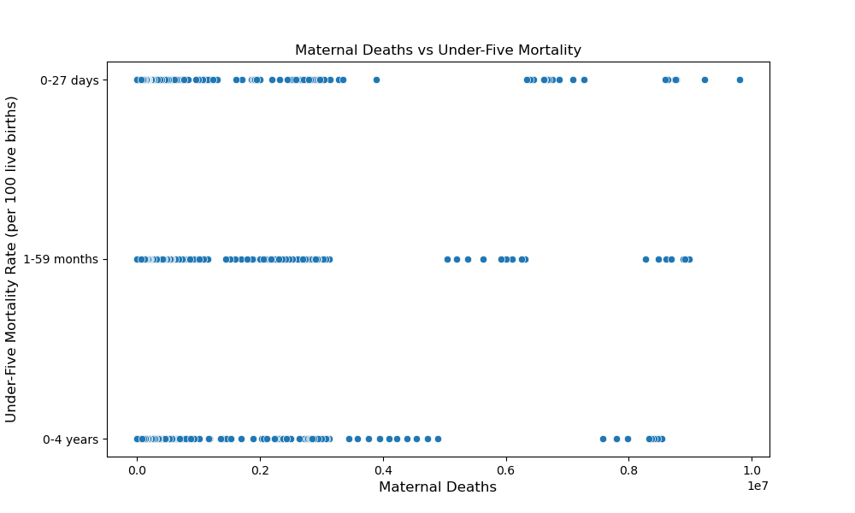

**Conclusions and Recommendations**

The distribution of under-five mortality rates and infant deaths shows a clear variation across different regions. Areas with higher mortality rates may need focused interventions in healthcare and vaccination.

The correlation analysis indicates significant relationships between various health indicators, particularly maternal health and health insurance coverage, and under-five mortality. Targeted efforts to improve maternal healthcare, expand health insurance coverage, and enhance vaccination coverage are essential for reducing infant and child mortality.