CHAPTER 3

METHODOLOGY
This chapter presents the complete methodology governing the design, construction, training, and empirical evaluation of AI-GIS (Artificial Intelligence Gateway for Intrusion Security). The methodology is organized into twelve sections: research design, research environment and guiding constraints, AI-GIS system architecture, data acquisition and preprocessing, LLM-generated adversarial payload creation, feature engineering, dataset splitting and class balancing, model training procedure, comparative evaluation procedure, software and reproducibility registry, ethical compliance and research boundaries, and a summary of the methodology. Each section is written in the future tense consistent with the proposed study framing, and every design decision is explicitly grounded in the literature reviewed in Chapter 2.

3.1 RESEARCH DESIGN
The methodology is structured around four operational phases, each one closing a specific gap identified in Chapter 1’s Statements of Problem rather than following a generic machine-learning pipeline. Phase 1 responds to SOP2, the honeypot training-data requirement, through data acquisition and corpus construction; Phase 2 then carries that corpus into SOP3’s payload-representation and generalization gap, generating adversarial payloads and building the feature and character-sequence representations the models will actually learn from. Phase 3 turns those representations into a trained system, addressing both SOP3 and SOP4 (attack-type performance variability) through model training and architecture construction, before Phase 4 closes the loop with a controlled comparative evaluation against ModSecurity that speaks to SOP1, SOP3, and SOP4 at once. The full set of research design parameters is summarized in Table 9.
Table 9 Research Design Parameters
Dimension | Description
Research Type | Quantitative experimental benchmark with controlled offline comparison
Study Classification | Applied systems evaluation
Research Environment | Air-gapped local laboratory — Ubuntu 22.04 LTS or Windows Subsystem for Linux (WSL2); minimum and recommended hardware specifications are documented in Section 3.2
Attack Coverage | SQL Injection (SQLi) and Cross-Site Scripting (XSS)
Detection Systems Under Comparison | AI-GIS (RF-LSTM stacked ensemble) vs. ModSecurity OWASP CRS Paranoia Level 2
Training Data Sources | Tier 1 — Supplementary datasets (structural dictionaries): SQLiV3 — attack samples only [32]; XSS Payloads — malicious samples only [33]  Tier 2 — Behavioral intelligence (primary source): Resecurity-generated synthetic honeypot telemetry (attack)  Benign class: Self-generated benign HTTP traffic (httperf against sandboxed test application)
Held-Out Adversarial Test Data | Code Llama 13B — 500 SQLi + 500 XSS (baseline); DeepSeek-R1 14B — 300 SQLi + 300 XSS polymorphic (adaptive mutation)
Held-Out Benign Test Data | Self-generated benign HTTP traffic — 600 held-out requests, generated separately from training benign samples, never seen during training
Total Held-Out Test Set | ~2,200 records (500 Code Llama SQLi + 500 Code Llama XSS + 300 DeepSeek SQLi + 300 DeepSeek XSS + 600 self-generated benign)
Primary Evaluation Metrics | F1-Score (primary), False Positive Rate (FPR), AUC-ROC, Precision, Recall
Evaluation Subsets | Combined (all records), SQLi-only, XSS-only
Dataset Split Ratio | 80% training / 20% validation — stratified random sampling [34]. Per-source accepted counts and training/validation splits are reported in Table 10's Development-Corpus Source Distribution Framework.
Random Seed | 42 — fixed where supported to reduce avoidable variability; preserved artifacts provide the authoritative reproduction basis

This study adopts a quantitative experimental benchmark design — the strongest empirical framework for evaluating detection system performance because it isolates the detection architecture as the independent variable while holding all other experimental conditions constant. Both AI-GIS and ModSecurity process identical inputs, eliminating dataset heterogeneity as a confounding variable and ensuring that observed performance differences are attributable solely to the detection approach rather than to differences in the test data each system encountered.

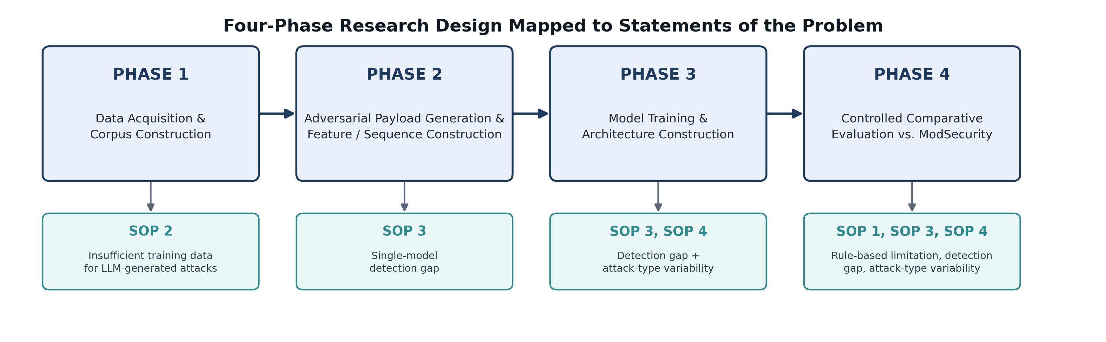
Figure. Four-Phase Research Design Mapped to Statements of the Problem

3.2 RESEARCH ENVIRONMENT AND GUIDING CONSTRAINTS
All experiments in this study will be conducted within a fully isolated local laboratory environment. No live production systems will be targeted, no generated payloads will be transmitted to any external system, and no internet-facing infrastructure will be involved at any stage of the research pipeline. The experimental platform will be Ubuntu 22.04 LTS or Windows Subsystem for Linux (WSL2), selected for compatibility with the full software stack and for the availability of reproducible containerized deployment of ModSecurity.
Hardware Specifications
To allow independent verification of the results, the hardware used for AI-GIS training is documented explicitly rather than described only as generic workstation hardware. Minimum requirements are a quad-core 64-bit x86 CPU (e.g., an Intel Core i5, 8th generation or newer, or an equivalent AMD Ryzen 5 processor), 8 GB of system RAM, 20 GB of free disk storage, and Ubuntu 22.04 LTS (64-bit) or Windows 10/11 with WSL2 as the operating system. Under this minimum configuration, both the Random Forest and LSTM layers will train in CPU-only mode, which is sufficient given the modest scale of the training corpus and the 200-step character-sequence input used by the LSTM.
Recommended requirements are a 6-core or higher 64-bit x86 CPU (e.g., an Intel Core i7 or AMD Ryzen 7, 10th generation or newer), an NVIDIA GPU with CUDA compute capability 6.0 or higher and at least 6 GB of VRAM (e.g., an NVIDIA GeForce RTX 3060 or newer) paired with a compatible CUDA Toolkit and cuDNN release, 16 GB or more of system RAM, and 50 GB of free SSD storage to accommodate the training corpus, model checkpoints, and the generated adversarial test set. The recommended GPU configuration is expected to reduce LSTM training time per epoch but is not required to reproduce the study’s results, since the character-sequence input size and training corpus scale used here do not require distributed or large-batch training [35], [36]. These minimum and recommended configurations are reported to satisfy the reproducibility documentation practice recommended for empirical machine learning research [37], and are calibrated conservatively so as not to overstate the computational demands of the study.
All Python packages will be version-pinned and recorded in requirements.txt to support controlled reproduction of the experiment, and random seeds will be fixed at 42 for Random Forest initialization, SMOTE oversampling, development-data splitting, and Ollama payload generation — though fixed seeds reduce avoidable variability without by themselves guaranteeing identical outputs across different hardware, model builds, inference backends, or software environments. Four guiding constraints sit underneath every procedure described in this chapter.
The first is offline-only execution: all payload generation, model training, threshold selection, and evaluation will be performed in a fully isolated local environment, with no live system targeted or affected at any point during the research. The second is a strict train/test separation — LLM-generated adversarial payloads are withheld entirely from model training and used exclusively as the held-out test set, which is the scientific core of the evasion-resistance claim, since AI-GIS must demonstrate detection capability against payloads it has never encountered during training or threshold optimization. The third is frozen configurations: neither AI-GIS nor ModSecurity will be updated, retrained, or reconfigured during the evaluation phase, so that any observed performance difference reflects architectural capability rather than post-hoc tuning. The fourth is controlled generation with artifact preservation — every Ollama call will use temperature=0, top_k=1, and documented seeds, and the researchers will preserve the exact model tags and digests, quantization, Ollama version, prompts, parameters, raw outputs, validation scripts, and final accepted CSV files. It is this frozen generated corpus, not an assumption of byte-for-byte regeneration on every machine, that will serve as the authoritative held-out benchmark [38].

3.3 AI-GIS SYSTEM ARCHITECTURE
AI-GIS is a three-layer stacked ensemble intrusion-detection system designed to classify SQL Injection and Cross-Site Scripting payloads using two complementary representations. Random Forest evaluates a 11-dimensional set of engineered request features, while LSTM evaluates the ordered sequence of characters within each decoded payload. No single representation is assumed to capture every generated variation. Random Forest was selected for nonlinear relationships among mixed numerical and indicator features. LSTM was selected because its gated memory can preserve relationships among characters and fragments located at different positions within one payload. A Logistic Regression meta-learner combines the two probabilities without introducing an unnecessarily complex second-level model [39], [40].
The theoretical roles and limitations of Random Forest, character-level LSTM, and Logistic Regression stacking are discussed in Section 2.2.4. This section focuses on the exact implementation used by the study.
Random Forest forms the first branch. It will examine each HTTP request independently, extracting an 11-dimensional numerical feature vector from each payload — capturing payload length, entropy, special-character and digit density, keyword flags, and quote and comment-token counts — and producing a per-request probability of maliciousness, P(malicious | features). This branch is applied across every training source — the WEB-IDS23-seeded corpus, SQLiV3, XSS Payloads, and Resecurity records if incorporated — all processed through the same feature extraction pipeline, and its ensemble mechanism — each tree trained on a bootstrapped sample with a random feature subset — ensures that no single tree dominates classification and that the model generalizes across the syntactic diversity of the training corpus [17].
Where Random Forest reasons over aggregated features, the LSTM branch reasons over order. It uses a single-branch character-sequence architecture: each record is processed independently, and once the raw payload is decoded according to the preprocessing rules, it is broken down into individual characters, each mapped to a numerical token and padded or truncated to 200 positions, producing the documented input shape of (200, 1). The two LSTM layers process these token positions in sequence and output one probability of maliciousness per payload — a representation that can preserve ordered relationships among comments, delimiters, encodings, fragmented keywords, and other structural elements that aggregate feature counts do not fully retain, though it does not represent several HTTP requests, a request timeline, or a complete attacker session [14], [15].
The two branches are reconciled by a Logistic Regression meta-learner, trained exclusively on the validation-set probability outputs of the Random Forest and LSTM base models rather than on the original 11-dimensional feature vectors. This is validation-based holdout stacking: one held-out validation partition supplies the base-model probabilities used to fit the second-level model, so the meta-learner learns how to weigh per-payload feature evidence from Random Forest against ordered character evidence from LSTM [18].

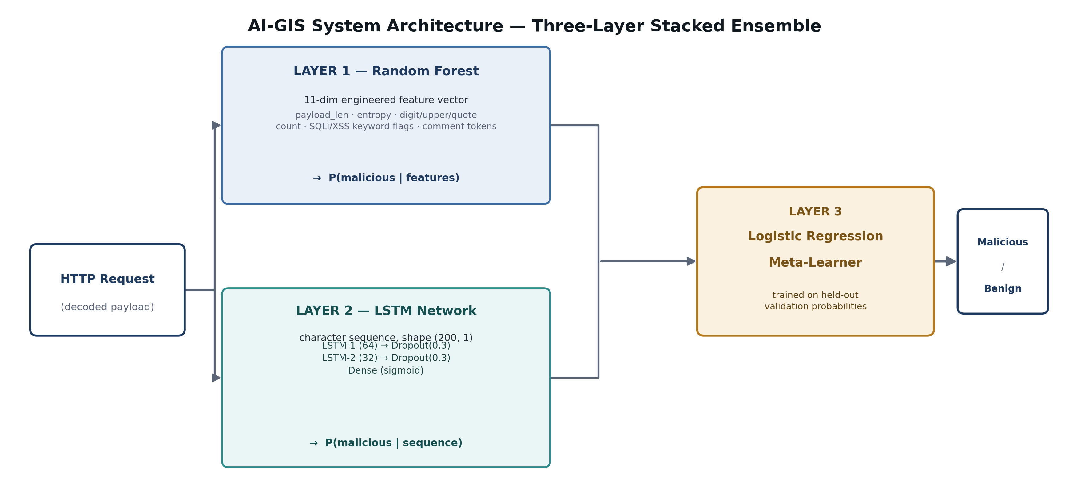
Figure. AI-GIS System Architecture — Three-Layer Stacked Ensemble

3.4 DATA ACQUISITION AND PREPROCESSING

3.4.1 Dataset Strategy and Rationale
The training corpus for AI-GIS is organized into three functional tiers that serve distinct roles in payload-level classification. The primary, title-defining tier is a synthetic honeypot log generated locally by the study’s own combinatorial payload generator, seeded from the WEB-IDS23 network intrusion dataset’s flow-level structure and attack-type labels [90]. This tier supplies the complete development corpus — training, validation, and an internal test split — in the same honeypot-log schema the methodology was designed around, and is already generated and in hand. A secondary, contingent tier consists of Resecurity-generated synthetic honeypot telemetry, which will be incorporated if institutional access is confirmed before the corpus is frozen (Section 3.4.2); the primary tier does not depend on this access being resolved. A third, supplementary tier consists of the SQLiV3 and XSS Payloads datasets [32], [33], which broaden known SQLi and XSS coverage through keywords, delimiter structures, encodings, comments, and other payload-level forms. The benign class for the development corpus is drawn from the same combinatorial generator that produces the primary tier, preserving session structure across malicious and benign records; a separately generated, Flask/httperf-based benign batch (Section 3.4.1.1) is reserved for the final held-out benchmark alongside the LLM-generated adversarial corpus described in Section 3.5.
The theoretical basis, quality requirements, and limitations of synthetic honeypot telemetry are discussed in Section 2.2.3. The procedures below specify how the available records will be accepted, represented, and separated for this experiment.
The WEB-IDS23-seeded synthetic honeypot log provides the primary honeypot-derived malicious training component. WEB-IDS23 itself is a published, DOI-registered network intrusion dataset built from a modular traffic generator run in a controlled environment [90]; it contributes flow-level structure, session timing, and fine-grained attack-type labels, not raw payload text. Payload content is synthetically generated per flow by this study’s own combinatorial generator — seven documented SQLi technique families (tautology, union-based, time-based blind, boolean blind, error-based, stacked query, auth bypass) and three documented XSS families (reflected, stored, DOM-based) — so, consistent with the disclosure standard already applied to Resecurity in Section 3.4.3, the study does not treat these records as exact representations of live attackers. The generated corpus totals 36,364 records: 9,091 SQLi, 9,091 XSS, and 18,182 benign, split by session_id into 24,819 training / 5,562 validation / 5,983 internal-test records (Section 3.7). SQLiV3 contributes 11,341 labeled malicious SQLi strings, and the XSS Payloads dataset contributes 15,149 malicious XSS strings, as supplementary coverage. The complete source roles and counts are documented in Table 10.

To make explicit how the development corpus is realized at the level of individual data sources, Table 10 decomposes it by source of origin, reporting each source’s proportional share and its corresponding training, validation, and internal-test counts under the session-grouped 70/15/15 split (Section 3.7). This decomposition allows the relative contribution of the WEB-IDS23-seeded corpus, Resecurity (if incorporated), SQLiV3, and XSS Payloads to be verified independently, rather than assumed from the aggregate split alone. Note that this internal test split is distinct from — and is not a substitute for — the LLM-generated held-out test set described in Section 3.5, which remains the basis for the study’s evasion-resistance evaluation.
Table 10 Dataset Composition and Partitioning Plan
Source | Partition | Attack Type | Label | Count | Notes
WEB-IDS23-seeded synthetic honeypot log [90] | Training + Validation + Internal Test | SQLi, XSS, Benign | Mixed | 36,364 (9,091 SQLi + 9,091 XSS + 18,182 benign) | Primary honeypot-derived source, already generated. Combinatorial generator seeded from WEB-IDS23 flow-level structure and attack-type labels; session-grouped 70/15/15 split (24,819 / 5,562 / 5,983); internal test split is distinct from the LLM-generated held-out set below.
Resecurity-generated synthetic honeypot telemetry | Training (if incorporated) | SQLi, XSS | 1 (attack) | Pending (contingent) | Secondary honeypot-derived source; incorporated only if institutional access is confirmed before corpus freeze (Section 3.4.2). Not required for the primary methodology.
SQLiV3 — attack samples only [32] | Training | SQLi | 1 (attack) | 11,341 | Raw SQL injection strings; benign column discarded — not representative of HTTP traffic
XSS Payloads — malicious samples only [33] | Training | XSS | 1 (attack) | 15,149 | URL-embedded XSS payload strings; benign column discarded — JS fragments, not HTTP requests
Self-generated benign HTTP traffic (httperf) | Held-out test only | Benign | 0 (benign) | ~600 | Reserved for the final held-out benchmark alongside the LLM-generated adversarial corpus (Section 3.5). Development-corpus benign records are now supplied by the WEB-IDS23-seeded generator (row above) for session-structure consistency.
Code Llama 13B (Ollama) | Test only (held-out) | SQLi | 1 (attack) | ~500 | Controlled generation settings documented and final accepted corpus preserved; 25 batches × 20 requested records
Code Llama 13B (Ollama) | Test only (held-out) | XSS | 1 (attack) | ~500 | Same controlled generation and preservation requirements; SQLi and XSS subsets validated separately
DeepSeek-R1 14B (Ollama) | Test only (held-out) | SQLi | 1 (attack) | ~300 | Feedback-informed two-round mutation protocol; detection outcome determined only during final evaluation
DeepSeek-R1 14B (Ollama) | Test only (held-out) | XSS | 1 (attack) | ~300 | Same feedback-informed protocol; results reported separately because of prior WAF feedback exposure
TOTAL — Held-Out Test Set | — | Mixed | Mixed | ~2,200 | 500+500 Code Llama + 300+300 DeepSeek + 600 self-generated benign
DEVELOPMENT-CORPUS SOURCE DISTRIBUTION (WEB-IDS23-seeded corpus finalized; SQLiV3/XSS Payloads/Resecurity integration pending)
Source | Accepted Records | Development Share | Training Count (70%) | Validation Count (15%) | Notes
WEB-IDS23-seeded synthetic corpus [90] | 36,364 | Primary source — see note | 24,819 | 5,562 | Also includes 5,983 internal-test records (15%), reported separately above (row 2). Session-grouped GroupShuffleSplit, seed=42. Cross-source blended percentages against SQLiV3/XSS Payloads/Resecurity pending an integration decision (Section 3.4.1).
Resecurity synthetic telemetry | [final accepted count] | [ ]% — contingent | [ ] | [ ] | Do not calculate until access and preprocessing are complete (Section 3.4.2); secondary source, not required for primary methodology
SQLiV3 malicious records [32] | 11,341 (pre-cleaning) | [ ]% | [ ] | [ ] | Report after duplicate and leakage checks
XSS Payloads malicious records [33] | 15,149 (pre-cleaning) | [ ]% | [ ] | [ ] | Report after duplicate and leakage checks
Locally generated benign (held-out only) | ~600 (target) | N/A — held-out, not development | N/A | N/A | Flask/httperf-generated; reserved for the final held-out benchmark, not the development corpus (see row above and Section 3.4.1.1)
TOTAL DEVELOPMENT CORPUS | 36,364 finalized (WEB-IDS23-seeded); SQLiV3/XSS Payloads/Resecurity integration pending | — | 24,819 (WEB-IDS23-seeded) | 5,562 (WEB-IDS23-seeded) | Full cross-source total will be reported once SQLiV3/XSS Payloads/Resecurity integration is finalized

3.4.1.1 Benign HTTP Traffic Generation and Validity Controls
The benign class will consist of controlled, locally generated HTTP requests—not captured production-user traffic. The sandboxed Flask application will document every implemented route, accepted HTTP method, expected parameter, and request-body format. The generation plan will cover multiple legitimate interaction patterns, including navigation, search, login or form submission, filtering, profile or record updates, and other routes actually implemented by the test application. GET and POST requests will vary in path, query-string structure, form values, headers, body length, and content type where the application supports them.
Legitimate values will not be limited to simple alphabetic words. The corpus will include ordinary punctuation, apostrophes, spaces, numeric values, URL-encoded characters, long form entries, multiple parameters, and benign text that may contain terms also seen in SQL or JavaScript contexts. Including difficult but legitimate inputs prevents the False Positive Rate from being evaluated only on unusually clean traffic.
The approximately 600-record final benign benchmark, reserved for the held-out evaluation alongside the LLM-generated adversarial corpus (Section 3.5), will be generated through a dedicated run and preserved as a separate file. Exact and normalized duplicate checks will be performed against the WEB-IDS23-seeded development corpus’s benign records to confirm the held-out benign batch is independent of them. Requests will be accepted only when they target a documented route, use an allowed method, contain the expected parameter structure, and receive the intended application response. The researchers will also manually inspect a documented sample from the generation run. Because one local application cannot represent every production workload, the resulting FPR will be reported with confidence intervals and interpreted within this limitation [41], [42].
The source percentages will be computed as accepted records from one source divided by the total accepted development corpus, multiplied by 100. Final training and validation counts will be recorded after the stratified split and before any balancing operation. SMOTE or sequence-level balancing results will be reported separately because synthetic or repeated training observations do not change the original source distribution.

3.4.1.2 WEB-IDS23-Seeded Synthetic Corpus Generation and Disclosure
Consistent with the disclosure already applied to Resecurity in Section 3.4.3, the WEB-IDS23-seeded corpus is disclosed here as synthetically generated rather than captured from a live honeypot. WEB-IDS23 supplies over 12 million labeled network flows across 20+ attack types, generated by a modular traffic generator operated in a controlled virtual environment and documented in a peer-reviewed technical report [90]; it is not itself a honeypot capture. This study uses only its flow-level session structure, timing, and fine-grained SQLi/XSS attack-type labels as a seed — payload text, request paths, and obfuscation are produced entirely by this study’s own combinatorial generator (webids23_to_honeypot_log_v4.py), reformatted into the same JSONL honeypot-log schema used for Resecurity and real post_audit.log records, so that both sources are interchangeable inputs to the identical preprocessing pipeline in Section 3.4.4.
Family selection within each attack type is uniform by construction, so the attack-family distribution reported in Table 10 reflects the generator’s design rather than an artifact of how many source examples existed per family. Duplicate control is handled explicitly: each base flow produces one unique payload, and any additional records needed to reach a target class size are marked as synthetic duplicates and reported separately, so apparent corpus size is never conflated with distinct-payload diversity. As with Resecurity, this source does not create a temporal-behavioral learning objective for the LSTM; each record is treated as one independent payload, consistent with Section 3.3.

3.4.2 Data Access Contingency Plan
With the WEB-IDS23-seeded corpus already generated and in hand (Section 3.4.1), Resecurity access is no longer a blocking dependency for the study’s primary methodology — it is now a contingent enhancement. The usable record count from Resecurity’s proprietary synthetic honeypot-generation framework will still be recorded if and when access, generation, and preprocessing are complete. If Resecurity access is confirmed before the corpus is frozen for model training, its records will be incorporated as an additional honeypot-derived source alongside the WEB-IDS23-seeded corpus, following the same fidelity validation in Section 3.4.3 and the same preprocessing pipeline in Section 3.4.4, and Table 10 will be updated accordingly. If Resecurity access is not confirmed in time, the study proceeds on the WEB-IDS23-seeded corpus alone, and this is reported as the finalized data composition rather than as an unresolved gap.
Resecurity has maintained its commitment to provide access to its proprietary synthetic honeypot dataset-generation framework through its institutional relationship with Asia Pacific College. At the time of this revision, the exact access arrangement, deliverable format, output schema, available request fields, SQLi/XSS coverage, usable record count, and delivery schedule remain subject to confirmation. Because the primary methodology no longer depends on this access, these details will be documented and Table 10 updated only if and when Resecurity access materializes, rather than gating any part of the current methodology on its resolution.

3.4.3 Fidelity Validation of the Resecurity-Generated Synthetic Corpus
Because the Resecurity-generated synthetic honeypot telemetry is not accompanied by disclosed raw operational captures against which its fidelity can be directly verified, the study will evaluate the observable properties that are relevant to the implemented payload-level classifiers. Before model training, the researchers will examine record validity, attack-category coverage, exact and normalized duplicate rates, encoding and obfuscation diversity, payload-length and entropy distributions, SQLi and XSS structural variation, and formatting artifacts that may reveal dataset origin. These controls assess whether the corpus adds meaningful payload diversity without claiming that it provides complete attacker sessions or temporal interaction histories.
If the corpus is unusually narrow, highly duplicated, dominated by one formatting pattern, or structurally inconsistent with its stated SQLi and XSS categories, the limitation will be reported in Chapter 4 and the honeypot-trained characterization will be qualified. The assessment does not prove equivalence to live attacker traffic and does not create a temporal-behavioral learning objective for the LSTM. It provides a partial and independently documented check on whether the synthetic source is suitable for the feature-based and character-sequence models used by AI-GIS.

3.4.4 Preprocessing Pipeline
All records from every training source will pass through a unified four-step preprocessing pipeline before feature extraction. The identical pipeline will be applied to training data, validation data, and the held-out test set without exception. Applying a consistent transformation across all partitions is a strict methodological requirement that prevents information asymmetry between training and evaluation and ensures that observed performance reflects classifier capability rather than preprocessing differences.

Parse.
For WEB-IDS23-seeded, Resecurity-derived (if incorporated), and self-generated benign HTTP logs — all sharing the same honeypot-log JSONL schema — a custom parser will extract the URL path, query string, and request body and concatenate the available fields into one payload representation. The HTTP method will be preserved separately for descriptive reporting but will not be included in the final classifier input, because method information is unavailable in the payload-only SQLiV3 and XSS sources and could allow the model to learn dataset origin. For SQLiV3, the Sentence column will be used as the payload field. For XSS Payloads, the Payloads column will be used directly.

Clean.
Records with empty or whitespace-only payload fields will be removed. For SQLiV3, rows where the Label column does not contain a strict numeric 0 or 1 will be dropped — the dataset is known to contain malformed label values including raw SQL strings in the label column that resulted from parsing errors in the original source. Exact duplicates on the combined payload-plus-label key will be deduplicated to prevent a single payload appearing in both training and validation partitions.

Label.
Each record will be assigned a binary label: 1 for attack, 0 for benign. Records from the WEB-IDS23-seeded honeypot log and, if incorporated, Resecurity honeypot logs will carry their original honeypot-schema classification. SQLiV3 attack samples and XSS Payloads malicious samples will be labeled 1. Self-generated benign HTTP traffic records will be labeled 0. For internal analysis, each attack record will additionally carry an attack_type tag (sqli or xss) — for the WEB-IDS23-seeded corpus this is the generator’s own documented family label; for SQLiV3 and XSS Payloads it is assigned by a regex-based heuristic classifier identifying SQL keywords or script/event-handler/JavaScript-protocol syntax respectively. This attack_type tag is used only for per-subset evaluation reporting and does not influence model training.

Validate.
Record counts per label and per attack type will be printed and recorded in the dataset composition table prior to any model training. This validation step confirms that the corpus composition matches the documented targets and that no partition contains unexpected class ratios before SMOTE is applied.

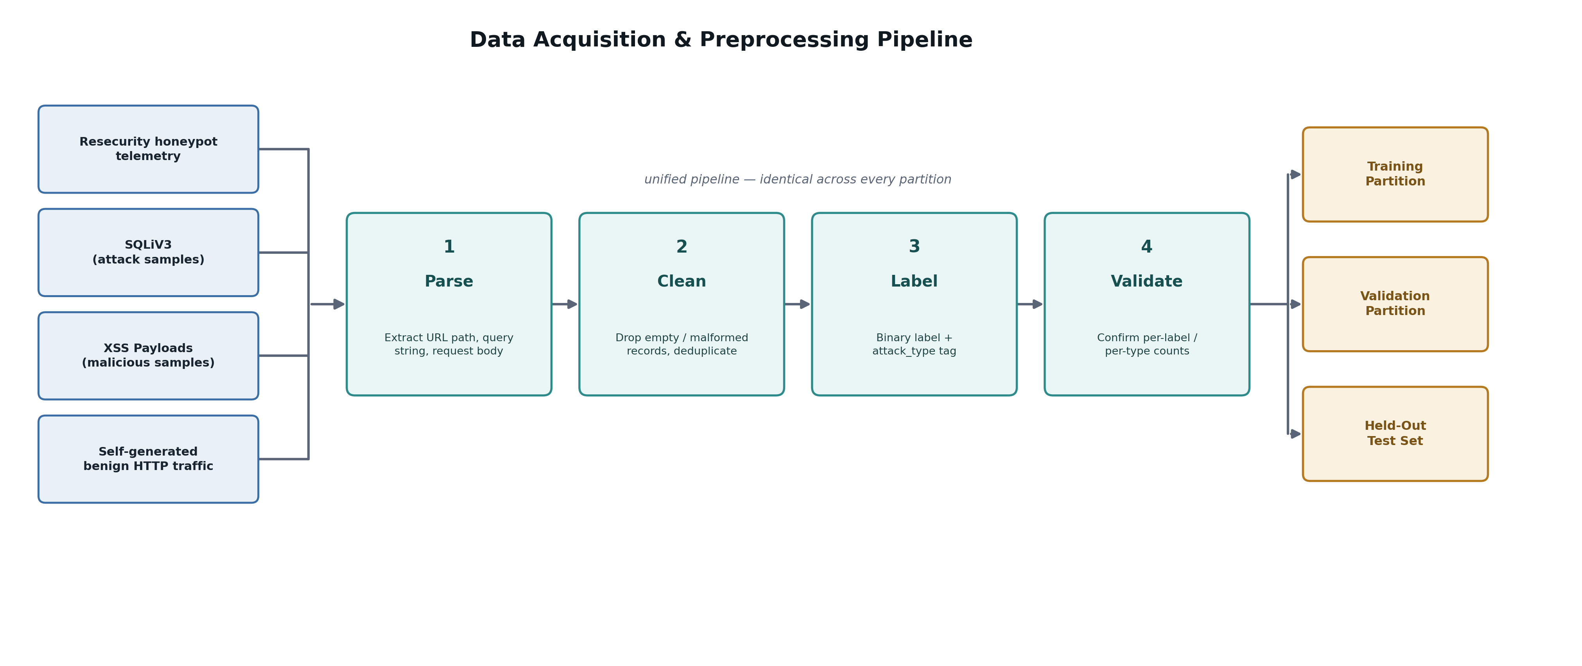
Figure. Data Acquisition and Preprocessing Pipeline

3.5 LLM-GENERATED ADVERSARIAL PAYLOAD CREATION
The held-out attack corpus will be generated locally through Ollama using Code Llama 13B and DeepSeek-R1 14B. None of these generated payloads will be used for model training, feature selection, vocabulary creation, hyperparameter tuning, stacking, or threshold selection. Local execution allows the researchers to preserve the exact model artifacts, prompts, settings, raw outputs, and accepted corpus. Section 2.2.2 provides the in-depth rationale for local execution and controlled reproducibility. Generated outputs will not be treated as valid attacks automatically; each record must pass the study validation and cleaning criteria.
All Ollama calls will use temperature=0, top_k=1, and documented seeds. These controls reduce sampling variability within the recorded environment, but identical output is not guaranteed across different hardware, model artifacts, quantization settings, or inference backends. The exact generated files retained after validation and deduplication will be frozen and used as the authoritative test corpus.

The first generator, Code Llama 13B, will produce the baseline SQLi and XSS payload subsets through the preserved local model tag codellama:13b. It is selected as a code-oriented generator that can produce structured SQL, HTML, and JavaScript-like text, but every output will still undergo functional and structural validation before acceptance [6].
Payload generation will proceed in 25 batches of 20 payloads per attack type, with the documented seed varied by batch to introduce controlled diversity under fixed settings. This produces approximately 500 SQLi payloads and 500 XSS payloads. SQLi generation will cover boolean-based blind, UNION-based, time-based blind, error-based, hexadecimal obfuscation, and stacked-query techniques. XSS generation will cover reflected, stored, DOM-based, and attribute-based patterns. Each batch will use a preserved prompt template and will remain subject to the validation, cleaning, and deduplication procedures described in this chapter [43].

The second generator, DeepSeek-R1 14B, will produce approximately 300 SQLi and 300 XSS payloads with different mutation behavior from Code Llama. The exact local model tag, digest, quantization, prompts, and output files will be preserved, and its role is to broaden the held-out corpus rather than to represent every reasoning-oriented model [5].
The specific DeepSeek-R1 14B build used for this study is an abliterated variant — one in which the model’s refusal direction has been located and removed through weight orthogonalization [89], rather than through prompt-based jailbreaking. This is a deliberate, disclosed methodological choice rather than an incidental one: the standard aligned release of DeepSeek-R1 refuses payload-generation requests outright, which would break the automated generation pipeline this section depends on. The abliterated build is used exclusively offline, inside the isolated laboratory environment described in Section 3.2, for the sole purpose of producing a held-out adversarial test corpus; its outputs are never deployed against a live system, distributed publicly, or used beyond the defensive evaluation described in this chapter. This use is further bounded by the constraints in Section 3.11.
Generation will follow an adaptive two-round protocol. Round 1 will produce an obfuscated candidate from a preserved prompt template. For Round 2, each Round 1 payload will be submitted to a local ModSecurity PL1 instance in DetectionOnly mode, and the matched CRS rule IDs and documented pattern descriptions will be supplied as feedback for one additional mutation. This creates a known circularity because the DeepSeek subset receives prior exposure to ModSecurity rule logic, although the final evaluation uses PL2. The adaptive loop will remain offline, and every call will use the same controlled settings as the Code Llama procedure: temperature=0, top_k=1, and documented seeds. Chapter 4 will report Code Llama, DeepSeek Round 1, and DeepSeek Round 2 separately so that this limitation can be evaluated rather than hidden.
The DeepSeek Round 2 payload subset is not fully independent of the ModSecurity evaluation baseline, and this structural limitation must be acknowledged explicitly. The Round 2 generation protocol uses matched CRS rule IDs from a ModSecurity PL1 instance as the feedback signal, meaning these payloads were partially optimized against ModSecurity rule logic prior to evaluation. Although the evaluation baseline uses PL2, which includes additional rules not present in PL1, the Round 2 payloads may exhibit a systematic advantage against the ModSecurity baseline that Code Llama payloads do not share. To allow readers to assess whether the observed ModSecurity detection gap is driven by both generators equally or primarily by the adversarially tuned DeepSeek subset, Chapter 4 will report Code Llama and DeepSeek payload results separately in addition to the combined evaluation. This generator-disaggregated reporting is treated as a required component of the results, not an optional supplement. The Code Llama subset provides a structurally clean, non-circular measurement of the detection gap because those payloads had no exposure to any ModSecurity configuration during generation — if the detection gap holds in the Code Llama-only subset, the DeepSeek circularity concern affects the magnitude of the reported gap but not the existence of the primary finding.

3.6 FEATURE ENGINEERING
Feature engineering will convert each raw payload into a 11-dimensional numerical vector used by the Random Forest branch. The LSTM does not consume this vector; it receives the separate character-level token sequence constructed in Section 3.7. The 11 engineered features are computed from the raw and decoded request representations according to their definitions, and the same extraction procedure is applied to every relevant partition. The complete Random Forest feature schema is documented in Table 11.
The conceptual basis for feature engineering, decoding, canonicalization, and character tokenization is discussed in Section 2.2.5. The present section documents the final computations applied in the implementation.

Table 11 Feature Engineering Schema - 11-Dimensional Payload Feature Vector
Feature Name | Type | Description and Detection Relevance
payload_len | Integer | Character count of the reconstructed payload text (query string + request body).
entropy | Float | Shannon entropy of the payload string; higher values indicate denser or more randomized/obfuscated content.
num_special_chars | Integer | Count of characters that are neither alphanumeric nor whitespace (quotes, brackets, semicolons, etc.) — injection syntax is disproportionately special-character-dense.
num_digits | Integer | Count of digit characters in the payload.
num_uppercase | Integer | Count of uppercase characters; SQL keywords are conventionally written in uppercase.
param_count | Integer | Number of URL query parameters, derived from '&' count plus one if '?' is present.
is_post | Binary | 1 if the HTTP method is POST, else 0.
has_sqli_keyword | Binary | 1 if any of 11 documented SQLi keywords/patterns (select, union, drop, sleep, waitfor, exec, 'or 1=1', xp_cmdshell, convert, extractvalue) appear in the lowercased payload.
has_xss_keyword | Binary | 1 if any of 11 documented XSS keywords/patterns (script, onerror, onload, onfocus, onmouseover, onstart, ontoggle, alert(, javascript:, <svg, <img) appear in the lowercased payload.
quote_count | Integer | Count of single and double quote characters; frequently manipulated in SQLi/XSS breakout attempts.
comment_token_count | Integer | Count of SQL/script comment tokens (--, /*, #) that can terminate or mask trailing query logic.

The feature categories capture complementary measurable characteristics of injection payloads. Length and character-composition features describe structural expansion. Entropy describes character-distribution complexity. Keyword flags and structural counts identify decoded SQLi- and XSS-associated structures without claiming that the model executes the payload or directly understands its semantic effect. The finalized Random Forest feature set is 11-dimensional — payload length, entropy, special-character count, digit count, uppercase count, parameter count, POST-method flag, SQLi-keyword flag, XSS-keyword flag, quote count, and comment-token count — documented in Table 11 below and implemented by prepare_honeypot_for_training.py. This supersedes the earlier 30-dimensional design. The narrower set is a deliberate choice, not a shortfall: with SMOTE applied to the training partition, a lower-dimensional feature space keeps minority-class interpolation meaningful rather than sparse, which matters more for this corpus size than maximizing feature count. The trade-off is that a few obfuscation-specific signals from the original design — hex-encoding detection, double-encoding detection, and raw-versus-decoded length divergence — are not currently captured, which bears directly on the evasion-resistance claim central to this thesis. Extending the feature set with these three signals specifically, rather than reverting to the full 30-feature design, is identified here as targeted future work once the current corpus and evaluation pipeline are stable.
All 11 Random Forest features are derived from raw or decoded payload content that is available consistently across every source. HTTP method is captured only as a binary is_post flag rather than a categorical field, and no request-to-total-length ratio is computed, since such ratios are unavailable in payload-only datasets like SQLiV3 and XSS Payloads and could reveal source origin rather than maliciousness. Source-level descriptive statistics and the diagnostic source-artifact check in Chapter 4 will be used to identify remaining formatting differences [41], [42].
Feature extraction is implemented as the engineer_rf_features function in prepare_honeypot_for_training.py, which accepts a raw payload string and returns a consistent 11-element numerical vector. The same function and decoding rules are applied to all sources so that the classifier cannot rely on source-specific preprocessing branches.

3.7 DATASET SPLITTING AND CLASS BALANCING

Train / Validation / Test Split
After preprocessing and deduplication, the WEB-IDS23-seeded development corpus is divided by session_id using scikit-learn’s GroupShuffleSplit into 70% training, 15% validation, and 15% internal-test data, with random_state=42 (prepare_honeypot_for_training.py). Splitting by session_id rather than by row is a stricter leakage control than row-level stratified sampling: it guarantees that no session’s requests are split across partitions, preventing the model from learning session-level artifacts (a shared source_ip or session_id hash, for instance) instead of payload structure, which would otherwise inflate evasion-resistance numbers. The 70/15/15 ratio remains consistent with the empirically supported heuristics for moderate-to-large sample sizes [34]. The separately generated Code Llama, DeepSeek-R1, and held-out benign records are not part of this division and remain untouched until final evaluation, as are SQLiV3, XSS Payloads, and Resecurity records pending their own integration into this split (Section 3.4.1).

Because session_id groups vary in size, the resulting split is not perfectly stratified by class at the row level; the realized label balance per partition (reported in the dataset composition table and manifest) is confirmed after the split rather than enforced by it. Table 10 reports the resulting per-source training, validation, and internal-test counts for the WEB-IDS23-seeded corpus. Once SQLiV3, XSS Payloads, and Resecurity (if incorporated) are integrated into a unified split, their session- or record-level grouping strategy and resulting per-source percentages will be finalized and reported here and in Table 10, carried forward into Chapter 4.

Source identifiers and attack_family tags are retained in split_manifest.json for reporting and leakage checks but are not supplied as model inputs. All normalization, vocabulary construction, balancing, hyperparameter tuning, meta-learner fitting, and threshold selection will use training and validation data only.

Character-Sequence Construction
For the LSTM branch, each decoded payload in the development corpus will be segmented into individual characters. A character vocabulary will be created from the training partition only. Each character will be mapped to its token identifier, with separate documented tokens for unknown characters and padding. The final held-out corpus will not influence the vocabulary.
Each token sequence will be padded or truncated to 200 positions using one documented truncation direction and reshaped to (200, 1). One payload therefore produces one LSTM sequence and one LSTM probability. The process does not construct windows of multiple HTTP requests. The proportion of payloads fully retained and the number exceeding 200 characters will be reported in Chapter 4.

SMOTE Class Balancing
The training partition may exhibit class imbalance depending on the realized session-grouped split, since session sizes vary and the split is not row-level stratified (Section 3.7). To address this, Synthetic Minority Over-sampling Technique (SMOTE) will be applied exclusively within the RF training partition after the split has been executed [19], exactly as implemented in prepare_honeypot_for_training.py’s --smote flag. SMOTE generates synthetic samples of the minority class by interpolating between existing minority-class feature vectors in the 11-dimensional feature space. Applying SMOTE only to the training partition is a strict data integrity requirement: if SMOTE were applied before splitting, synthetic samples derived from training records could appear in the validation set, constituting data leakage that would artificially inflate validation metrics and invalidate threshold optimization. SMOTE is not applied to the LSTM branch’s character-sequence arrays, which use the original, non-oversampled training rows.
The theoretical role and representational limitation of SMOTE are discussed in Section 2.2.6.4. Validation records and the final held-out benchmark will remain unchanged.

3.8 AI-GIS MODEL TRAINING PROCEDURE
The theoretical basis for Random Forest, character-level LSTM, optimization controls, class balancing, and holdout stacking is discussed in Sections 2.2.4 and 2.2.6. The procedures below specify how those methods will be fitted using development data only.

Layer 1 — Random Forest Classifier
The Random Forest classifier will be trained on the SMOTE-balanced training partition using sklearn's RandomForestClassifier. Hyperparameters will be selected through a 5-fold stratified grid search using GridSearchCV with scoring='f1' as the optimization objective. F1-Score is chosen as the grid search objective rather than accuracy because the detection task requires balancing false positive and false negative costs — a classifier that maximizes accuracy by predicting the majority class cannot achieve high F1. The candidate hyperparameter grid and rationale for each parameter are documented in Table 12.
Table 12 Random Forest Hyperparameter Search Space
Hyperparameter | Values Evaluated | Selected Value | Rationale
n_estimators | 100, 200, 300 | — | More trees reduce variance through ensemble averaging; 300 is the upper ceiling given available compute.
max_depth | None, 15, 25 | — | Unconstrained depth (None) risks overfitting; constrained values impose regularization.
min_samples_split | 2, 5 | — | Controls minimum sample requirement to split a node; higher values reduce overfitting on noisy payload features.
max_features | sqrt, log2 | — | Random feature subsets at each split reduce inter-tree correlation and improve ensemble diversity.
class_weight | balanced (fixed) | balanced | Compensates for any residual class imbalance remaining after SMOTE by up-weighting minority class samples.
random_state | 42 (fixed) | 42 | Fixed seed supports controlled repeatability within the documented software and data environment; it does not guarantee identical results across every platform.
Cross-validation strategy | StratifiedKFold (k=5) | F1-Score | Stratified folds preserve attack/benign ratio in every fold; F1 is chosen as the optimization target because it penalizes both false positives and false negatives.

Layer 2 — LSTM Neural Network
The LSTM network will be trained on the character-sequence arrays constructed in the Character-Sequence Construction subsection of Section 3.7. Each array represents one decoded payload as 200 ordered token positions rather than a window of several requests. The architecture is fixed and does not undergo grid search because sequence-model hyperparameter optimization would exceed the constrained laboratory scope. Table 13 documents the complete architecture.
Table 13 LSTM Neural Network
Layer | Type / Config | Units / Activation | Output Shape | Purpose
Input | Input layer | — | (200, 1) | Receives a character-level token sequence of length 200 derived from the decoded payload string.
LSTM-1 | LSTM (return_sequences=True) | 64 / tanh | (200, 64) | Extracts sequential character-level dependencies across the payload token sequence.
Dropout-1 | Dropout | Rate = 0.3 | (200, 64) | Reduces overfitting by randomly zeroing activations during training.
LSTM-2 | LSTM (return_sequences=False) | 32 / tanh | (32,) | Condenses the ordered character sequence into one fixed-length representation for the individual payload.
Dropout-2 | Dropout | Rate = 0.3 | (32,) | Second regularization layer for the 32-unit compressed payload representation.
Dense | Fully connected | 1 / sigmoid | (1,) | Outputs P(malicious) for the individual payload record.

Layer 3 — Logistic Regression Meta-Learner
The Logistic Regression meta-learner will be trained on a two-column matrix constructed from the validation-set probability outputs of the Random Forest and LSTM base models. Random Forest will produce P(malicious | features) and LSTM will produce P(malicious | character_sequence) for the same validation record. These aligned columns will be the sole meta-learner input. Because the second-level model is fitted using one held-out validation partition, the procedure is validation-based holdout stacking [18], [39].

Optimal Classification Threshold Selection
The default 0.5 probability threshold is suboptimal for detection tasks where false negative costs (missed attacks that reach the backend) and false positive costs (alert fatigue from spurious blocks) must be explicitly balanced against each other. The optimal threshold will be selected by evaluating the F1-Score of the meta-learner output across the validation set at threshold increments of 0.01 from 0.1 to 0.9. The threshold that maximizes F1-Score on the validation set will be recorded and applied to all held-out test set evaluations. This threshold must be selected before any access to the held-out test set to prevent implicit optimization against the test distribution.

3.9 COMPARATIVE EVALUATION PROCEDURE
The comparative evaluation will apply the identical held-out test set of approximately 2,200 records independently to both AI-GIS and ModSecurity. Neither system will be updated, retrained, or reconfigured during the evaluation phase. Both systems will process the same inputs in the same order, and their binary classification outputs will be collected for confusion matrix analysis. The evaluation will be conducted across four subsets: the combined test set containing all records, the SQLi-only subset, the XSS-only subset, and a generator-disaggregated subset reporting Code Llama and DeepSeek-R1 results separately. Evaluating across all four subsets directly addresses RQ2 by revealing whether performance differences between AI-GIS and ModSecurity are consistent across attack types or concentrated in one category.
ModSecurity and AI-GIS represent two different detection approaches that will be evaluated under the same frozen conditions. ModSecurity applies the configured OWASP CRS rules, transformations, anomaly scoring, threshold, paranoia level, and exclusions. AI-GIS applies learned relationships from the Random Forest feature representation and the LSTM character sequence. The held-out corpus contains previously unseen generated variants, but their ability to evade either system is not assumed before testing. Both systems are therefore treated as valid comparison approaches rather than designing the benchmark for one system to win.
AI-GIS is expected to offer possible additional coverage because learned combinations of decoded features and ordered characters may generalize to arrangements that do not accumulate enough anomaly score in the selected ModSecurity configuration. This is a testable expectation, not an established result. ModSecurity may detect many generated payloads through generic rule logic, and AI-GIS may miss attacks or incorrectly flag benign requests. Any favorable result for AI-GIS will therefore be interpreted as evidence of additional or complementary passive detection value under the tested conditions, such as supporting analyst review, disagreement analysis, or alert prioritization alongside an existing WAF.
The study separates AI-GIS model adequacy from comparative advantage. An overall AI-GIS F1-Score below 0.75 on the combined held-out set will indicate that the proposed model does not meet its pre-established minimum adequacy target for this experiment. However, this absolute threshold alone will not determine whether AI-GIS is better than ModSecurity. Evidence of additional detection value for RQ3 will be based on the side-by-side F1-Score, False Positive Rate, Precision, Recall, ROC-AUC, bootstrap confidence intervals, McNemar paired results, and the kinds of records uniquely detected or incorrectly classified by each system. For RQ2, an F1-Score difference greater than 0.10 between SQLi and XSS will indicate that AI-GIS does not generalize uniformly across the two attack categories. These criteria are specified before evaluation and will not be changed after the results are observed [14], [39].
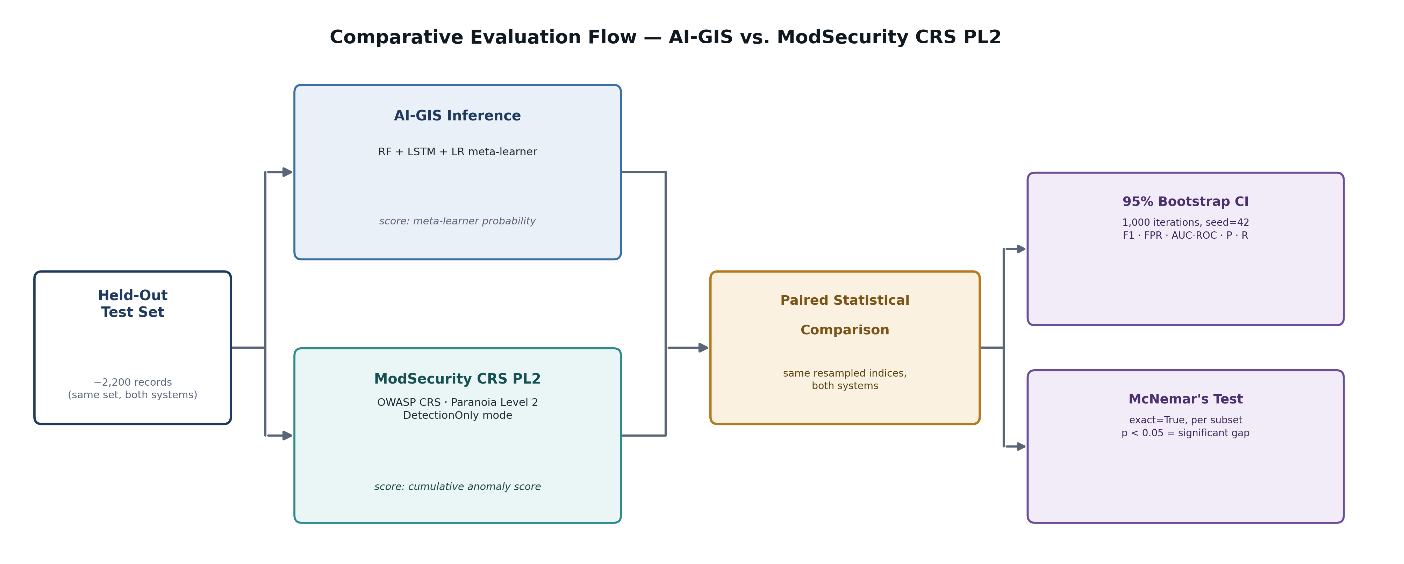
Figure. Comparative Evaluation Flow — AI-GIS vs. ModSecurity CRS PL2

Ablation Study
To verify that the stacked RF-LSTM architecture is responsible for any observed performance gain — rather than a single component carrying the result on its own — the evaluation will include a structured ablation study using the same held-out test set and the same evaluation metrics, summarized in the component matrix below. Three conditions establish standalone baselines: Random Forest alone, LSTM alone, and Logistic Regression trained directly on the 11-dimensional feature vectors without any base-model output. Two further conditions test partial stacking — Random Forest paired with the meta-learner but no LSTM branch, and LSTM paired with the meta-learner but no Random Forest branch — isolating what each half of the ensemble contributes on its own before the sixth and final condition, the full RF-LSTM stacked ensemble described throughout this chapter, is evaluated against all five. Every condition will be scored on F1-Score, FPR, AUC-ROC, Precision, and Recall across the combined, SQLi-only, and XSS-only subsets, with results reported in a comparative ablation table in Chapter 4. The logic is a direct test of attribution: if the full stack does not outperform the best single-layer baseline, the study will conclude that stacking does not add meaningful value beyond its strongest individual component.

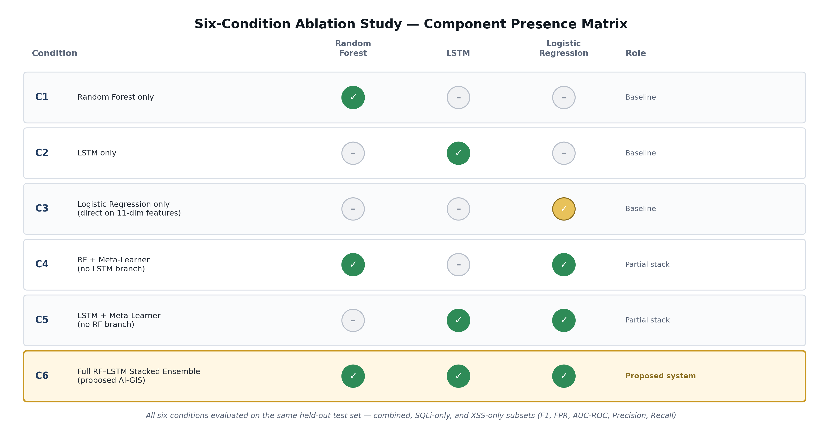
Figure. Six-Condition Ablation Study — Component Presence Matrix

Data-Source Ablation
A separate data-source ablation will determine whether Resecurity, if incorporated, adds measurable value beyond the WEB-IDS23-seeded corpus and its SQLiV3/XSS Payloads supplements. The primary comparison trains the same finalized AI-GIS architecture under two conditions: the baseline corpus — WEB-IDS23-seeded records plus SQLiV3 and XSS Payloads — and that same baseline with Resecurity records added. The benign development records, preprocessing rules, split, model architecture, tuning procedure, threshold selection, and frozen held-out benchmark remain unchanged across both conditions, isolating the contribution of the Resecurity tier specifically rather than confusing it with an architecture change.
This ablation only runs if Resecurity access is confirmed before the corpus is frozen (Section 3.4.2); if it is not, the WEB-IDS23-seeded baseline stands as the finalized data composition and this comparison is reported as not applicable rather than as a missing result. If the ablation does run and the Resecurity-augmented model does not improve generalization, unique detection coverage, or error balance over the baseline, the thesis will state that the Resecurity component did not provide a measurable contribution under the tested conditions.

ModSecurity Baseline Evaluation
ModSecurity will be deployed as a Docker container running the OWASP Core Rule Set at Paranoia Level 2 (PL2) in DetectionOnly mode. PL2 is selected as a security-conscious but operationally practical documented baseline. DetectionOnly mode records rule matches and anomaly scores without interrupting requests, ensuring that the complete test set is processed by both systems. Each held-out payload will be submitted as a synthetic HTTP request. The audit log will be parsed to extract detected or not-detected decisions according to the fixed inbound anomaly-score threshold, together with the continuous cumulative anomaly score used for analysis. The exact ModSecurity version, CRS version, threshold, exclusions, enabled rules, and Docker image will be recorded at execution time [44]. The resulting anomaly-score and rule-match structure follows the same audit log format illustrated in Figure 3 (Chapter 1).
The operation of ModSecurity, CRS anomaly scoring, Paranoia Level 2, DetectionOnly mode, and tuning considerations is discussed in Section 2.2.1.

AI-GIS Inference
AI-GIS inference will apply the three-layer pipeline to each held-out record. The Random Forest will produce a per-request probability from the 11-dimensional feature vector. For the LSTM, the same decoded payload will be segmented into characters, mapped through the training vocabulary, padded or truncated to 200 positions, and reshaped to (200, 1). The LSTM will produce P(malicious | character_sequence) for that individual record. The Logistic Regression meta-learner will combine the aligned Random Forest and LSTM probabilities using the validation-selected threshold to produce the final binary classification. Results will be recorded for the combined, SQLi-only, XSS-only, and generator-disaggregated subsets.

Evaluation Metrics
All evaluation metrics will be computed using sklearn.metrics functions. Table 14 defines each metric, its mathematical formulation, the research question it addresses, and its operational interpretation in the context of web application attack detection.
Table 14 Evaluation Metrics - Definitions and Research Question Mapping
Metric | Formula | Addresses | Interpretation
F1-Score | 2 × (Precision × Recall) / (Precision + Recall) or equivalently: 2TP / (2TP + FP + FN) | RQ1, RQ2, RQ3 / SOP1–4 | Primary comparison metric. The harmonic mean of precision and recall penalizes systems that maximize one at the expense of the other. A trivial classifier cannot achieve high F1 by flagging everything as malicious.
False Positive Rate (FPR) | FP / (FP + TN) | RQ3 / SOP1, SOP3 | Proportion of legitimate traffic incorrectly classified as attacks. Directly measures alert fatigue risk — the operational burden imposed on SOC analysts by spurious alerts.
AUC-ROC | Area under the Receiver Operating Characteristic curve (TPR vs. FPR across all thresholds) | RQ1, RQ2, RQ3 | Threshold-independent discrimination capacity. Interpreted as the probability that a randomly selected attack record receives a higher score than a randomly selected benign record. AI-GIS uses the meta-learner probability; ModSecurity uses the cumulative anomaly score extracted consistently from the audit log to construct its ROC curve.
Precision | TP / (TP + FP) | RQ2, RQ3 | Proportion of flagged records that are true attacks. High precision means fewer wasted analyst resources on false alarms.
Recall (True Positive Rate) | TP / (TP + FN) | RQ1, RQ2 | Proportion of actual attacks correctly detected. High recall means fewer missed attacks reaching the application backend.

Results will be reported in three formats, with all metric tables including four evaluation subsets: combined, SQLi-only, XSS-only, and generator-disaggregated (Code Llama vs. DeepSeek-R1 separately). Confusion matrices will present raw classification counts (TP, FP, TN, FN) for each system across each evaluation subset. Metric tables will present all five metrics side by side for AI-GIS and ModSecurity per subset, enabling direct quantitative comparison. ROC curves will be plotted for both AI-GIS and ModSecurity. AI-GIS uses the meta-learner probability output as its continuous score. ModSecurity uses the cumulative anomaly score from the audit log as its continuous score, enabling full ROC curve construction rather than a single operating point. Both AUC values will be reported and compared. The AI-GIS ROC curve will additionally mark the optimal threshold operating point selected during validation.
Generator-disaggregated results will be presented as a required fourth subset in all metric tables and confusion matrices, reporting Code Llama 13B and DeepSeek-R1 14B payload results independently in addition to the combined evaluation. This disaggregation is necessary to determine whether any observed ModSecurity detection gap is driven uniformly across both generators or concentrated in the adversarially tuned DeepSeek subset, and constitutes a required component of the Chapter 4 results rather than an optional supplement.
To account for sampling uncertainty on the approximately 2,200-record benchmark, all evaluation metrics for AI-GIS and ModSecurity will be accompanied by 95% bootstrap confidence intervals. The procedure will run for 1,000 iterations. During each iteration, sklearn.utils.resample will draw a same-sized set of held-out record indices with replacement. The statistical rationale for this procedure follows standard nonparametric bootstrap resampling practice [87] and is discussed further in Section 2.2.7.5. The same resampled indices will be applied to both systems so that their predictions remain paired. Precision, Recall, F1-Score, False Positive Rate, and ROC-AUC will be recalculated, and the 2.5th and 97.5th percentiles will form the confidence bounds. A reproducibly controlled random-state sequence beginning from seed 42 will be documented. The procedure occurs after final prediction and does not create training records, balance classes, select hyperparameters, or tune thresholds. Metric definitions and the statistical rationale are discussed in Section 2.2.7.
In addition to bootstrap confidence intervals, McNemar’s paired significance test [88] will be applied to formally assess whether the classification disagreements between AI-GIS and ModSecurity are statistically significant. McNemar’s test is appropriate for this design because both systems classify the same set of test records, producing paired binary outcomes. The test examines the 2×2 contingency table of discordant pairs — records where one system is correct and the other is incorrect — and determines whether the asymmetry between these discordant cells is larger than expected by chance. A p-value below 0.05 will be interpreted as evidence that the performance difference between the two systems is statistically significant rather than attributable to sampling variability. McNemar’s test will be computed using statsmodels.stats.contingency_tables.mcnemar with exact=True for the combined test set and for each evaluation subset (SQLi-only, XSS-only). This paired test complements the bootstrap confidence intervals by directly addressing the question: “is the observed detection gap real, or could it have arisen from the specific composition of the held-out sample?”

3.10 SOFTWARE AND REPRODUCIBILITY REGISTRY
Reproducibility is a primary methodological commitment of this study. Every software component used in the pipeline will be version-pinned before execution begins, and the complete version registry will be recorded at the time of actual experiment execution. Table 15 documents the planned software configuration.
Table 15 Software and Reproducibility Registry
Component | Version / Tag | Role in Pipeline | Notes
Python | 3.10.x | Runtime environment | All scripts executed within an isolated virtual environment with frozen requirements.txt.
scikit-learn | 1.4.2 | Layer 1 (RF) and Layer 3 (Meta-Learner) | RandomForestClassifier, LogisticRegression, StratifiedKFold, GridSearchCV, metrics, and resampling utilities. SMOTE is provided by imbalanced-learn.
TensorFlow / Keras | 2.16.1 / 3.3.3 | Layer 2 (LSTM) | Sequential model, LSTM layers, Dropout, Dense, EarlyStopping, ModelCheckpoint callbacks.
imbalanced-learn | 0.12.3 | Class balancing | SMOTE implementation applied exclusively to training partition.
pandas | 2.2.2 | Data manipulation | CSV ingestion, DataFrame operations, label handling, development-data splitting, and result aggregation.
numpy | 1.26.4 | Numerical operations | Character-sequence array construction, tensor reshaping, and feature-matrix operations.
scipy | 1.13.0 | Statistical utilities | Shannon entropy computation for payload entropy features.
matplotlib / seaborn | 3.9.0 / 0.13.2 | Visualization | ROC curve generation, confusion matrix heatmaps, feature importance plots.
Ollama | [ollama --version at run time] | LLM inference runtime | Local inference runtime. Preserve exact version, model tags/digests, quantization, prompts, parameters, seeds, raw outputs, and accepted corpus.
Code Llama 13B | codellama:13b | Adversarial payload generator | Generates held-out SQLi and XSS test payloads. Deployed via: ollama pull codellama:13b.
DeepSeek-R1 14B | deepseek-r1:14b-abliterated | Adversarial payload generator | Abliterated build (refusal direction removed via weight orthogonalization [89]); exact tag/digest confirmed at execution time. Generates 300 polymorphic SQLi and 300 XSS payloads via adaptive two-round mutation. Used exclusively offline for held-out adversarial test corpus generation; see Section 3.5 disclosure and Section 3.11 ethical constraints. Deployed via: ollama pull deepseek-r1:14b-abliterated.
httperf | [httperf --version at run time] | Benign traffic generator | Generates separate controlled benign development and held-out request batches against the sandboxed Flask application.
ModSecurity + OWASP CRS | owasp/modsecurity-crs:4.3.0-nginx | Rule-based WAF baseline | Deployed as Docker container in DetectionOnly mode. Record embedded CRS version at execution time.
Docker | [docker --version at run time] | Container runtime | ModSecurity deployment and network isolation.
Ubuntu / WSL2 | 22.04 LTS | Operating system | Primary experimental platform. All paths and commands documented relative to this environment.

To ensure full reproducibility, the following artifacts will be preserved and documented alongside the final thesis submission: requirements.txt containing all Python package versions, the Ollama model manifest confirming the exact model weights used for payload generation, the ModSecurity Docker image digest, the full adversarial payload CSV files generated by Code Llama, and all trained model artifacts (.pkl for RF and meta-learner, .h5 for LSTM) with their associated training logs. Any deviation from the planned software versions encountered during execution will be documented explicitly in the final methodology.

3.11 ETHICAL COMPLIANCE AND RESEARCH BOUNDARIES
This study operates entirely within an offline, air-gapped laboratory environment. The following ethical constraints govern the entire research:
- All payload generation will be performed offline with no connection to an external target system.
- No generated payload will be transmitted to a live production system, unauthorized external server, or public exploit repository.
- ModSecurity will be deployed only inside the isolated laboratory network with no public network exposure.
- Generated adversarial payloads will be stored only in the controlled local project directory and will not be reproduced in full in the thesis, a public repository, or an appendix.
- The abliterated DeepSeek-R1 14B variant (Section 3.5) will be used exclusively in the closed testing environment for the defensive evaluation described in this methodology, will never be used to generate content outside this pipeline, and its outputs will never be transmitted to a live target.
These constraints will be verified before experiment execution and confirmed again before the final Chapters 3 and 4 submission. Any deviation will be documented together with its effect on safety, reproducibility, and interpretation.

3.12 SUMMARY OF THE METHODOLOGY
This chapter presents the complete research methodology for AI-GIS. AI-GIS and ModSecurity OWASP CRS PL2 will be evaluated independently on the same frozen held-out set of LLM-generated SQLi and XSS payloads together with controlled locally generated benign HTTP requests. The methodology is governed by offline execution, strict development/held-out separation, frozen evaluation configurations, and controlled generation with preserved artifacts.
The malicious development corpus uses a WEB-IDS23-seeded synthetic honeypot log as the primary honeypot-derived source — already generated, verified, and split — with SQLiV3 and XSS Payloads providing supplementary payload coverage. Resecurity-generated synthetic honeypot telemetry remains a secondary, contingent tier: incorporated if institutional access is confirmed before the corpus is frozen, not required either way. Controlled locally generated HTTP requests provide the benign class for the final held-out benchmark, generated separately from the WEB-IDS23-seeded corpus's own benign records. Whether Resecurity contributes measurable value beyond the WEB-IDS23-seeded baseline, if it is incorporated at all, will be determined by the data-source ablation in Section 3.9.
The AI-GIS architecture combines a Random Forest feature-based classifier and an LSTM character-sequence classifier through a Logistic Regression meta-learner. Random Forest operates on the 11-dimensional engineered vector, while LSTM operates on a separate 200-position token sequence created by breaking one decoded payload into individual characters. The LSTM does not analyze several requests or complete sessions. SMOTE is applied only to the Random Forest training representation, while valid sequence balancing must use actual character sequences. The meta-learner is trained through validation-based holdout stacking, and the classification threshold is selected on validation data before any final test exposure.
Code Llama 13B generates approximately 500 SQLi and 500 XSS baseline payloads. DeepSeek-R1 14B generates an additional 300 SQLi and 300 XSS polymorphic payloads, and self-generated benign traffic contributes approximately 600 held-out records. AI-GIS and ModSecurity will independently process the same frozen benchmark. Their outputs will be evaluated using F1-Score, False Positive Rate, ROC-AUC, Precision, Recall, bootstrap confidence intervals, McNemar paired testing, and disagreement analysis. The final interpretation will determine whether AI-GIS offers additional or complementary passive detection value under the tested conditions rather than assuming that it universally replaces or outperforms ModSecurity.

NEW REFERENCES TO MERGE INTO THE MASTER REFERENCE LIST
This chapter now cites four sources not yet in the master reference list (numbered here as the next available slots after [86]; final numbering depends on where they land in true first-appearance order once merged — note that [87] and [88] ideally belong with their existing Chapter 2 theory subsections, 2.2.7.5 and 2.2.7.6, which are also currently uncited).
[87] B. Efron and R. J. Tibshirani, An introduction to the bootstrap. New York: Chapman & Hall, 1993.
[88] Q. McNemar, Note on the sampling error of the difference between correlated proportions or percentages. Psychometrika, 12(2), 153–157. https://doi.org/10.1007/BF02295996 1947.
[89] A. Arditi, O. Obeso, A. Syed, D. Paleka, N. Panickssery, W. Gurnee, and N. Nanda, Refusal in language models is mediated by a single direction. Advances in Neural Information Processing Systems, 37. https://doi.org/10.48550/arXiv.2406.11717 2024.
[90] E. Lanfer, D. Brockmann, and N. Aschenbruck, Technical report: Generating the WEB-IDS23 dataset. arXiv. https://doi.org/10.48550/arXiv.2502.03909 2025.

