Game Design Document

Fill up the following document

1. Write the title of your project.

Harry Potter: The ultimate running Game

1. What is the goal of the game?

Collect treasures

1. Write a brief story of your game.

Harry potter is a famous boy . voldemort the villian is after him to kill him. He has captured his frnds in treasure boxes. Now Harry has to collect the boxes and save his frnds without being caught by voldemort

1. Which are the playing characters of this game?

* Playing characters are the ones who respond to the user based on the input from the user.
* Cars, monkeys, dinos, wizards, etc., are the playing characters in the game.

|  |  |  |
| --- | --- | --- |
| Number | Character Name | What can this character do? |
| 1 | Harry | Move in all directions and collect treasures |
| 2 |  |  |
| 3 |  |  |
| 4 |  |  |
| 5 |  |  |
| 6 |  |  |
| 7 |  |  |
| 8 |  |  |

1. Which are the Non-Playing Characters of this game?

* Non-Playing characters are the ones that don't have an action or behavior when the user interacts with the game.
* Hurdles, stones, bananas, coins, etc., are non-playing characters in the game.

|  |  |  |
| --- | --- | --- |
| Number | Character Name | What can this character do? |
| 1 | Voldemort | If touched results in game over |
| 2 | Treasure | Can be collected to earn points |
| 3 |  |  |
| 4 |  |  |
| 5 |  |  |
| 6 |  |  |
| 7 |  |  |
| 8 |  |  |

Draw your imagination of this game. What does this game look like?

* Draw the game either on your computer or on paper.
* Add images of the game scenes to show each of the playing and non-playing characters at least once.

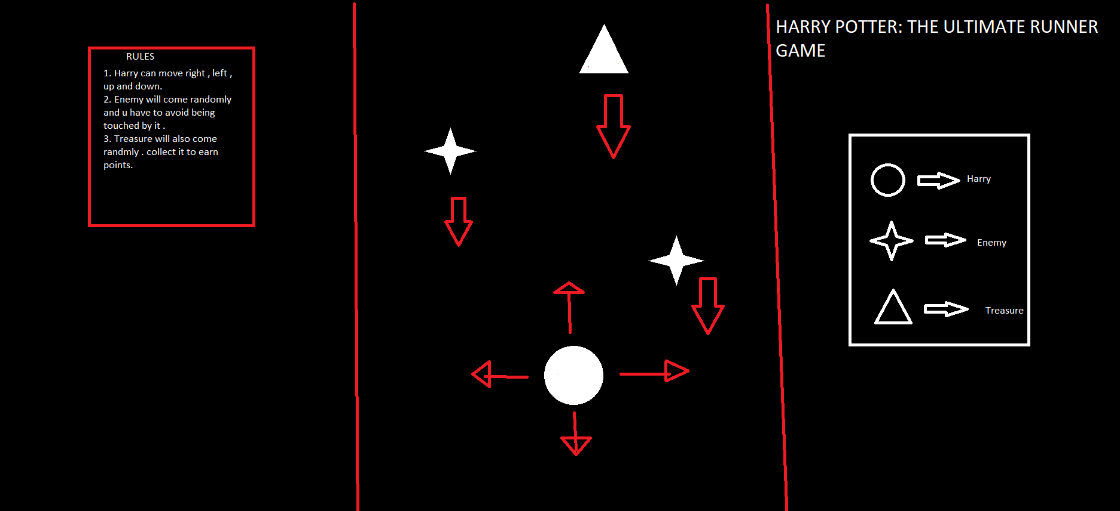

How do you plan to make your game engaging?

By adding music , awesome characters , simple rules and awesome scoring system .