# The Wombat Librarian

It is the frontend (built with React) for a web application for book lovers, where people can browse books, keep track of what books they have and what books they want to read.

Backend repository can be found here: https://github.com/Dusernajder/WombatLibrarianApi

## Project Status

This project is currently in development. The user can add books to his/her bookshelf and wishlist, which is stored on the server side, in an in-memory database. The current sprint's scope is to implement storage of these information in a database.
Further tasks for subsequent sprints: add registration/login, so that these data can be stored for individual users, develop a community library, with possibilities to follow other members, borrow/trade books, discuss reads.

## Project Screen Shot(s)

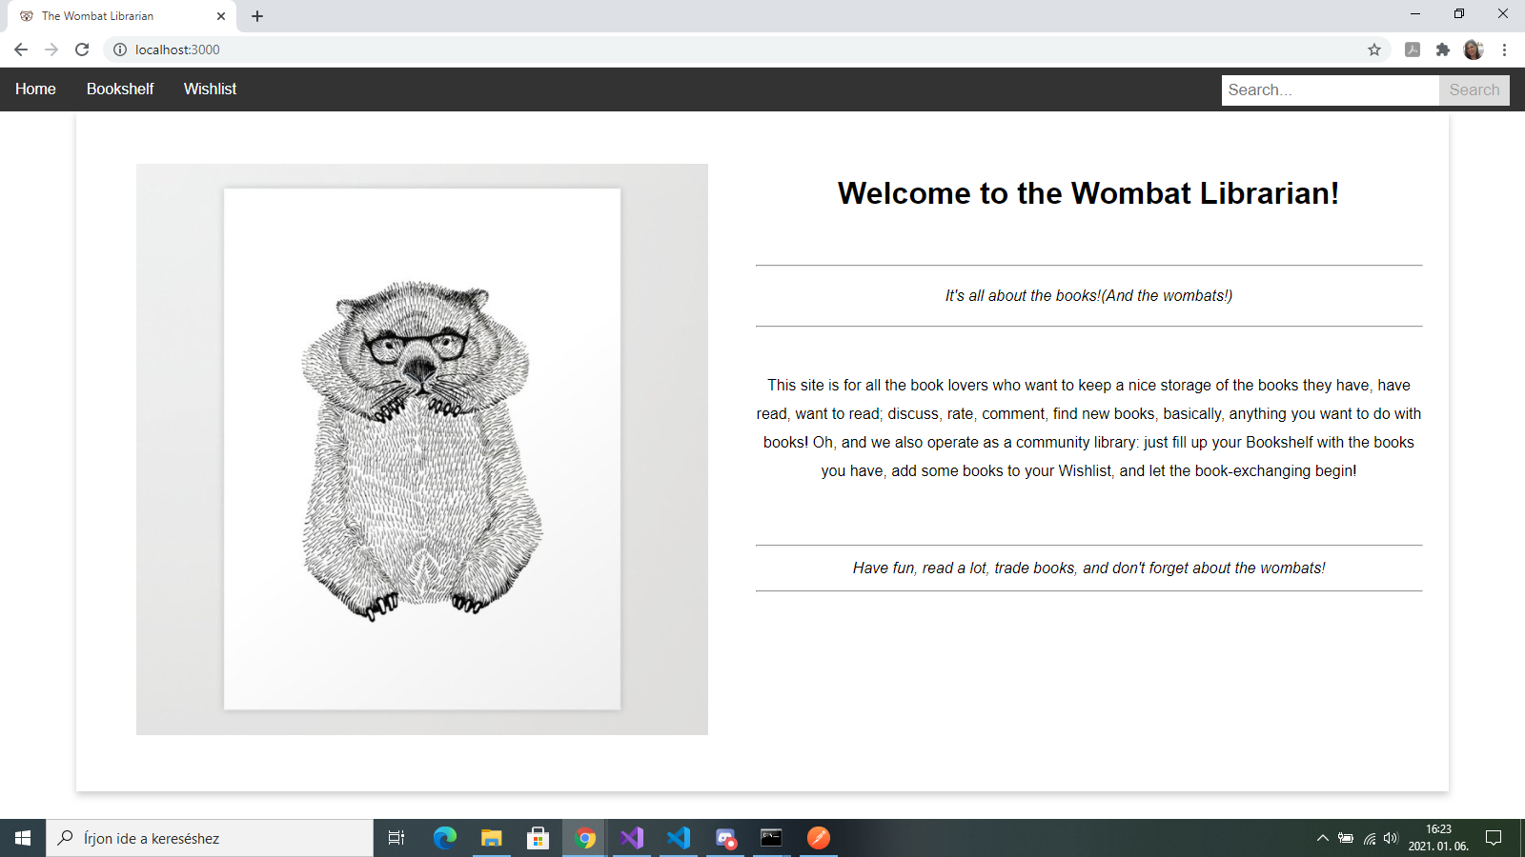

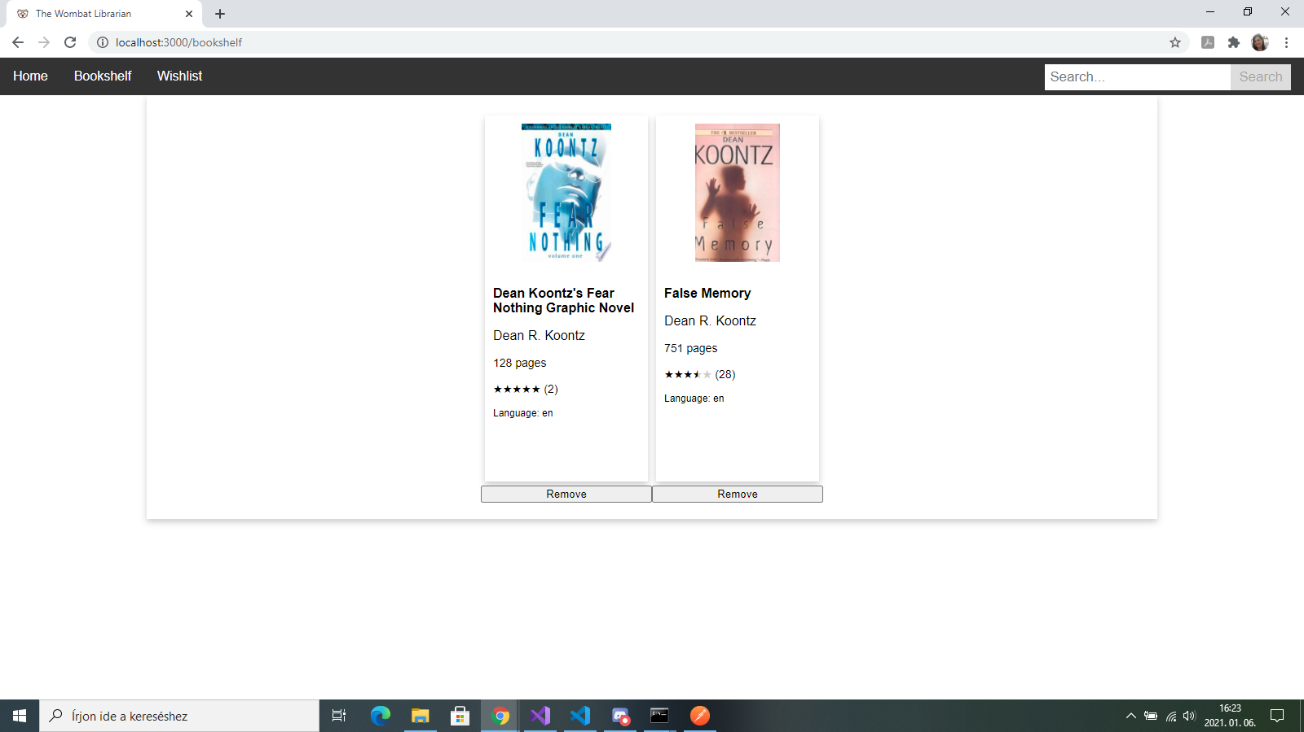

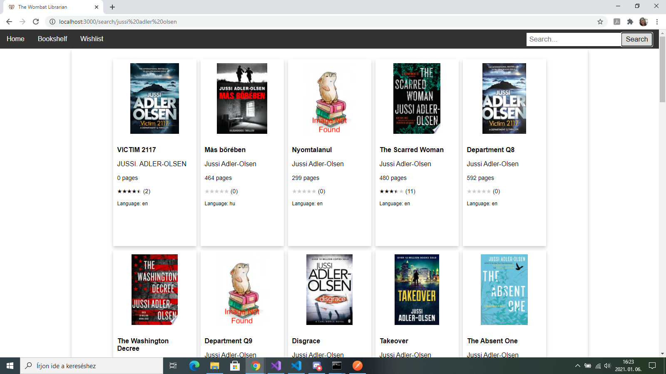

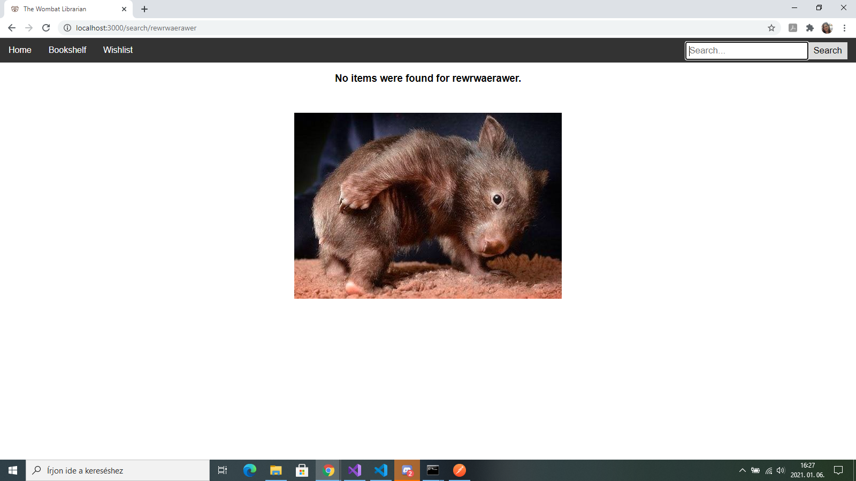
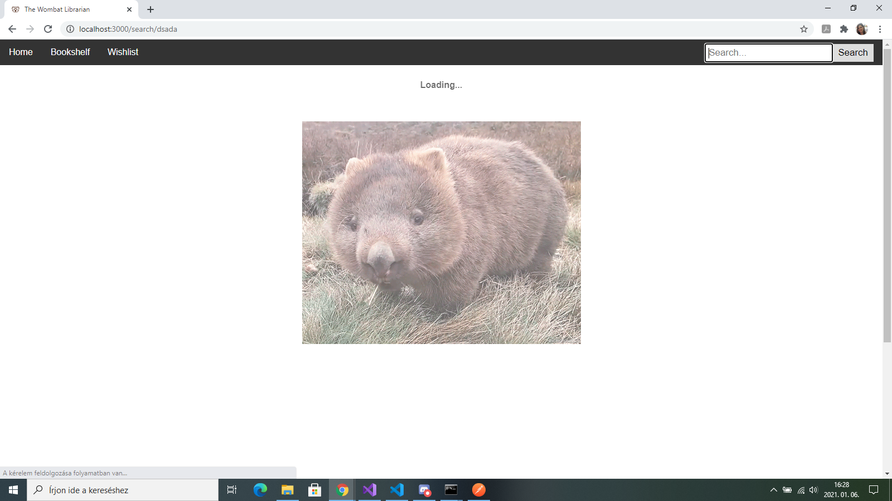

## Installation and Setup Instructions

Clone down this repository. You will need node and npm installed globally on your machine.
You also have to clone the backend repository and follow those instructions as well.

### `npm install`

Installs npm.

### `npm start`

Runs the app in the development mode.\
Open [http://localhost:3000](http://localhost:3000) to view it in the browser.

The page will reload if you make edits.\
You will also see any lint errors in the console.

