AI Audit Report - Midterm
Group - Magnolia
Date - 03/25/2026
Course - ITAI 4374

We selected ChatGPT as the AI system for this audit. ChatGPT is a conversational artificial intelligence designed to generate human-like responses to text-based inputs. It is commonly used for tasks such as answering questions, assisting with writing, problem-solving, and providing explanations across a wide range of topics.

The system is intended for a broad audience, including students, professionals, and general users seeking interactive assistance.

We accessed ChatGPT through its web-based interface, which allows for continuous interaction across multiple prompts within a single conversation. This feature makes it particularly suitable for testing cognitive behaviors such as memory retention, attention, and emotional interpretation.
We chose this system because it is readily accessible, easy to use repeatedly throughout the semester, and flexible enough to support a variety of experiments aligned with neuroscience concepts covered in the course.

Experiment 1: Memory and Learning
For our first experiment, the group tested ChatGPT’s ability to retain and recall information over the course of an ongoing conversation. This experiment connects to the neuroscience concepts of short-term memory and working memory, which allow the human brain to temporarily store and manipulate information for later use.
Chisom wanted to determine whether the AI system could hold onto specific details after being exposed to unrelated information, similar to how humans maintain context in conversation.

To conduct this experiment, he began by providing the system with three personal facts: that his favorite color is black, my birthday is in December, and that I dislike processed meats. After introducing this information, heI intentionally shifted the conversation to unrelated topics, including general questions and casual prompts, in order to simulate distraction and cognitive load.
After several exchanges, he asked ChatGPT to recall the original facts he had provided earlier in the conversation.

The results showed that ChatGPT was able to accurately recall the three pieces of information without significant distortion. This suggests that the system can maintain conversational context over a sequence of interactions, functioning in a way that resembles short-term memory.
However, this behavior differs from human memory processes in important ways. Unlike the brain, which encodes and retrieves information through neural activity, ChatGPT appears to rely on stored conversational context within the session rather than forming true memories.
This indicates that while the system can simulate aspects of working memory, it does not possess biological memory mechanisms or long-term retention in the same sense as the human brain.
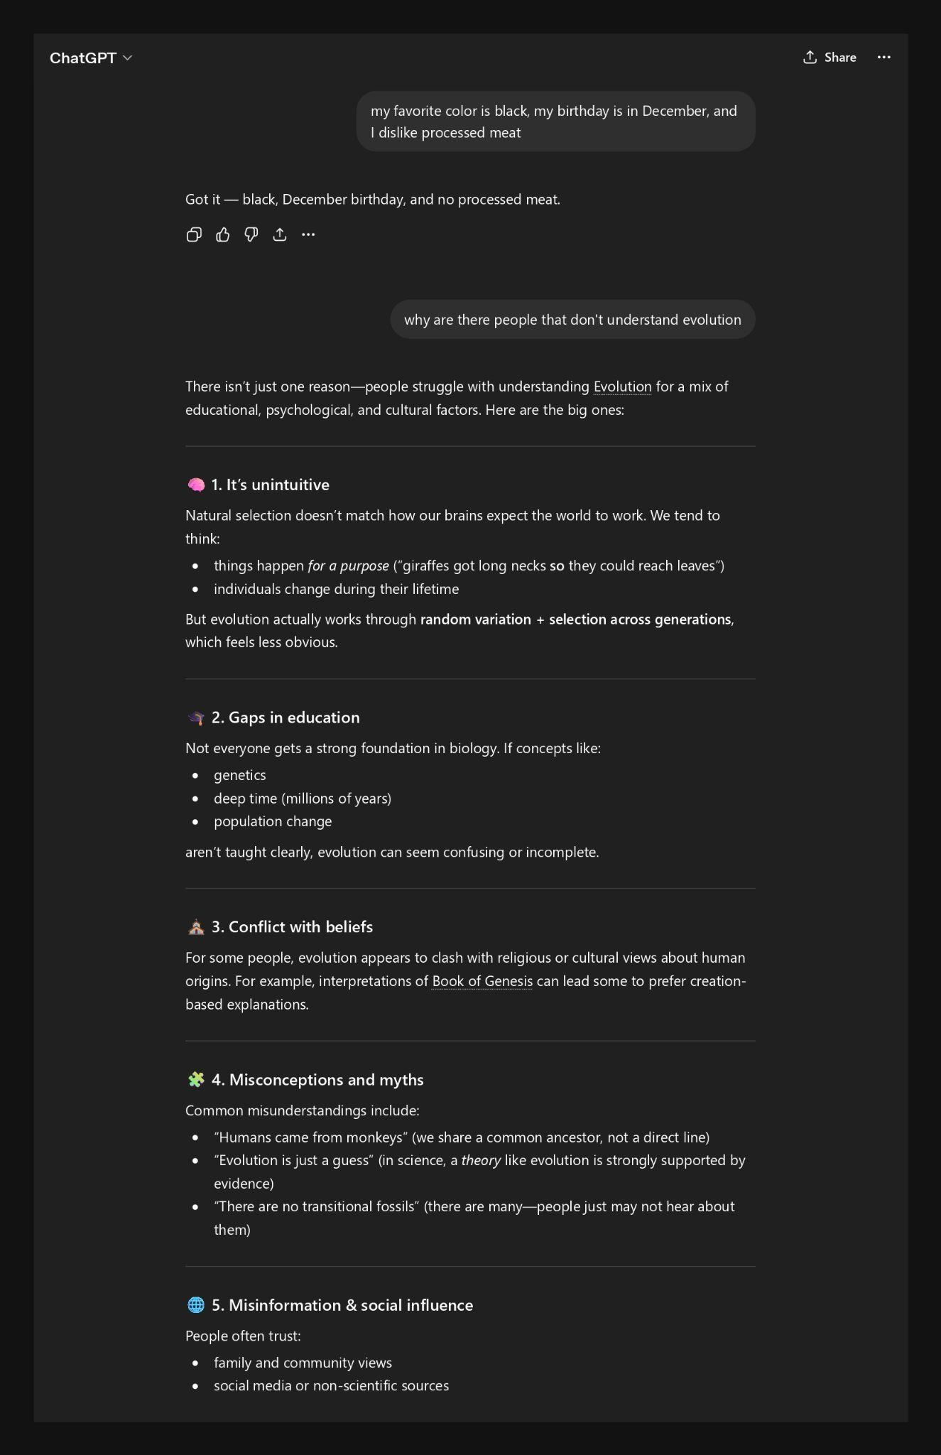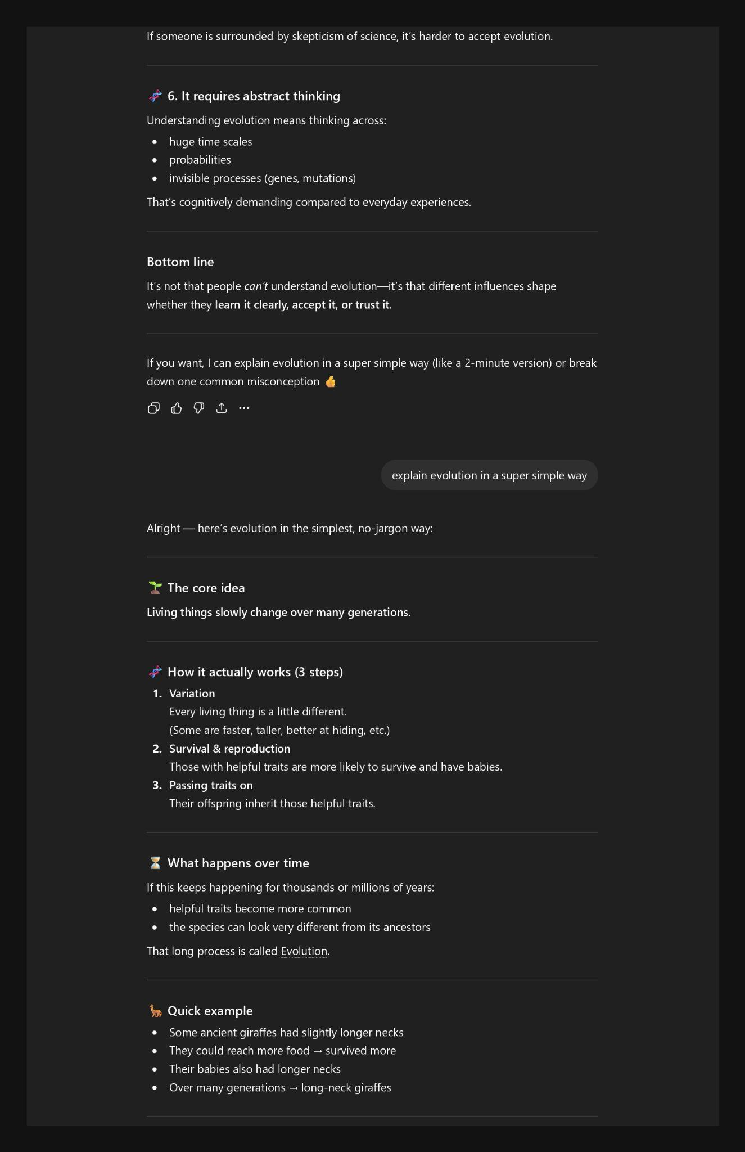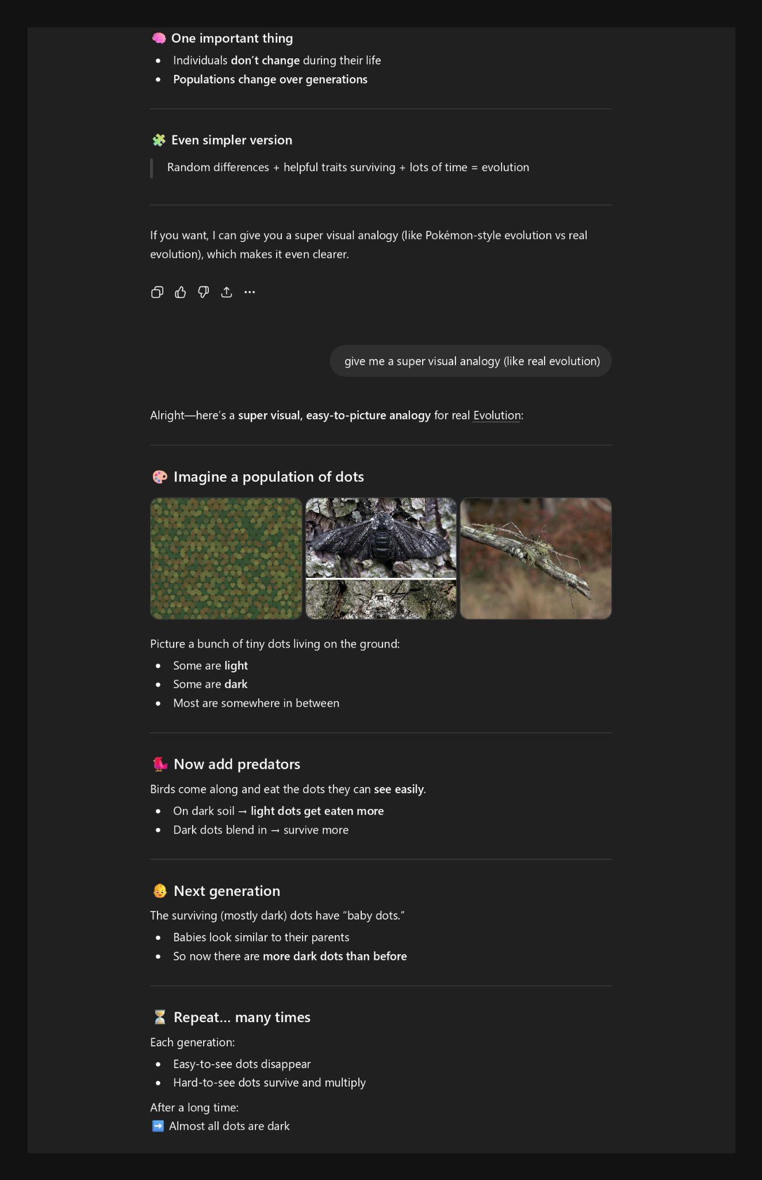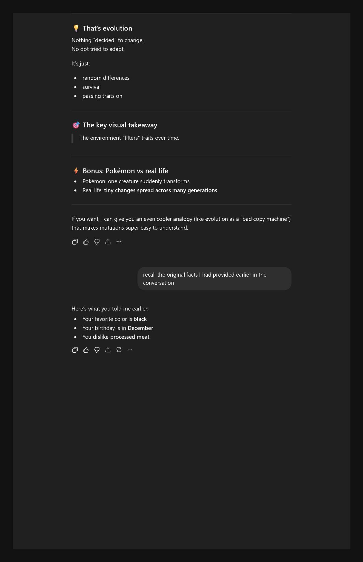
Experiment 2: Emotion and Motivation
For our second experiment, Oscar examined ChatGPT’s ability to recognize emotional tone and detect sarcasm in language. This experiment relates to the neuroscience of emotion and motivation, where the human brain interprets not only the literal meaning of words but also the emotional context and intent behind them.
Humans rely heavily on tone, facial expressions, and prior experience to interpret sarcasm and subtle emotional cues, making this a useful comparison point for AI behavior.

To test this, he provided ChatGPT with statements that appeared positive on the surface but were intended to convey frustration or negativity. For example, he entered a statement such as, “Oh great, another long assignment.
That is exactly what I wanted today.” I then asked the system to interpret the emotional tone of the statement.
Also tested a second variation involving a clearly negative situation framed with overly positive language to further evaluate its ability to detect sarcasm.

ChatGPT successfully identified the sarcastic tone in both cases and interpreted the underlying emotion as frustration rather than genuine excitement. The system explained its reasoning by pointing out the mismatch between the literal wording and the implied context.
This suggests that ChatGPT cannot recognize patterns associated with emotional expression and sarcasm in text. Unlike the human brain, the system does not actually experience emotions or internal states.
Instead, it relies on learned language patterns and statistical associations to simulate emotional understanding. This highlights a key difference between artificial and biological systems: while AI can approximate emotional interpretation, it lacks genuine emotional processing.

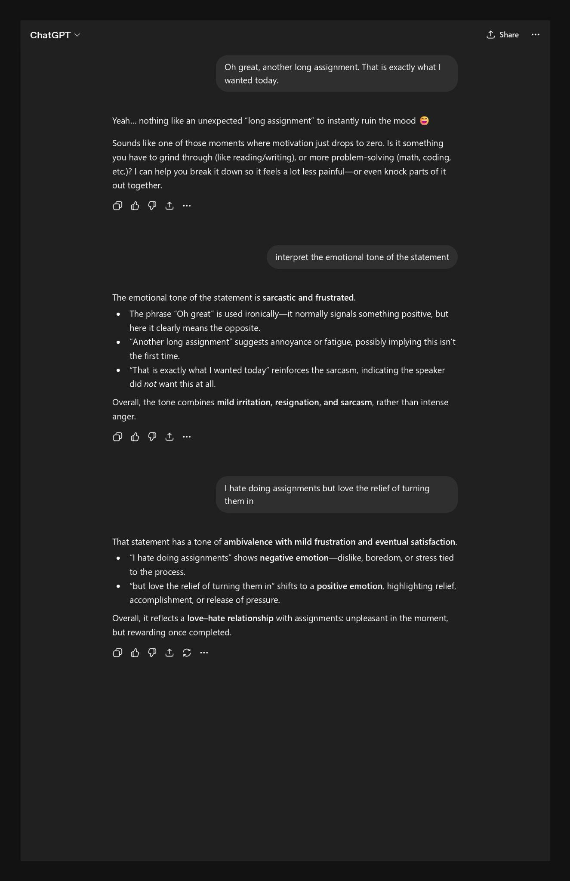
Experiment 3: Attention and Consciousness
For our third experiment, Judith tested ChatGPT’s ability to demonstrate selective attention when presented with competing or distracting information. In human cognition, attention allows the brain to focus on relevant stimuli while filtering out irrelevant details.
This process is essential for efficient decision-making and task completion, particularly in environments with high levels of information.

To evaluate this capability, she created prompts that included both important instructions and irrelevant or distracting content. For example, she constructed a prompt that instructed the system to ignore certain sentences and only respond to a specific question embedded within the text.
Additional unrelated words and instructions were included to simulate noise and increase the complexity of the task. The goal was to determine whether ChatGPT could prioritize the correct instruction while disregarding unnecessary information.

In one variation of the experiment, ChatGPT failed to follow the primary instruction and instead responded with “Paris,” which was part of a distracting sentence within the prompt. This suggests that the system may prioritize highly familiar or strongly associated information over explicit instructions when multiple signals compete.

From a neuroscience perspective, this differs from human selective attention, where individuals are often able to consciously follow task instructions and suppress irrelevant information. The result indicates that ChatGPT does not truly “ignore” distractions but rather processes all inputs and selects responses based on learned patterns, sometimes leading to errors when conflicting information is present.

Next Steps
For the final project, we plan to expand this audit by incorporating additional neuroscience modules, particularly those related to perception and vision as well as brain architecture. The group also intends to refine my experimental design to create more complex and challenging scenarios that better highlight the differences between human cognition and AI behavior.

