Judith Barrios
ITAI 3377
Professor Sitaram Ayyagari

02/07/26

L03 Reflective Journal: Deploying AI Model on Simulated Edge device

Setup and Environment
I used Google Collab for this assignment, which provided Python and TensorFlow pre-installed in a cloud environment. This dropped local installation needs and saved setup time. I simply created a new notebook and ran the provided code at once.

Dataset Preparation
I loaded the MNIST dataset having 60,000 training images and 10,000 test images of handwritten digits (0-9). Each image is 28x28 pixels. I normalized the pixel values by dividing by 255.0 to scale them between 0 and 1, which helps the model train better. I also reshape the data to include a channel dimension (28, 28, 1) required by conventional layers.

Model Training
I built a simple CNN with one convolutional layer (32 filters), one max pooling layer, one dense hidden layer (128 neurons), and an output layer (10 classes). The model had 693,962 trainable parameters.

Training results across 5 epochs:

- Epoch 1: 91.26% training accuracy, 97.82% validation accuracy
- Epoch 5: 99.66% training accuracy, 98.63% validation accuracy
- Final test accuracy: 98.63%

Training took 4-5 minutes total on Google Colab. The high accuracy from the first epoch showed the CNN architecture works well for this task.

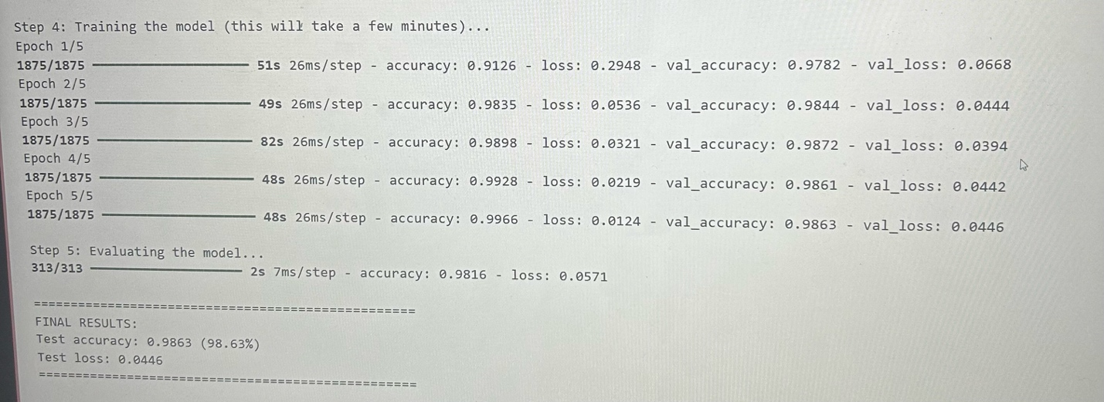

Model Conversion and Deployment

I converted the Keras model to TensorFlow Lite format (.tflite). The TFLite model was 2713.46 KBmin size. This conversion is important for edge deployment because TFLite models are designed for resource-constrained devices like mobile phones, Raspberry Pi, or NVIDIA Jetson boards.

The conversion was successful, and I tested the TFLite model using the interpreter. All 5 test samples were predicted correctly (100% sample accuracy), confirming the model works after conversion.

Observations

Key observations:

- The model achieved 98.63% test accuracy, showing effective digit classification
- Validation accuracy was consistently high across all epochs
- TFLite conversion-maintained accuracy while creating a deployment-ready model
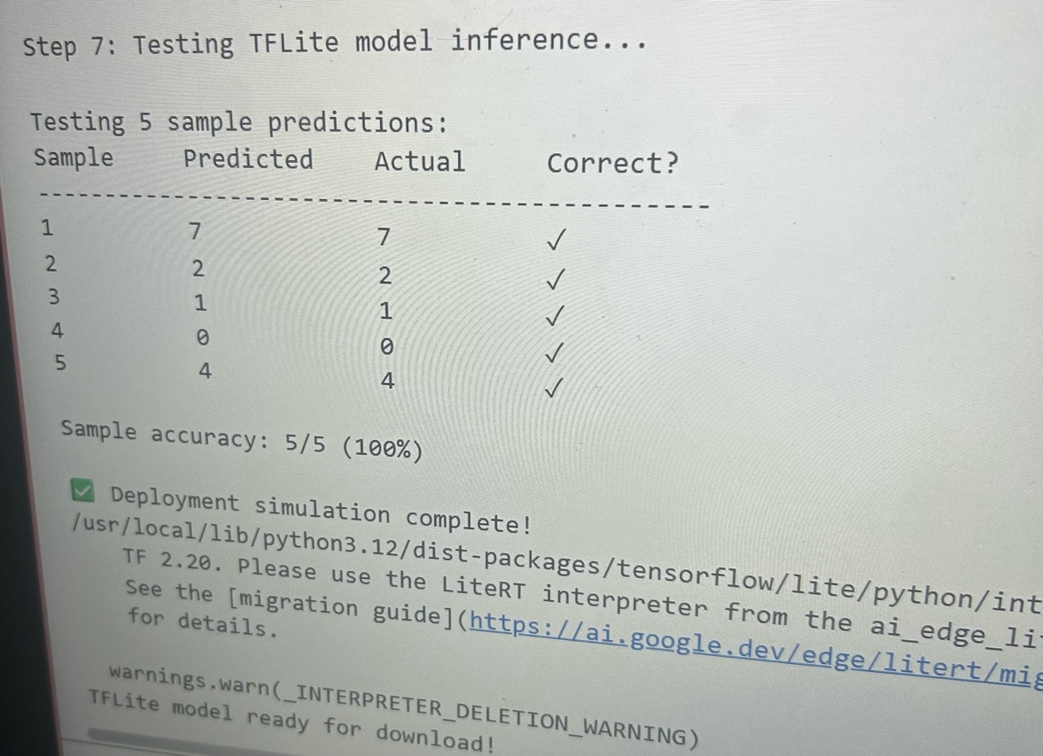
- Sample predictions: 5/5 correct (100%)

Challenges

The main challenge was understanding how the TFLite conversion process works and why it is necessary for edge devices. However, Google Colab’s pre-configured environment made the technical implementation straightforward.

Personal Reflection

This exercise shows the complete machine learning pipeline: data preparation, training, conversion, and testing. The key insight is that edge AI requires model optimization - the TFLite format makes models smaller and faster for devices with limited resources.

Connection to Course Concepts

This connects to Module 2 (Edge Computing and AI) by showing how AI models must be fine-tuned for edge deployment. The TFLite conversion reduces model size and enables local processing rather than cloud-based inference.

This relates to Module 3 (IIoT Devices and Sensors) by proving how edge devices can run AI models locally. Like the Liverpool Smart Pedestrians project (A03 case study), where the NVIDIA Jetson TX2 ran YOLO for object detection, this exercise showed how lightweight models enable real-time processing on edge hardware without sending data to the cloud.

