Judith Barrios
ITAI 3377
Professor Sitaram Ayyagari

02/07/26

L03 Simulation Documentation: AI Model Deployment on Edge Device

Introduction

This document details the setup, deployment, testing, and validation of a simple AI model on a simulated edge device using Google Colab. The aim was to train a convolutional neural network on the MNIST dataset and convert it to TensorFlow Lite format for edge deployment.

Setup and Environment

- Platform: Google Colab (cloud-based Jupyter notebook environment)
- Python Version: 3.x
- TensorFlow Versions: 2.x (pre-installed)
- Hardware: Google Colab CPU runtime

Dataset Preparation

Dataset: MNIST handwritten digits

- Training samples:

Model Architecture

The CNN model architecture:

- Conv2D layer: 32 filters, 3x3 kernel, ReLU activation
- MaxPooling2D layer: 2x2 pool size
- Flatten layer: Converts 2D feature maps to 1D
- Dense layer: 128 neurons, ReLU activation
- Output layer: 10 neurons, softmax activation

Total parameters: 693,962 trainable parameters

Model size: 2.65 MB (before TFLite conversion)

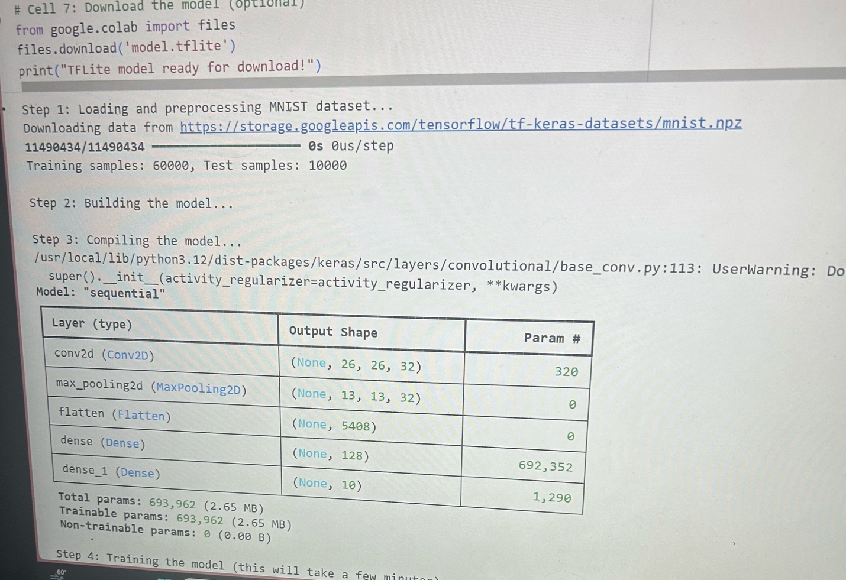

Training Process

Optimizer: Adam

Loss function: Sparse categorical cross-entropy

Metrics: Accuracy

Epochs: 5

Batch size: Default (32)

Training Results:

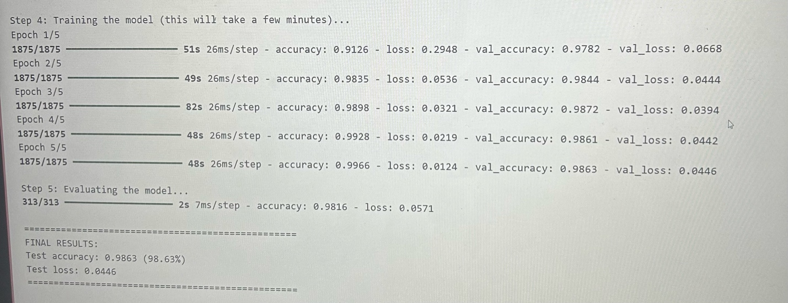

Training duration: 4-5 minutes

Model Evaluation

Final test results on 10,000 test samples:

- Test Accuracy: 98.63%
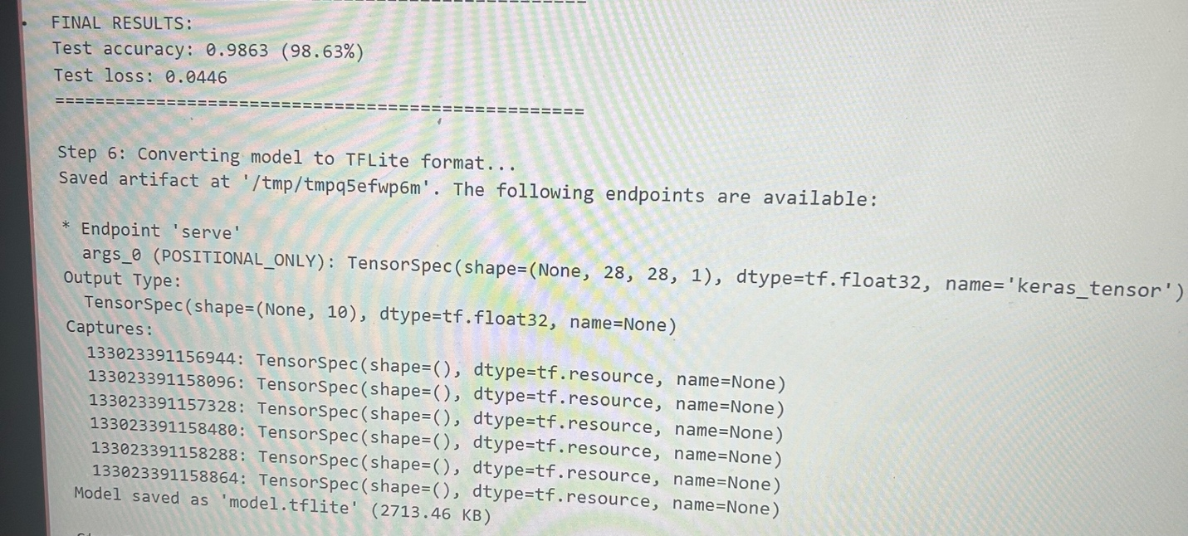
- Test Loss: 0.0446

Deployment Process

The trained Keras model was converted to TensorFlow Lite format for edge deployment.

- Conversion method: TFLiteConverter.from_keras_model()
- Output file: model.tflite
- TFLite model size: 2713.46 KB (~ 2.65 MB)

Validation and Testing

The TFLite model was confirmed using the TensorFlow Lite interpreter to ensure successful conversion.

Sample Test Results (5 random test images):

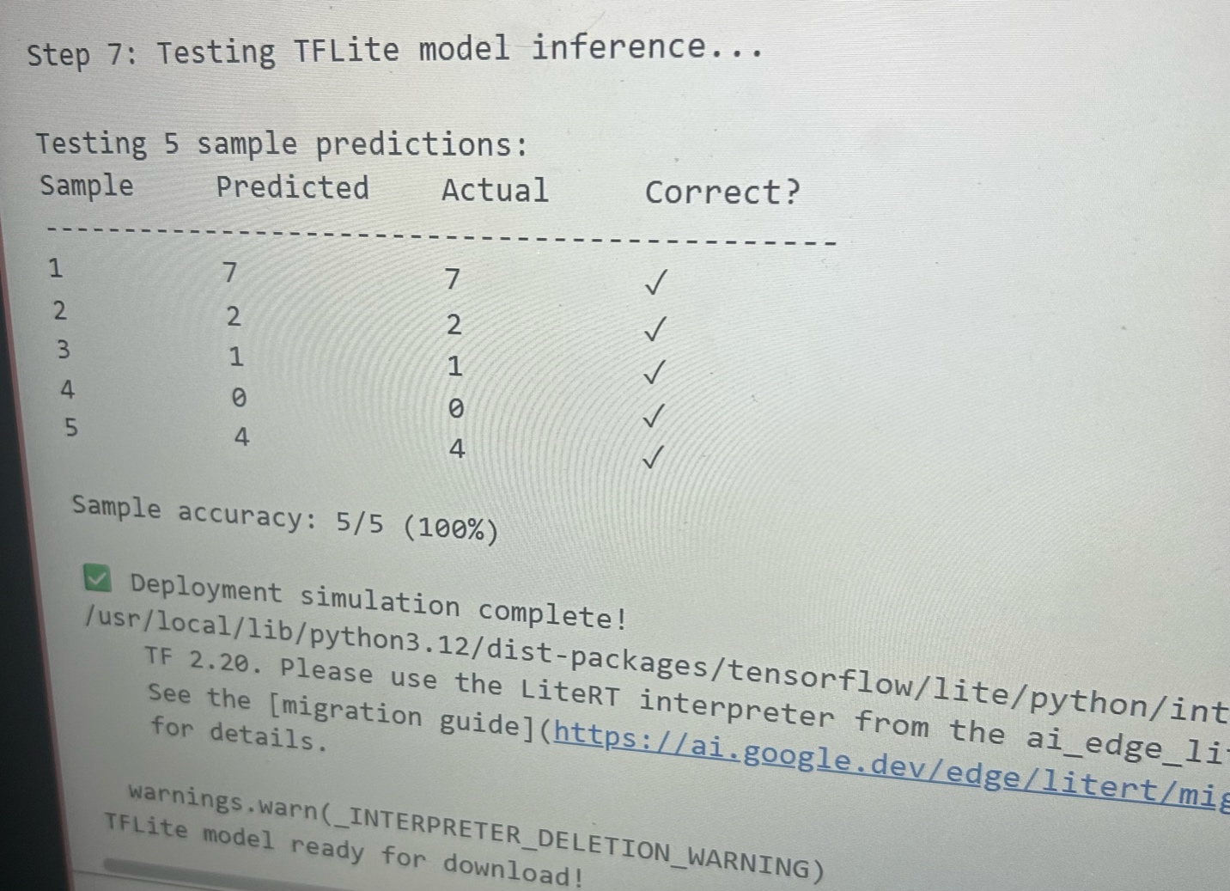

Sample accuracy 5/5 (100%)

Technical Observations

- Model performance: The CNN achieved excellent accuracy (98.63%) with a simple architecture
- Training efficiency: Model converged quickly, reaching > 98% validation accuracy by epoch 1
- Conversion success: TFLite conversion-maintained model accuracy
- Inference speed: TFLite interpreter processed test samples instantly
- Model size: TFLite format kept similar file size (~2.7 MB), suitable for edge devices with moderate storage

System Logs

Key log outputs from the simulation:

Training samples: 60000, Test Samples: 10000
Model: “sequential”
Total params: 693,962 (2.65 MB)
Trainable params: 0 (0.00 B)

Final Results:
Test accuracy: 0.9863 (98.63%)
Test loss: 0.0446

Model saved as ‘model.tflite’ (2713.46 KB)
Sample accuracy: 5/5 (100%)
Deployment simulation complete

Conclusion

The simulation successfully shows the complete workflow of training, converting, and placing an AI model for edge devices. The MMIST digit classifier achieved 98.63% accuracy and was successfully converted to TensorFlow Lite format. The TFLite model-maintained accuracy while being improved for edge deployment on resource-constrained devices.

Supporting Materials

- Model architecture summary
- Training progress across 5 epochs
- Final evaluation results
- TFLite conversion output

