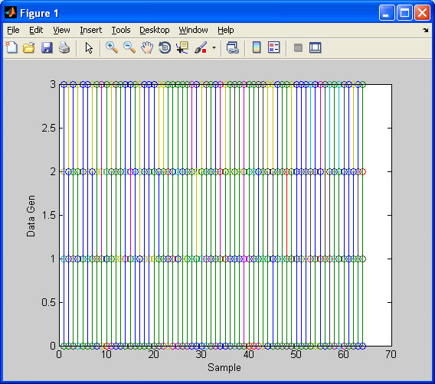

Generate Random binary data

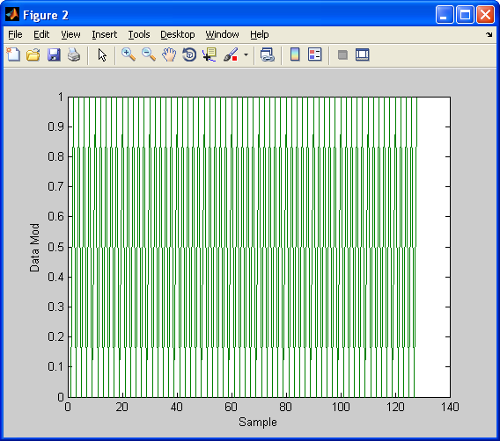

After QAM Modulation

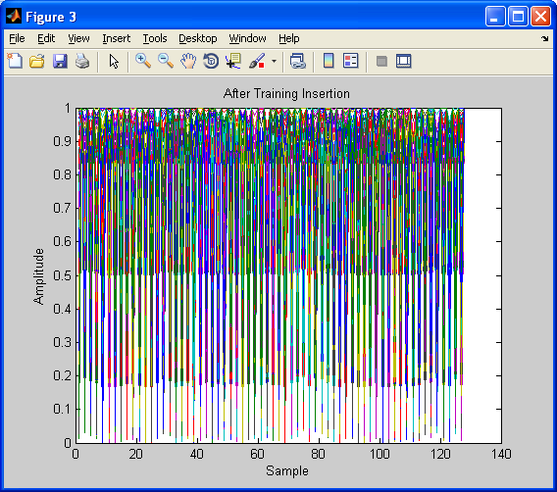

After Random training Data Insertion

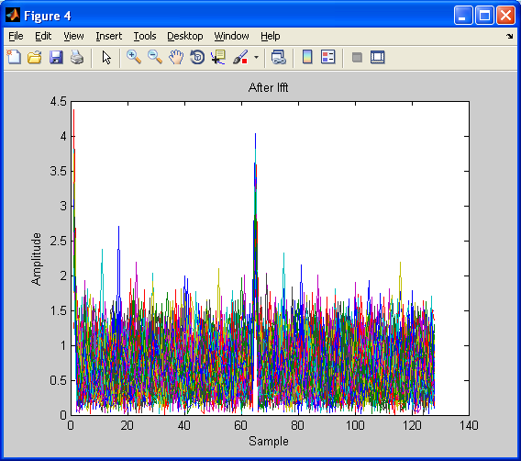

After IFFT in OFDM Tx

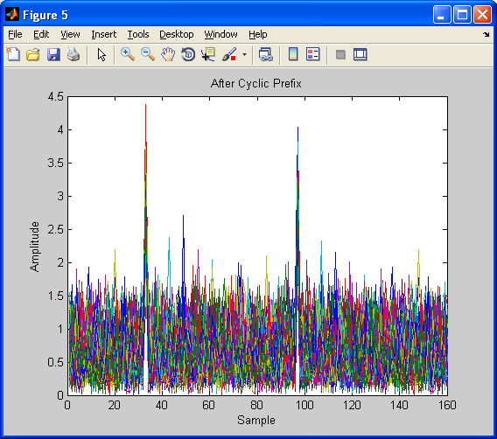

Cyclic prefix add

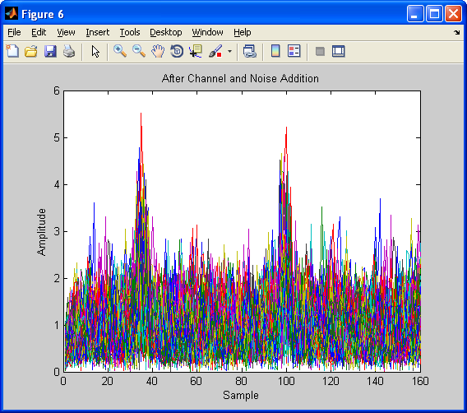

Channel Noise and Fading add to Tx Data

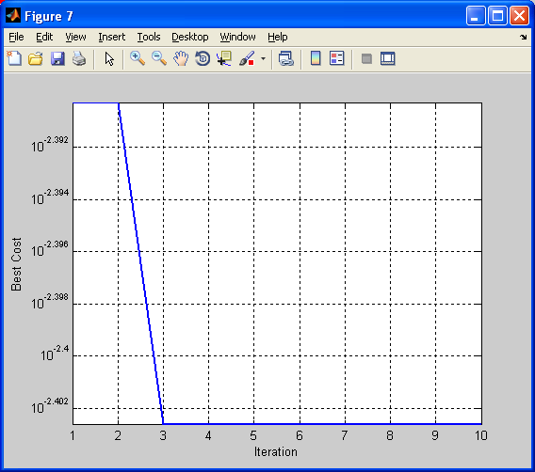

Harmony Search

Optimization algorithm used for identify optimal training Sequence

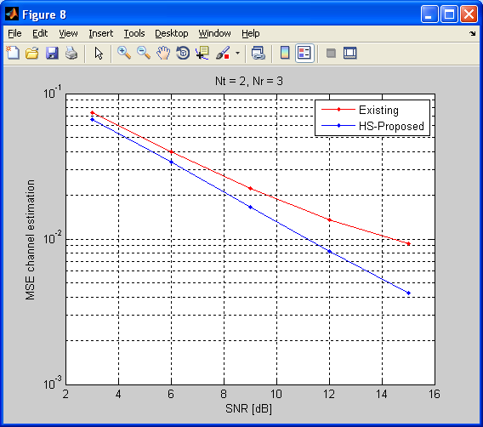

MSE decrease when SNR increase

Compare to existing method proposed method have low MSE

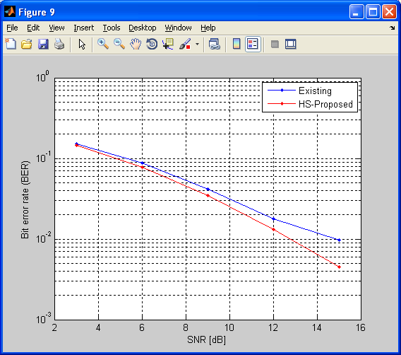

BER decrease when SNR increase

Compare to existing method proposed method have low BER