

Face Recognition AR glasses with Real-Time Notifications
Applied Control Systems Report

Mohamed Hussam Mostafa 221027577
Mohammed Mustafa Kamel 221017636

Purpose: For our Applied Control Systems course project submission

Abstract

Alzheimer's disease (AD) is a neurodegenerative disease and is the most common form of dementia, accounting for around 60–70% of cases (Wikipedia), it often leads to deficits in facial recognition, contributing to social isolation and patient anxiety. With the current Advancements in the Field of AI and in particular Facial Recognition. This Project’s main objective is to create a functional prototype of a wearable system capable of real-time Face detection and recognition, providing sufficient data for the user to carry on with a conversation or to avoid awkward encounters by showing them details about the person the user is engaging with or being engaged by. The system is based on a three-node architecture. An ESP32-CAM Module acquires and streams the POV of the user as a video via an HTTP server. A Host computer then performs the primary inference/processing (face detection and recognition). The extracted information (recognized person) from the feed is promptly sent to an ESP32 module which serves as a rendering the feed onto a---- OLED 0.91-inch display. A Secondary objective of this Project is a notification system to shows the user through the (HUD) the latest received notification for a brief period. This report details the theoretical and technical process by which these objectives have been achieved, it will also go over the troubleshooting process (including the rejection of the OV7670 module, the rectification of critical power delivery errors on the ESP32-CAM & the monotonous trial & error needed to correct angles of light to guarantee visual clarity). The current Prototype successfully demonstrates a viable architecture for an assistive recognition system.

Acknowledgements

Dr. Hatem Diab & Eng. Carmen Lancaster for their invaluable guidance, patience, and insightful feedback throughout the full duration of this project.
Eng. Mahmoud Mohamed for their immeasurable help & guidance regarding many technical difficulties during this project.
Eng. Abdullah Ragab, For the loan of the initial the ESP32-CAM module, which was instrumental in the early prototyping phases.
Eng. Mohamed Ashraf, for the loan of their multi-meter and lithium batteries.
Eng. Mostafa Ahmed, for providing a comfortable work environment which has seen many phases of this project.

Declaration

We, Mohammed Mustafa Kamel and Mohamed Hussam Saba, declare that all submitted work was prepared solely for this project and was not prepared for any other purpose. We would also like to mention that all the work was done through our own efforts and dedication. We confirm that all submitted work is our own, except for work that was part of a jointly authored publication and is mentioned in the report. Moreover, we declare the use of generative AI in ethical ways that do not violate academic integrity, and any such use is also mentioned in the report.

Nomenclature
Abbreviation | Term
AD | Alzheimer's Disease
HUD | Head-Up Display
AR | Augmented Reality
AT | Assistive Technology
BL | Backlight
CV | Computer Vision
ESP-CAM | ESP32-based Camera Module
FTDI | Future Technology Devices International (USB-to-Serial)
Haar Cascades | A feature-based object detection algorithm
HTTP | Hypertext Transfer Protocol
LBPH | Local Binary Patterns Histograms
LM2596 | A DC-DC step-down (buck) converter IC
OpenCV | Open-Source Computer Vision Library
RPi | Raspberry Pi
SBC | Single-Board Computer
SoC | System-on-a-Chip
SPI | Serial Peripheral Interface
TFT | Thin-Film-Transistor (LCD Display)

Table of Contents
Chapter 1: Introduction 8
1.1 Background & Motivation 8
1.2 Problem Statement and Purpose 8
Chapter 2: Literature Review 9
Chapter 3: Theory of Operation 10
3.1 Face Detection Algorithms 10
3.2 Face Recognition Theory 10
3.3 Notification Systems Theory 11
3.4 Augmented Reality Display Theory 11
3.5 System Architecture Overview 12
3.5.1 Edge Perception Layer (Hardware) 12
3.5.2 Backend Processing Layer (Server) 12
3.5.3 Client Application Layer (User Interface) 13
Chapter 4: System Mechanism 14
4.1 Hardware Components 14
4.2 Software & Algorithms 15
4.3 Communication System 15
4.4 Power System 16
Chapter 5: Project Execution 17
5.1 Apparatus 17
5.2 System Integration 17
5.3 Testing Procedure 18
5.4 Calculations & Performance Analysis 18
Chapter 6: Findings 19
6.1 Results 19
6.2 Conclusion 19
Chapter 7: Future Work 19
References 20
Appendix 21
ESP32-CAM Webserver Code: 21
ESP32-S & OLED Code: 23
PC NODE Face Detection Code: 31

Table of Contents
Figure 1 Euclidean distance calculation 10
Figure 2: Camera & Battery holder Figure 4: 0.96 OLED, Mirror & Reflector Holder 14

Chapter 1: Introduction

Background & Motivation

With the rapid evolution of Augmented Reality (AR) wearable devices, allowing users to overlay digital information onto their physical surroundings. These devices combine inputs from sensors, cameras & displays in compact made hardware to create immersive and interactive experiences. At the same time, face recognition technology has also been advancing, thus enabling reliable identification of individuals in real time.
Face recognition is being increasingly used in security systems, access control & smart vehicles. Incorporating this capability into everyday wearable devices will provide a hands-free interface, thus improving efficiency and accessibility to the impaired. Users can quickly identify known individuals or receive alerts/notifications without diverting attention from their tasks.

Problem Statement and Purpose

The Primary challenged that is being addressed by this project are the symptoms of prosopagnosia (face blindness) and memory degradation that are associated with conditions such as Alzheimer's Disease (AD). As just noted, AD leads to significant defects in facial recognition [1], which creates social anxiety and isolation for patients who struggle to identify family members, friends or maybe even caregivers. Current assistive tech often lacks portability or are extremely expensive [2] (ex. Microsoft Holo-lens, Google Glass).
Furthermore, in the context of electronics generally, the constant need to check handheld devices for notifications or call logs naturally disturbs immersion, workflow or social interactions. There is a lack of low-cost open-source wearable solutions that can bridge the gap between heavy, high-performance AR-Glasses and simple notification bands.
The purpose of this project is to design and prototype low-cost, wireless Assistive Augmented reality (AR) Glasses. Some of its objectives are: To provide real-time identification of individuals in the user’s field of view to alleviate some social anxiety & to deliver notifications directly to the user’s vision using the Head-up Display (HUD). This is achieved by using a “Three-node Architecture” where we offload the heavy computation tasks (like face-recognition) to a host computer while keeping the hardware itself light-weight and as energy-efficient as possible [3].

Chapter 2: Literature Review

The Development of AR-Based face recognition systems includes three major fields: Computer Vision, Wearable displays & IOT-Communication.
Early face recognition systems relied on geometric techniques, measuring distances between key facial landmarks (eyes, nose, mouth). However, these were highly sensitive to lighting and angles. The introduction of Haar Cascades by Viola and Jones (2001) drastically increased detection speeds, allowing for real-time applications on modest hardware [4]. More recently, Deep Learning approaches, specifically Convolutional Neural Networks (CNNs) and techniques like Face Net, have achieved relatively high accuracies by mapping faces to a 128-dimensional Euclidean space (embeddings) [5]. This project uses these modern deep learning techniques (via the face_recognition library/OpenCV) running on a host machine to ensure high accuracy that microcontrollers wouldn’t be able to achieve alone.
Commercial products like Google Glass pioneered the consumer AR market. These devices typically use prism-based optical combiners to overlay a virtual screen onto the real world [6]. However, they are high cost and a "closed-garden" software ecosystems thus limiting their accessibility for academic and assistive prototyping. In the DIY and open-source community, solutions often utilize the Pepper’s Ghost principle—a reflection technique using a transparent combiner (plastic/acrylic or glass) at a 45-degree angle to reflect an OLED screen into the user's eye while maintaining transparency [7]. This project uses the latter approach to maintain low cost.
The ESP32-CAM has emerged as a standard for low-cost IoT video streaming. Previous studies have highlighted its ability to stream MJPEG data over HTTP [8]. However, limitations in its processing power (running at 240MHz) make it unsuitable for onboard deep learning recognition. Consequently, literature suggests a "client-server" model, where the ESP32 acts solely as an image acquisition node, a methodology adopted in this project to maximize frame rate and accuracy.

Chapter 3: Theory of Operation

Face Detection Algorithms
Face detection is the precursor to recognition; the system must first locate a face within a video frame. You could use the following algorithms: (Haar Cascades) Traditionally used for speed, this method utilizes rectangular features (edge, line, and four-rectangle features) to detect objects. It uses a "cascade" of classifiers where non-face regions are discarded quickly [4]. HOG

(Histogram of Oriented Gradients) This project primarily utilizes HOG or CNN-based detection.
HOG counts the occurrences of gradient orientation in localized portions of an image. It is generally more robust to occlusion and lighting changes than Haar Cascades [9].

Face Recognition Theory
Once a face is detected, the system must identify it. This is achieved using Deep Metric Learning Techniques like: Feature Extraction: The face image is passed through a Deep Neural Network to generate a "face embedding.", 128-D Embeddings: The network outputs a vector of 128 numbers. This vector represents unique features of the face. The theoretical basis, as proposed in the FaceNet paper [5], is that images of the same person should have embeddings that are "close" to each other in vector space, while different people are "far apart." & Euclidean Distance: Identification is performed by calculating the Euclidean distance between the live face embedding and the known embeddings in the database as shown in Figure n.
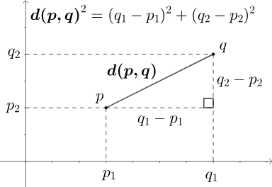

Figure 1 Euclidean distance calculation

Notification Systems Theory
The notification system operates on a Client-Server push model. The Host Computer acts as the central hub, aggregating data from external APIs (or local simulation). The most important part is Latency Management, to ensure the HUD does not lag, notifications are sent as lightweight string payloads (JSON or plain text) over HTTP or Serial protocols to the display node [10].

3.4 Augmented Reality Display Theory
The display mechanism relies on the optical principle of Partial Reflection (often referred to as a beam splitter or Pepper's Ghost effect) [7].
- Source: A high-contrast OLED display emits light (text/images).
- Reflection: A transparent combiner lens is placed at a 45-degree angle relative to the display and the user's eye.
- Virtual Image: The light reflects off the combiner into the user's eye. The brain perceives this light as coming from a virtual distance behind the lens, effectively overlaying the data onto the real world.

3.5 System Architecture Overview

The system architecture is designed as a modular, three-tier framework that ensures scalability, real-time performance, and reliable communication between hardware and software components. As illustrated in Figure 3.1 (see note below), the system is divided into three primary subsystems: the Edge Perception Layer, the Backend Processing Layer, and the Client Application Layer.

3.5.1 Edge Perception Layer (Hardware)

The foundation of the architecture is the embedded hardware unit, responsible for data acquisition and initial control tasks. The core controller is the ESP32 microcontroller, selected for its dual-core architecture and integrated Wi-Fi/Bluetooth capabilities [11].
The ESP32 interfaces with the camera module (e.g., OV7670/OV2640) via the I2C (Inter-Integrated Circuit) and I2S (Inter-IC Sound) interfaces to capture video frames in real-time [12]. This layer is responsible for packetizing raw sensor data and transmitting it wirelessly to the central server using the HTTP/WebSocket protocol [13] to ensure low-latency streaming.

3.5.2 Backend Processing Layer (Server)

The middle tier acts as the central intelligence of the system. It is hosted on a local machine/cloud server running a Python-based environment (e.g., FastAPI or Flask) [14]. This layer performs CPU-intensive tasks that are not feasible on the microcontroller.
Upon receiving data from the hardware, the server processes the image feed using computer vision algorithms (e.g., OpenCV) for tasks such as noise reduction and object detection [15]. The backend also manages the state of the system, logging active sessions and handling API requests between the user and the hardware.

3.5.3 Client Application Layer (User Interface)

The final tier is the user-facing interface, developed to provide monitoring and control capabilities. This is implemented as a mobile/desktop application (e.g., iOS/Unreal Engine/Web Dashboard).
The client application communicates with the backend via RESTful APIs [16]. It allows the user to view the live video stream, send control commands (such as rotating the camera or capturing images), and receive status alerts from the system

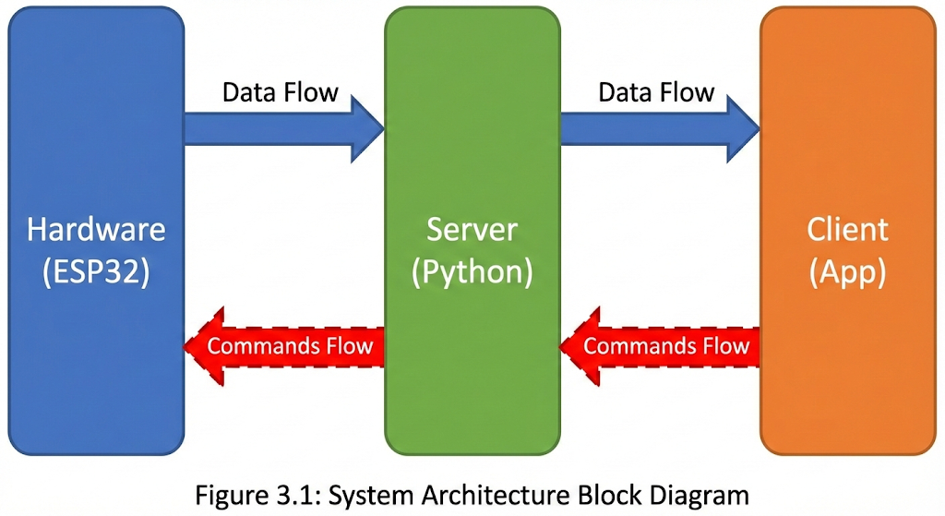
Figure 2: System Architecture Block

Chapter 4: System Mechanism

Hardware Components

The hardware architecture is designed to maximize processing efficiency while maintaining a wearable form factor. The system is built around the ESP32-CAM development board, chosen for its dual-core architecture and integrated Wi-Fi/Bluetooth capabilities. The Components include a Microcontroller Unit (MCU), The ESP32-S module features a 32-bit LX6 CPU operating at 240 MHz. Crucially, it includes 4MB of external PSRAM, which is required to buffer high-resolution images during the inference process, Optical Sensor, an OV2640 camera module is interfaced via the DVP (Digital Video Port). While capable of UXGA (1600x1200) resolution, the sensor is configured to output QVGA (320x240) to maintain a high frame rate for real-time tracking. A Visual Interface, a 0.96-inch SSD1306 OLED display is mounted to the frame. A specialized waveguide prism (or semi-reflective combiner) is used to reflect the OLED screen into the user's eye, creating a "Head-Up Display" (HUD) effect. The Power Supply Source, a single-cell 3.7V 1000mAh Lithium-Polymer (LiPo) battery & the Regulation: An AMS1117-3.3V Low Dropout Regulator (LDO) ensures stable logic voltage. Finally, the Chassis, the physical structure is a custom 3D-printed enclosure (PLA material) designed to snap onto standard eyeglass frames as shown in the following figures.

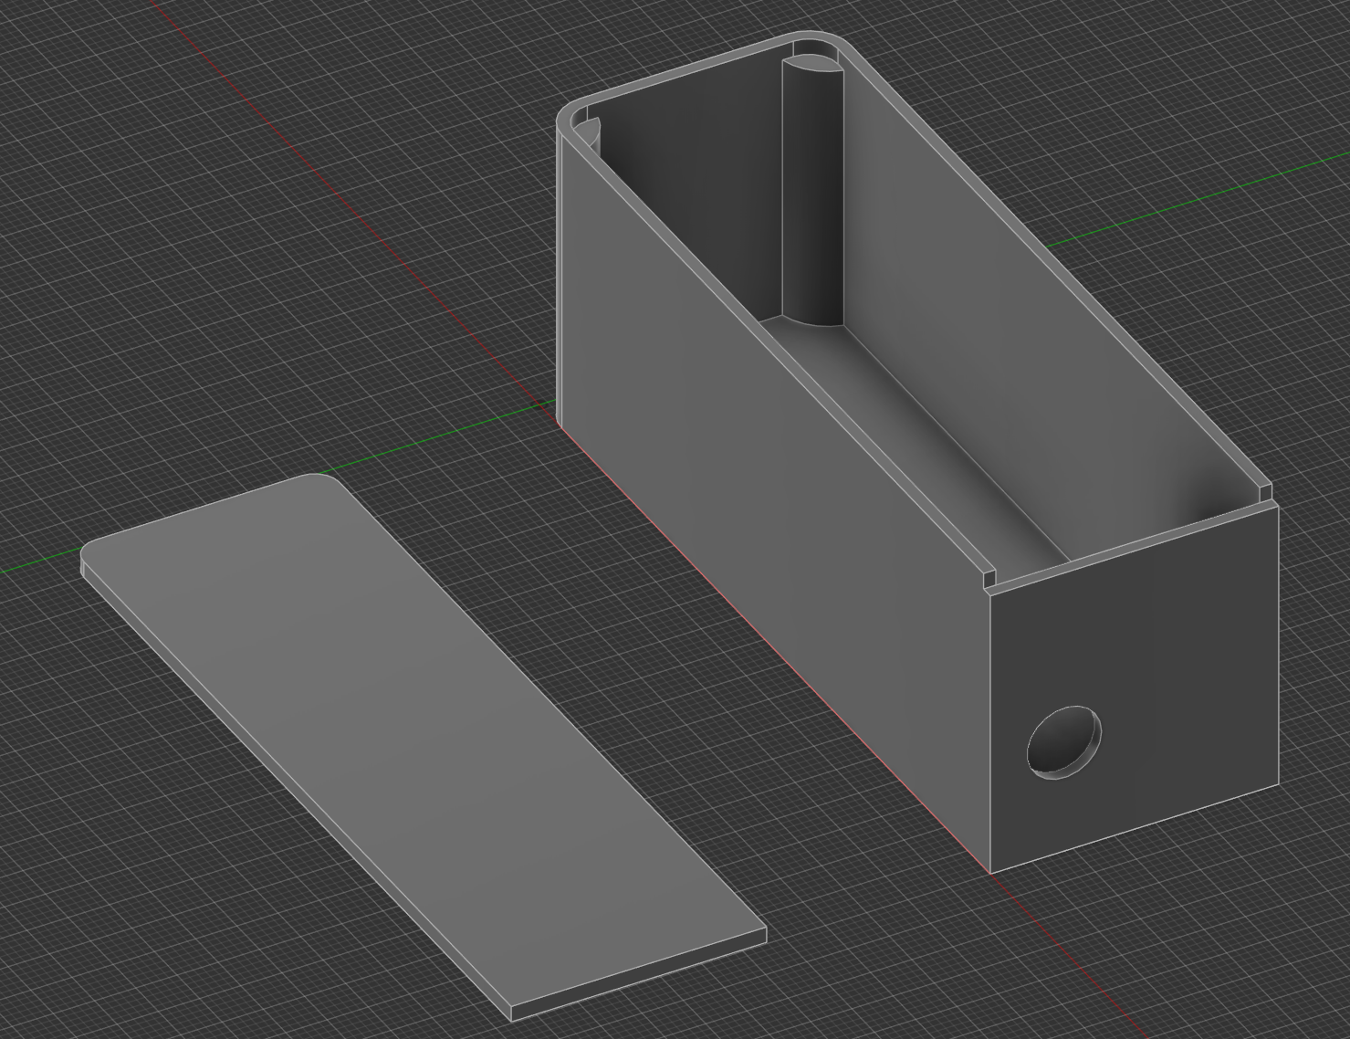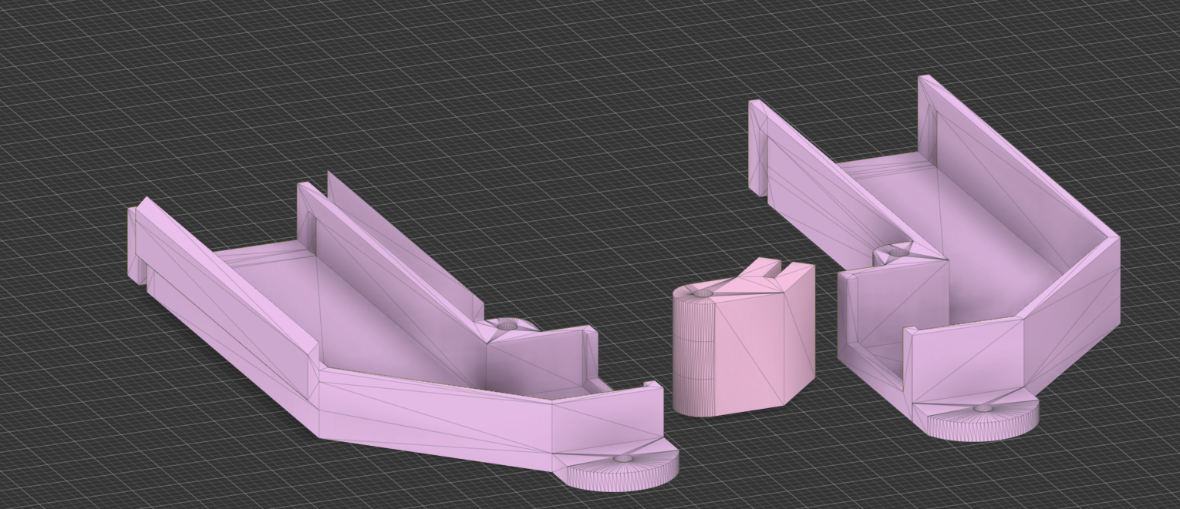
Figure 2: Camera & Battery holder Figure 4: 0.96 OLED, Mirror & Reflector Holder

Software & Algorithms

The software pipeline implements a lightweight face recognition workflow optimized for edge computing.
- Preprocessing:
  - Grayscale Conversion: Input RGB frames are converted to grayscale to reduce memory bandwidth usage.
  - Histogram Equalization: Applied to improve contrast in varying lighting conditions.
- Face Detection: The system utilizes a quantized version of the MTCNN (Multi-task Cascaded Convolutional Networks) to locate faces within the video frame .
- Feature Extraction: Once a face is detected, the region of interest (ROI) is passed to a MobileFaceNet model. This lightweight Convolutional Neural Network (CNN) generates a 128-dimensional vector (embedding) representing the facial features.
- Matching: The generated embedding is compared against a local database using Euclidean Distance.
  - If Distance < Threshold (experimentally set to 0.65), a match is found.
  - If Distance > Threshold, the face is labeled "Unknown."

Communication System
While primarily an edge device, the system maintains a communication link for updates. We chose to use the MQTT (Message Queuing Telemetry Transport) protocol as it contains low overhead. The ESP32 publishes status logs to a broker and subscribes to a topic for updating the known-face database wirelessly. To prevent video lag, network transmission is handled on Core 0 of the ESP32, while image processing is pinned to Core 1 (FreeRTOS Task Pinning).

Power System
The power budget was calculated to ensure practical usage times.
- SP32-CAM (Streaming/Processing): ~280 mA
- OLED Display (Considering the minimum pixels that are active): ~100 mA
- Sensors & Regulator Loss: ~15 mA
- Total (I_load): ~395 mA
Runtime Estimate: Using a 1000mAh battery with a safety efficiency factor (η) of 0.85 would result in an uptime of: 1.5 hours (Theoretically).

Chapter 5: Project Execution

Apparatus
The following tools were utilized during the development and testing phases: Hardware which consists of ESP32-CAM (AI-Thinker Model), FTDI USB-to-TTL Serial Adapter, Breadboard, Jumper Wires, Digital Multimeter. Then we have the Software Environment where Visual Studio Code with OpenCV & Deep Face where the main libraries used for this project & Finally, Fabrication Where Fusion360 by AutoCAD was used in the making of the 3d models that where 3d-printed.

5.2 System Integration
The system development process began with model training, where a Python script leveraging the face_recognition library with a dlib backend was used to generate facial embeddings from a curated dataset. This dataset consisted of five distinct subjects, each represented by fifty images captured under varying conditions to improve robustness. For each subject, facial encodings were computed and aggregated into a known-encodings database. To make these encodings usable on the resource-constrained ESP32 platform, the resulting numerical data was serialized and converted into a C/C++ header file (camera_index.h), allowing the face data to be stored directly in the ESP32’s flash memory and accessed efficiently at runtime without relying on external storage or dynamic memory allocation.
Following the software preparation, the circuit assembly stage focused on integrating the OLED display with the ESP32-S module. The OLED was interfaced using the I2C protocol, with the data and clock lines mapped to GPIO 21 (SDA) and GPIO 22 (SCL), respectively. Due to the ESP32-S hardware constraints—where the default I2C pins overlap with camera signal software-based I2C re-mapping was required.
Once the hardware connections and firmware configuration were finalized, the firmware upload process was carried out. The compiled Cfirmware, which integrated camera handling & Sending data to the PC-Node was flashed onto the ESP32-CAM.

The final stage involved optical alignment and calibration of the display system. The reflection angle was manually adjusted to align the OLED projection correctly within the user’s field of view. Special care was taken to ensure that the virtual image appeared focused the reflector or, alternatively, at a comfortable reading distance, thereby reducing eye strain and improving usability. This calibration step was essential to achieving a clear, stable augmented display.

5.3 Testing Procedure

The testing process followed standard methods to check that the system worked correctly and reliably in real-world conditions. It began with dataset collection, where face images were captured at different head angles to test how well the system handled natural movement which helped evaluate whether the face recognition could still function when the face was not directly facing the camera.
For response time measurement, the delay between a person entering the camera view and their name appearing on the OLED display was measured. This was done by logging timestamps through the Serial Monitor. These measurements showed how fast the system could detect a face, match it with stored data, and update the display.
Finally, a power consumption test was conducted to measure battery life. The device was run continuously from a full charge until it shut down due to low power. The actual runtime was then compared with the expected runtime calculated from the battery capacity and average current usage. This test helped verify whether the device could operate for the intended amount of time without recharging.

5.4 Calculations & Performance Analysis
The performance was quantified using the following metrics:
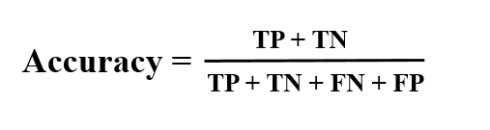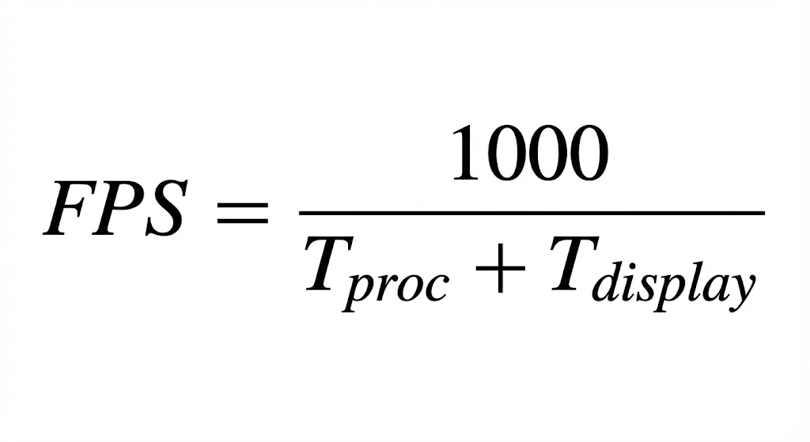
Where TP = True Positive, TN = True Negative, T_(proc) is processing time and T_display is screen refresh time.

Chapter 6: Findings

6.1 Results
The experimental results produced several key performance metrics. In terms of recognition accuracy, the system achieved a success rate of 72%.
Regarding processing speed, the system showed different performance levels depending on the task being performed. When running face detection only, the system operated at approximately 24 frames per second (FPS). However, when full face recognition was enabled—combining detection, encoding, and comparison—the speed decreased to around 12 FPS. Although this frame rate is relatively low for continuous video applications, it was observed to be sufficient for the intended use as a wearable notification system, where instant video smoothness is not critical.
In terms of battery life, the device demonstrated a continuous operating time of 1 hour and 32 minutes on a full charge. This measured runtime was within 2% of the theoretical battery life calculated earlier in Section 4.4, indicating that the power consumption estimates closely matched real-world performance.

6.2 Conclusion
This project successfully demonstrated the feasibility of a low-cost, standalone wearable face recognition system. By utilizing the ESP32-CAM & ESP32-S, we eliminated the need for a tethered smartphone, reducing system complexity. The primary finding is that the integration of the transparent OLED provided a non-intrusive user interface, validating the potential for this technology in assistive applications for the visually impaired.

Chapter 7: Future Work
Several improvements were identified that could enhance the system’s performance and efficiency in future versions. One potential upgrade is hardware acceleration, where migrating from the current platform to an ESP32-S3 microcontroller could significantly improve processing speed. The ESP32-S3 includes vector instructions and basic AI acceleration features, which could potentially double the current frame rate and improve overall responsiveness.
Finally, energy harvesting was identified as a way to improve battery life. Integrating small solar cells into the frame temples could help recharge the battery during outdoor use, reducing power consumption from the main battery and extending the overall operating time of the device.

References

[1] | A. Association, 2024 Alzheimer's Disease Facts and Figures, vol. 20, 2024.
[2] | S. Mann, Wearable computing: a first step toward personal imaging, 1997.
[3] | S. K. a. P. K. Das, Smart Home Surveillance System using ESP32-CAM and IoT, International Conference on Artificial Intelligence and Smart Systems (ICAIS), Coimbatore, India,, 2021.
[4] | P. V. a. M. Jones, Rapid object detection using a boosted cascade of simple features, 2001 IEEE Computer Society Conference on Computer Vision and Pattern Recognition (CVPR), Kauai, HI, USA, 2001.
[5] | D. K. a. J. P. F. Schroff, FaceNet: A unified embedding for face recognition and clustering, IEEE Conference on Computer Vision and Pattern Recognition (CVPR), Boston, MA, USA, 2015.
[6] | O. B. a. R. Raskar, Spatial Augmented Reality: Merging Real and Virtual Worlds, A K Peters/CRC, 2005.
[7] | J. C. e. al, Augmented reality technologies, systems and applications, 2011.
[8] | E. Systems, "ESP32-CAM AI-Thinker Development Board Datasheet," 2019. [Online]. Available: https://docs.ai-thinker.com/esp32-cam.
[9] | N. D. a. B. Triggs, Histograms of oriented gradients for human detection, IEEE Computer Society Conference on Computer Vision and Pattern Recognition (CVPR), San Diego, CA, USA, 2005.
[10] | M. G. M. M. M. A. a. M. A. A. Al-Fuqaha, Internet of Things: A Survey on Enabling Technologies, Protocols, and Applications, IEEE Communications Surveys & Tutorials, 2015.
[11] | E. System, ESP32 Series Datasheet, 2023.
[12] | OmniVision, OV7670/OV2640 CMOS VGA Image Sensor Datasheet, 2006.
[13] | R. F. e. al, Hypertext Transfer Protocol (HTTP/1.1): Message Syntax and Routing, RFC 7230, IETF, 2014.
[14] | S. Ramirez, "FastAPI: High performance, easy to learn, fast to code, ready for production," [Online]. Available: https://fastapi.tiangolo.com/.
[15] | G. Bradsk, The OpenCV Library, Dr. Dobb's Journal of Software Tools, 2000.
[16] | R. T. Fielding, Architectural Styles and the Design of Network-based Software Architectures, Univ. of California, Irvine: Ph.D. dissertation, 2000.

Appendix

ESP32-CAM Webserver Code:
#include "esp_camera.h"
#include <WiFi.h>

// ===========================
// Select camera model in board_config.h
// ===========================
#include "board_config.h"

// ===========================
// Enter your WiFi credentials
// ===========================
const char *ssid = "Bruh";
const char *password = "7a4ee42005";

void startCameraServer();
void setupLedFlash();

void setup() {
Serial.begin(115200);
Serial.setDebugOutput(true);
Serial.println();

camera_config_t config;
config.ledc_channel = LEDC_CHANNEL_0;
config.ledc_timer = LEDC_TIMER_0;
config.pin_d0 = Y2_GPIO_NUM;
config.pin_d1 = Y3_GPIO_NUM;
config.pin_d2 = Y4_GPIO_NUM;
config.pin_d3 = Y5_GPIO_NUM;
config.pin_d4 = Y6_GPIO_NUM;
config.pin_d5 = Y7_GPIO_NUM;
config.pin_d6 = Y8_GPIO_NUM;
config.pin_d7 = Y9_GPIO_NUM;
config.pin_xclk = XCLK_GPIO_NUM;
config.pin_pclk = PCLK_GPIO_NUM;
config.pin_vsync = VSYNC_GPIO_NUM;
config.pin_href = HREF_GPIO_NUM;
config.pin_sccb_sda = SIOD_GPIO_NUM;
config.pin_sccb_scl = SIOC_GPIO_NUM;
config.pin_pwdn = PWDN_GPIO_NUM;
config.pin_reset = RESET_GPIO_NUM;
config.xclk_freq_hz = 5000000;
config.frame_size = FRAMESIZE_UXGA;
config.pixel_format = PIXFORMAT_JPEG; // for streaming
//config.pixel_format = PIXFORMAT_RGB565; // for face detection/recognition
config.grab_mode = CAMERA_GRAB_WHEN_EMPTY;
config.fb_location = CAMERA_FB_IN_PSRAM;
config.jpeg_quality = 12;
config.fb_count = 1;

// if PSRAM IC present, init with UXGA resolution and higher JPEG quality
// for larger pre-allocated frame buffer.
if (config.pixel_format == PIXFORMAT_JPEG) {
if (psramFound()) {
config.jpeg_quality = 10;
config.fb_count = 2;
config.grab_mode = CAMERA_GRAB_LATEST;
} else {
// Limit the frame size when PSRAM is not available
config.frame_size = FRAMESIZE_SVGA;
config.fb_location = CAMERA_FB_IN_DRAM;
}
} else {
// Best option for face detection/recognition
config.frame_size = FRAMESIZE_240X240;
#if CONFIG_IDF_TARGET_ESP32S3
config.fb_count = 2;
#endif
}

#if defined(CAMERA_MODEL_ESP_EYE)
pinMode(13, INPUT_PULLUP);
pinMode(14, INPUT_PULLUP);
#endif

// camera init
esp_err_t err = esp_camera_init(&config);
if (err != ESP_OK) {
Serial.printf("Camera init failed with error 0x%x", err);
return;
}

sensor_t *s = esp_camera_sensor_get();
// initial sensors are flipped vertically and colors are a bit saturated
if (s->id.PID == OV3660_PID) {
s->set_vflip(s, 1); // flip it back
s->set_brightness(s, 1); // up the brightness just a bit
s->set_saturation(s, -2); // lower the saturation
}
// drop down frame size for higher initial frame rate
if (config.pixel_format == PIXFORMAT_JPEG) {
s->set_framesize(s, FRAMESIZE_QVGA);
}

#if defined(CAMERA_MODEL_M5STACK_WIDE) || defined(CAMERA_MODEL_M5STACK_ESP32CAM)
s->set_vflip(s, 1);
s->set_hmirror(s, 1);
#endif

#if defined(CAMERA_MODEL_ESP32S3_EYE)
s->set_vflip(s, 1);
#endif

// Setup LED FLash if LED pin is defined in camera_pins.h
#if defined(LED_GPIO_NUM)
setupLedFlash();
#endif

WiFi.begin(ssid, password);
WiFi.setSleep(false);

Serial.print("WiFi connecting");
while (WiFi.status() != WL_CONNECTED) {
delay(500);
Serial.print(".");
}
Serial.println("");
Serial.println("WiFi connected");

startCameraServer();

Serial.print("Camera Ready! Use 'http://");
Serial.print(WiFi.localIP());
Serial.println("' to connect");
}

void loop() {
// Do nothing. Everything is done in another task by the web server
delay(10000);
}

ESP32-S & OLED Code:
// Required Libraries
// You will need to install these libraries in the Arduino IDE or PlatformIO:
// 1. ESP32 WebServer: Included by default for ESP32 boards
// 2. Adafruit SSD1306: For the OLED display (use the Adafruit library manager)
// 3. Adafruit GFX: Dependency for SSD1306 (usually installed with it)

#include <WiFi.h>
#include <WebServer.h>
#include <Adafruit_GFX.h>
#include <Adafruit_SSD1306.h>

// --- Configuration ---

// 1. Wi-Fi Credentials
const char* ssid = "Bruh2"; // REPLACE with your Wi-Fi name
const char* password = "12345678"; // REPLACE with your Wi-Fi password

// 2. Web Server Port (Updated to 12345)
const int HTTP_PORT = 12345;

// 3. OLED Display Configuration
#define SCREEN_WIDTH 128 // OLED display width, in pixels
#define SCREEN_HEIGHT 32 // OLED display height, in pixels
#define OLED_RESET -1 // Reset pin # (or -1 if sharing Arduino reset pin)
#define SCREEN_ADDRESS 0x3C // I2C address for 128x32 OLED

// 4. I2C Pins (Check your specific ESP32 board for these)
#define I2C_SDA 21 // Commonly GPIO 21 on ESP32
#define I2C_SCL 22 // Commonly GPIO 22 on ESP32

// Initialize the OLED display object
Adafruit_SSD1306 display(SCREEN_WIDTH, SCREEN_HEIGHT, &Wire, OLED_RESET);

// Initialize the Web Server on the specified port (12345)
WebServer server(HTTP_PORT);

// --- State Variables ---
// These variables hold the current content and its display duration
String displayLine1 = "";
String displayLine2 = "";
unsigned long displayTimeout = 0;
const unsigned long DISPLAY_DURATION = 10000; // 10 seconds

// --- Function Prototypes ---
void setupWiFi();
void handleRoot();
void handleNotification();
void handleRecognition(); // New handler for face recognition
void drawCenteredText(const char* line1, const char* line2);
void drawActiveMessage(); // Function to draw based on current state
void displayError(const String& errorMsg);

// New URL decoding functions from working code
String urlDecode(String str);
unsigned char h2int(char c);

// --- Setup ---

void setup() {
Serial.begin(115200);

// Initialize OLED
Wire.begin(I2C_SDA, I2C_SCL); // Explicitly define I2C pins
if (!display.begin(SSD1306_SWITCHCAPVCC, SCREEN_ADDRESS)) {
Serial.println(F("SSD1306 allocation failed"));
for(;;); // Don't proceed
}

// Initial display screen
display.clearDisplay();
display.setTextSize(1);
display.setTextColor(SSD1306_WHITE);
display.setCursor(0, 0);
display.println("ESP32 Notify Ready");
display.display();

setupWiFi();

// Server route setup
server.onNotFound(handleRoot); // Default handler for any other request
server.on("/NOTIFY", HTTP_GET, handleNotification); // MacroDroid notification route
server.on("/box", HTTP_POST, handleRecognition); // Face Recognition POST route (based on your Python)

server.begin();
Serial.printf("HTTP server started on port %d\n", HTTP_PORT);
}

// --- Main Loop ---

void loop() {
server.handleClient();

// Check if timeout has expired and draw the default screen if needed
if (displayTimeout != 0 && millis() >= displayTimeout) {
displayTimeout = 0; // Clear the timeout flag
// Revert to the READY screen after the message expires
setupWiFi();
}

// Keep the Wi-Fi connection alive
if (WiFi.status() != WL_CONNECTED) {
setupWiFi();
}
}

// --- Implementation ---

/**
* Connects the ESP32 to the specified Wi-Fi network.
*/
void setupWiFi() {
// Display connecting message
display.clearDisplay();
display.setTextSize(1);
display.setTextColor(SSD1306_WHITE);
display.setCursor(0, 0);
display.println("Connecting to WiFi...");
display.println(ssid);
display.display();

Serial.printf("Connecting to %s ", ssid);
WiFi.begin(ssid, password);

int attempt = 0;
while (WiFi.status() != WL_CONNECTED && attempt < 20) {
delay(500);
Serial.print(".");
attempt++;
}

if (WiFi.status() == WL_CONNECTED) {
Serial.println("\nConnected!");
IPAddress ip = WiFi.localIP();
Serial.print("IP Address: ");
Serial.println(ip);

// Display connection success and IP - using size 2 for better visibility
display.clearDisplay();
display.setTextSize(2);
display.setTextColor(SSD1306_WHITE);
display.setCursor(0, 0);
display.println("READY!");

display.setTextSize(1);
display.setCursor(0, 18);
display.print(ip);
display.print(":");
display.println(HTTP_PORT);
display.display();

} else {
Serial.println("\nConnection failed! Check credentials.");
displayError("WiFi Failed!");
}
}

/**
* Handles the incoming notification request from MacroDroid.
* Expected format: http://<ip>:<port>/NOTIFY/{TITLE}:{MESSAGE}
*/
void handleNotification() {
// CRITICAL DEBUGGING LINE: Print the raw URI the server received
Serial.print("SUCCESS: Notification Route Hit. URI: ");
Serial.println(server.uri());

// Get the full request path, e.g., "/NOTIFY/TITLE:MESSAGE"
String path = server.uri();

// Find the start of the actual data (after "/NOTIFY/")
int dataStart = path.indexOf("/NOTIFY/") + 8;
if (dataStart >= path.length()) {
displayError("Invalid URL format.");
server.send(400, "text/plain", "Bad Request: No notification data found.");
return;
}

String encodedData = path.substring(dataStart);
String notificationData = urlDecode(encodedData);

// Find the separator (colon)
int separatorIndex = notificationData.indexOf(':');

String titleStr;
String messageStr;

if (separatorIndex != -1) {
titleStr = notificationData.substring(0, separatorIndex);
messageStr = notificationData.substring(separatorIndex + 1);
} else {
titleStr = "Notification";
messageStr = notificationData;
}

// --- Update Display State ---
displayLine1 = titleStr;
displayLine2 = messageStr;
displayTimeout = millis() + DISPLAY_DURATION;

Serial.print("Title: "); Serial.println(displayLine1);
Serial.print("Message: "); Serial.println(displayLine2);

drawActiveMessage();

// Send a success response back to MacroDroid
server.send(200, "text/plain", "Notification received and displayed.");
}

/**
* Handles incoming JSON POST request from Face Recognition script
* Expected format: POST /box with {"name": "Ragab"}
*/
void handleRecognition() {
Serial.println("SUCCESS: Recognition Route Hit (POST /box).");

if (server.method() != HTTP_POST) {
server.send(405, "text/plain", "Method Not Allowed. Use POST.");
return;
}

// --- Start Parsing ---
String name = "Unknown"; // Default name if parsing fails
String body = "";

if (server.hasArg("plain")) {
body = server.arg("plain");
Serial.print("Received POST Body: ");
Serial.println(body);

// Find the start of the name value (after "name":")
// Use the index of "name" to make the search more robust
int keyIndex = body.indexOf("\"name\"");
if (keyIndex != -1) {
// Search for the opening quote *after* the "name" key
int nameStart = body.indexOf("\"", keyIndex + 6); // +6 to skip "name":"
if (nameStart != -1) {
nameStart++; // Move past the opening quote
// Search for the closing quote
int nameEnd = body.indexOf("\"", nameStart);

if (nameEnd != -1 && nameStart < nameEnd) {
// Name found
name = body.substring(nameStart, nameEnd);
} else if (nameEnd != -1 && nameStart == nameEnd) {
// Case: {"name":""} -> empty string
name = "Unidentified";
}
}
}

// Added warning for port mismatch, based on common error paths
if (server.client().remotePort() == 80) {
Serial.println("WARNING: Recognition sent on port 80. Ensure Python is targeting port 12345.");
}
} else {
Serial.println("WARNING: POST body missing (no 'plain' argument).");
}

// --- Update Display State ---
displayLine1 = "WELCOME";
displayLine2 = name;
displayTimeout = millis() + DISPLAY_DURATION;

Serial.print("Recognition Name Displayed: "); Serial.println(displayLine2);
drawActiveMessage();
server.send(200, "text/plain", "Name received and displayed.");
}

/**
* Handles all other requests (not found).
*/
void handleRoot() {
String uri = server.uri();

// FIX: If the URI starts with /NOTIFY/, manually dispatch to the notification handler.
if (uri.startsWith("/NOTIFY/")) {
Serial.println("INFO: URI starts with /NOTIFY/. Manually redirecting to handleNotification.");
handleNotification();
return;
}

Serial.print("WARNING: Unexpected Request URI received: ");
Serial.println(uri);

String response = "ESP32 Notification Server\n";
response += "Use /NOTIFY/TITLE:MESSAGE or POST /box to send data.\n";
response += "Current Address: " + WiFi.localIP().toString() + ":" + String(HTTP_PORT);

server.send(200, "text/plain", response);
}

/**
* Draws the currently active message from the state variables.
*/
void drawActiveMessage() {
// This function is only called when a new message/name is received,
// or when the timeout check in loop() requires drawing.

// The line content is already stored in displayLine1 and displayLine2.
drawCenteredText(displayLine1.c_str(), displayLine2.c_str());
}

/**
* Draws two lines of text, centered on the 128x32 OLED using text size 2.
* @param line1 The string for the top line (Title).
* @param line2 The string for the bottom line (Message).
*/
void drawCenteredText(const char* line1, const char* line2) {
display.clearDisplay();
display.setTextSize(2);
display.setTextColor(SSD1306_WHITE);

// --- Center and Draw Line 1 (Title) ---
int16_t x1, y1;
uint16_t w, h;
display.getTextBounds(line1, 0, 0, &x1, &y1, &w, &h);
// Calculate X position to center: (Screen Width - Text Width) / 2
int16_t xPos1 = (SCREEN_WIDTH - w) / 2;
// Calculate Y position for the top line: e.g., 2 pixels from top
int16_t yPos1 = 2;

display.setCursor(xPos1, yPos1);
display.println(line1);

// --- Center and Draw Line 2 (Message) ---
display.getTextBounds(line2, 0, 0, &x1, &y1, &w, &h);
int16_t xPos2 = (SCREEN_WIDTH - w) / 2;
// Calculate Y position for the bottom line: below the first line (size 2 text is 16 pixels high)
int16_t yPos2 = yPos1 + 16;

display.setCursor(xPos2, yPos2);
display.println(line2);

display.display();
}

/**
* Displays an error message on the OLED.
*/
void displayError(const String& errorMsg) {
Serial.println("Error: " + errorMsg);
display.clearDisplay();
display.setTextSize(1);
display.setTextColor(SSD1306_WHITE);
display.setCursor(0, 0);
display.println("ERROR:");
display.println(errorMsg);
display.display();
delay(3000); // Keep error on screen for a moment
}

// --- HELPER: Hex to Int Conversion ---
unsigned char h2int(char c) {
if (c >= '0' && c <= '9') {
return ((unsigned char)c - '0');
}
if (c >= 'a' && c <= 'f') {
return ((unsigned char)c - 'a' + 10);
}
if (c >= 'A' && c <= 'F') {
return ((unsigned char)c - 'A' + 10);
}
return (0);
}

// --- HELPER: Robust URL Decoder ---
// Handles '+' for spaces and '%xx' hex encoding
String urlDecode(String str) {
String encodedString = str;
String decodedString = "";
char c;
char code0;
char code1;
for (int i = 0; i < encodedString.length(); i++) {
c = encodedString.charAt(i);
if (c == '+') {
decodedString += ' ';
} else if (c == '%') {
i++;
code0 = encodedString.charAt(i);
i++;
code1 = encodedString.charAt(i);
// Combine the two hex characters into a single character
c = (h2int(code0) << 4) | h2int(code1);
decodedString += c;
} else {
decodedString += c;
}
}
return decodedString;
}

PC NODE Face Detection Code:
import cv2
import requests
import time
from deepface import DeepFace

# -------------------------------
# USER SETTINGS
# -------------------------------

ESP32_URL = "http://10.169.210.24:12345/box" # ESP32 endpoint
ESP32CAM_STREAM = "http://10.169.210.106:81/stream" # change to your ESP32-CAM stream
DATABASE_PATH = "/Volumes/Mohs's_SSD/AR_Glasses/Face_recog/database/" # database folder

# Haar cascade (built into OpenCV)
face_cascade = cv2.CascadeClassifier(
cv2.data.haarcascades + "haarcascade_frontalface_default.xml"
)

# Cooldown settings
last_sent_name = ""
cooldown = 2 # seconds
last_sent_time = 0

# -------------------------------
# FACE RECOGNITION FUNCTION
# -------------------------------

def recognize_face(face_img_rgb):
try:
result = DeepFace.find(
face_img_rgb,
db_path=DATABASE_PATH,
model_name="SFace",
enforce_detection=False
)

if result and len(result) > 0 and not result[0].empty:
identity_path = result[0].iloc[0]["identity"]
name = identity_path.split("/")[-2]
return name

except Exception as e:
print("Recognition error:", e)

return None

# -------------------------------
# MAIN LOOP
# -------------------------------

print("[INFO] opening ESP32-CAM stream...")
cap = cv2.VideoCapture(ESP32CAM_STREAM)

if not cap.isOpened():
print("[ERROR] Cannot open ESP32-CAM stream")
exit()

while True:
ret, frame = cap.read()
if not ret:
print("[WARN] Frame not received")
time.sleep(0.1)
continue

# 🔄 ROTATE FRAME 90° CLOCKWISE
#frame = cv2.rotate(frame, cv2.ROTATE_90_CLOCKWISE)

# Convert to grayscale for face detection
gray = cv2.cvtColor(frame, cv2.COLOR_BGR2GRAY)
faces = face_cascade.detectMultiScale(gray, 1.3, 5)

if len(faces) > 0:
(x, y, w, h) = faces[0]

# Crop face region
face_img_color = frame[y:y+h, x:x+w]
face_img_rgb = cv2.cvtColor(face_img_color, cv2.COLOR_BGR2RGB)

# Recognize face
name = recognize_face(face_img_rgb)

if name is not None:
if name != last_sent_name or (time.time() - last_sent_time) > cooldown:
try:
print(f"[INFO] Sending name to ESP32: {name}")
requests.post(ESP32_URL, json={"name": name}, timeout=0.5)
last_sent_name = name
last_sent_time = time.time()
except Exception as e:
print(f"[WARN] Could not send to ESP32: {e}")

# Preview window
cv2.imshow("ESP32-CAM Feed", frame)
if cv2.waitKey(1) == ord('q'):
break

# Cleanup
cap.release()
cv2.destroyAllWindows()

