CALIFORNIA STATE UNIVERSITY, LONG BEACH

**IS 445/545 – Internet Application Development**

## Fall 2020 Term – Section 01 (#7818/7354) – Individual Assignment #3

## Due: September 22, 2020

**Notes:**

* You will create a web site using tutorial 4 lab as a template
* **Submission requirements.**   
  A zipped file containing the following:

1. Web site directory containing all your code
2. A file containing the following:
   1. Links to your GitHub repository and to your Netlify application.   
      For example (below are not valid, use your own):

<https://github.com/ashercsulb/hw4>

<https://asherhw4.netlify.app>

* 1. Solution to questions following the programming exercises

Name the file as follows:

1. yourLastNmae_hw3.zip (e.g. asher_hw3.zip)

**Programming Assignment**

The programming assignment requires you to create solutions to several exercises below. Use tutorial 4 lab as a template, that is

* Create the directory structure as in tutorial 4 (html, js, and css)
* Create an index.html file
  + It will have links to the solution for each exercise
* For each exercise, create two files (replace # with the exercise number)
  + ex#.js (placed in js directory)
    - Contains JavaScript code
  + ex#.html (placed in html directory)
    - Runs the JavaScript code
    - Contains link back to index.html
* styles.css (optional)
  + Optional style sheet

1. Class Standing - The program has the following requirements:

Input

Ask the user for their name and number of units completed at college (use prompt).

Validate input (integer >= 0, assume no decimal data entry)

Output

Output the following message (Text in *Italics* will change depending on input)

Hello *NameEntered*

Your grade standing is *GradeStanding*

*NameEntered* – This is the name entered

*GradeStanding* – Calcluate as follows:

Number of units:

0 – 30: Freshman

31 – 60: Sophomore

61 – 90: Junior

> 91: Senior

1. Following Day - The program has the following requirements:

**Use the switch/case syntax NOT if/then**

Input

A day of the week

Valid input is three letter abbreviation in lower case (validate input):  
sun, mon, tue, wed, thu, fri, sat, and sun

Output

Output the following message (Text in *Italics* will change depending on input)

You entered: *DayEntered*

The following day is: *FollowingDay*

1. Simple Calculation - The program has the following requirements:

Input

Two integer numbers (validate input, assume no decimal data entry)

Output

The following mathematical operations for the numbers entered

* Addition (e.g. num1 + num2 = sum; 3 + 4 = 7)
* Subtraction
* Multiplication
* Division
* Modulo

1. Password (use loop) - The program has the following requirements:

Input

A password

Output

Assume password is "secret"

If "secret" is not entered, prompt the user for a password again (up to 3 times)

If a correct password is entered, display the following message (# represents number of attempts):

You entered the correct password after # attempt(s)

If after three attempts, the user fails to enter the correct password, display the following message:

Your account is locked! You failed to enter the correct password # times

Note: Can hard code three for failure, but if you need to change this it's more difficult.

1. Multiplication Table (use loop) - The program has the following requirements:

Input

A number (assume valid input)

Output

The multiplication table for the input number multiplied by 0 – 10. For example, assume 3 is entered:

3 x 0 = 0

3 x 1 = 3

3 x 2 = 6

3 x 3 = 9

3 x 4 = 12

3 x 5 = 15

3 x 6 = 18

3 x 7 = 21

3 x 8 = 24

3 x 9 = 27

3 x 10 = 30

1. Following Second - The program has the following requirements:

Input

Time as three values: hours, minutes, seconds (validate input)

Output

Output the time entered and the time one second later.

Examples:

Time input: 14h17m59s

One second later: 14h18m0s

Time input: 6h59m59s

One second later: 7h0m0s

Time input: 23h59m59s

One second later: 0h0m0s

**Answer the following**

1. What are the links to your web site (see notes on first page)?
   1. GitHub URL:
   2. Netlify URL:
2. What is the output of the following?

console.log(4 + 5);

console.log("4 + 5");

console.log("4" + "5");

console.log(2 + 3 * 5);

console.log((2 + 3) * 5);

console.log(10 % 3);

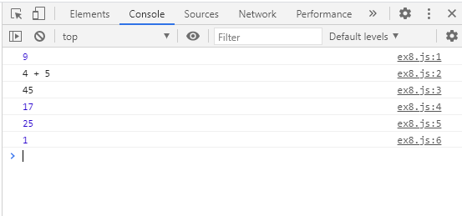

1. Variable Scope: What is the output of the following?

let num1 = 0;

{

  num1 = 1;

  const num2 = 0;

}

console.log(num1);

console.log(num2);

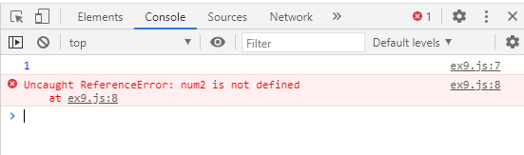

1. Constants: What is the output of the following?

const pi = 3.14;

pi = 3.14159;

console.log(pi);

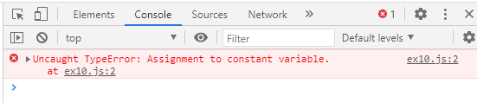

1. What is the output of the following?

let a = 2;

a -= 1;

a++;

let b = 8;

b += 2;

const c = a + b * b;

const d = a * b + b;

const e = a * (b + b);

const f = a * b / a;

const g = b / a * a;

console.log(a, b, c, d, e, f, g);

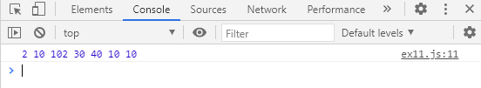

1. What is the output of the following?

console.log(true && "Hello");

console.log(false && "Hello");

console.log(undefined && "Hello");

console.log("" && "Hello");

console.log("Hello" && "Goodbye")

console.log(true || "Hello");

console.log(false || "Hello");

console.log(undefined || "Hello");

console.log("" || "Hello");

console.log("Hello" || "Goodbye")

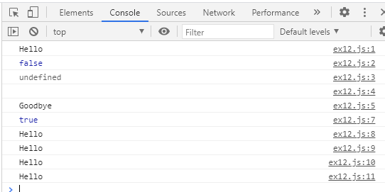

1. What is the output of the following?

console.log("0" == 0);

console.log("" == 0);

console.log("" == 1);

console.log(true == 0);

console.log(true == 1);

console.log("0" === 0);

console.log("" === 0);

console.log("" === 1);

console.log(true === 0);

console.log(true === 1);

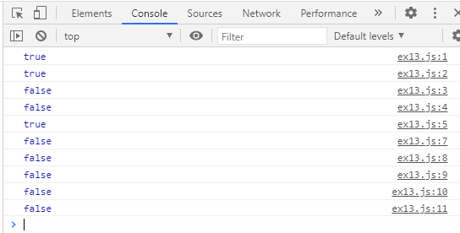

1. Short Circuit Test
   1. What is the output of the following?

let i = 1;

if ((1 > 2) && i++) {

   //Nothing.  Want to test condition

}

console.log(`The value of i is: ${i}`);

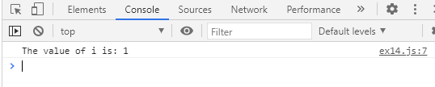

* 1. What is the output of the following?

let i = 1;

if ((1 < 2) && i++) {

   //Nothing.  Want to test condition

}

console.log(`The value of i is: ${i}`);

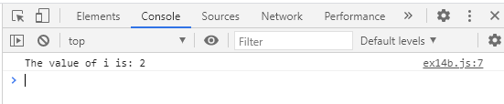

1. Break Test
   1. What is the output of the following?

const x = "abc";

switch (x) {

  case "abc":

    console.log("x = abc");

    break;

  case "def":

    console.log("x = def");

    break;

}

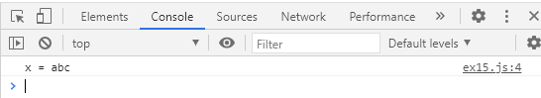

* 1. What is the output of the following?

const x = "abc";

switch (x) {

  case "abc":

    console.log("x = abc");

    //no break

  case "def":

    console.log("x = def");

    break;

}

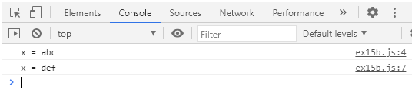

1. What is the output of the following?

if (x > 2) {

   if  (y > 2) {

      z = x + y;

      console.log("z is: ", z);

   }

} else {

   console.log("x is: ", x);

}

* 1. When x = 2 and y = 3

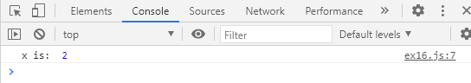

* 1. When x = 3 and y = 2
  2. When x = 3 and y = 3

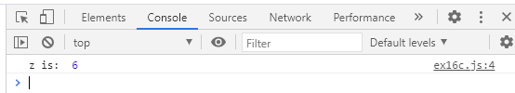

1. What is the output of the following, if any (indent this properly)?

if (x > 2) {

if  (y > 2) {

z = x + y;

console.log("z is: ", z);

}

else {

console.log("x is: ", x);

}

}

* 1. When x = 2 and y = 3
  2. When x = 3 and y = 2

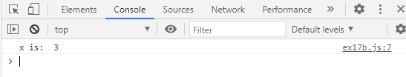

* 1. When x = 3 and y = 3

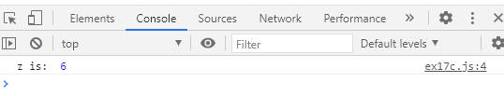

1. How many times does this loop run and what is the output?
   1. While loop

let number = 1;

while (number <= 5) {

  console.log(number);

  number++;

}

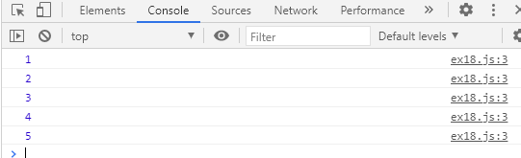

* 1. While loop

let number = 1;

while (number <= 5) {

  console.log(number);

}

1. How many times does this loop run and what is the output?
   1. For loop

for (let i = 1; i <= 5; i++) {

   console.log(i);

 }

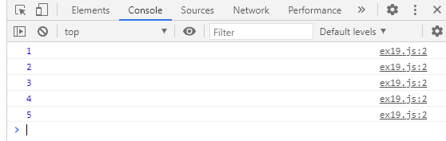

* 1. For loop

for (let i = 1; i <= 5; i++) {

   console.log(i);

   i++;

 }

