Answers displayed in red
1 day extra time
Part 1 Mandelbrot
1.
Modify the starter code to parallelize the Mandelbrot generation using two processors. Specifically, compute the top half of the image in thread 0, and the bottom half of the image in thread 1. This type of problem decomposition is referred to as spatial decomposition since different spatial regions of the image are computed by different processors.
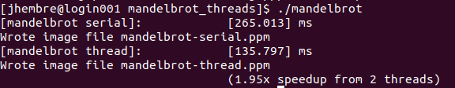

2.
Extend your code to utilize 2, 4, 8, and 16 threads, partitioning the image generation work accordingly, if the processor has 8 cores supporting two hyper-threads. Use the same idea to extend to 20 threads if the processor has 10 cores supporting two hyper-threads. In your write-up, produce a graph of speedup compared to the reference sequential implementation as a function of the number of cores used FOR VIEW 1. Is speedup linear in the number of cores used? In your write-up hypothesize why this is (or is not) the case? (you may also wish to produce a graph for VIEW 2 to help you come up with an answer.)
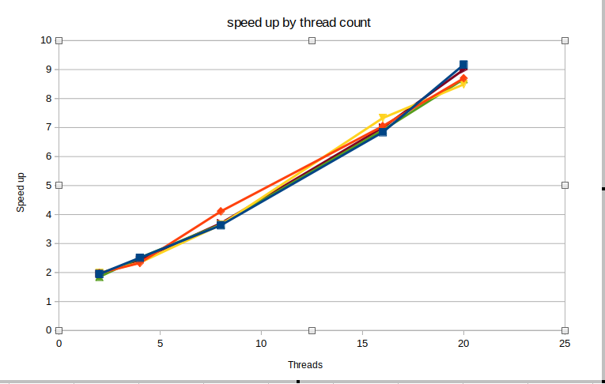
Here is the graph for speed up partitioning work by height/numThreads. I’ve graphed 5 lines to account for variance. While the graph is linear it is not 1 to 1 speed up. With 20 threads around 9x speed up is achieved. Ideally speedup should be around the amount of threads assigned. Since we are partitioning work by rectangular sections, this would indicate that some threads are likely doing more work than others. This is likely due to the higher levels of computation in the center of the image.

3.
To confirm (or disprove) your hypothesis, measure the amount of time each thread requires to complete its work by inserting timing code at the beginning and end of workerThreadStart(). How do your measurements explain the speedup graph you previously created?

Threads consistently finish in the order 0,7,1,6,2,5,3, and 4. This would indicate that threads that are allocated work towards the middle of the image are doing more work than threads on the outside. There is an imbalance in workload.

4.
Modify the assignment of work to threads to improve speedup to at about 8.5x on a 8-core machine on both views of the Mandelbrot set (if you're close to 8.5x that's fine, don't sweat it). You may not use any synchronization between threads. We are expecting you to come up with a single work decomposition policy that will work well for all thread counts---hard coding a solution specific to each configuration is not allowed! (Hint: There is a very simple static assignment that will achieve this goal, and no communication/synchronization among threads is necessary.). In your writeup, describe your approach and report the final 16-thread speedup obtained. Also comment on the difference in scaling behavior from 4 to 8 threads vs 8 to 16 threads.
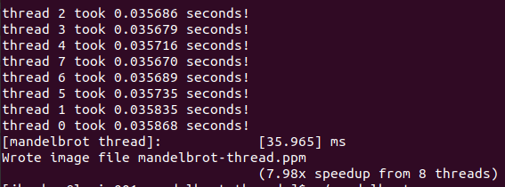
The terminal output above uses a new method of partitioning work among threads. Instead of partitioning into data blocks, I’ve interleaved the threads. It is evident that the work balance is far greater. Every thread finishes in roughly equivalent 0.35 second intervals. I achieved this balance by allocating work by individual rows rather than in blocked sections. This method allows threads to share work throughout the entirety of the Mandelbrot set instead of having threads work on a specific part of the set. In this way threads share the complex parts of the Mandelbrot set and the simple parts rather than having some threads doing easy work and others complex work.
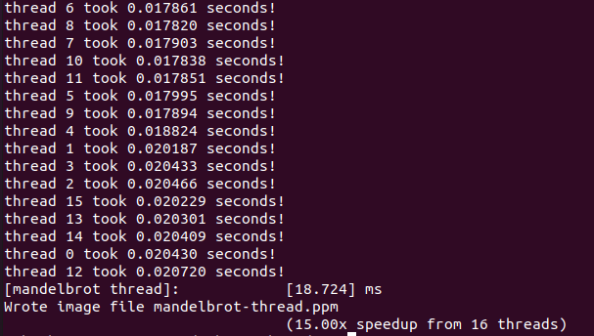
Here we have the final 16 thread speedup. We achieve near 1 to 1 speedup, but the ratio has begun to decline. Threads have diminishing returns so allocating 4 threads to 8 threads is more efficient than allocating from 8 to 16. Thread efficiency declines, but speedup is still increasing. This method is much more efficient than partitioning by blocked segments. In addition it is flexible enough to allow for any amount of threads less than 800 while the other method relied on having an amount of threads that distributed an integer amount of rows.
Part2: Saxpy
Compile and run saxpy. The program will report the performance of ISPC (without tasks) and ISPC (with tasks) implementations of saxpy.

1.
What speedup from using ISPC with tasks do you observe? Explain the performance of this program.
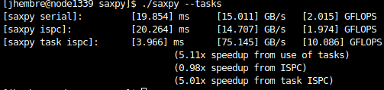
2.
Do you think it can be substantially improved? (for example, could you rewrite the problem to achieve near linear speedup?) (yes or no? Please justify your answer.)

No you cannot achieve linear speedup. This process has a very simple computation, but it is memory intensive. It makes calls to memory every time array X,Y, and Result is used. So the processor ends up waiting on memory to pass it information. The only speedup possible is better memory hardware.
Part 3: parallelize with ISPC
Compile and run the program mandelbrot ispc. The ISPC compiler is currently configured to emit 4-wide SSE vector instructions. (although you're encouraged to experiment with changing that compile flag to emit AVX, please answer this question for the SSE configuration.)

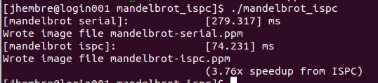
1.
What is the maximum speedup you expect given what you know about these CPUs? Why might the number you observe be less than this ideal? (Hint: Consider the characteristics of the computation you are performing? Describe the parts of the image that present challenges for SIMD execution? Comparing the performance of rendering the different views of the Mandelbrot set may help confirm your hypothesis.)

Since ISPC executes in gangs we should expect a speed up roughly around the programs gang size. It could be less than ideal due to calling sub-processes.

2.
Run mandelbrot_ispc with the parameter --tasks. What speedup do you observe on view 1? What is the speedup over the version of mandelbrot_ispc that does not partition that computation into tasks?

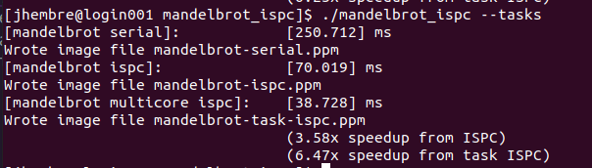
We get around a 3.58 speedup with the standard ISPC compiler vs. a 6.47 speedup using tasks. Specifically two tasks.
3.
There is a simple way to improve the performance of mandelbrot_ispc --tasks by changing the number of tasks the code creates. By only changing code in the function mandelbrot_ispc_withtasks(), you should be able to achieve performance that exceeds the sequential version of the code by about 16-18 times!
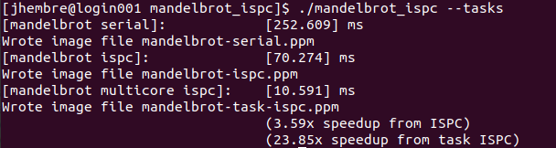
Here I’ve run 20 mandelbrot_ispc with 20 tasks.
4.
How did you determine how many tasks to create? Why does the number you chose work best?

The Ispc documentation for launching tasks states, “In general, one should launch many more tasks than there are processors in the system to ensure good load-balancing, but not so many that the overhead of scheduling and running tasks dominates the computation.” So I chose 50 as my best core amount possible. It seems to produce the best results. This node Is different than the above nodes. This is due to me previously operating in the login node which I had a fellow student tell me is not a good idea. He said the admins could get mad so I switched. This node had 20 cpus so I chose 50 as my task number.
