Prog3:

Preface:

I’ve been unable to rid my program of bugs, so I’m unsure if my matmul is truly accurate. I have reason to believe that it does function and the bugs are coming from the testing portion of my program, but I cannot for sure say that the matmul is accurate. I wish I had more time to fix my program so that it was clean, but midterms have done me in. I apologize.

Bugs:

- When testing performance my top and bottom end results are at times massively inflated.
  - I do not know the cause of this bug.
- My testing script runs, sort of.
  - I’ve commented them out because they were causing strange errors as I changed size away from what I created them with initially.
  - I’m fairly certain that if I updated the test to call matmul with variables adjusting for num_proc and SZ I could fix this. I don’t have the time I’m sorry.
  - They run well when -np = 4 and SZ = 40.
  - However the output does not match golden this is due to how MPI works. It feeds in partial matrices and not full matrices. As a result I have not truly done the bi-diagonal test. Its more of a mini bi-diagonal test where it only functions in a certain part of the true C out.

Testing:

I implemented two tests to test matrix correctness. The first test sets all array values to one. Once matmul is completed you should be able to print out sections of c that display size SZ. So for every item in C it should equal SZ.

The Second test was the bi-diagonal matrix test. I did not fully implement this successfully. I had difficulty understanding how to place the ones in the correct spot for the partitioned MPI version and lacked the time to overcome my confusion. However, the first test gives me reason to believe that the problem is not in the matmul, but my failure to implement the test correctly. Something I would have figured out more cleanly with more time. It is close to working, but it doesn’t.

Execution:

All results run with the following setup:

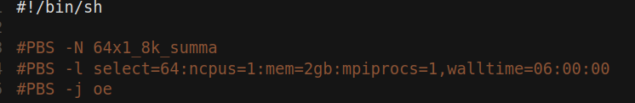
SZ = 2000:

Here I’ve run for the minimum size listed in the Project doc. There is a strong decline as number of MPI processes increases.

SZ = 3000:

Here we encounter our first potential bug. In testing I ran a pbs bash script that ran the program for a list of points. However, for some reason, at times, the value for 64 would be exponentially larger than expected. In the interest of authenticity I’ve shown this.

Here I have corrected for the bug by excluding the 64 value.
SZ=5000:

When running for size 5000 we see similar output to the other graphs. The bug has disappeared.

Size 6000:

Here are the results for size 6000. It falls in line with the other graphs as well. Summa appears to have a very consistent efficiency across all matrix sizes.

Discussion:

MPI remains difficult for me. I understand how it works, but it’s difficult to debug due to it not operating on a full matrix. If I could pass in full matrices instead of partials I think I would fair better.

MPI provides high performance by implementing a version of parallelism based on message passing through buffers. As Summa processes it broadcasts rows to columns in buffers that need that row to compute the block of C that they represent and vice versa. It spreads work out achieving high parallel computation by distributing all of the mini matrices of output c across many processors. There is some message passing overhead, but it is negligible.

