Use Steg-Expose to detect hidden data in images
Ex.No:8
Date:

Aim:

To conduct a comprehensive steganalysis lifecycle on digital image evidence using the StegExpose command-line utility; to evaluate Least Significant Bit (LSB) statistical properties and detection algorithms across a target evidence directory; to compute quantitative suspicion scores based on configurable thresholds; and to automatically compile, format, and export the analytical findings into a structured CSV report for forensic documentation

Description
StegExpose is a tool used to detect hidden data in images using steganography analysis. It works by evaluating the statistical properties of an image to estimate whether any hidden data is embedded. Below is a step-by-step guide on how to use StegExpose to detect hidden data in images:
Prerequisites:
- Java Runtime Environment (JRE): StegExpose is a Java-based tool, so ensure you have JRE installed.
- StegExpose Tool: Download StegExpose from the official GitHub repository.
Step-by-Step Process:
1. Download and Set Up StegExpose:
- Download the tool: Go to StegExpose GitHub and download the .jar file.
- Install Java: Ensure that Java is installed on your machine. You can download it from the official site.
- Prepare environment: Place the .jar file in a folder where you plan to work on the image files.
2. Select Images for Analysis:
- Collect the images you suspect might have hidden data. StegExpose supports formats such as .png, .jpg, .bmp, etc.
3. Open Command Line or Terminal:
- Navigate to the folder where you have saved the StegExpose.jar file.
- Open your Command Prompt (Windows) or Terminal (Linux/macOS).
4. Run StegExpose on an Image:
- Use the following command to check a single image for hidden data:
bash
java -jar StegExpose.jar <image_file_path>
Example:
bash
java -jar StegExpose.jar test_image.png
- Replace <image_file_path> with the actual path of the image you want to check.
5. Analyze the Output:
- After running the tool, it will analyze the image and provide a score.
- Output Explanation:
  - StegExpose calculates a "suspect" score (between 0 and 1). The higher the score, the more likely that hidden data is present.
  - Threshold values (suggested by the tool):
    - Less than 0.2: Image is clean (no hidden data).
    - 0.2 - 0.3: Possibly some hidden data.
    - Above 0.3: Likely that steganography is present.
6. Batch Analysis (Multiple Images):
- If you have multiple images to check, you can analyze them in bulk by specifying a folder. For example:
bash
java -jar StegExpose.jar <folder_path>
- Replace <folder_path> with the path to the folder containing the images.
7. Advanced Options (Optional):
- StegExpose provides additional parameters, such as adjusting the sensitivity of detection and output verbosity. Use --help to see the list of options:
bash
java -jar StegExpose.jar --help
8. Review the Results:
- For each image analyzed, review the scores and determine whether you need to investigate further.
Example:
bash
java -jar StegExpose.jar suspect_image.png
Output:
makefile
Analyzing suspect_image.png...
Result: 0.4
Steganography likely present

This output indicates that hidden data is likely present in the image suspect_image.png.
Sample outputs:
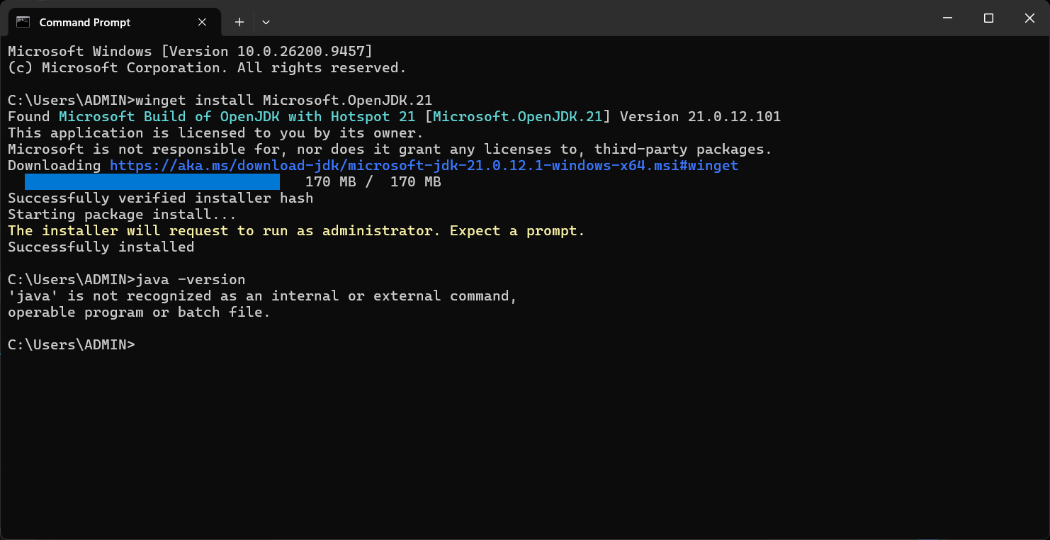
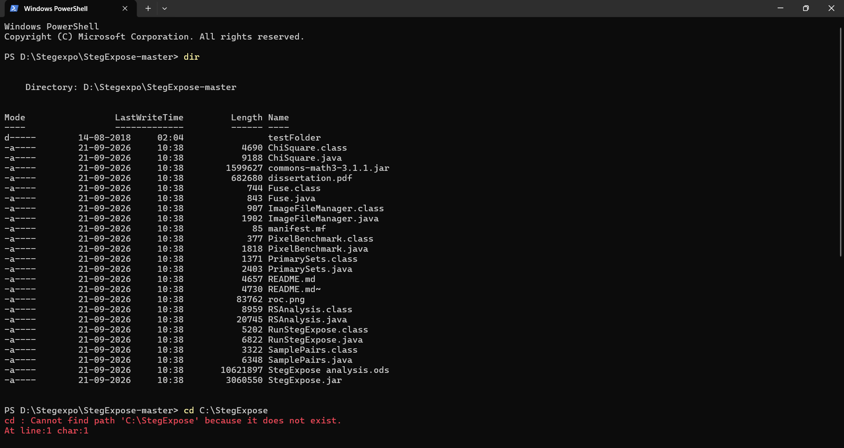
Fig8.1:JDK is being installed for the scan
Fig8.2:The files and folders in directories are shown
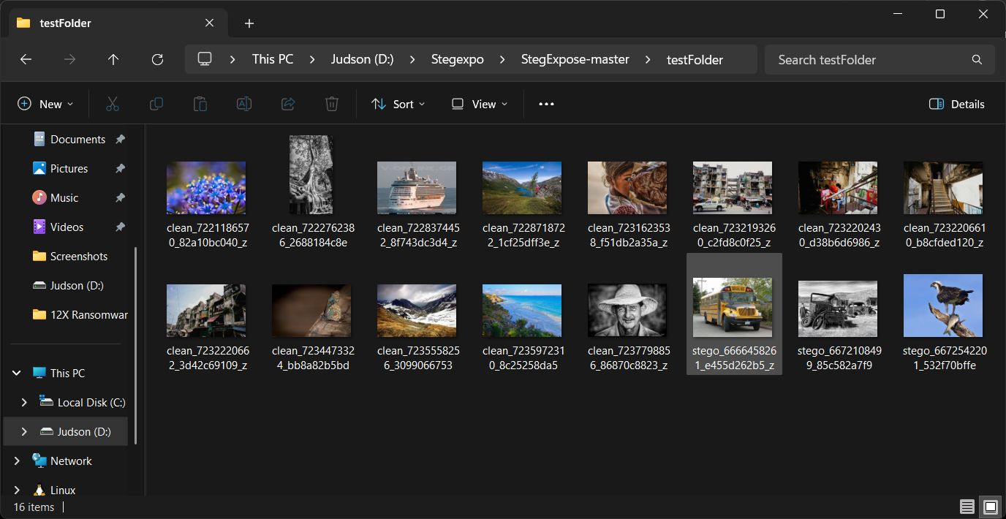
Fig8.3:Images which we are going to be scanned

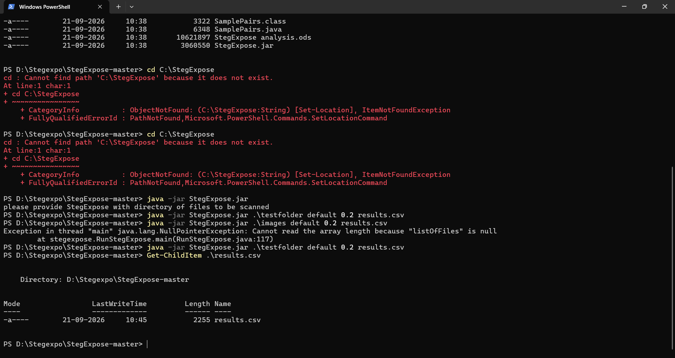
Fig8.4:The images are being scanned and stored in results.csv

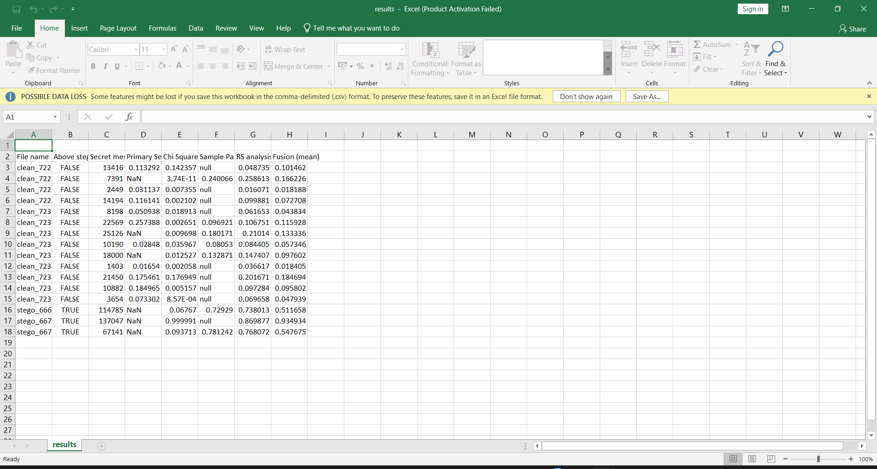

Fig8.5:The csv file were the reports are being stored

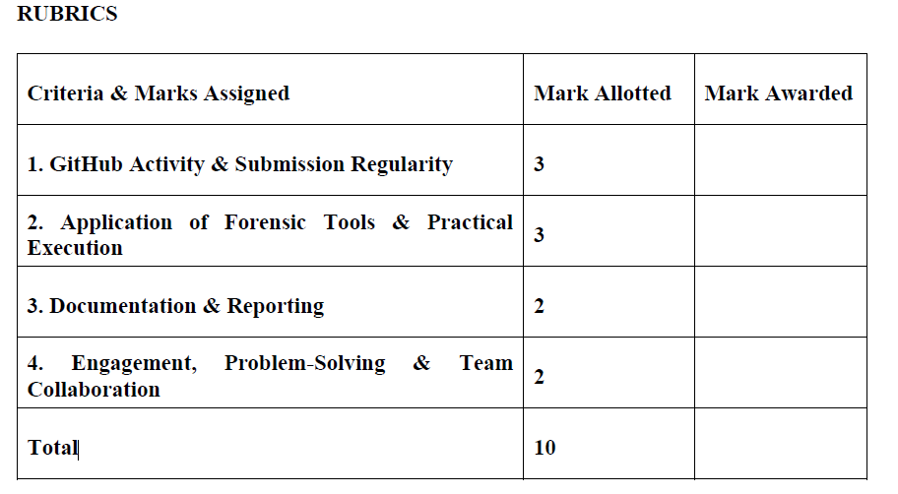

Result:
The steganography detection experiment was successfully executed using StegExpose. The tool scanned the evidence directory via the command line, analyzed combinations of LSB metrics, and generated a clean CSV report detailing the cleanliness or suspicion level of each digital image artifact.

