Malware Disassembly and Code Analysis Using Ghidra
EXPERIMENT NO: 10
DATE:
1. AIM
To set up a secure analysis environment, utilize the Ghidra reverse engineering framework to disassemble and decompile binary code, and interpret low-level assembly functions to identify common malware behaviors, persistence mechanisms, and indicators of compromise.
2. SOFTWARE / TOOLS REQUIRED
- Operating System: Isolated Virtual Machine (Windows/Linux OS)
- Forensics Tool: Ghidra (Open-source software reverse engineering suite developed by the NSA)
- Runtime Environment: Java Development Kit (JDK) required for running Ghidra (OpenJDK 21)
- Sample Files: Benign sample binaries (benign_sample1.bin, benign_sample2.hex) or controlled test binaries exhibiting typical executable structures (/bin/ls ELF 64-bit x86-64).
3. DESCRIPTION
Malware analysis is the critical process of dissecting compiled software to understand its capabilities, origins, and operational intent without executing it live (static analysis). Ghidra, an open-source Software Reverse Engineering framework developed by the National Security Agency (NSA), is utilized extensively by forensic investigators for this purpose. When original source code is unavailable or intentionally obfuscated by adversaries, analysts rely on Ghidra to bridge the gap between raw, machine-executable binaries and human-readable logic.
The framework's core strength lies in its CodeBrowser, which parses raw binary instructions into low-level assembly language, while its advanced Decompiler algorithmically reconstructs higher-level, C-like pseudo-code. This dual approach significantly reduces the cognitive load required to decipher complex malware algorithms. To further aid in understanding the execution logic, Ghidra generates interactive Control Flow Graphs (CFGs) that visually map out function calls, decision branches, and loops, allowing analysts to trace execution paths and identify evasion techniques.
4. PROCEDURE
Step 1: Installation, Project Initialization, and Binary Import
1. Open the terminal and ensure the Ghidra framework and Java Development Kit (JDK 21) are installed.
Bash: sudo apt update && sudo apt install ghidra -y
Windows: ghidraRun.bat (JDK 21 configured)
2. Launch Ghidra from the terminal or command line by executing ghidraRun.
3. Create a new non-shared project titled Ghidra_Malware_Analysis.
4. Navigate to File > Import File, select the target binary (/bin/ls), and proceed with the default import configuration (ELF 64-bit x86-64 executable).
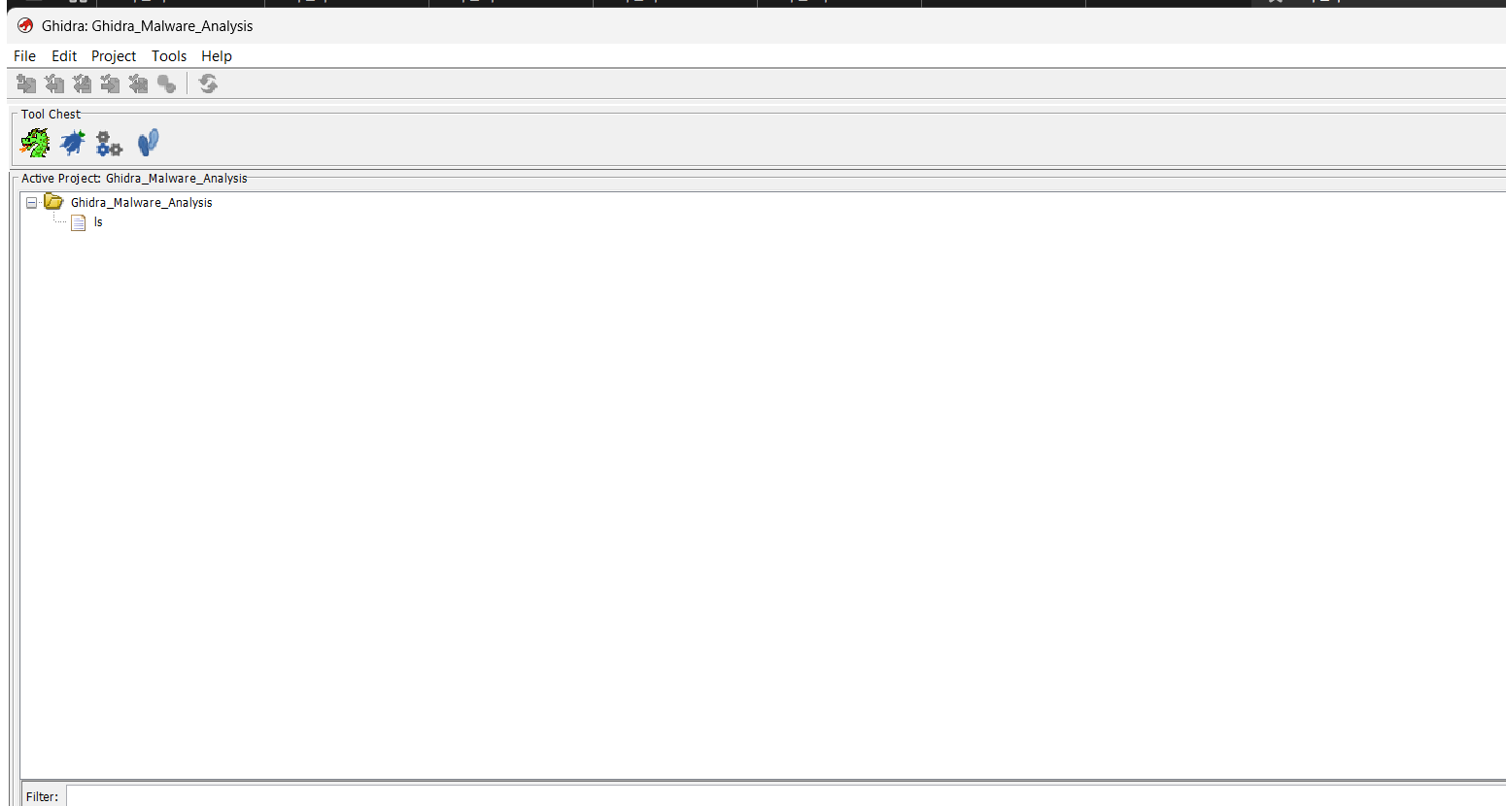
Figure 1: Initial Ghidra Project Window showing the newly imported binary
5. Double-click the imported file to open it in the CodeBrowser tool and execute the initial Auto-Analyze function when prompted.
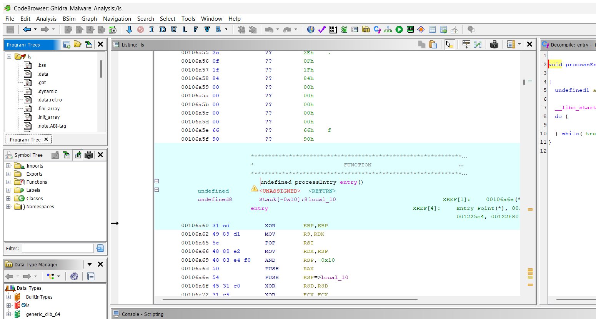
Figure 2: Ghidra CodeBrowser interface displaying the disassembly after Auto-Analysis
Step 2: String Extraction and Import Analysis
1. Navigate to Window > Defined Strings to extract hardcoded ASCII and Unicode strings from the binary.
2. In the Symbol Tree pane on the left, expand the Imports directory to identify the external shared libraries the binary relies on (e.g., libc.so.6).
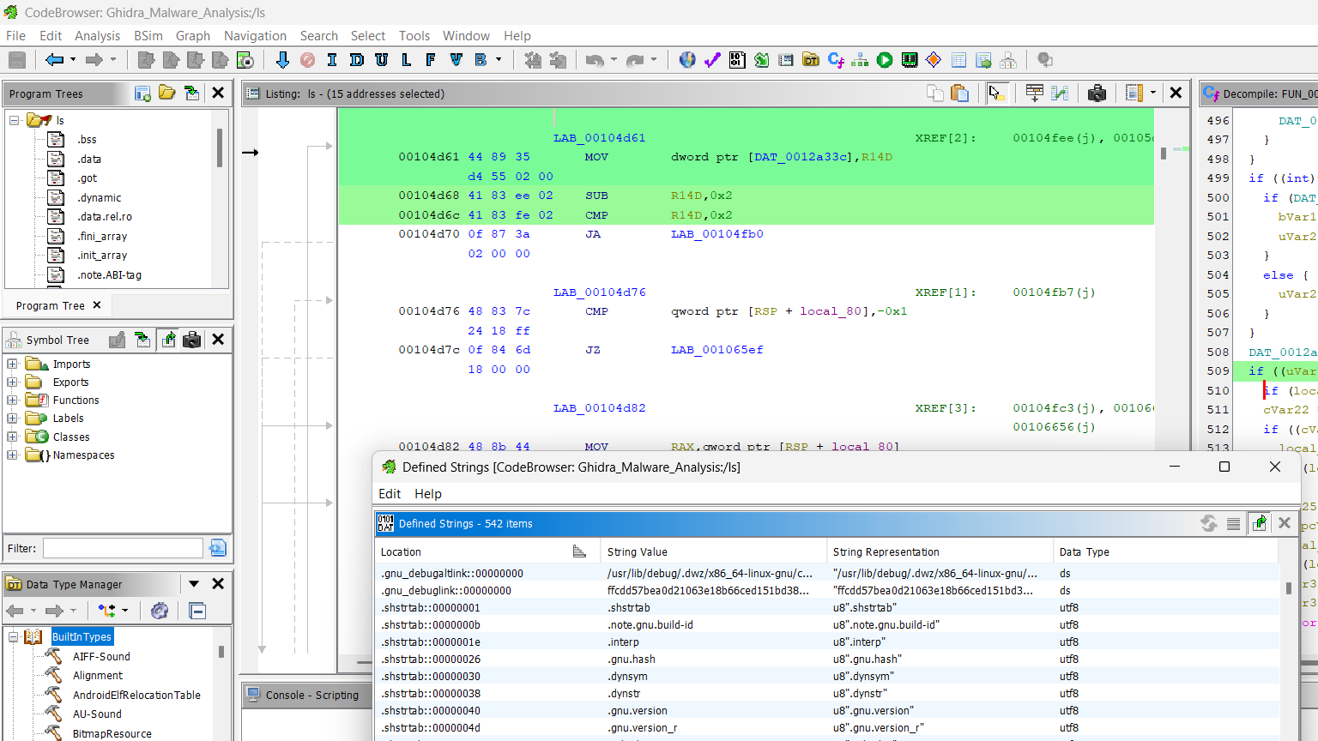
Figure 3: Extraction of Defined Strings and identification of system Imports
Step 3: Function Decompilation
1. In the Symbol Tree pane, expand the Functions directory.
2. Locate and select the entry function (processEntry entry at address 00106a60).
3. Observe the raw Assembly instructions in the center Listing window, and analyze the translated C-like pseudocode in the right-hand Decompile window.
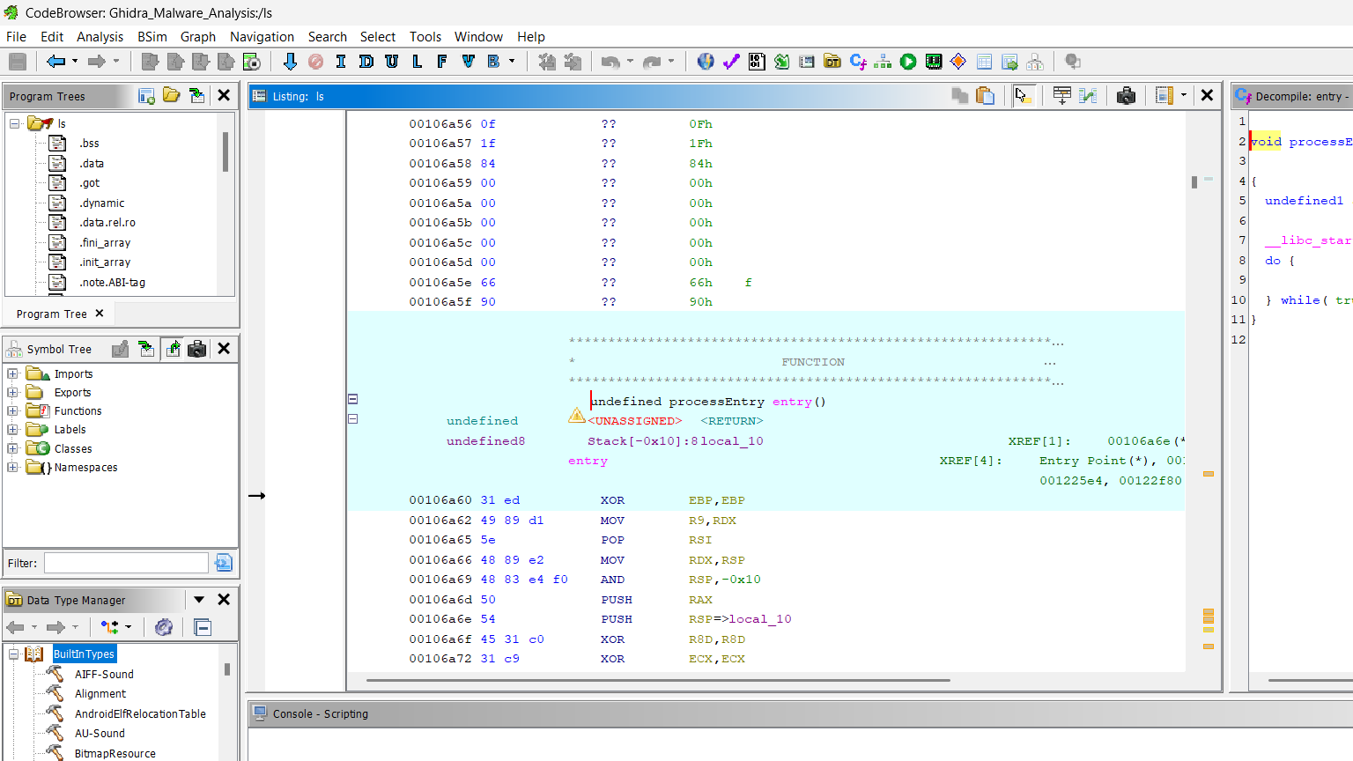
Figure 4: Decompiled C-like pseudocode of the entry function
Step 4: Execution Flow Visualization (Main Function)
1. Due to the binary being stripped, the original main function name was removed (.symtab stripped). In the Decompiler window for the entry function, identify the first parameter passed to __libc_start_main (e.g., FUN_00104be0).
2. Double-click FUN_00104be0 to navigate to the actual main execution logic of the program.
3. With FUN_00104be0 selected, navigate to Window > Function Graph (or press Ctrl+Space).
4. Analyze the visual block diagram that illustrates the complex logical execution paths, decision branches (green and red arrows), jump tables (blue lines), and loops within the core code.
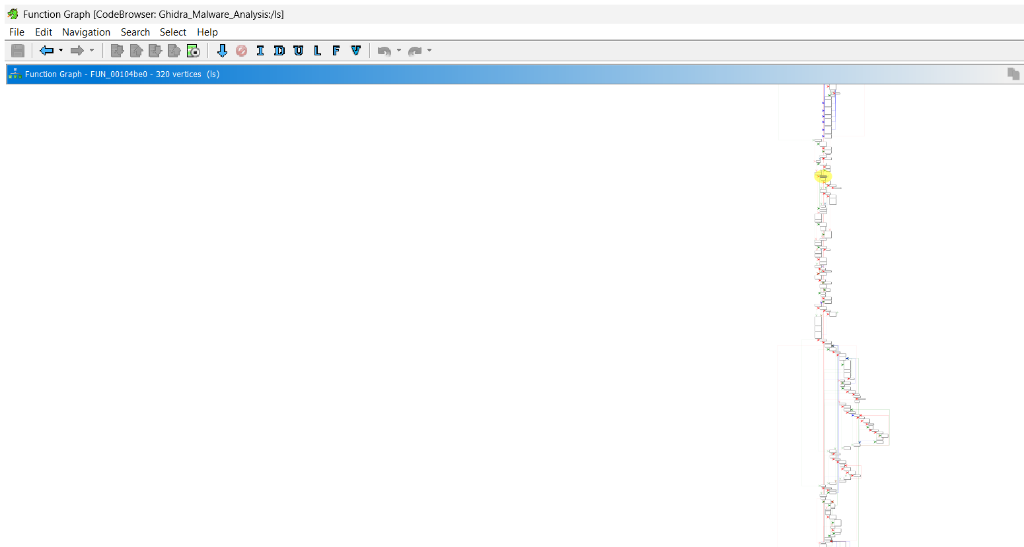
Figure 5: Visual Function Graph illustrating the complex execution flow of the stripped main function (FUN_00104be0)
5. OBSERVATIONS / FORENSIC FINDINGS
- Code Structure: Ghidra successfully disassembled the ELF binary, revealing the core architecture (x86-64), data sections (.text, .data, .rodata, .bss, .got, .plt), and metadata headers.
- Strings & Imports: The extraction of defined strings (542 defined strings identified) and imports confirmed the binary's reliance on standard system libraries (libc.so.6), consistent with a benign Linux utility. In a malware context, this step would reveal imported networking, evasion, or encryption libraries.
- Decompilation: The Decompiler successfully translated the low-level assembly of the entry function into an understandable C-code format, highlighting the __libc_start_main execution call.
- Flow Analysis: The Function Graph provided a clear, node-based visualization of the function's structural logic (320 vertices mapped), simplifying the analysis of complex execution paths, decision blocks, and potential infinite loops.
- Stripped Binary Analysis & Symbol Resolution: The binary had its symbol table stripped (.symtab removed), obscuring original developer function identifiers and variable names. Forensic examination of the execution entry vector resolved the actual main routine (FUN_00104be0) by tracing the primary pointer passed into the __libc_start_main parameter list.
RUBRICS
Criteria & Marks Assigned | Mark Allotted | Mark Awarded
1. GitHub Activity & Submission Regularity | 3
2. Application of Forensic Tools & Practical Execution | 3
3. Documentation & Reporting | 2
4. Engagement, Problem-Solving & Team Collaboration | 2
Total | 10

6. RESULT
Ghidra was successfully utilized to disassemble, decompile, and analyze the target binary code. Through automated analysis, string inspection, API import tracking, and decompiler evaluation, the binary's underlying structure and behavioral logic were effectively interpreted.

